Class Work – COMP397 – March 21th

Andre Batista Valentim Oliveira - 300909648

Contents

Setup 1

Go to chapter 5 2

CheckForWin Functionality 3

Test Cases 4

# Setup

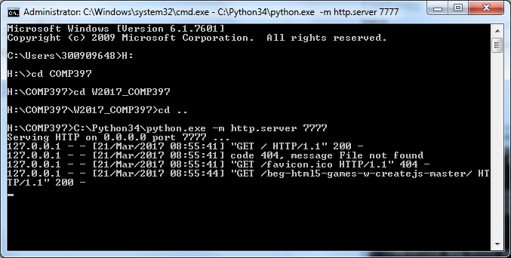

# Go to chapter 5

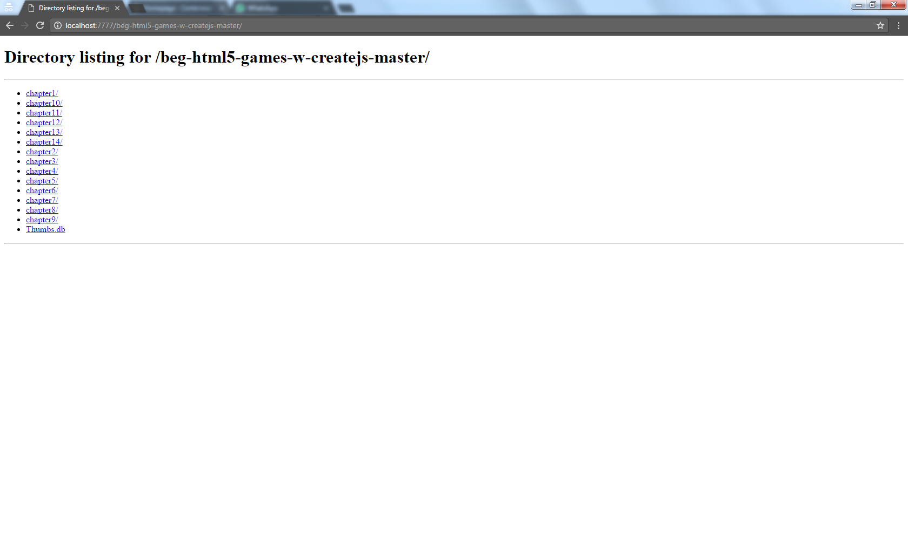

# CheckForWin Functionality

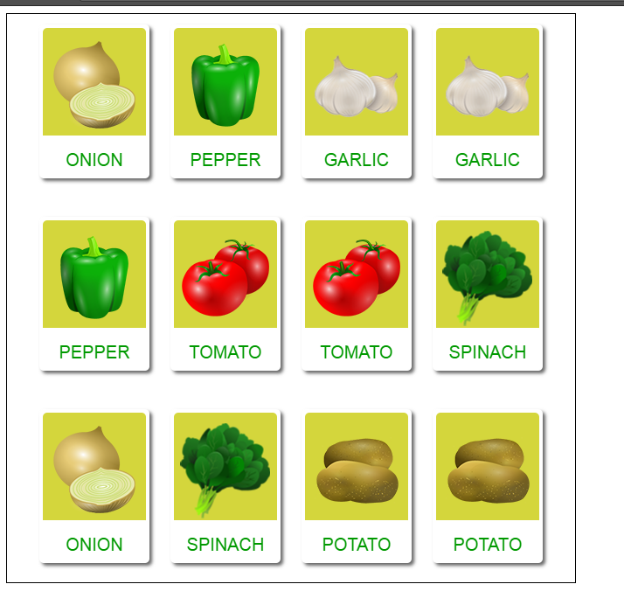

# Test Cases

