Class Work – COMP397 – March 28h

Andre Batista Valentim Oliveira - 300909648

Contents

Setup 1

Go to chapter 7 2

Changing Game Title 2

Solitaire Game 3

# Setup

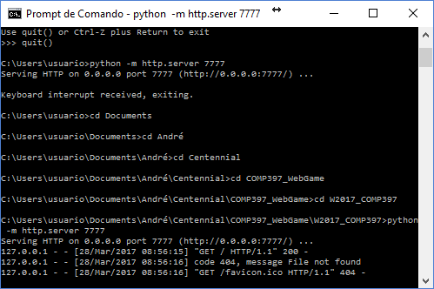

# Go to chapter 7

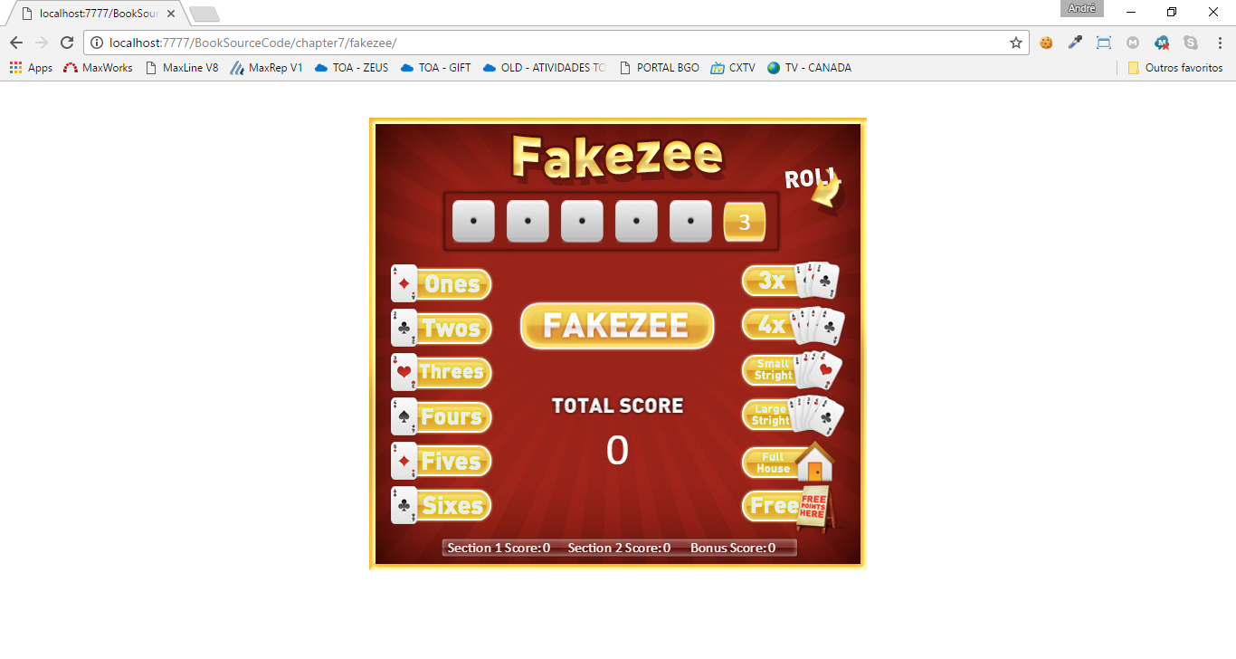

# Changing Game Title

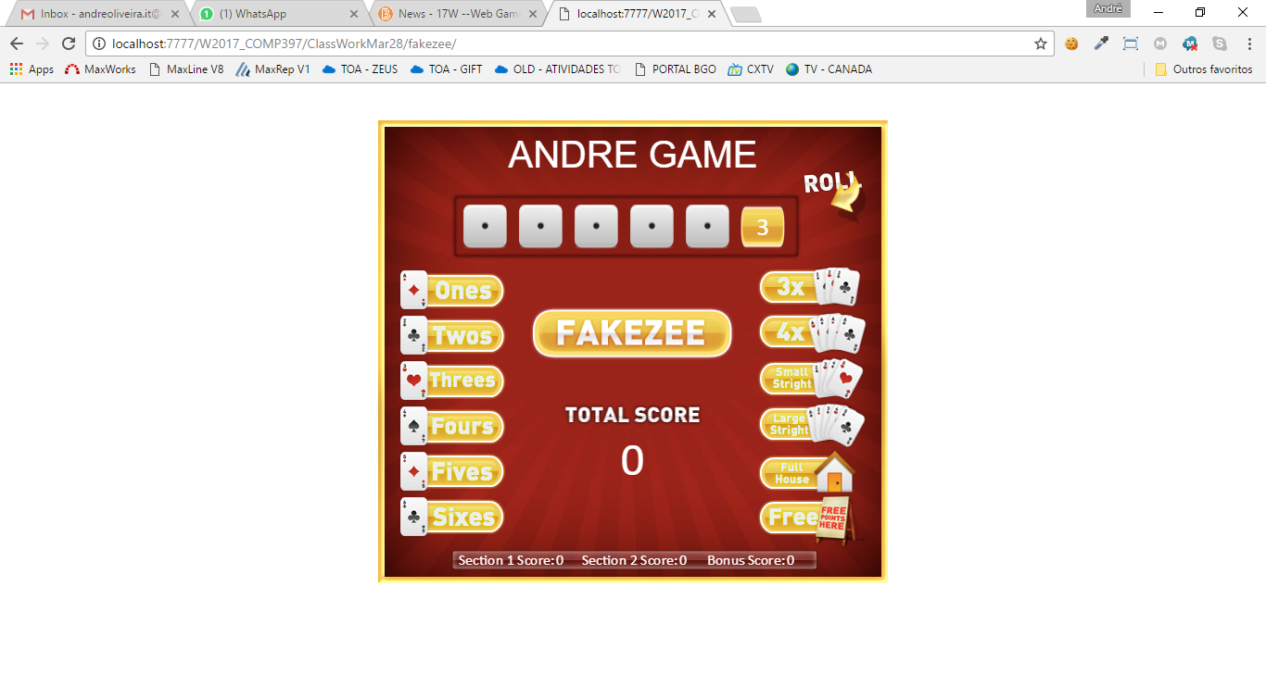

# Solitaire Game

