Binary representations of integers
- dimensions of the memory location: n= 8, 16, 32,64 bits
- the structure of the memory location : bit 0 (the rightmost bit) is the least significant bit, bit n-1 (the leftmost) is the most significant one ;
bit n-1 bit n-2 bit 1 bit 0
…

Rules for binary operations with integers:

R1) Addition and subtraction on n bits: both terms and the result are represented on n bits.
R2) Multiplication on n bits: both factors represented on n bits and the product represented on 2⋅n bits.

R3) Division on n bits: dividend represented on 2⋅n bits, the divisor on n bits. This operation provides a quotient and a remainder represented both on n bits.

R4) In case of overflow the most significant bits are lost.

There are two classes of representations:
- unsigned representation: only for natural numbers;
- signed representations: for integers with sign.

Unsigned representation
- the number is converted into binary and then the bits are filled with the corresponding binary digits (aligned to the right), eventually the leftmost bits are filled with insignificant zeros.
- min: 0...0₍₂₎= 0
- max: 1…1₍₂₎= 2^{n} – 1
- intervals of values:
n = 8 [ 0 , 255 ]
n = 16 [ 0 , 65535 ]
n = 32 [ 0 , 4 294 967 295 ]
n = 64 [ 0 , 18 446 824 753 389 551 615 ]
Examples of representations and operations on 8 bits:
1) 18+ 12₍₁₆₎+ 00010010₍₂₎+
18 12₍₁₆₎ 00010010₍₂₎
--- ----- -------------
36 24₍₁₆₎ 00100100₍₂₎

2) 243- F3₍₁₆₎- 11110011₍₂₎-
18 12₍₁₆₎ 00010010₍₂₎
---- ---- ------------
225 E1₍₁₆₎ 11100001₍₂₎

3) 243+ F3₍₁₆₎+ 11110011₍₂₎+
18 12₍₁₆₎ 00010010₍₂₎
--- -- -----------
261 05₍₁₆₎ 100000101₍₂₎ ! overflow at addition!

4) 18- 12₍₁₆₎- 00010010₍₂₎-
243 F3₍₁₆₎ 11110011₍₂₎
--- -- -----------
-225 1F₍₁₆₎ 00011111₍₂₎ ! overflow at subtraction !

Signed representations – codes
- dimensions of the memory location n{8,16,32,64} bits
- the most significant bit (bit n-1) is used for the sign (S=0 for positive numbers, S=1 for negative numbers), and for the magnitude of the number n-1 bits are used.

bit n-1 bit n-2 bit 1 bit 0
S |  | …

Direct code
Let x be an integer, ⏐x⏐ < 2^{n-1}. The direct code of x is defined as follows:
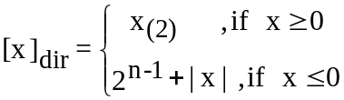
- for a positive number the bits from the memory location are filled with the digits from the binary representation, aligned to the right, the sign bit is 0;
- for negative number: its absolute value is represented and then the sign bit is set to 1 (equivalent with the operation: 10...0₍₂₎+|x| )
- disadvantage: there are 2 different direct codes for 0:
[+0]_{dir}: |0|0....0| and [-0]_{dir}: |1|0....0|

Inverse code (complement to 1)
Let x be an integer, ⏐x⏐ < 2^{n-1}. The inverse code of x is defined as follows:
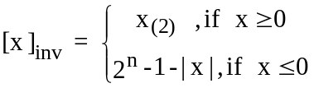
- the inverse code of a positive number is the same as the direct code
- for a negative number: its absolute value is represented and then the values of all bits are inversed (complemented to 1): equivalent with the operation: 11…1₍₂₎-|x₍₂₎| ;
- disadvantage: there are 2 different inverse codes for 0:
[+0]_{inv}: |0|0....0| and [-0]_{inv}: |1|1...1|

Complementary code (complement to 2)
Let x be an integer, ⏐x⏐ < 2^{n-1}. the complementary code of x is defined as follows:
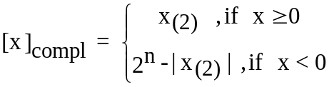
- for a positive number x, [x]_{compl} = [x]_{inv} =[x]_{dir}
- for a negative number: its absolute value is represented, then from right to left, beginning with bit 0, all the bits with value 0 and the first bit 1 remain unchanged and all the other bits to the left are inversed.
- if x < 0, then [x]_{compl} = [x]_{inv} + 1
- advantage: there is a unique code for 0: [0]_{compl}: |0|0....0|
- there is a configuration of bits which does not correspond to a number: |1|0...0|

Intervals of values for integers:

n= 8 [-127 , 127]
n=16 [-32767 , 32767]
n=32 [-2 147 483 647 , 2 147 483 647]
n=64 [-9 223 412 376 694 775 807, +9 223 412 376 694 775 807]

Examples: the codes on 8 bits:
100= 1100100₍₂₎
[100]_{dir} =[100]_{inv} =[100]_{compl} =|0|1100100|
[-100]_{dir} = |1|1100100|
[-100]_{inv} =|1|0011011|
[-100]_{compl}=|1|0011100|
40= 101000₍₂₎
[40]_{dir} =[40]_{inv} =[40]_{compl} = |0|0101000|
[-40]_{dir} = |1|0101000|
[-40]_{inv} =|1|1010111|
[-40]_{compl}=|1|1011000|

Addition and subtraction in complementary code

[x]_{compl} is considered an array of n bits, representing a positive number in base 2.
The complementary codes of the sum and difference of the integers x, y>=0:
[x+y]_{compl} =[x]_{compl} ⊕[y]_{compl}
[x-y]_{compl} =[x]_{compl} ⊕[-y]_{compl}

The algebraic sum: ⊕, is defined as follows:
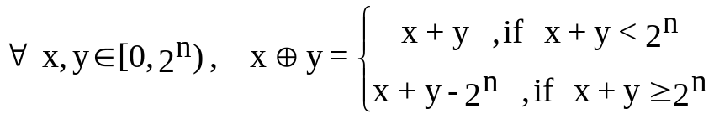
Rules
r1: if x, y have the same sign, but x⊕y has the opposite sign=>overflow.
r2: if in the result of x⊕y, there is a carry digit outside the representation space this will be eliminated (the second branch of the above definition).
Example:
[40+40]_{compl} =[40]_{compl} ⊕ 0|0101000⊕
[40]_{compl} 0|0101000
----------------------------------------------------
[80] _{compl} = 0|1010000 - correct result

[100+100]_{compl} =[100]_{compl} ⊕ 0|1100100⊕
[100]_{compl} 0|1100100
----------------------------------------------------
[200]_{compl} = 1|1001000 - overflow (r1)

[100-40]_{compl} =[100]_{compl} ⊕ 0|1100100⊕
[-40]_{compl} 1|1011000
----------------------------------------------------
[60]_{compl} = 10|0111100 - correct result (r2)

Subunitary convention:
bit n-1 , bit n-2 bit 1 bit 0
S |  | …

Let x ∈ R, ⏐x⏐ < 1, with at most n-1 binary digits after the decimal point.
The direct code of x is:
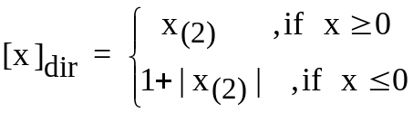

The inverse code (complement to 1) of x is:
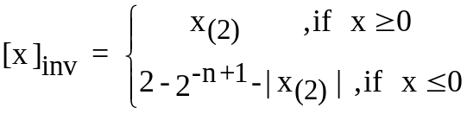

The complementary code (complement to 2) of x is:
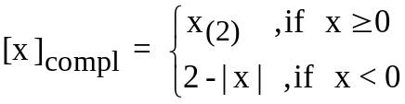

The complementary codes for the sum and difference of two subunitary positive numbers x, y:
[x+y]_{compl} =[x]_{compl} ⊕[y]_{compl}
[x-y]_{compl} =[x]_{compl} ⊕[-y]_{compl}

The algebraic sum ⊕ on n bits, is defined as follows:
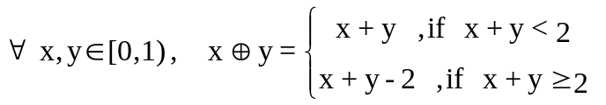

Remarks:
- for a positive number: the number is converted into binary, the sign bit is 0, beginning with the bit n-2, from left to the right, the bits are filled with the corresponding binary digits.
- the same practical rules for obtaining the codes for negative numbers and for the addition and subtraction in complementary code as for integers are applied.
- if x >= 0, then [x]_{compl} = [x]_{inv} =[x]_{dir}
- if x < 0, then [x]_{compl} = [x]_{inv} + 2^{-n+1}

Examples:
0,25= 0,01₍₂₎ 13/16=0,D₍₁₆₎ =0,1101₍₂₎
,
[13/16] _{dir} = [13/16]_{inv}= [13/16]_{compl} = |0|1101000|
[-13/16]_{dir} = |1|1101000|
[-13/16]_{inv} = |1|0010111|
[-13/16]_{compl} = |1|0011000|
[0,25]_{compl} = |0|0100000|
[-0,25]_{compl} = |1|1100000|
,
[0,25+0,25]_{compl} =[0,25]_{compl} ⊕ 0|0100000⊕
[0,25]_{compl} 0|0100000
----------------------------------------------------
[0,5] _{compl} = 0|1000000 correct result

,
[0,25+13/16]_{compl} =[0,25]_{compl} ⊕ 0|0100000⊕
[13/16]_{compl} 0|1101000
----------------------------------------------------
= 1|0001000 - overflow (r1)
!!positive operands, negative sum !!
,
[13/16-0,25]_{compl} =[13/16]_{compl} ⊕ 0|1101000⊕
[-0,25=-4/16]_{compl} 1|1100000
----------------------------------------------------
[0,5625=9/16]_{compl} = 10|1001000 - correct result (r2)

Binary representations for real numbers

- fixed point representation and floating point representation

Fixed point representation
- dimension of memory location: n bits (n=16,32,64)
- 3 zones of the memory location with predefined dimensions (1,I,F):
  - the most significant bit (S), position n-1, is the sign bit with the values: 0 for positive numbers and 1 for negative numbers;
  - the decimal point has a fixed position, a virtual one, separating the integer part from the fractional one;
  - 1+I+F= n bits (n=16,32,64)
  - the integer part (I bits)
    - memorizes (aligned to the right relative to the virtual position of the decimal point) the digits of the absolute value of the number converted in binary;
    - if I > the number of digits of the binary representation of the absolute value of the number, the remaining bits to the left are filled with 0.
    - if I < the number of digits of the binary representation of the absolute value of the number, then the most significant digits of the integer part are lost (!! disadvantage).
  - the fractional part (F bits)
    - memorizes (aligned to the left relative to the virtual position of the decimal point) the digits of the fractional part
    - if F > the number of binary digits of the fractional part then the remaining digits to the right are filled with 0.
    - if F < the number of binary digits of the fractional part then the least significant digits of the fractional part are lost.

I-1 1 0 , -1 -F
 |  | … |  | → | ← | …
S | integer part : I bits |  |  |  | fractional part: F bits
virtual position
of the decimal point

A nonzero real number x is represented in fixed point convention on n=1+I+F bits if: 2^{-F} ≤ ⏐x⏐ ≤ 2^{I} - 2^{-F}

The representation of the minimum absolute value 2^{-F} is:
S| I bits , F bits
0 | 0 | ... | 0 | 0 | ... | 0 | 1

The representation of the maximum absolute value 2^{I} -2^{-F} is:

S| I bits , F bits
0 | 1 | ... | 1 | 1 | ... | 1 | 1

Remark: =10...0,0...00₍₂₎ - (2^{I})
0,0...01₍₂₎ ( 2^{-F})
-------------
1...1,1...11₍₂₎

Example 1:
Represent in fixed point convention on 16 bits, I=6 bits, F=9 bits the number: – 29,21.
Conversion into binary:
- integer part: the number is written as a sum of powers of 2:
29 = 16+8+4+1= 2⁴+2³+2²+2⁰= 11101₍₂₎
- fractional part: successive multiplications by the destination base 2:
9 multiplications by 2 (F=9 bits)
0,21*2=0,42 0,42*2=0,84 0,84*2=1,68 0,68*2=1,36
0,36*2=0,72 0,72*2=1,44 0,44*2=0,88 0,88*2=1,76
0,76*2=1,52
0,21=0,001101011₍₂₎
– 29,21=-11101,001101011₍₂₎
Representation:
S | 6 bits , 9 bits
1 | 0 | 1 | 1 | 1 | 0 | 1 | 0 | 0 | 1 | 1 | 0 | 1 | 0 | 1 | 1 | = | BA6B
| |
location’s content in hexa

Example 2.
Represent in fixed point convention on 16 bits, I=6 bits, F=9 bits, the number: + 70,21.
70 = 64+4+2= 2⁶+2²+2¹= 1000110₍₂₎,
70,21= 1000110,001101011₍₂₎
Remark:
The integer part does not fit in 6 bits, the most significant bit is lost: 1.
S | 6 bits , 9 bits
0 | 0 | 0 | 0 | 1 | 1 | 0 | 0 | 0 | 1 | 1 | 0 | 1 | 0 | 1 | 1 | = | 0C6B
| |
location’s content in hexa

Floating point representation
- used to represent very large and very small numbers with a high precision
- if there is an overflow the least significant digits are lost

Any real number x can be written as: x = ±0,m ⋅ b^{e} where:
m - mantissa ;
b - numeration base;
e - exponent

Example :
1234,5678 =0,12345678 *10⁴
0,004371 =0,4371 *10⁻²
1101,0011₍₂₎ =0,11010011₍₂₎ *2⁴

Def 1: A real number x is written with a subunitary mantissa and an exponent of base b if x = ±0,m ⋅ b^{e}

Def 2: A real number x, x ≠ 0, is written with a subunitary normalized mantissa, if x is written with a subunitary mantissa and an exponent of base b and 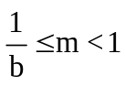.

Ex : 0,12345678 *10⁴ - subunitary normalized mantissa
0,004371 *10⁻⁴ - mantissa is not normalized

Def 3 : A real number x, x ≠ 0, is written with a 1<mantissa <2 ,
if x = ±1,m ⋅ 2e

Def 4: A real number x is represented in floating point notation if it is used the binary representation with exponent and subunitary mantissa or 1<mantissa<2.

Remarks:
- If 1<mantissa<2 the digit 1 from the integer part is not represented (is hidden) but will be used in the operations with the representations.
- Computers use now 1< mantissa <2.
| E bits | M bits
S | c = e + q | m
|
, virtual position of the decimal point
where:
S – sign bit
c - e (exponent) + q(bias)
q – bias (a constant of the computer)
e - the exponent from the binary representation with mantissa and exponent
m - mantissa from the binary representation with mantissa and exponent

The precision of representation is provided by the min and max values of the exponent:
0 ≤ c=(e + q ) ≤ 2E - 1 ⇒ -q ≤ e ≤ 2E -1 - q

Standards IEEE 1<mantissa< 2.

Standard IEEE 754 Single precision
32 bits
| 8 bits , 23 bits E=8 bits, M=23 bits
S | c = e + 127 | m
| q = 127= 2⁷-1= 2^{E-1}-1, -127≤ e ≤ 128

Standard IEEE 754 Double precision
64 bits
| 11 bits , 52 bits E=11bits, M=52 bits
S | c = e + 1023 | m
q= 1023=2¹⁰-1=2^{E-1}-1, -1023≤ e ≤ 1024

Special values
Value | Representation  S | c | m
0₊ | 0 | 0...0 | 0...0
0- | 1 | 0...0 | 0...0
-inf | 1 | 1...1 | 0...0
+inf | 0 | 1...1 | 0...0
NaN (not a number) | 1 sau 0 | 1...1 | Nonzero value

Remarks
1. c= 11..1₍₂₎ is used only for the special values: +inf, -inf, NaN
2. The smallest positive number which can be represented in single precision
has the representation:
S c , m
0 | 00000001 | 00000000000000000000000

c=1 => e +127(q)=1 => e= -126

Using the hidden bit the value of the mantissa is 1.0 and:
min =1.0 * 2⁻¹²⁶ =2⁻¹²⁶

2. The largest positive number which can be represented in single precision has the representation:
S c , m
0 | 11111110 | 11111111111111111111111

c=11111110₍₂₎=2⁸-2=(the biggest value of c for a valid number)

  - e +127(q)= 254 => e= 127

Using the hidden bit, the value of the mantissa is:

1,11111111111111111111111₍₂₎=2-0,00000000000000000000001₍₂₎=2-2⁻²³
max =(2-2⁻²³)* 2¹²⁷

Precision | Binary  absolute value | Decimal  absolute value
Single | min = 2⁻¹²⁶  max= (2-2⁻²³)*2¹²⁷ | min ≈ 10⁻³⁸  max ≈ 10³⁸
Double | min = 2⁻¹⁰²²  max = (2-2⁻⁵²)*2¹⁰²³ | min ≈ 10⁻³⁰⁸  max ≈ 10³⁰⁸

Example 1:
Represent in floating point notation, single precision the number 2530,41.
8 is used as an intermediate base:
- Conversion of the integer part: successive divisions by 8
2530: 8 = 316 remainder 2
316: 8 = 39 remainder 4
39: 8 = 4 remainder 7
4: 8 = 0 remainder 4
2530=4742₍₈₎=100 111 100 010₍₂₎= 1,00111100010₍₂₎*2¹¹
The number is written with exponent and a mantissa >1
=> e=11 şi c=127+11=138 =128+8+2= 2⁷+2³+2¹ =10001010₍₂₎
- Conversion of the fractional part: successive multiplications by 8
- there are 11 digits in mantissa from the integer part
- we need 12 more binary digits obtained from the fractional part:
12 binary digits are covered by 4 octal digits: 4 multiplications by 8
0,41*8 = 3,28
0,28*8 = 2,24
0,24*8 = 1,92
0,92*8 = 7,36
0,41=0,3217₍₈₎=0,011 010 001 111₍₂₎ (rapid conversion)

2530,41= 1,00111100010011010001111₍₂₎*2¹¹
Representation on 32 bits:
S c , m memory content in hexa
0 | 10001010 | 00111100010011010001111 | = | 451E268F

