- Create a new DB (name it dvdrental) : right click on postgres -> create -> Database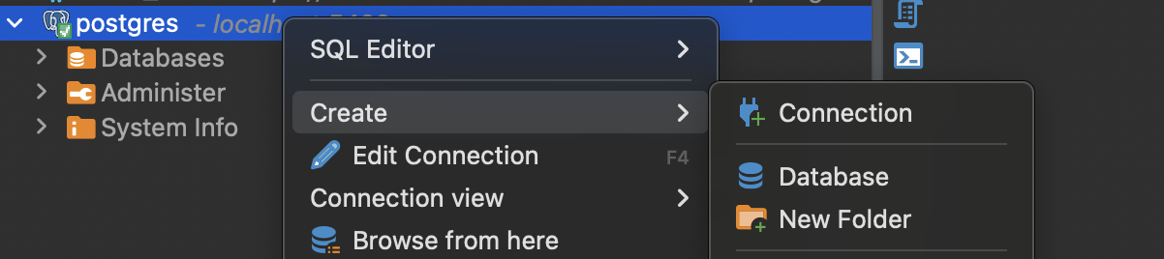 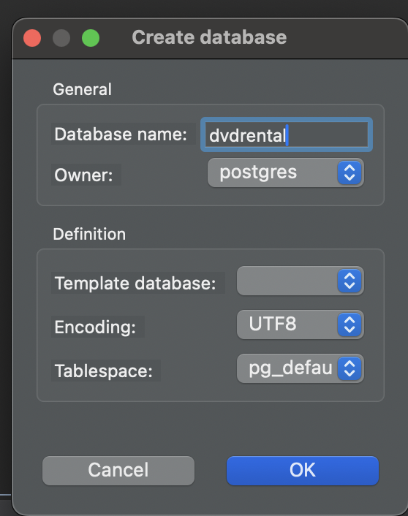
- Restore a dvdrental db: right click on dvdrental -> tools - restore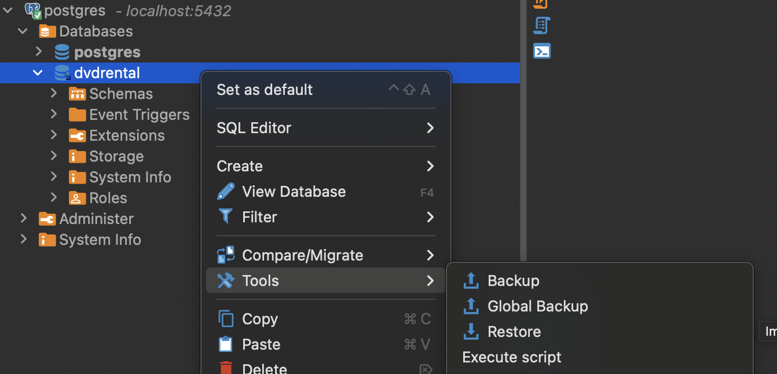
- Choose right options and hit the start button (you need to unzip the dvdrental.zip file into the dvdrental.tar file)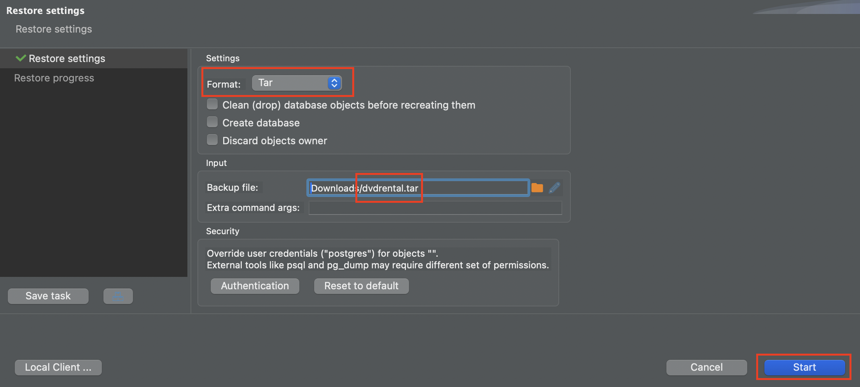
- Close the window as soon as the process is completed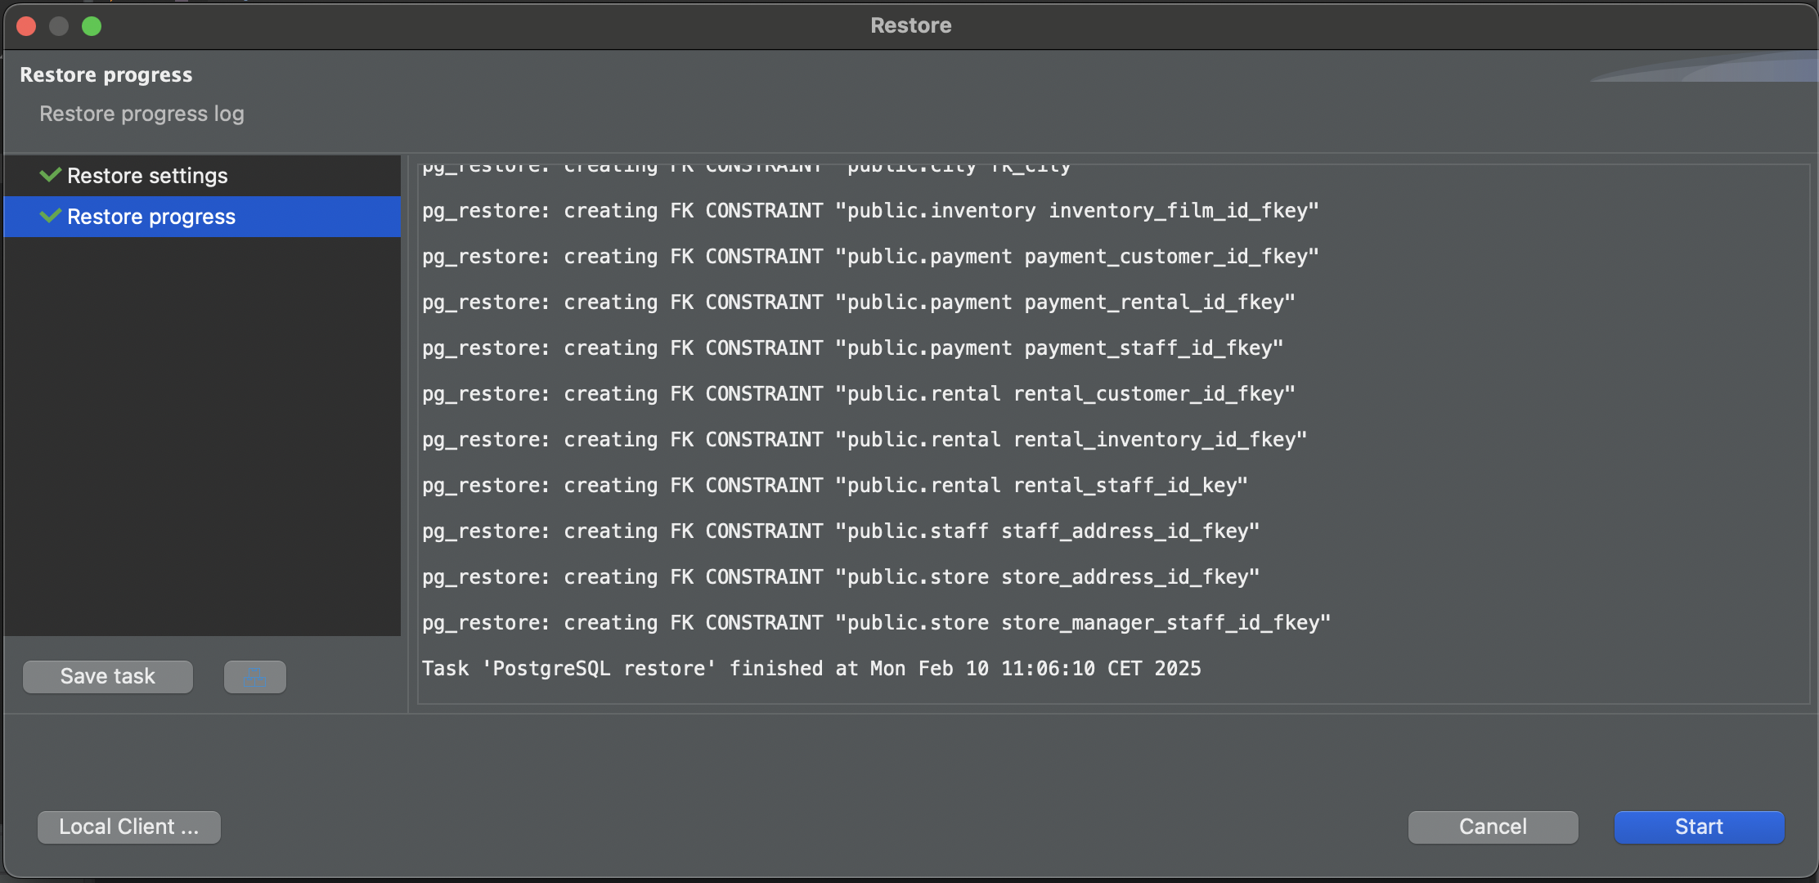
- Create a new DB connection for the dvdrental db 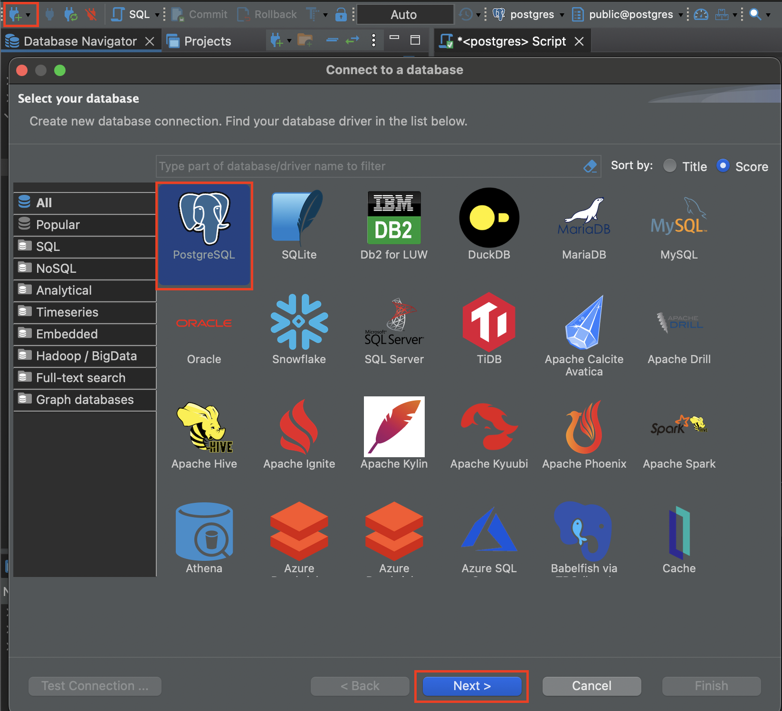 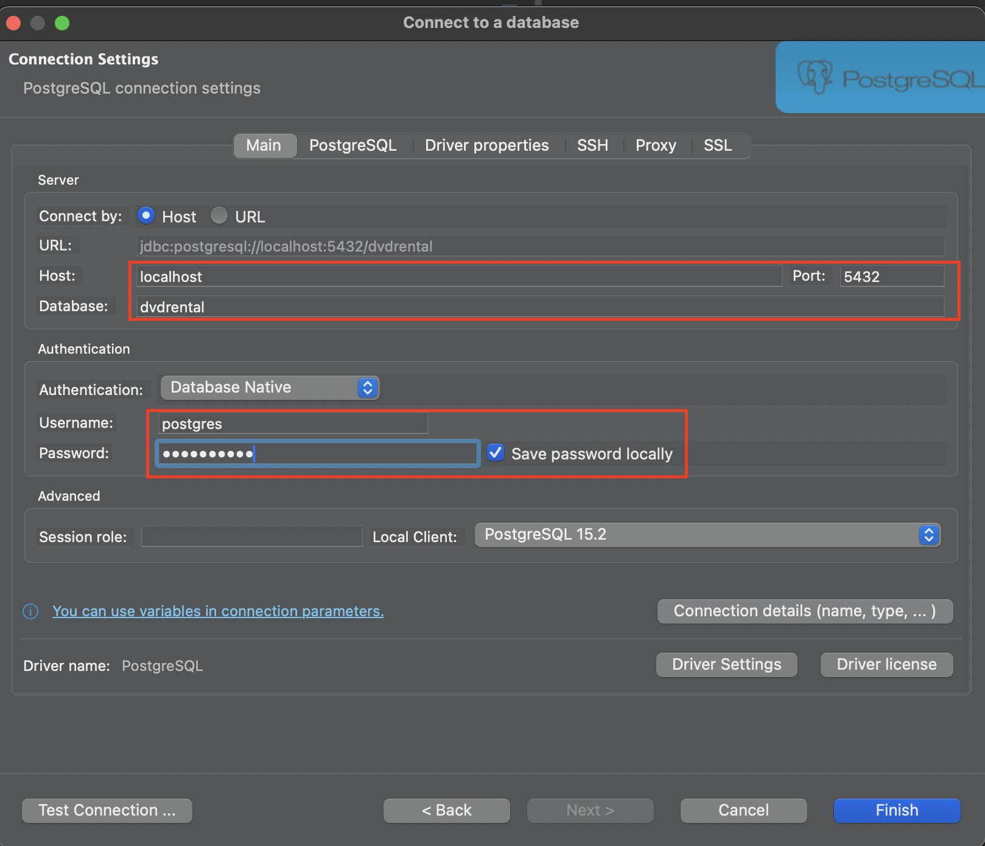
- Enjoy 