DOCUMENTATION

ASSIGNMENT 3

STUDENT NAME: MUREȘAN ANDREI-IOAN
GROUP: 30425_2

CONTENTS

1. Assignment Objective 3
2. Problem Analysis, Modeling, Scenarios, Use Cases 3
3. Design 3
4. Implementation 3
5. Results 3
6. Conclusions 3
7. Bibliography 3

Assignment Objective
  - Main Objective
Create an application Orders Management for processing client orders for a warehouse.
  - Sub-objectives
Objective | Importance | Addressed | Details
Use an object-oriented programming design | Imperative | Design | Used encapsulation, abstractism, inheritance and composition
Use JavaDoc for documenting classes and generate the corresponding JavaDoc files | Imperative | Design | Created JavaDoc comments and generate JavaDoc
Use relational database to store the data for the application, minimum three tables: Client, Product, Order | Imperative | Design Implementation | Used mysql server and database. Also worked with MySql Workbench
Implement a GUI | Imperative | Design and Implementation | Used Java Swing
Add, Edit, Delete, View clients | Imperative | Implementation | No details
Add, Edit, Delete, View products | Imperative | Implementation | No details
Create orders | Imperative | Implementation | No details
Use reflection techniques to create a method that receives an object list and generate the header of a JTable | Imperative | Implemetation | No details
Good documentation | Imperative | Design and Implementation | No details
Use Layered Architecture (minimum 4 packages: dao, bl, model, presentation) | Needed for high grade | Design | No details
Define an immutable Bill class in the Model package using Java records | Needed for high grade | Implementation | Every order has an associated bill. They are generated automatically when an order is created.
Use reflection techniques to create a generic class that contains the methods for accessing the DB | Needed for high grade | Implementation | Created an AbstractDao and AbstractView and Controller

Problem Analysis, Modeling, Scenarios, Use Cases
Problem Analysis
The objective of the Orders Management application is to facilitate the processing of client orders within a warehouse environment. The system needs to handle the storage, retrieval, and manipulation of data concerning clients, products, and orders. The data will be stored in a relational database to ensure efficient management and retrieval. The application should be designed using a layered architecture pattern, ensuring a clear separation of concerns and maintainability. The key functionalities include CRUD (Create, Read, Update, Delete) operations for clients and products, and the creation and management of orders. Additionally, the application should generate bills for each order and log them in an immutable manner.

Few Scenarios
- Adding a New Client:
- The user opens the client management window.
- The user clicks the "Add" button.
- The user inputs the client's details (name, email and address).
- The system validates the input and inserts a new record into the Client table.

Error flow: The client details don’t follow the format, a prompt is displayed, back to step 2.\

- Updating Product Information:
- The user opens the product management window.
- The user selects a product from the list.
- The user edits the product details (price, description, stock quantity, etc.).
- The user clicks the "Update" button.
- The system validates the input and updates the corresponding record in the Product table.
Error flow: The client details don’t follow the format, a prompt is displayed, back to step 2.

- Creating an Order:
- The user opens the order creation window.
- The user selects a client and a product.
- The user enters the desired quantity for the product.
- The user clicks the "Create Order" button.
- The system checks the stock availability and, if sufficient, decrements the product stock, creates a new order, and generates a bill.
- The bill is logged in the Log table.

Error flow: The client and/or product aren’t existent or it isn’t enough stock. Back to step 2.

- Viewing All Clients:
- The user opens the client management window.
- The system retrieves all client records from the Client table and displays them in a JTable.
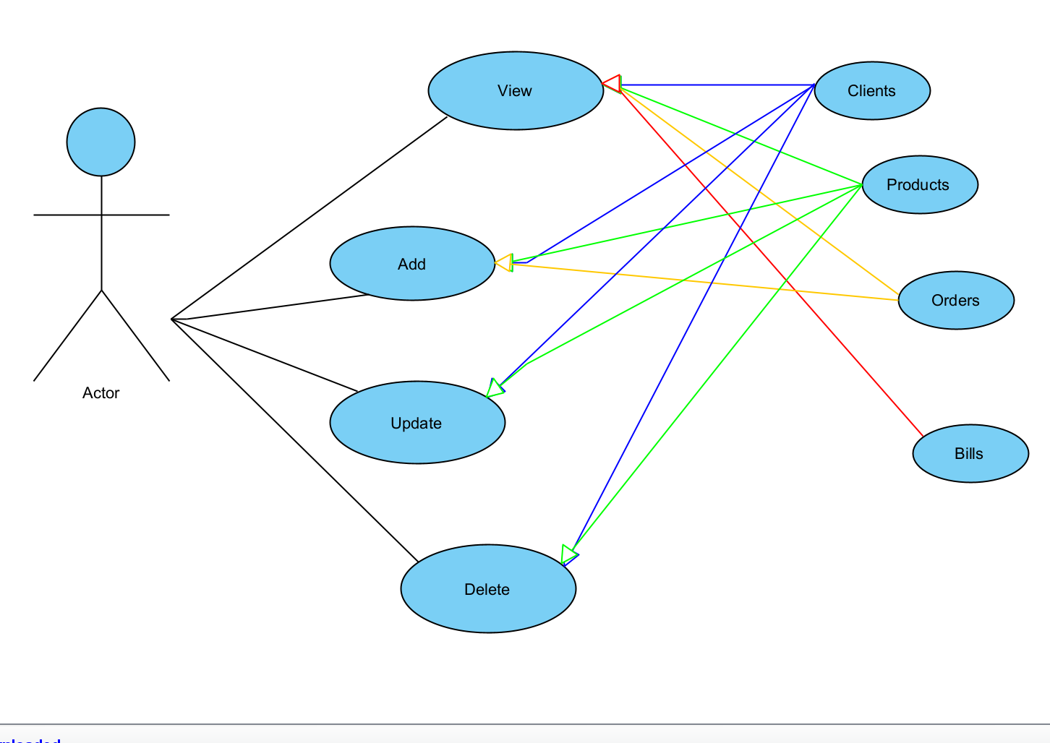

Success examples:

Action: Client addition
Name: Muresan Andrei
Email: murimoro67@gmail.com
Address: Sibiu

Action: Product addition
Name: PC
Price: 1599
Stock: 20

Action: Order addition
Product id: 2
Client id: 3
Quantity: 4

Error examples:

Action: Client addition
Name: Muresan Andrei
Email: adsmas
Address: Sibiu

Action: Product addition
Name: 2
Price: -3
Quantity: -4

- Design

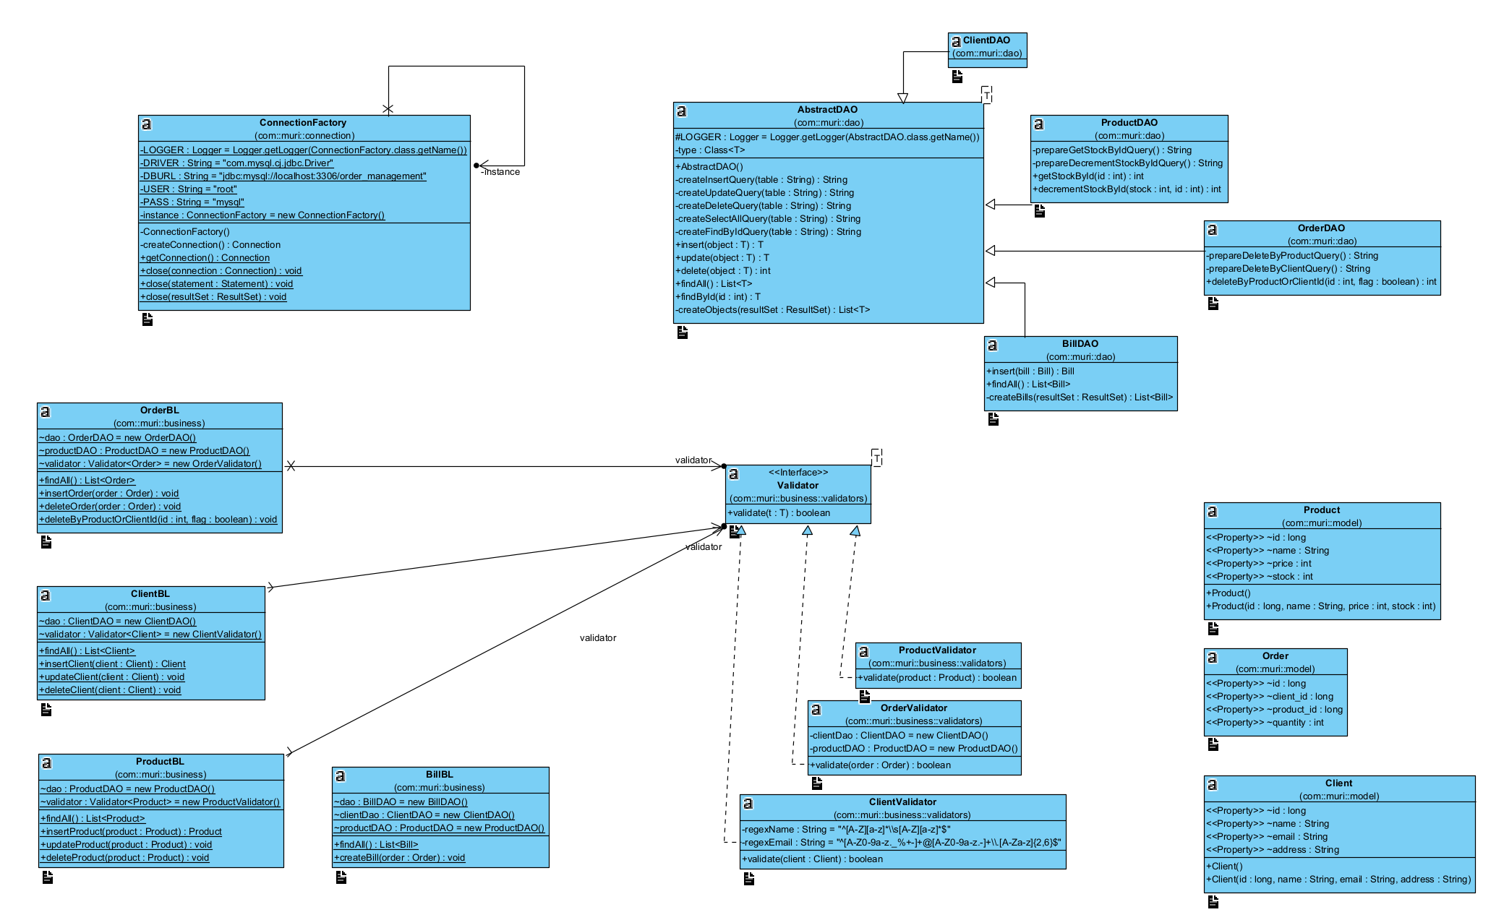

The application will follow a layered architecture consisting of the following layers:
- Model Layer: This layer represents the data models of the application. It includes classes like Client, Product, Order, and Bill.
- Business Logic Layer: This layer contains the application logic. It includes classes that implement the core functionality of the application, such as order processing, stock management, and business rules.
- Presentation Layer: This layer is responsible for the GUI components of the application. It includes classes for the windows and dialogs for client, product, and order operations.
- Data Access Layer: This layer contains classes that handle database access. It includes methods for CRUD operations on the database tables and uses reflection to dynamically generate SQL queries.

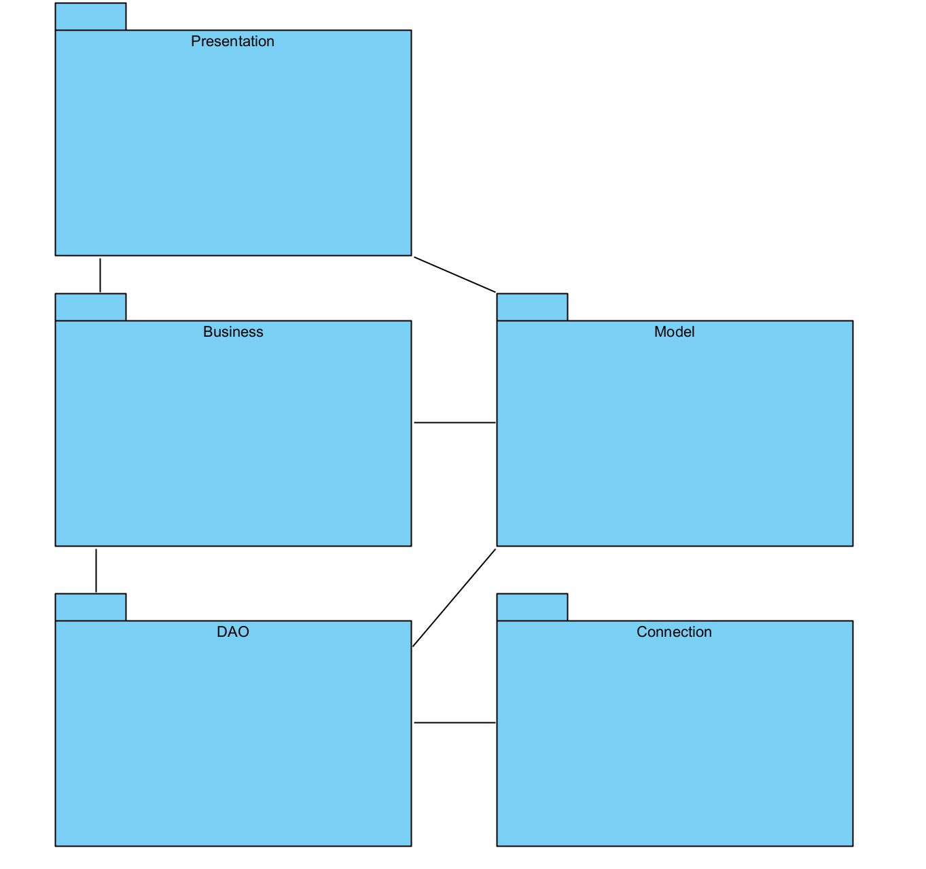

Implementation
Connection Factory (com.muri.connection)
ConnectionFactory: This singleton class is responsible for managing the database connections. It includes methods for creating, retrieving, and closing connections to the database.
LOGGER: A logger for logging messages.
DRIVER: The database driver.
DBURL: The URL of the database.
USER: The username for the database connection.
PASS: The password for the database connection.
instance: A static instance of the ConnectionFactory.
createConnection(): Creates a new database connection.
getConnection(): Retrieves the current database connection.
close(Connection): Closes the given database connection.
close(Statement): Closes the given statement.
close(ResultSet): Closes the given result set.

Data Access Objects (com.muri.dao)
AbstractDAO<T>: A generic abstract class that provides basic CRUD operations. Subclasses extend this class to implement specific data access methods for different entities.
type: The class type for which DAO is created.
createInsertQuery(table): Generates an SQL insert query.
createSelectQuery(table): Generates an SQL select query.
createUpdateQuery(table): Generates an SQL update query.
createDeleteQuery(table): Generates an SQL delete query.
createFindByIdQuery(table): Generates an SQL query to find a record by ID.
insert(object): Inserts an object into the database.
update(object): Updates an object in the database.
delete(object): Deletes an object from the database.
findAll(): Retrieves all records from the database.
findById(id): Finds a record by its ID.
createObjects(resultSet): Creates a list of objects from the result set.

ClientDAO: Extends AbstractDAO to provide specific data access methods for the Client entity.

ProductDAO: Extends AbstractDAO to provide specific data access methods for the Product entity.
prepareGetStockByIdQuery(): Prepares an SQL query to get the stock of a product by ID.
prepareDecrementStockByIdQuery(): Prepares an SQL query to decrement the stock of a product by ID.
getStockById(id): Gets the stock of a product by its ID.
decrementStockById(stock, id): Decrements the stock of a product by its ID.

OrderDAO: Extends AbstractDAO to provide specific data access methods for the Order entity.

prepareDeleteByProductQuery(): Prepares an SQL query to delete orders by product.
prepareDeleteByClientQuery(): Prepares an SQL query to delete orders by client.
deleteByProductOrClient(id, flag): Deletes orders by product or client based on the flag.

BillDAO: Extends AbstractDAO to provide specific data access methods for the Bill entity.

insert(bill): Inserts a bill into the database.
findAll(): Retrieves all bills from the database.
createBills(resultSet): Creates a list of bill objects from the result set.

Business Logic (com.muri.business)
OrderBL: Business logic class for handling operations related to orders.
dao: An instance of OrderDAO.
productDAO: An instance of ProductDAO.
validator: An instance of OrderValidator.
findAll(): Retrieves all orders.
insertOrder(order): Inserts a new order.
deleteOrder(order): Deletes an order.
deleteByProductOrClient(id, flag): Deletes orders by product or client based on the flag.

ClientBL: Business logic class for handling operations related to clients.
dao: An instance of ClientDAO.
validator: An instance of ClientValidator.
findAll(): Retrieves all clients.
insertClient(client): Inserts a new client.
updateClient(client): Updates a client.
deleteClient(client): Deletes a client.

ProductBL: Business logic class for handling operations related to products.
dao: An instance of ProductDAO.
validator: An instance of ProductValidator.
findAll(): Retrieves all products.
insertProduct(product): Inserts a new product.
updateProduct(product): Updates a product.
deleteProduct(product): Deletes a product.

BillBL: Business logic class for handling operations related to bills.
dao: An instance of BillDAO.
clientDao: An instance of ClientDAO.
productDAO: An instance of ProductDAO.
insertBill(bill): Inserts a new bill.
findAll(): Retrieves all bills.
createBill(order): Creates a bill for an order.

Validators (com.muri.business.validators)
Validator<T>: An interface defining a validation method for validating objects.
validate(T): Validates an object.

ClientValidator: Implements Validator to provide validation logic for Client objects.
regexName: Regular expression for validating names.
regexEmail: Regular expression for validating emails.
validate(client): Validates a client object.

ProductValidator: Implements Validator to provide validation logic for Product objects.
validate(product): Validates a product object.

OrderValidator: Implements Validator to provide validation logic for Order objects.
clientDao: An instance of ClientDAO.
productDAO: An instance of ProductDAO.
validate(order): Validates an order object.

Model (com.muri.model)
Client: Represents a client entity with properties id, name, email, and address.
Client(): Default constructor.
Client(id, name, email, address): Parameterized constructor.

Product: Represents a product entity with properties id, name, price, and stock.
Product(): Default constructor.
Product(id, name, price, stock): Parameterized constructor.

Order: Represents an order entity with properties id, client_id, product_id, and quantity.
Order(): Default constructor.
Order(id, client_id, product_id, quantity): Parameterized constructor.

Bill: Represents a bill entity with properties id, order_id, amount, and date.
Bill(): Default constructor.
Bill(id, order_id, amount, date): Parameterized constructor.

Results
The implementation of the Orders Management application successfully meets the requirements specified in the assignment. The following key results were achieved:

- Successful implementation of a layered architecture.

The application was designed using a layered architecture pattern, which ensures a clean separation of concerns. This approach divides the application into distinct layers: model, business logic, presentation, and data access. Each layer is responsible for specific functionality, which promotes modularity, maintainability, and scalability. This structure allows for easier debugging, testing, and future enhancements.

- Utilization of a relational database with proper table structures.

A relational database was used to manage the application's data, ensuring efficient storage, retrieval, and manipulation. The database schema includes tables for clients, products, orders, and a log for bill records. The schema design adheres to normalization principles to reduce redundancy and ensure data integrity. SQL scripts were provided to create and populate the database tables, facilitating quick setup and testing.

- Development of a comprehensive GUI for managing clients, products, and orders.

The graphical user interface (GUI) of the application is intuitive and user-friendly. It includes separate windows for managing clients, products, and orders. Each window provides functionality for adding, editing, deleting, and viewing records in a table format (JTable). The GUI enhances user interaction and ensures that all operations can be performed efficiently.

- Implementation of reflection techniques for dynamic table header generation and SQL query creation.

The application employs reflection techniques to dynamically generate table headers and SQL queries. A method was created that receives a list of objects, extracts their properties through reflection, and generates the table headers. This method improves code reusability and reduces redundancy. Additionally, a generic data access class uses reflection to dynamically generate SQL queries for CRUD operations, streamlining database interactions.

- Creation of an immutable Bill class and proper logging of bill records.

An immutable Bill class was implemented using Java records. For each order, a Bill object is generated and logged in the Log table. The Log table is designed to only allow insert and read operations, ensuring that bill records remain immutable. This approach maintains the integrity and reliability of the billing system, providing a trustworthy record of transactions.

- Comprehensive documentation and JavaDoc generation.

Detailed documentation was provided, covering all aspects of the application. The documentation includes a description of the architecture, class responsibilities, and detailed use case scenarios. Javadoc comments were added to classes and methods, and the corresponding JavaDoc files were generated. This comprehensive documentation ensures that the codebase is well-understood and facilitates future development efforts.

Conclusions

The Orders Management application project has been a successful endeavor, achieving all specified requirements and demonstrating effective use of object-oriented design, relational database management, and advanced Java programming techniques. Through the implementation of a layered architecture, the application provides a clear separation of concerns, enhancing maintainability and scalability.
This project provided valuable experience in applying object-oriented programming principles, designing and managing relational databases, and utilizing Java's advanced features such as reflection and records. The process of developing a layered application reinforced the importance of architectural patterns in software engineering.
The Orders Management application is a robust and efficient solution for processing client orders in a warehouse environment. By adhering to best practices in software design and development, the project delivers a maintainable and scalable system. The successful implementation of this project demonstrates a solid understanding of the concepts and techniques required to build complex software applications, laying a strong foundation for future software engineering endeavors.

Bibliography
- Layered architecture: https://dzone.com/articles/layers-standard-enterprise
- Reflection in java: https://tutorials.jenkov.com/java-reflection/index.html
- SQL dump file generator: https://dev.mysql.com/workbench/en/wb-admin-export-import-management.html

