DOCUMENTATION

ASSIGNMENT ASSIGNMENT_1

STUDENT NAME: MUREȘAN ANDREI
GROUP: 30425_2

CONTENTS

1. Assignment Objective 3
2. Problem Analysis, Modeling, Scenarios, Use Cases 3
3. Design 3
4. Implementation 3
5. Results 3
6. Conclusions 3
7. Bibliography 3

Assignment Objective
  - Main Objective
Implement a polynomial calculator.
  - Sub-objectives
Objective | Importance | Addressed | Details
Use an object-oriented programming design | Imperative | Design | Used encapsulation, abstractism, inheritance and composition
Use Map for designing the Polynomial | Imperative | Design | Used TreeMap implementation to keep sorted by power (key)
Use foreach instead of classic for loop | Imperative | Implementation | Used to iterate trough each element in the map
Implement a GUI | Imperative | Design and Implementation | Used Java Swing
Implement addition and subtraction operations | Imperative | Implementation | No details
Max 300 lines in classes and 30 in methods. Except GUI | Imperative | Design and Implementation | No details
Use Java naming conventions | Imperative | Implementation | No details
Good documentation | Imperative |  | No details
Good organization of the source code | Needed for high grade | Design and Implementation | No details
Multiplication | Needed for high grade | Implementation | No details
Division | Needed for high grade | Implementation | No details
Differentiation | Needed for high grade | Implementation | No details
Integration | Needed for high grade | Implementation | No details
Use pattern matching for extraction of polynomials | Needed for high grade | Implementation | No details
Use Junit for testing | Needed for high grade | Results | Used parameterized tests

Problem Analysis, Modeling, Scenarios, Use Cases
The problem that this software aims to solve is the elimination of the time invested in making operations on polynomials.
This software is similar to a normal calculator, but its target data structure is polynomial. It consists in a GUI that lets the use select an operation (addition, subtraction, multiplication, division, differentiation and integration), input polynomials in string format and observe the result. The use case is presented in the next diagram:
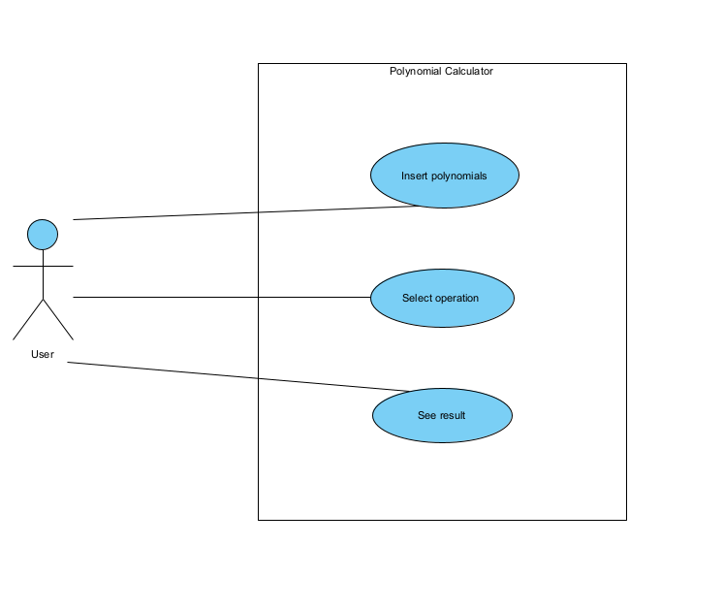

The flow is presented in the next diagram:
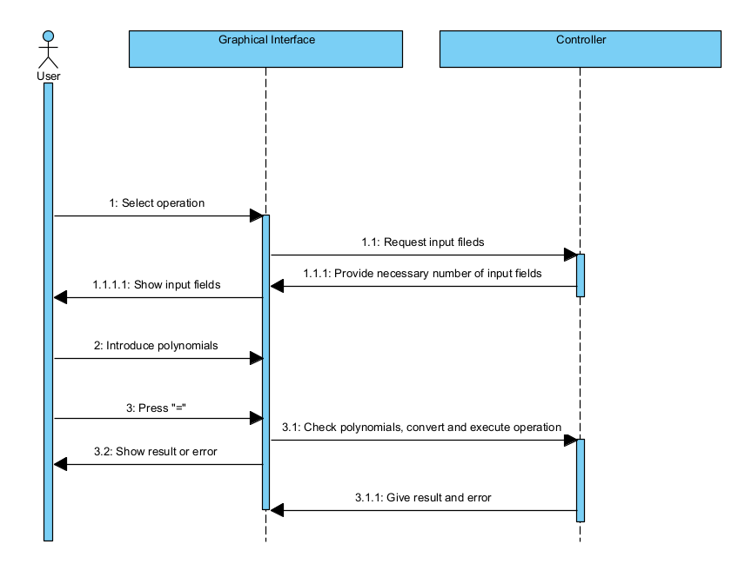

Actors:
- User: The person using the polynomial calculator to perform operations on polynomials.
- System: The polynomial calculator software.
Preconditions:
- The user has access to the polynomial calculator interface.
- The system is operational and ready to accept input.
Postconditions:
- The system displays the result of the polynomial operation.
- The system is ready for a new operation or to be closed.
Main Flow:
- The user launches the polynomial calculator application.
- The system presents an interface where the user can input one or more polynomials and select the desired operation (e.g., addition, subtraction, multiplication).
- The user enters the polynomial(s) into the designated input field(s).
- The user selects the operation they wish to perform on the polynomial(s).
- The user initiates the calculation by pressing the "=" button.
- The system processes the input and performs the specified operation on the polynomial(s).
- The system displays the result of the operation to the user.
Alternate Flows:
- Multiple Operations: After viewing the result, the user decides to perform another operation using the result as one of the inputs. The user inputs a new polynomial if necessary, selects the operation, and the process repeats from step 5.
Exception Flows:
- E1. Invalid Input: If the user enters an invalid polynomial (e.g., incorrect syntax), the system displays an error message and prompts the user to correct the input. The process then resumes from step 3.
- E2. Operation Error: If an error occurs during the operation (e.g., division by zero in polynomial division), the system displays an appropriate error message and allows the user to modify the input or operation selection, resuming from step 3.

E.G.
Operation: Addition
Input1: 3x^2
Input2: 7x^2+2+3x
Output: 10x^2+3x+2

Operation: Differentiation
Input: 3x^3+7x
Output: 9x^2+7

Operation: Division
Input1: 7x^7+9x^2+5x
Input2: 0
Output: Error, cannot divide by 0

Operation: Multiplication
Input1: 7a^2+9
Input2: 5a^5+6
Output: Error, invalid polynomial format

Design
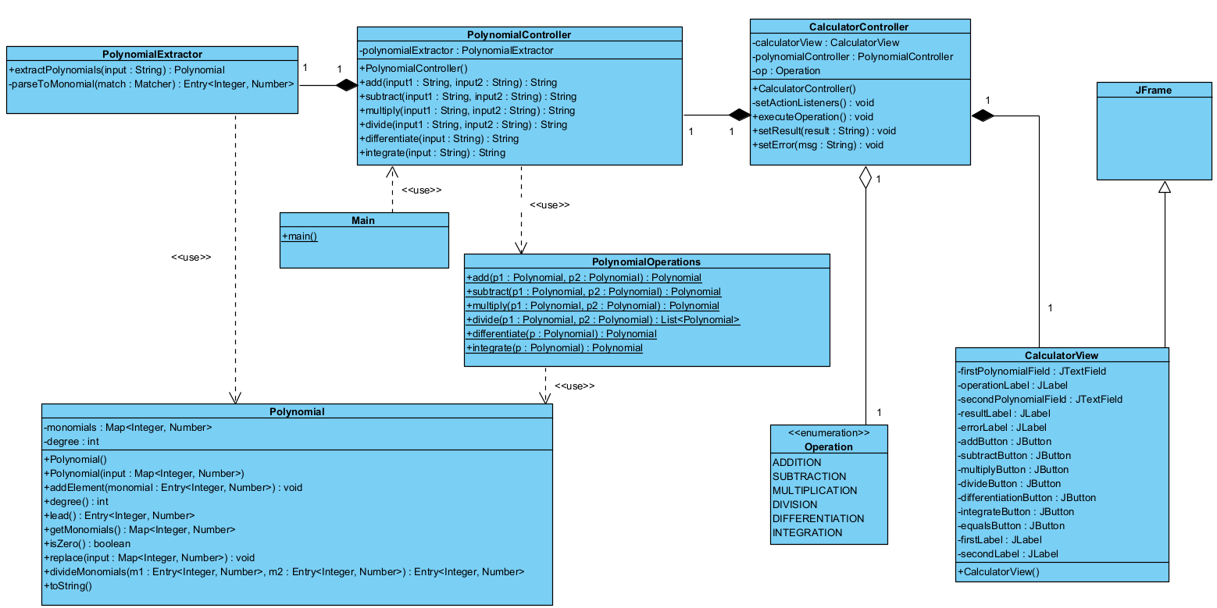

The model, view, logic architecture was used in package organization. The Model consists of the Polynomial class and Operation enumeration. The Logic package consists of the classes CalculatorController, PolynomialController, PolynomialExtractor and PolynomialOperations. The View package consists of the only view present in this software, CalculatorView. The package diagram is presented in the next diagram:

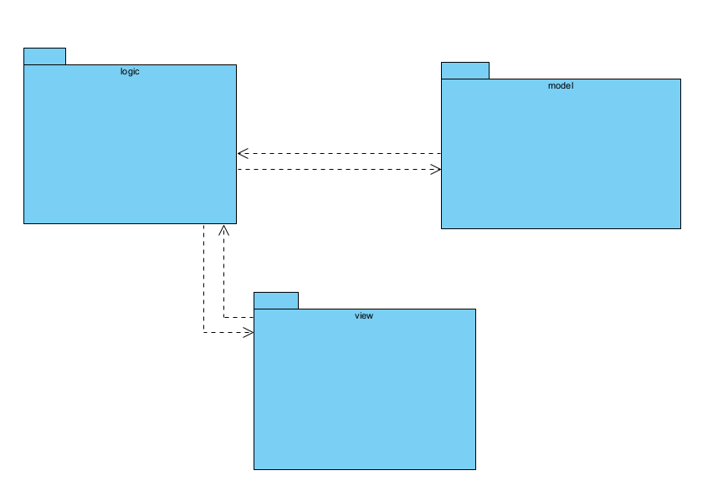

Implementation
1. MODEL
1.1. Polynomial
This is the class that aims to model the polynomial data structure. The polynomial is represented by a Map that uses an Integer as the key and Number as the value. The key represents the power, and the value represents the coefficient of a monomial. The TreeMap implementation of the Map interface was used because it keeps the elements sorted. The descending by key value sorting method was used to keep the highest power always on the first position.

FIELDS:
- monomials : Map<Integer, Number> => used to represent the polynomial
- degree : int => highest power among the monomials

CONSTRUCTORS:
- no parameter => initializes the map collection with a TreeMap implementation and adds the 0 element (0^0)
- input : Map<Integer, Number> => initializes the monomials field with an existing collection of monomials
SOME IMPORTANT METHODS:
- addElement(monomial : Entry<Integer, Monomial>) : void => adds an element to the existing collection. It checks if the power already exists, if it does it makes the corresponding calculations. It always checks if the 0 element needs to be added.
- lead() : Entry<Integer, Monomial> => returns the element with the highest power
- degree() : int => returns the degree of the polynomial (the highest power)

1.2. Operations
An enumeration with the possible operations that can be done on a polynomial (ADDITION, SUBTRACTION, DIVISION, MULTIPLICATION, DIFFERENTIATION, INTEGRATION).

2. VIEW
2.1. CalculatorView
This is the only view of the software. It is implemented using Java Swing. It consists in input fields, labels for result and error, buttons for selecting the operation, and a button “=” for executing the selected operation. The interface is controlled by the CalculatorController class. Some examples of the graphical interface:

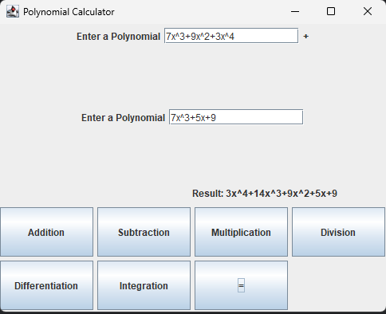
Successful addition
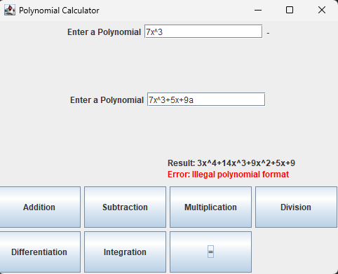
Wrong polynomial format
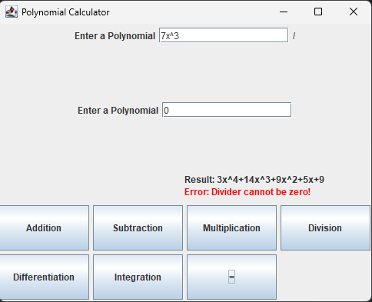
Division by zero error

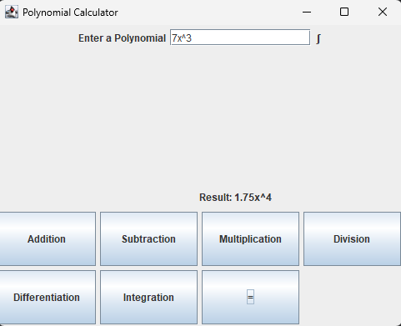
Successful integration

3. LOGIC
3.1. PolynomialExtractor
This is the class that takes care of the string to polynomial parsing. It uses the Pattern and Matcher classes, and the regex for a monomial is this:
((^|[-+])\\b(\\d{1,9}(\\.\\d{1,4})?)?(x(\\^(\\d{1,2}))?)?)

Methods:
- extractPolynomials(input : String) : Polynomial => This is the classes’ interface. It takes a string input and converts it to a Polynomial type. It throws an error if the string is not in the specific format.
- parseToMonomial(match : Matcher) : Entry<Integer, Number> => this is a helper method. It takes as input a match and returns the corresponding monomial.
3.2. PolynomialOperations
This is an utility class. It has only static methods. It implements all the operations on the Polynomial (addition, subtraction, division, multiplication, differentiation, integration).
3.3. PolynomialController
This is the string based interface with the main controller. It is the controller that handles requests related to polynomials. It uses the utility methods from PolynomialOperations. It takes input string from the controller, parses to polynomial using PolynomialExtractor, calculates the result using the static methods and returns the result in string format.
3.4. CalculatorController
This is the main controller. It controls the gui, and handles the requests coming from the user. It sets the action listeners of the buttons, receives the polynomials in string format, it redirects the polynomial related requests to PolynomialController, decides which text fields should appear, and sends the result and error to the gui.

Results
The result is a software that emulates a polynomial calculator. Any user can select from one of the operations available, input desired polynomial in specific string format and receive the result.

The testing was done using the Junit framework. A series of tests with 100% coverage were done. The tests consists of possible inputs of the user and if the result is the desired one. These are the tests that were done:
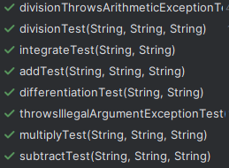

Conclusions

In conclusion, the detailed use case for a Polynomial Calculator not only serves as a blueprint for the development and testing of the software but also ensures that user interactions are comprehensively understood and accounted for. By breaking down the use case into specific components—such as the main goal, actors involved, preconditions, postconditions, the main flow of operations, alternate flows, and exception flows—we provide a structured framework that guides the design and implementation process. This approach helps in identifying potential challenges and user requirements early in the development cycle, ensuring that the final product is user-centric, robust, and capable of handling various user scenarios effectively. Through this meticulous planning and documentation, the development team can create a Polynomial Calculator that is intuitive, efficient, and reliable, thereby enhancing user satisfaction and engagement.

In this project I learned to better prepare myself for the implementation, to take more time into designing, I improved my problem solving skills, I developed a better understanding of the oop concepts, and most importantly, I solved a problem.

This project can have a better gui, a way to store the results, more complex operations (like finding the roots), and a more flexible input format. Also I can develop a way to visualize on the plot the polynomials.

Bibliography
- https://regex101.com/ - a tool to create regex and see the matches and groups more efficiently
- https://www.youtube.com/watch?v=vZm0lHciFsQ&ab_channel=CodingwithJohn – a youtube video that gave me more insights into Junit

