AUTOMATION Example – Excel FORM

These days , my father , an automation engineer(he is electrical automation engineer ... this subject has no connection with what my dad is working with) was wondering how to make an automated Excel form because the excel macro’s were not working properly . He asked me to do it because he knows that I’m up to date with the latest technologies … and of course as I like challenges I accepted.

What is this form about and how is it useful in a factory ???

Well … is it very important when you want to keep up the evidence of the people and write down what defects appeared on each shift.

So , how we think the program to fit the situation ?

We think what modules we need based on user needs . The boss’ shift had to enter the data easily right ? So , we think a GUI based app , and the GUI module that I’ve chosen is **TKINTER** (you can go with **PyQt** if you want , but for small projects like this I recommend **TKINTER**) . After that we think what widgets we need … and I think that , as user , I need to select my name(in this case , shift’ boss names) , another combobox for the date ( we need to select the date … time is important in a factory to know when a defect occurred ) , and the last combobox is for the shift. We need a button for the create function( you want to create the file only after you pressed the button , we keep the evidence by click events … that is basically how widgets are working… by keyboard events ). You want to write the objections/defects of that shift … so we create a textbox to write them . After all these al filled up(combobxes , texbox) , by click event , whn “create excel” button is being pressed , it takes user data , creating an excel to a specified path and after that copy the extracted data to the excel. Look how the main page is:

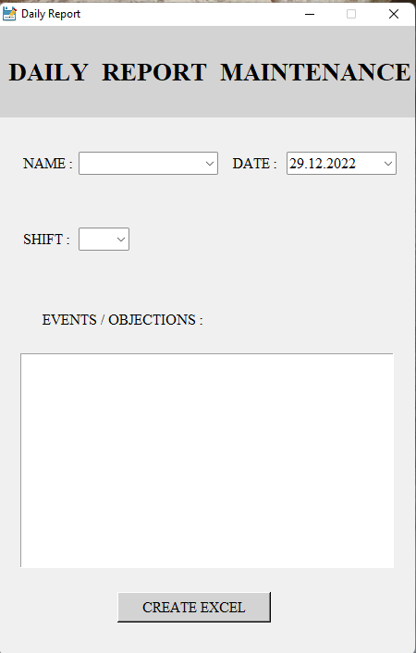

After clicking the button we are being redirected to the second page , which is called “edit” , in case we need to edit the content of the excel file. I forgot to mention that , **xlsxwriter** module is the responsible one with creating , editing and rewriting excel files. Basicaly both of buttons , “ADD” and “CREATE” are doing the same thing(rewrite data into files) but “ADD” concats the new data inputed by user on the second page. How concats data? Data is memorized by variables , and variables from the first page , from create section, I’m not erasing them , I memorize them9make a copy of them by puttinginto other bariables) and use it later , at the “ADD” button function(we don’t need an eficiently program from the memory point of view , we need to solve our task quickly) .

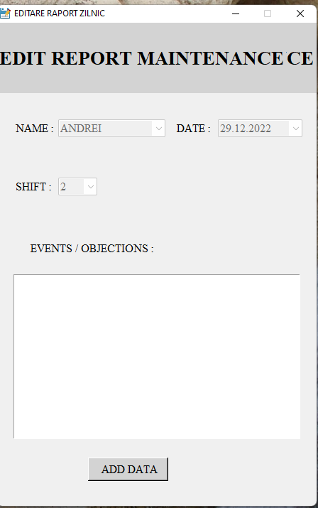

Probably you’ll ask me … man how the program will know the path again and again ? …I memorize every time into a string the path of the excel file , and of course as starting point I help it by creating a base folder where to save all the data located on desktop(mandatory … for example if you want to change and use the app on other systems and that system has other language than yours , “Desktop” folder will remain in English no matter what). OK ! But how to detect the Desktop folder in general ? For that , we use **OS** module which will search user’s name and after that , I create the string path by advantage of string formatting(allows us to enter others strings into the current one! , between the “{}” – formatting function searching them and put there the string that we want . In case of conflict , put “{{}}” , double the brackets!! ) in python .

Below , I will attach the pythoun source program. Until next time , be patient , and don’t forget !!! … The straightest way to success is perseverance!!!

**Source(save with .py extension) :** [Reports.txt](Rapoarte_zilnice.txt)