*INTRO to my BLOG*

What is my blog for ?

This blog is for amateur people that loves IT&C domain , especially wanna work with Python programming language and its tools and features.

How my blog is divided ?

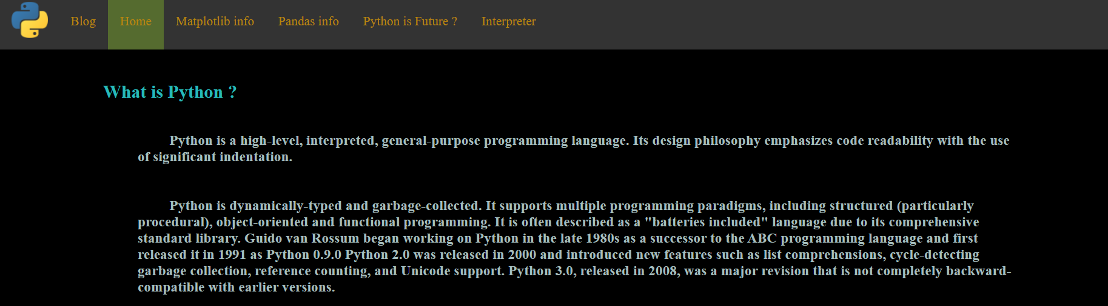

My blog is based on 6 pages :

* ***BLOG*** (the post page – section where I publish news , tutorials related to my projects or modules that I like or things that you suggest to me by email)
* ***HOME*** ( short introduction to python and its features … Everyone , in my opinion have to know the very basics of python lang. )
* ***Matplotlib info*** (short introduction to matplotlib module – you’ll learn about charts & data visualization)
* ***Pandas info*** (short introduction to pandas – one of the most used modules in python)
* ***Python is Future ?*** (debate section mostly based on question *“why?”* and **personal opinion**)
* ***Interpreter***(here you can execute in the browser your python programs to understand things dynamically)

[**BACK TO BLOG**](blog.html)