**Remote Car Monitoring**

**Coordinator:Mihaela CRISAN-VIDA**

**Students: Andrei STEFANESCU**

**Serban MEMA**

**1.Description**

The objective of the project is to monitorize the interaction of a car with the surrounding environment.

Moreover, the registration status of the vehicle is also recorded.

**2.UML Use Case diagrams**

*Use case diagram for the Vehicle*

(Can be found in the file UseCaseDiagram_RemoteCarMonitoring, at the path:

Untitled/Model1/UsecaseDiagram1)

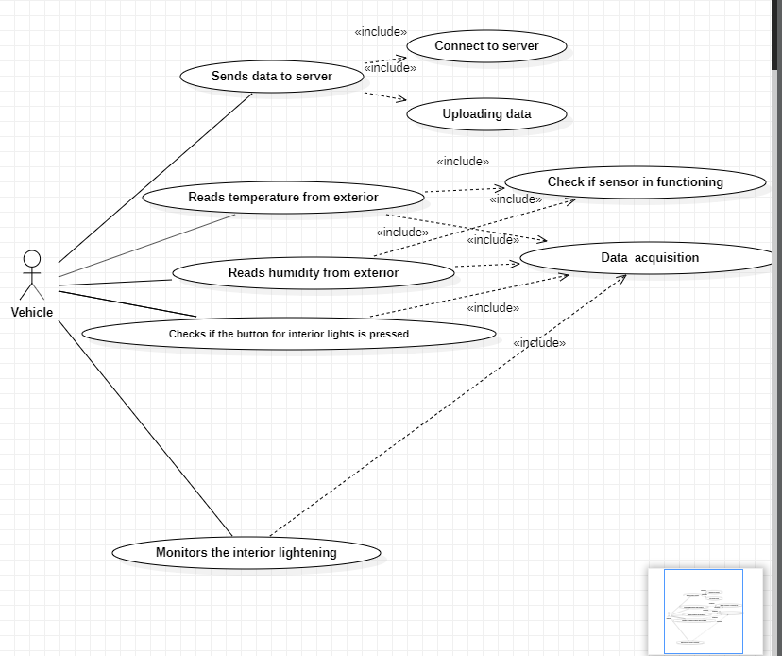

*Use case diagram for the Server*

(Can be found in the file UseCaseDiagram_RemoteCarMonitoring, at the path:

Untitled/Model1/UsecaseDiagram2)

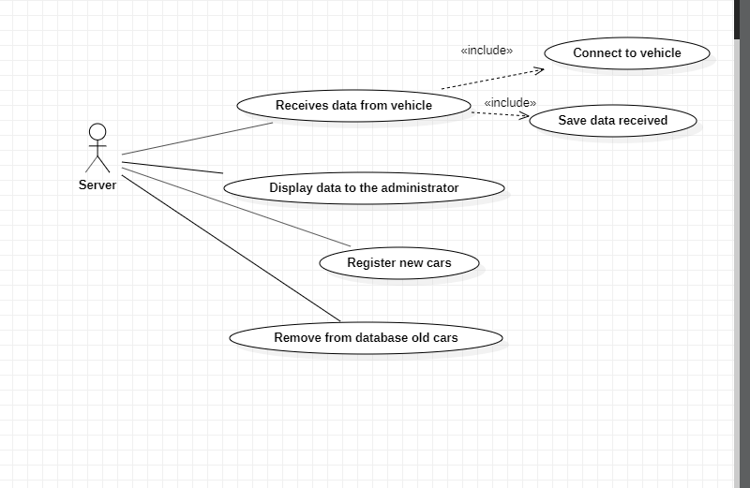

**3.Design pattern and the motivation of using it**

Design patterns have two major benefits. First, they provide you with a way to solve issues related to software development using a proven solution. The solution facilitates the development of highly cohesive modules with minimal coupling. They isolate the variability that may exist in the system requirements, making the overall system easier to understand and maintain. Second, design patterns make communication between designers more efficient. Software professionals can immediately picture the high-level design in their heads when they refer the name of the pattern used to solve a particular issue when discussing system design.[1]

**4.UML Class diagrams**

(The diagram can be found in the file ClassSequenceDiagrams_RemoteCarMonitoring,  
at the path Untitled/Model2/Classidiagram1)

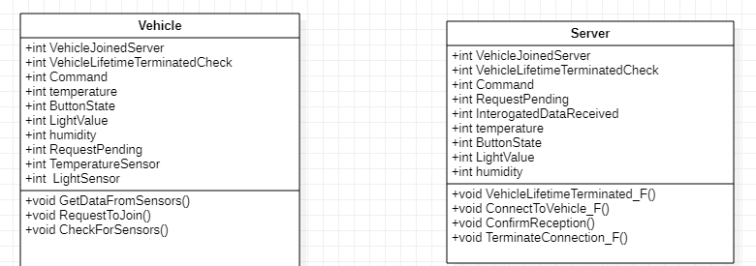

**5.UML Sequence diagrams**

*Sequence Diagram Server-Vehicle-Sensors data acquisition*

(The diagram can be found in the file ClassSequenceDiagrams_RemoteCarMonitoring,  
at the path Untitled/Model1/Collaboration1/Interaction1/Sequence Diagram-Vehicle Sensors data acquisition)

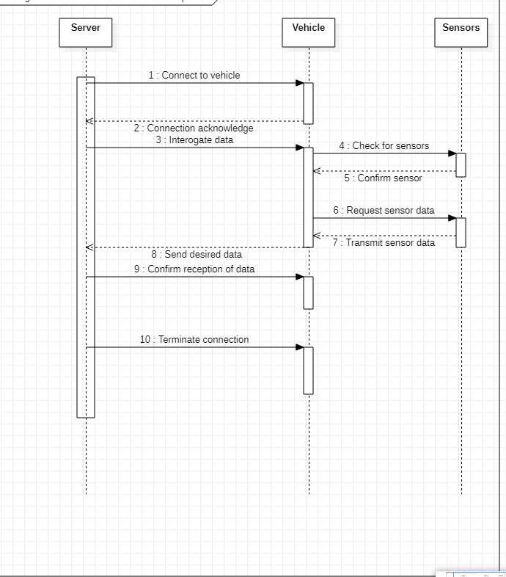

**Table**

|  |  |  |  |  |
| --- | --- | --- | --- | --- |
| **Sequence number** | **Sender** | **Reiceiver** | **Function** | **Description** |
| 1. | Server | Vehicle | Connect to vehicle | Establish the communication with vehicle |
| 2. | Vehicle | Server | Connection acknowledged | Acknowledgement of the server for the communication |
| 3. | Server | Vehicle | Interogate data | Server asks for vehicle data and status |
| 4. | Vehicle | Sensors | Check for sensors | Vehicle checks if the sensors are available |
| 5. | Sensors | Vehicle | Confirm sensor | The sensors confirm their presence |
| 6. | Vehicle | Sensors | Request sensor data | Vehicle interogates sensors for data |
| 7. | Sensors | Vehicle | Transmit sensor data | Sensors send data to the vehicle |
| 8. | Vehicle | Server | Send desired data | The desired data is sent from vehicle to server |
| 9. | Server | Vehicle | Confirm reception of data | The server confirms that the data was received |
| 10. | Server | Vehicle | Terminate connection | Server stops the communication with the vehicle |

*Sequence Diagram: Vehicle management diagram*

(The diagram can be found in the file ClassSequenceDiagrams_RemoteCarMonitoring,  
at the path Untitled/Model1/Collaboration1/Interaction2/Vehicle management diagram)

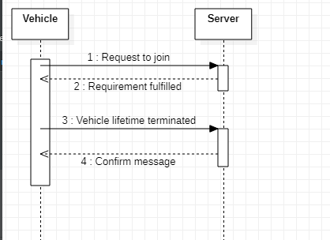

**Table**

|  |  |  |  |  |
| --- | --- | --- | --- | --- |
| **Sequence number** | **Sender** | **Reiceiver** | **Function** | **Description** |
| 1. | Vehicle | Server | Request to join | Vehicle initiates the acces into the database |
| 2. | Server | Vehicle | Requirement fulfilled | Server accepts the acces |
| 3. | Vehicle | Server | Vehicle lifetime terminated | Vehicles notifies the server that its lifetime was terminated |
| 4. | Server | Vehicle | Confirm message | The message was received |

**6. Application architecture**

Due to the fact that the project was made with Arduino and we used the Arduino IDE, the only module created is called RemoteCarMonitoring which contains the source file RemoteCarMonitoring.ino

**7. The code**

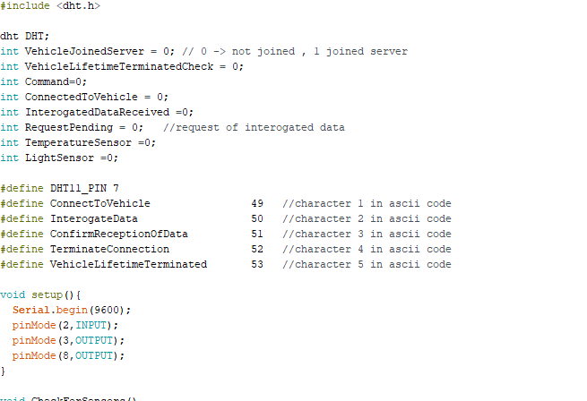

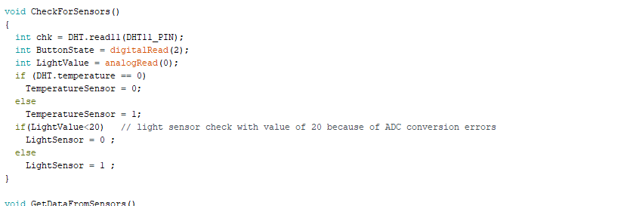

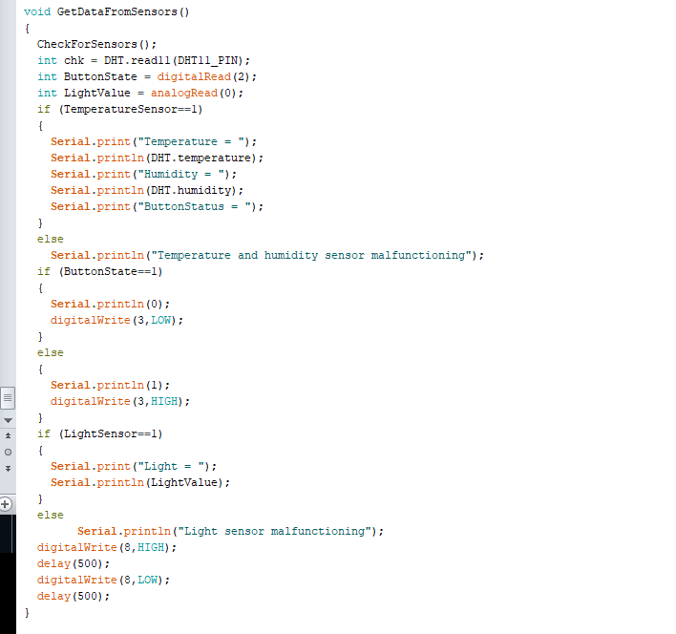

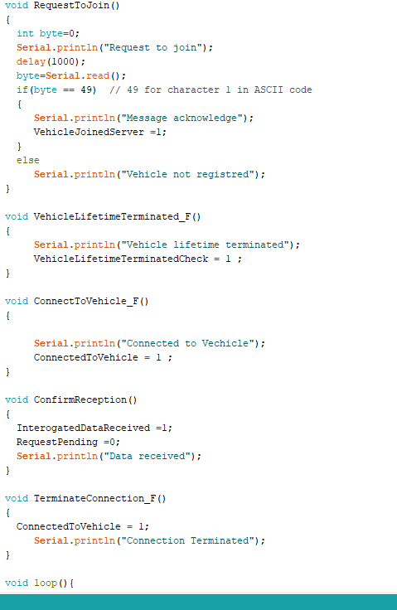

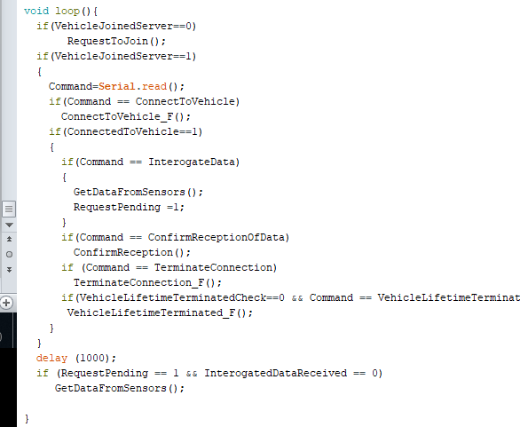

**8. Pictures from the developed project**

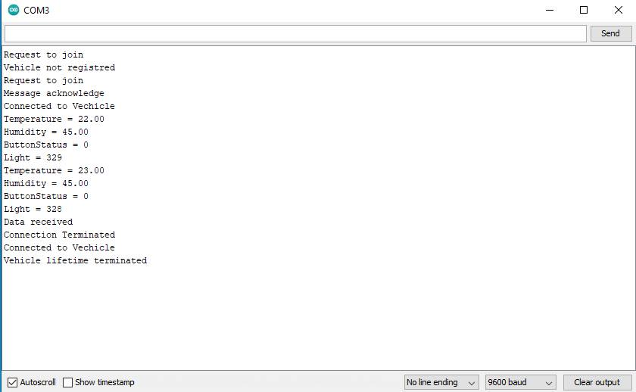

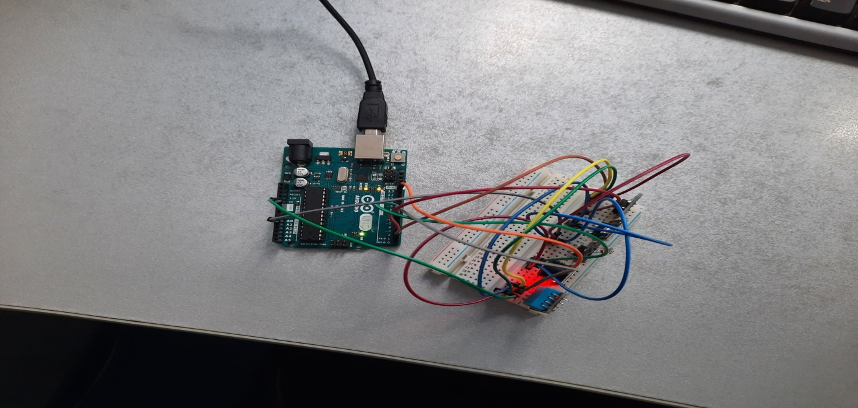

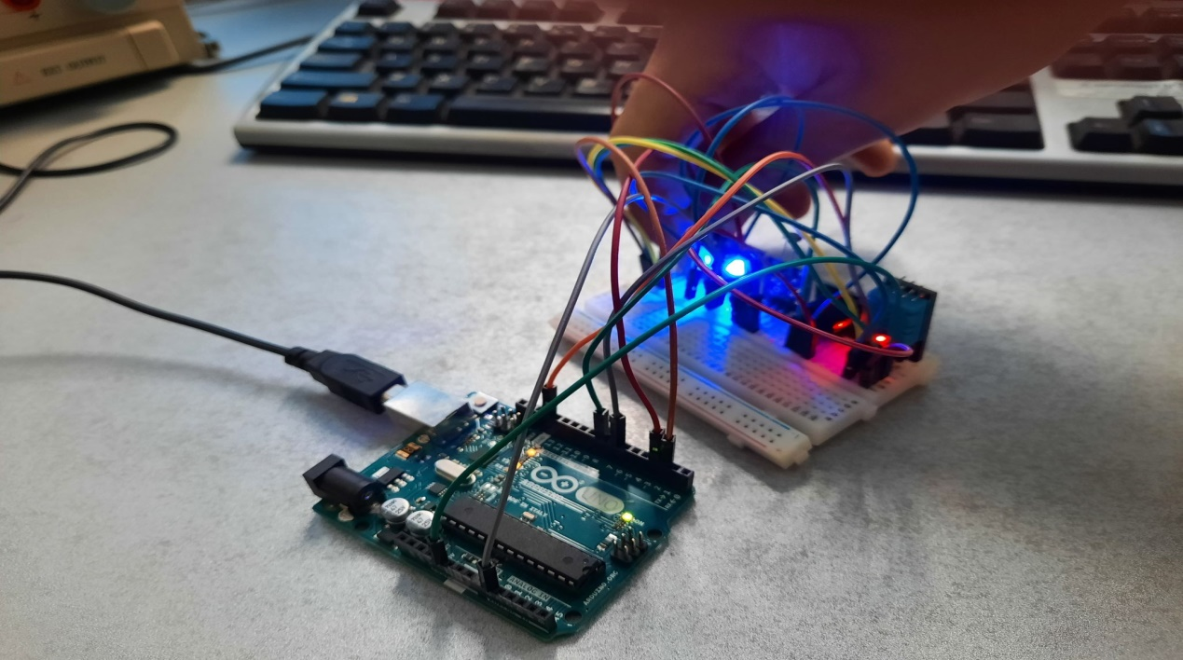

**9. Bibliography**

[1]

<https://www.developer.com/design/article.php/1474561/What-Are-Design-Patterns-and-Do-I-Need-Them.htm>