Points e) g)

→ PrgState List from e) point - that ListView is actually a Program List with the prints, the fork and the LOAD button that loads in the List View the execution stack of the PrgStments whose ID has been selected from the PrgState list.

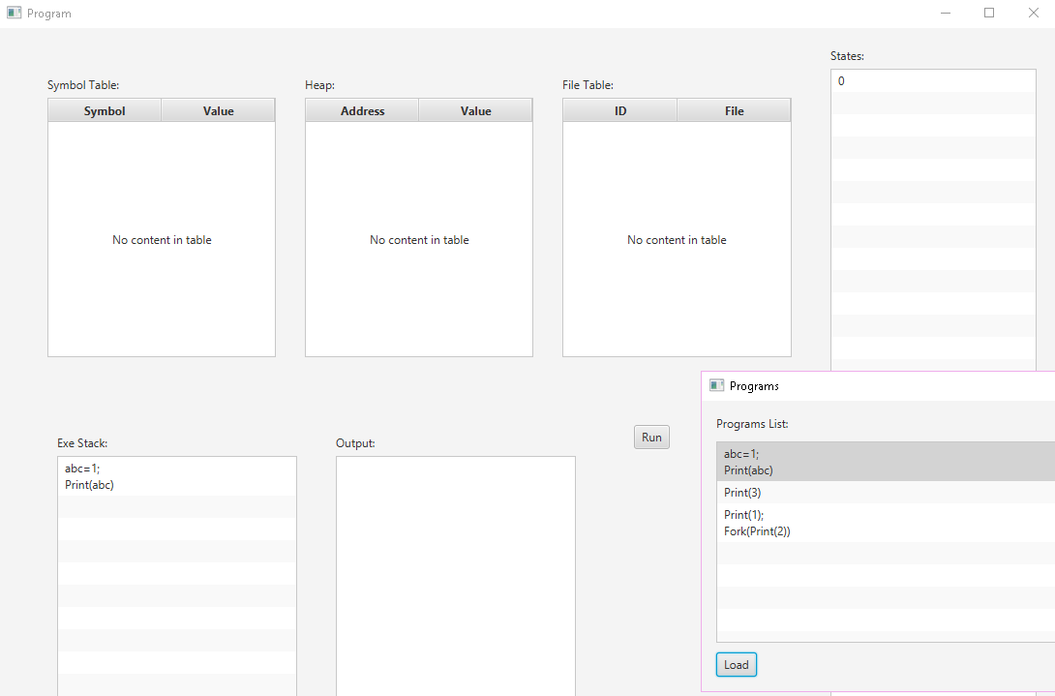

→"Run One Step" button that running oneStepForAllPrg (you need to design and implement this button's handler based on the previous allStep method). After each run, the displayed information is updated. You can write a service that packs the repository and reports any changes to the PrgStates list.

* Run -> 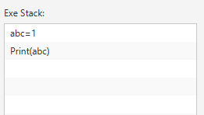 Run -> 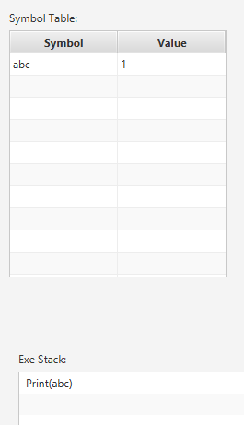
* Run -> 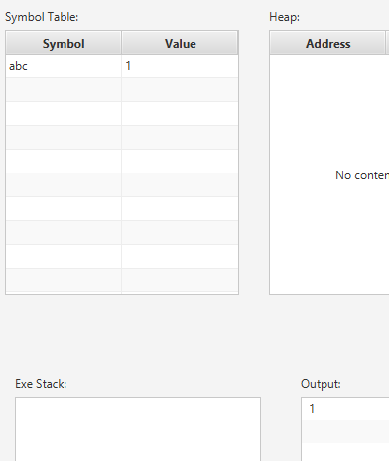 Run -> 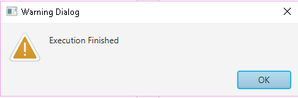
* **Load**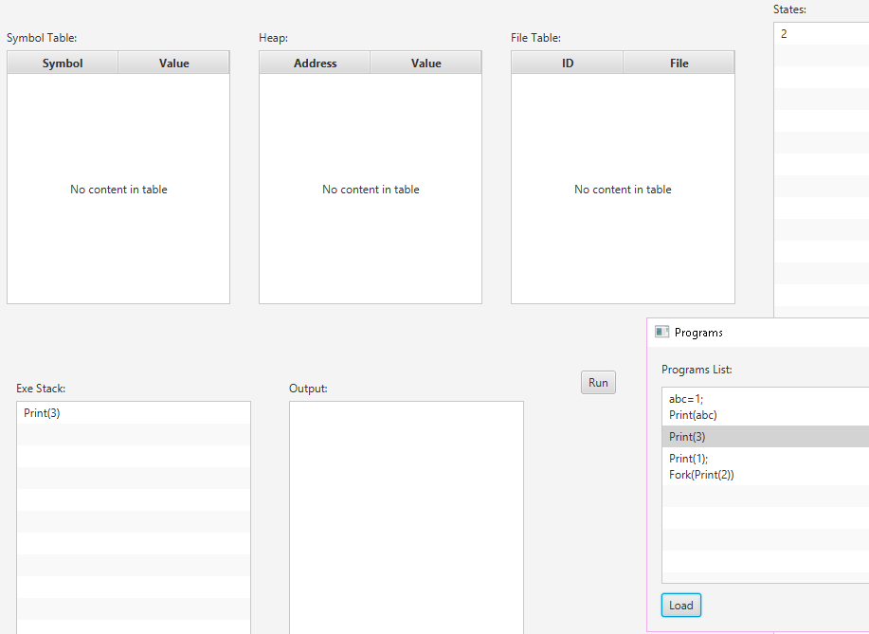
* Run -> 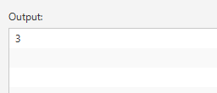 Run - > 

**Load**

* 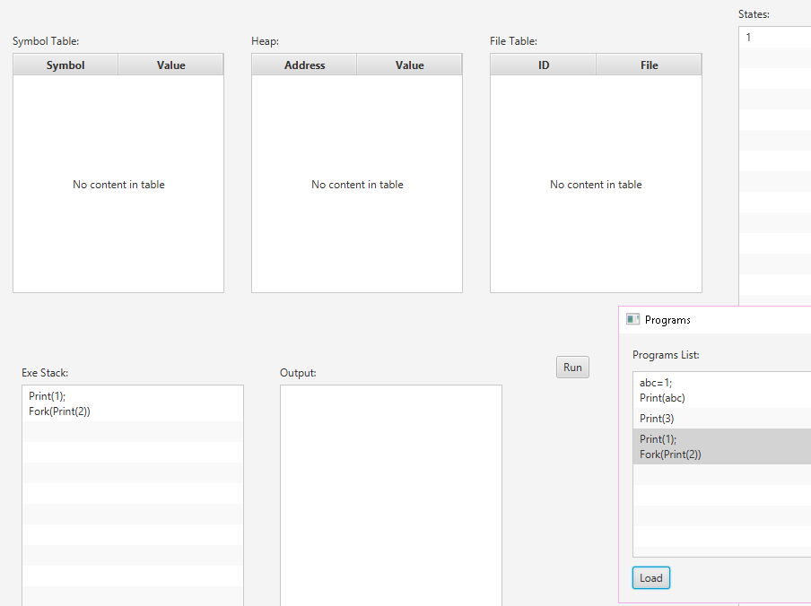
* **Run ->** 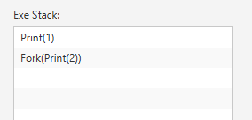
* **Run ->** 
 