Colegiul Național “Ienăchiță Văcărescu”

**Pyhton-Games**

Elev: Constantinescu Andrei Alexandru

2020-2021

**Cuprins**

Prezentare proiect 2

Despre Python 6

Codul 7

Bibliografie 24

Prezentare proiect

Proiectul meu este format din 4 aplicații:

* Un fel de shooter
* Un fel de paint
* X si 0 pe bune
* Un fel de hangman

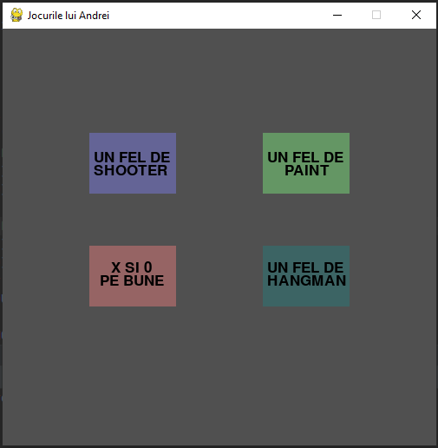

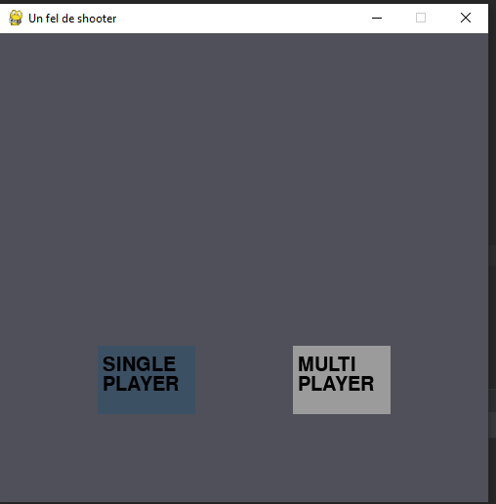

Jocul „Un fel de shooter” are 2 moduri, unul pentru un singur jucător, în care trebuie omorâți goblini, și unul multiplayer de tip PvP.

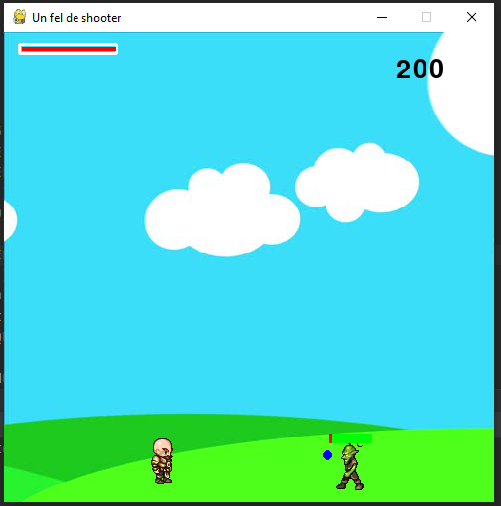

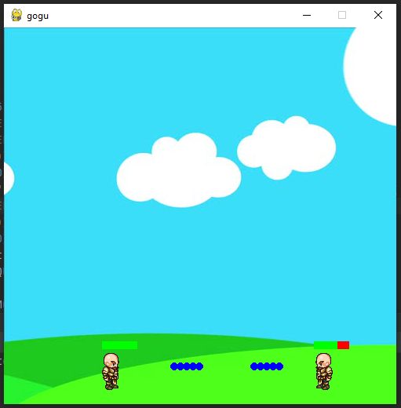

Cea de-a doua apicație este o încercare de a recrea faimoasa aplicație Paint.

Intr o fereastră impărțită în mii de pătrățele de mici dimensiuni (numărul și totodată mărimea acestora poate fi ușor modificată din cod) utilizatorul poate desena folosind 6 culori. Desenul poate fi finalizat prin apasarea Click stânga asupra butonului „GATA”, și astfel grila va dispărea.

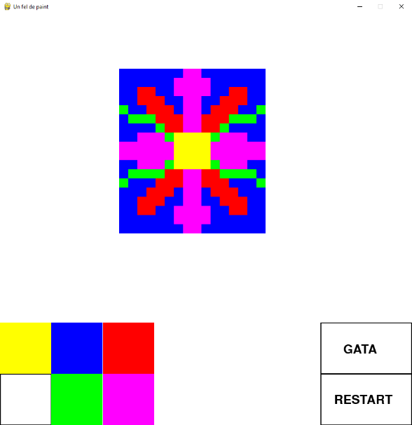

A treia aplicație este “X si 0 pe bune”.

Jocul este multiplayer. La finalul fiecărui meci se afișează atât câștigătorul cât și linia pe care

s-au plasat cele 3 forme de același tip. În caz de remiză, tabla se golește automat și jucătorii pot continua. Butonul de Replay apare după fiecare meci în urma căruia s-a putut desemna un câștigator, și după apasarea lui cu Click stânga tabla se golește și jocul poate reîncepe.

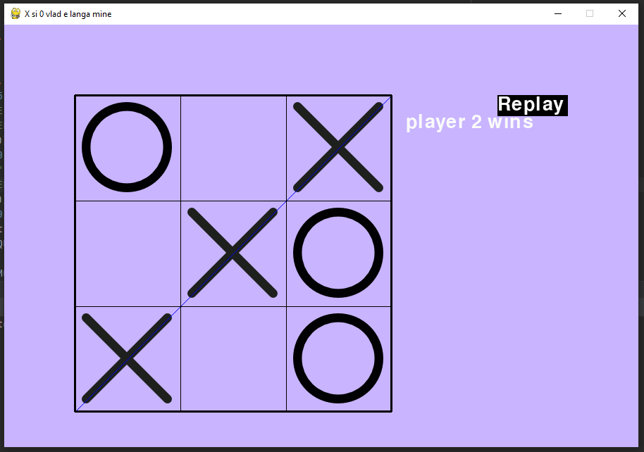

A patra aplicație este “Un fel de hangman”

Cuvântul ce urmează sa fie ghicit poate fi modificat ușor din cod, iar la apăsarea butoanelor aferente literelor, respectivea literă va fi plasată în toate locurile din cuvânt unde apare. Pe măsură ce sunt alese litere ce nu apar in componența cuvântului misterios, pe spânzuratoare se desenează un om. Jocul se termină în momentul în care cuvântul este ghicit complet (moment în care se afișează un mesaj încurajator) sau în momentul în care jucătorul a fost sacrificat (moment în care apare celebrul “GAME OVER”, dar și variantele Replay și Quit)

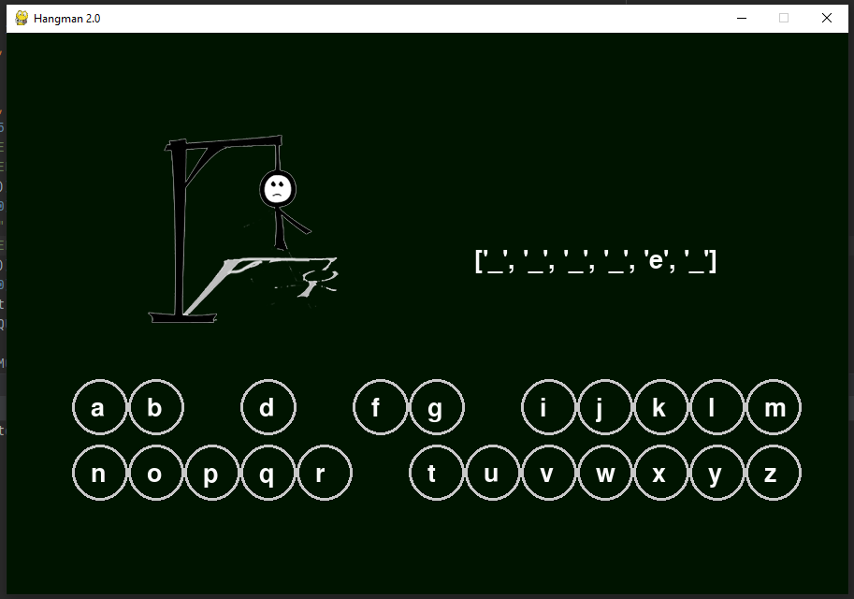

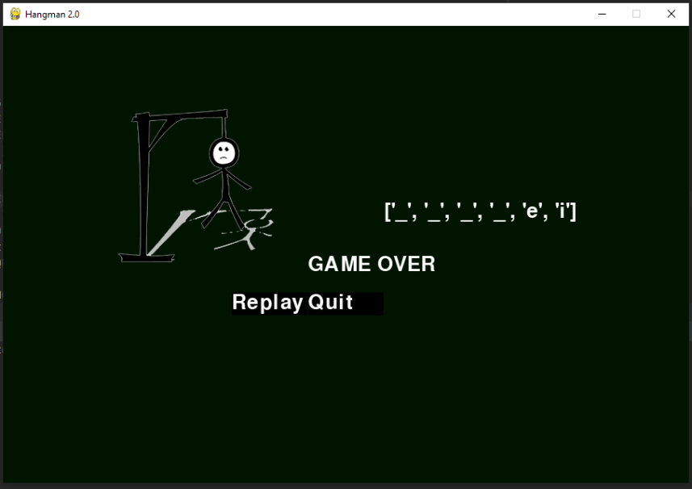

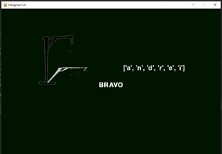

Despre Python

Python este un limbaj de programare dinamic [multi-paradigmă](https://ro.wikipedia.org/wiki/Limbaj_de_programare_multiparadigm%C4%83" \o "Limbaj de programare multiparadigmă), creat în [1989](https://ro.wikipedia.org/wiki/1989" \o "1989) de programatorul olandez [Guido van Rossum](https://ro.wikipedia.org/w/index.php?title=Guido_van_Rossum&action=edit&redlink=1" \o "Guido van Rossum — pagină inexistentă). Van Rossum este și în ziua de astăzi un lider al comunității de dezvoltatori de software care lucrează la perfecționarea limbajul Python și implementarea de bază a acestuia, CPython, scrisă în [C](https://ro.wikipedia.org/wiki/C" \o "C). Python este un limbaj multifuncțional folosit de exemplu de către companii ca [Google](https://ro.wikipedia.org/wiki/Google" \o "Google) sau [Yahoo!](https://ro.wikipedia.org/wiki/Yahoo!) pentru programarea aplicațiilor web, însă există și o serie de aplicații științifice sau de divertisment programate parțial sau în întregime în Python. Popularitatea în creștere, dar și puterea limbajului de programare Python au dus la adoptarea sa ca limbaj principal de dezvoltare de către programatori specializați și chiar și la predarea limbajului în unele medii universitare. Din aceleași motive, multe sisteme bazate pe Unix, inclusiv [Linux](https://ro.wikipedia.org/wiki/Linux" \o "Linux), [BSD](https://ro.wikipedia.org/wiki/BSD) și [Mac OS X](https://ro.wikipedia.org/wiki/Mac_OS_X) includ din start interpretatorul CPython.

Python pune accentul pe curățenia și simplitatea codului, iar sintaxa sa le permite dezvoltatorilor să exprime unele idei programatice într-o manieră mai clară și mai concisă decât în alte limbaje de programare ca [C](https://ro.wikipedia.org/wiki/C" \o "C). În ceea ce privește paradigma de programare, Python poate servi ca limbaj pentru software de tipul object-oriented, dar permite și programarea imperativă, funcțională sau procedurală. Sistemul de tipizare este dinamic iar administrarea memoriei decurge automat prin intermediul unui serviciu „gunoier” (garbage collector). Alt avantaj al limbajului este existența unei ample biblioteci standard de metode.

Implementarea de referință a Python este scrisă în C și poartă deci numele de CPython. Această implementare este software liber și este administrată de fundația Python Software Foundation

Codul

import pygame  
import random  
pygame.init()  
def spanzuratoare():  
 screen = pygame.display.set_mode((900, 600))  
 pygame.display.set_caption("Hangman 2.0")  
 # fonts  
 fontt = pygame.font.SysFont('comicsans', 40)  
  
 secret = "andrei"  
 # poze  
 images = []  
 for i in range(7):  
 images.append(pygame.image.load("hangman" + str(i) + ".png"))  
 # variabile  
 hs = 0  
 ok = 0  
 # litere  
 x = []  
 y = []  
 x1 = 100  
 y1 = 400  
 r = []  
 t = 0  
 ko = 0  
 replay = pygame.Rect(300, 350, 99, 30)  
 quitt = pygame.Rect(400, 350, 99, 30)  
 for i in range(26):  
 if i <= 12:  
 x.append(x1 + i * 60)  
 else:  
 x.append(x1 + (i - 13) * 60)  
 if i > 12:  
 y.append(y1 + 70)  
 else:  
 y.append(y1)  
 r.append(True)  
 alf = "abcdefghijklmnopqrstuvwxyz"  
 displayword = []  
 for i in range(len(secret)):  
 displayword.append("_")  
 # gameloop  
 FPS = 60  
 clock = pygame.time.Clock()  
 run = True  
 while run:  
 clock.tick(FPS)  
 screen.fill((0, 20, 0))  
 for i in range(26):  
 if r[i] == True:  
 pygame.draw.circle(screen, (200, 200, 200), (x[i], y[i]), 30, 3)  
 text = fontt.render(chr(97 + i), 1, (250, 250, 250))  
 screen.blit(text, (x[i] - 10, y[i] - 12))  
 screen.blit(images[hs], (150, 100))  
 textt = fontt.render(str(displayword), 1, (250, 250, 250))  
 screen.blit(textt, (500, 230))  
 for event in pygame.event.get():  
 if event.type == pygame.QUIT:  
 run = False  
 if event.type == pygame.MOUSEBUTTONDOWN:  
 pos = pygame.mouse.get_pos()  
 if pos[0] >= 300 and pos[0] <= 399 and pos[1] > 350 and pos[1] < 380 and ko == 1 and w == True:  
 w = False  
 for i in range(26):  
 r[i] = True  
 if pos[0] >= 400 and pos[0] <= 499 and pos[1] > 350 and pos[1] < 380 and ko == 1 and w == True:  
 run = False  
 for i in range(26):  
 if r[i] == True:  
 if abs(pos[0] - x[i]) * abs(pos[0] - x[i]) + abs(pos[1] - y[i]) * abs(pos[1] - y[i]) <= 900:  
 l = alf[i]  
 # print(l)  
 k = 0  
 for j in range(len(secret)):  
 if secret[j] == l:  
 k = k + 1  
 t = t + 1  
 displayword[j] = secret[j]  
 r[i] = False  
 if k == 0:  
 hs = hs + 1  
 if hs == 6:  
 ko = 1  
 if t == len(secret):  
 for i in range(26):  
 r[i] = False  
 textu = fontt.render("BRAVO", 1, (250, 250, 250))  
 screen.blit(textu, (400, 300))  
 if ko == 1:  
 textttt = fontt.render(  
 chr(71) + chr(65) + chr(77) + chr(69) + chr(32) + chr(79) + chr(86) + chr(69) + chr(82), 1,  
 (250, 250, 250))  
 screen.blit(textttt, (400, 300))  
 w = True  
 for i in range(26):  
 r[i] = False  
 if w == True:  
 pygame.draw.rect(screen, (0, 0, 0), replay)  
 teextttt = fontt.render(chr(82) + chr(101) + chr(112) + chr(108) + chr(97) + chr(121), 1,  
 (250, 250, 250))  
 screen.blit(teextttt, (300, 350))  
 pygame.draw.rect(screen, (0, 0, 0), quitt)  
 teeextttt = fontt.render(chr(81) + chr(117) + chr(105) + chr(116), 1, (250, 250, 250))  
 screen.blit(teeextttt, (400, 350))  
  
 pygame.display.update()  
 pygame.quit()  
def plm():  
 screen = pygame.display.set_mode((900, 600))  
 pygame.display.set_caption("X si 0 vlad e langa mine")  
  
 player = pygame.Rect(100, 100, 450, 450)  
 replay = pygame.Rect(700, 100, 100, 30)  
 images = []  
 images.append(pygame.image.load("circl.png"))  
 images.append(pygame.image.load("letter-x (1).png"))  
 fontt = pygame.font.SysFont('comicsans', 40)  
  
 win = 1  
  
 rrun = True  
 while rrun:  
 fontt = pygame.font.SysFont('comicsans', 40)  
 k = 1  
 xc = 0  
 ok = -1  
 okk = -1  
 okkk = -1  
 okkkk = -1  
 okkkkk = -1  
 okkkkkk = -1  
 okkkkkkk = -1  
 okkkkkkkk = -1  
 okkkkkkkkk = -1  
 px = 0  
 p1 = 0  
 p2 = 0  
 qw = 0  
 er = 0  
 v = [0, 0, 0, 0, 0, 0, 0, 0, 0]  
 r = [True, True, True, True, True, True, True, True, True]  
 FPS = 60  
 clock = pygame.time.Clock()  
 run = True  
 while run:  
 clock.tick(FPS)  
 screen.fill((200, 180, 255))  
  
 for event in pygame.event.get():  
 if event.type == pygame.QUIT:  
 run = False  
 if event.type == pygame.MOUSEBUTTONDOWN:  
 pos = pygame.mouse.get_pos()  
 if win == 0:  
 pygame.draw.rect(screen, (0, 0, 0), player, 3)  
 pygame.draw.aaline(screen, (0, 0, 0), (250, 100), (250, 550))  
 pygame.draw.aaline(screen, (0, 0, 0), (400, 100), (400, 550))  
 pygame.draw.aaline(screen, (0, 0, 0), (100, 250), (550, 250))  
 pygame.draw.aaline(screen, (0, 0, 0), (100, 250), (550, 250))  
 pygame.draw.aaline(screen, (0, 0, 0), (100, 400), (550, 400))  
 for i in range(9):  
 v[i] = 0  
 r[i] = True  
 k = 1  
 win = 1  
 if pos[0] > 100 and pos[0] < 250 and pos[1] > 100 and pos[1] < 250 and k % 2 == 1 and r[0] == True:  
 ok = 0  
 v[0] = 1  
 r[0] = False  
 k = k + 1  
 if pos[0] > 250 and pos[0] < 400 and pos[1] > 100 and pos[1] < 250 and k % 2 == 1 and r[1] == True:  
 okk = 1  
 v[1] = 1  
 r[1] = False  
 k = k + 1  
 if pos[0] > 400 and pos[0] < 550 and pos[1] > 100 and pos[1] < 250 and k % 2 == 1 and r[2] == True:  
 okkk = 2  
 v[2] = 1  
 r[2] = False  
 k = k + 1  
 if pos[0] > 100 and pos[0] < 250 and pos[1] > 250 and pos[1] < 400 and k % 2 == 1 and r[3] == True:  
 okkkk = 3  
 v[3] = 1  
 r[3] = False  
 k = k + 1  
 if pos[0] > 250 and pos[0] < 400 and pos[1] > 250 and pos[1] < 400 and k % 2 == 1 and r[4] == True:  
 okkkkk = 4  
 v[4] = 1  
 r[4] = False  
 k = k + 1  
 if pos[0] > 400 and pos[0] < 550 and pos[1] > 250 and pos[1] < 400 and k % 2 == 1 and r[5] == True:  
 okkkkkk = 5  
 v[5] = 1  
 r[5] = False  
 k = k + 1  
 if pos[0] > 100 and pos[0] < 250 and pos[1] > 400 and pos[1] < 550 and k % 2 == 1 and r[6] == True:  
 okkkkkkk = 6  
 v[6] = 1  
 r[6] = False  
 k = k + 1  
 if pos[0] > 250 and pos[0] < 400 and pos[1] > 400 and pos[1] < 550 and k % 2 == 1 and r[7] == True:  
 okkkkkkkk = 7  
 v[7] = 1  
 r[7] = False  
 k = k + 1  
 if pos[0] > 400 and pos[0] < 550 and pos[1] > 400 and pos[1] < 550 and k % 2 == 1 and r[8] == True:  
 okkkkkkkkk = 8  
 v[8] = 1  
 r[8] = False  
 k = k + 1  
  
 if pos[0] > 100 and pos[0] < 250 and pos[1] > 100 and pos[1] < 250 and k % 2 == 0 and r[0] == True:  
 ok = 0  
 v[0] = 2  
 r[0] = False  
 k = k + 1  
 if pos[0] > 250 and pos[0] < 400 and pos[1] > 100 and pos[1] < 250 and k % 2 == 0 and r[1] == True:  
 okk = 1  
 v[1] = 2  
 r[1] = False  
 k = k + 1  
 if pos[0] > 400 and pos[0] < 550 and pos[1] > 100 and pos[1] < 250 and k % 2 == 0 and r[2] == True:  
 okkk = 2  
 v[2] = 2  
 r[2] = False  
 k = k + 1  
 if pos[0] > 100 and pos[0] < 250 and pos[1] > 250 and pos[1] < 400 and k % 2 == 0 and r[3] == True:  
 okkkk = 3  
 v[3] = 2  
 r[3] = False  
 k = k + 1  
 if pos[0] > 250 and pos[0] < 400 and pos[1] > 250 and pos[1] < 400 and k % 2 == 0 and r[4] == True:  
 okkkkk = 4  
 v[4] = 2  
 r[4] = False  
 k = k + 1  
 if pos[0] > 400 and pos[0] < 550 and pos[1] > 250 and pos[1] < 400 and k % 2 == 0 and r[5] == True:  
 okkkkkk = 5  
 v[5] = 2  
 r[5] = False  
 k = k + 1  
 if pos[0] > 100 and pos[0] < 250 and pos[1] > 400 and pos[1] < 550 and k % 2 == 0 and r[6] == True:  
 okkkkkkk = 6  
 v[6] = 2  
 r[6] = False  
 k = k + 1  
 if pos[0] > 250 and pos[0] < 400 and pos[1] > 400 and pos[1] < 550 and k % 2 == 0 and r[7] == True:  
 okkkkkkkk = 7  
 v[7] = 2  
 r[7] = False  
 k = k + 1  
 if pos[0] > 400 and pos[0] < 550 and pos[1] > 400 and pos[1] < 550 and k % 2 == 0 and r[8] == True:  
 okkkkkkkkk = 8  
 v[8] = 2  
 r[8] = False  
 k = k + 1  
 for i in range(9):  
 q = i % 3  
 w = int(i / 3)  
 if v[i] == 1:  
 screen.blit(images[0], (110 + q * 150, 110 + w * 150))  
 if v[i] == 2:  
 screen.blit(images[1], (110 + q * 150, 110 + w * 150))  
 if v[0] == v[3] and v[0] == v[6] and v[0] != 0:  
 pygame.draw.aaline(screen, (0, 0, 255), (175, 100), (175, 550))  
 for i in range(9):  
 r[i] = False  
 if v[0] == 1:  
 text = fontt.render("player 1 wins", 1, (250, 250, 250))  
 screen.blit(text, (570, 125))  
 else:  
 text = fontt.render("player 2 wins", 1, (250, 250, 250))  
 screen.blit(text, (570, 125))  
 p2 = er + 1  
 win = 0  
 elif v[0] == v[4] and v[0] == v[8] and v[0] != 0:  
 pygame.draw.aaline(screen, (0, 0, 255), (100, 100), (550, 550))  
 for i in range(9):  
 r[i] = False  
 if v[0] == 1:  
 text = fontt.render("player 1 wins", 1, (250, 250, 250))  
 screen.blit(text, (570, 125))  
 else:  
 text = fontt.render("player 2 wins", 1, (250, 250, 250))  
 screen.blit(text, (570, 125))  
 win = 0  
 elif v[1] == v[4] and v[1] == v[7] and v[1] != 0:  
 pygame.draw.aaline(screen, (0, 0, 255), (325, 100), (325, 550))  
 for i in range(9):  
 r[i] = False  
 if v[1] == 1:  
 text = fontt.render("player 1 wins", 1, (250, 250, 250))  
 screen.blit(text, (570, 125))  
 else:  
 text = fontt.render("player 2 wins", 1, (250, 250, 250))  
 screen.blit(text, (570, 125))  
 win = 0  
 elif v[1] == v[0] and v[1] == v[2] and v[1] != 0:  
 pygame.draw.aaline(screen, (0, 0, 255), (100, 175), (550, 175))  
 for i in range(9):  
 r[i] = False  
 if v[0] == 1:  
 text = fontt.render("player 1 wins", 1, (250, 250, 250))  
 screen.blit(text, (570, 125))  
 else:  
 text = fontt.render("player 2 wins", 1, (250, 250, 250))  
 screen.blit(text, (570, 125))  
 win = 0  
 elif v[3] == v[4] and v[4] == v[5] and v[3] != 0:  
 pygame.draw.aaline(screen, (0, 0, 255), (100, 325), (550, 325))  
 for i in range(9):  
 r[i] = False  
 if v[3] == 1:  
 text = fontt.render("player 1 wins", 1, (250, 250, 250))  
 screen.blit(text, (570, 125))  
 else:  
 text = fontt.render("player 2 wins", 1, (250, 250, 250))  
 screen.blit(text, (570, 125))  
 win = 0  
 elif v[6] == v[7] and v[7] == v[8] and v[6] != 0:  
 pygame.draw.aaline(screen, (0, 0, 255), (100, 475), (550, 475))  
 for i in range(9):  
 r[i] = False  
 if v[6] == 1:  
 text = fontt.render("player 1 wins", 1, (250, 250, 250))  
 screen.blit(text, (570, 125))  
 p1 += 1  
 else:  
 text = fontt.render("player 2 wins", 1, (250, 250, 250))  
 screen.blit(text, (570, 125))  
 p2 += 1  
 win = 0  
 elif v[2] == v[5] and v[8] == v[2] and v[2] != 0:  
 pygame.draw.aaline(screen, (0, 0, 255), (475, 100), (475, 550))  
 for i in range(9):  
 r[i] = False  
 if v[2] == 1:  
 text = fontt.render("player 1 wins", 1, (250, 250, 250))  
 screen.blit(text, (570, 125))  
 p1 += 1  
 else:  
 text = fontt.render("player 2 wins", 1, (250, 250, 250))  
 screen.blit(text, (570, 125))  
 p2 += 1  
 win = 0  
 elif v[6] == v[4] and v[4] == v[2] and v[2] != 0:  
 pygame.draw.aaline(screen, (0, 0, 255), (100, 550), (550, 100))  
 for i in range(9):  
 r[i] = False  
 if v[6] == 1:  
 text = fontt.render("player 1 wins", 1, (250, 250, 250))  
 screen.blit(text, (570, 125))  
 p1 += 1  
 else:  
 text = fontt.render("player 2 wins", 1, (250, 250, 250))  
 screen.blit(text, (570, 125))  
 p2 += 1  
 win = 0  
 elif k == 10:  
 pygame.draw.rect(screen, (0, 0, 0), player, 3)  
 pygame.draw.aaline(screen, (0, 0, 0), (250, 100), (250, 550))  
 pygame.draw.aaline(screen, (0, 0, 0), (400, 100), (400, 550))  
 pygame.draw.aaline(screen, (0, 0, 0), (100, 250), (550, 250))  
 pygame.draw.aaline(screen, (0, 0, 0), (100, 250), (550, 250))  
 pygame.draw.aaline(screen, (0, 0, 0), (100, 400), (550, 400))  
 for i in range(9):  
 v[i] = 0  
 r[i] = True  
 k = 1  
 win = 1  
 if win == 0:  
 pygame.draw.rect(screen, (0, 0, 0), replay)  
 text = fontt.render("Replay", 1, (250, 250, 250))  
 screen.blit(text, (700, 100))  
 pygame.draw.rect(screen, (0, 0, 0), player, 3)  
 pygame.draw.aaline(screen, (0, 0, 0), (250, 100), (250, 550))  
 pygame.draw.aaline(screen, (0, 0, 0), (400, 100), (400, 550))  
 pygame.draw.aaline(screen, (0, 0, 0), (100, 250), (550, 250))  
 pygame.draw.aaline(screen, (0, 0, 0), (100, 250), (550, 250))  
 pygame.draw.aaline(screen, (0, 0, 0), (100, 400), (550, 400))  
 pygame.display.update()  
 rrun = False  
  
 pygame.quit()  
  
def shooter():  
 def joc2():  
 imagesleft = []  
 for i in range(9):  
 imagesleft.append(pygame.image.load("L" + str(i + 1) + ".png"))  
  
 imagesright = []  
 for i in range(9):  
 imagesright.append(pygame.image.load("R" + str(i + 1) + ".png"))  
 imagesleftt = []  
 for i in range(9):  
 imagesleft.append(pygame.image.load("L" + str(i + 1) + ".png"))  
  
 imagesrightt = []  
 for i in range(9):  
 imagesright.append(pygame.image.load("R" + str(i + 1) + ".png"))  
  
 bg = pygame.image.load("bg.jpg")  
 chr = pygame.image.load("standing.png")  
 chrr = pygame.image.load("standing.png")  
  
 cloc = pygame.time.Clock()  
 screen = pygame.display.set_mode((500, 480))  
 pygame.display.set_caption("gogu")  
  
 class player(object):  
 def __init__(self, x, y, latime, inaltime):  
 self.x = x  
 self.y = y  
 self.inaltime = inaltime  
 self.latime = latime  
 self.v = 5  
 self.isJump = False  
 self.JumpCount = 10  
 self.right = False  
 self.left = False  
 self.walk = 0  
 self.standing = True  
  
 def draaw(self, screen):  
  
 if self.walk + 1 >= 27:  
 self.walk = 0  
 if not (self.standing):  
 if self.left:  
 screen.blit(imagesleft[self.walk // 3], (self.x, self.y))  
 self.walk += 1  
 elif self.right:  
 screen.blit(imagesright[self.walk // 3], (self.x, self.y))  
 self.walk += 1  
 else:  
 if self.left:  
 screen.blit(imagesleft[0], (self.x, self.y))  
 elif self.right:  
 screen.blit(imagesright[0], (self.x, self.y))  
  
 class proiectile(object):  
 def __init__(self, x, y, radius, color, facing):  
 self.x = x  
 self.y = y  
 self.radius = radius  
 self.color = color  
 self.facing = facing  
 self.v = 8 * facing  
  
 def draw(self):  
 pygame.draw.circle(screen, self.color, (self.x, self.y), self.radius)  
  
 def redrawwindow():  
 global walk, patrat2  
 screen.blit(bg, (0, 0))  
  
 man.draaw(screen)  
 mann.draaw(screen)  
 pygame.draw.rect(screen, (255, 0, 0), patrat3)  
 pygame.draw.rect(screen, (0, 255, 0), patrat4)  
 pygame.draw.rect(screen, (255, 0, 0), patrat5)  
 pygame.draw.rect(screen, (0, 255, 0), patrat6)  
 for ball in bullets:  
 ball.draw()  
 for bal in bullet:  
 bal.draw()  
 if man.left == False and man.right == False:  
 screen.blit(chr, (man.x, man.y))  
 if mann.left == False and mann.right == False:  
 screen.blit(chr, (mann.x, mann.y))  
 if qw > 0 and qwe <= 0:  
 text = fontt.render("player 1 wins", 1, (0, 0, 0))  
 screen.blit(text, (200, 25))  
 if qw <= 0 and qwe > 0:  
 text = fontt.render("player 2 wins", 1, (0, 0, 0))  
 screen.blit(text, (200, 25))  
 pygame.display.update()  
  
 man = player(300, 410, 64, 64)  
 mann = player(350, 410, 64, 64)  
 bullets = []  
 bullet = []  
 q = 0  
 k = 0  
 y = 0  
 run = True  
 while run:  
  
 qwe = 45 - k * 5  
 patrat4 = pygame.Rect(man.x + 20, man.y, qwe, 10)  
 patrat3 = pygame.Rect(man.x + 20, man.y, 45, 10)  
 qw = 45 - y * 5  
 patrat6 = pygame.Rect(mann.x + 20, mann.y, qw, 10)  
 patrat5 = pygame.Rect(mann.x + 20, mann.y, 45, 10)  
 for event in pygame.event.get():  
 if event.type == pygame.QUIT:  
 pygame.quit()  
 cloc.tick(27)  
 for ball in bullets:  
 if ball.x < 500 and ball.x > 0:  
 ball.x += ball.v  
 else:  
 bullets.pop(bullets.index(ball))  
 if ball.x > mann.x + 20 and ball.x < mann.x + 30 and ball.y > mann.y and ball.y < mann.y + 54 and qwe > 0:  
 y = y + 1  
 bullets.pop(bullets.index(ball))  
  
 for bal in bullet:  
 if bal.x < 500 and bal.x > 0:  
 bal.x += bal.v  
 else:  
 bullet.pop(bullet.index(bal))  
 if bal.x > man.x + 20 and bal.x < man.x + 30 and bal.y > man.y and bal.y < man.y + 54 and qwe > 0:  
 k = k + 1  
 bullet.pop(bullet.index(bal))  
 keys = pygame.key.get_pressed()  
 if qw > 0 and qwe > 0:  
 if keys[pygame.K_SPACE]:  
 if len(bullets) < 5:  
 if man.left:  
 bullets.append(proiectile(man.x + 32, man.y + 32, 5, (0, 0, 255), -1))  
  
 if man.right:  
 bullets.append(proiectile(man.x + 32, man.y + 32, 5, (0, 0, 255), 1))  
 if keys[pygame.K_x]:  
 if len(bullet) < 5:  
 if mann.left:  
 bullet.append(proiectile(mann.x + 32, mann.y + 32, 5, (0, 0, 255), -1))  
  
 if mann.right:  
 bullet.append(proiectile(mann.x + 32, mann.y + 32, 5, (0, 0, 255), 1))  
 if keys[pygame.K_LEFT] and man.x > -10:  
 man.x -= man.v  
 man.left = True  
 man.right = False  
 man.standing = False  
 elif keys[pygame.K_RIGHT] and man.x < 450:  
 man.x += man.v  
 man.right = True  
 man.left = False  
 man.standing = False  
 else:  
 man.standing = True  
 man.walk = 0  
 if not (man.isJump):  
 if keys[pygame.K_DOWN] and man.y < 400:  
 man.y += man.v  
 if keys[pygame.K_UP]:  
 man.isJump = True  
 man.y = 400  
 else:  
 if man.JumpCount > -10:  
 man.y -= int((man.JumpCount * abs(man.JumpCount)) / 2)  
 man.JumpCount -= 1  
 else:  
 man.isJump = False  
 man.JumpCount = 10  
  
 if keys[pygame.K_a] and mann.x > -10:  
 mann.x -= mann.v  
 mann.left = True  
 mann.right = False  
 mann.standing = False  
 elif keys[pygame.K_d] and mann.x < 450:  
 mann.x += mann.v  
 mann.right = True  
 mann.left = False  
 mann.standing = False  
 else:  
 mann.standing = True  
 mann.walk = 0  
 if not (mann.isJump):  
 if keys[pygame.K_s] and mann.y < 400:  
 mann.y += mann.v  
 if keys[pygame.K_w]:  
 mann.isJump = True  
 mann.y = 400  
 else:  
 if mann.JumpCount > -10:  
 mann.y -= int((mann.JumpCount * abs(mann.JumpCount)) / 2)  
 mann.JumpCount -= 1  
 else:  
 mann.isJump = False  
 mann.JumpCount = 10  
 else:  
 if keys[pygame.K_r]:  
 qwe = 45  
 qw = 45  
 k = 0  
 y = 0  
  
 redrawwindow()  
  
 def joc1():  
  
 imagesleft = []  
 for i in range(9):  
 imagesleft.append(pygame.image.load("L" + str(i + 1) + ".png"))  
  
 imagesright = []  
 for i in range(9):  
 imagesright.append(pygame.image.load("R" + str(i + 1) + ".png"))  
  
 bg = pygame.image.load("bg.jpg")  
 chr = pygame.image.load("standing.png")  
  
 class player(object):  
 def __init__(self, x, y, latime, inaltime):  
 self.x = x  
 self.y = y  
 self.inaltime = inaltime  
 self.latime = latime  
 self.v = 5  
 self.isJump = False  
 self.JumpCount = 10  
 self.right = False  
 self.left = False  
 self.walk = 0  
 self.standing = True  
  
 def draaw(self, screen):  
  
 if self.walk + 1 >= 27:  
 self.walk = 0  
 if not (self.standing):  
 if self.left:  
 screen.blit(imagesleft[self.walk // 3], (self.x, self.y))  
 self.walk += 1  
 elif self.right:  
 screen.blit(imagesright[self.walk // 3], (self.x, self.y))  
 self.walk += 1  
 else:  
 if self.left:  
 screen.blit(imagesleft[0], (self.x, self.y))  
 elif self.right:  
 screen.blit(imagesright[0], (self.x, self.y))  
  
 class enemy(object):  
 walkright = []  
 for i in range(11):  
 walkright.append(pygame.image.load("R" + str(i + 1) + "E.png"))  
 walkleft = []  
 for i in range(11):  
 walkleft.append(pygame.image.load("L" + str(i + 1) + "E.png"))  
  
 def __init__(self, x, y, inaltime, latime, sf):  
 self.x = x  
 self.y = y  
 self.ok = 0  
 self.inaltime = inaltime  
 self.latime = latime  
 self.sf = sf  
 self.path = [1, self.sf]  
 self.walcount = 0  
 self.v = 3  
 self.k = 0  
  
 def draw(self, screen):  
 if qw > 1:  
 self.move()  
 if self.walcount + 1 >= 33:  
 self.walcount = 0  
 if self.v > 0:  
 screen.blit(self.walkright[self.walcount // 3], (self.x, self.y))  
 self.walcount += 1  
 else:  
 screen.blit(self.walkleft[self.walcount // 3], (self.x, self.y))  
 self.walcount += 1  
 else:  
 screen.blit(self.walkleft[1], (self.x, self.y))  
  
 def move(self):  
 if self.v > 0:  
 if self.x + self.v < self.path[1]:  
 self.x += self.v  
 elif self.x + self.v >= self.path[1]:  
 self.v = self.v * -1  
 self.walcount = 0  
 else:  
 if self.x - self.v > self.path[0]:  
 self.x += self.v  
 else:  
 self.v = self.v * -1  
 self.walcount = 0  
 self.patrat2 = pygame.Rect(self.x + 20, self.y, 30, 54)  
 self.patrat3 = pygame.Rect(self.x + 20, self.y, 40, 10)  
  
 class proiectile(object):  
 def __init__(self, x, y, radius, color, facing):  
 self.x = x  
 self.y = y  
 self.radius = radius  
 self.color = color  
 self.facing = facing  
 self.v = 8 * facing  
  
 def draw(self):  
 pygame.draw.circle(screen, self.color, (self.x, self.y), self.radius)  
  
 def redrawwindow():  
 global walk, patrat2  
 screen.blit(bg, (0, 0))  
 man.draaw(screen)  
 for ball in bullets:  
 ball.draw()  
  
 en.draw(screen)  
 pygame.draw.rect(screen, (255, 0, 0), en.patrat3)  
 pygame.draw.rect(screen, (0, 255, 0), patrat4)  
 pygame.draw.rect(screen, (255, 255, 255), vchen, 3)  
 if qw >= 1:  
 pygame.draw.rect(screen, (255, 0, 0), vchen2)  
 else:  
 textt = fontt.render("GAME OVER", 1, (0, 0, 0))  
 screen.blit(textt, (200, 250))  
 if man.left == False and man.right == False:  
 screen.blit(chr, (man.x, man.y))  
 text = fontt.render(str(ass * 100), 1, (0, 0, 0))  
 screen.blit(text, (400, 25))  
 pygame.display.update()  
  
 man = player(300, 410, 64, 64)  
 en = enemy(150, 410, 64, 64, 450)  
 bullets = []  
 q = 0  
 k = 0  
 ass = 0  
 p = 8  
 run = True  
 while run:  
 cloc.tick(27)  
 # patrat1 = pygame.Rect(man.x + 15, man.y + 12, 35, 54)  
 qwe = 45 - k * 5  
 patrat4 = pygame.Rect(en.x + 20, en.y, qwe, 10)  
 vchen = pygame.Rect(15, 12, 100, 10)  
 qw = 96 - int(q * p / 10)  
 vchen2 = pygame.Rect(18, 15, qw, 4)  
 if qwe == 0 and qw > 0:  
 qwe = 45  
 en.v = en.v + 5  
 k = 0  
 p += 2  
 en.x = random.randint(1, 400)  
 en.y = 410  
 if abs(man.x + 12 - en.x) < 30 and abs(man.y + 25 - en.y) < 54 and qwe > 0:  
 q = q + 1  
 for event in pygame.event.get():  
 if event.type == pygame.QUIT:  
 pygame.quit()  
  
 for ball in bullets:  
 if ball.x < 500 and ball.x > 0:  
 ball.x += ball.v  
 else:  
 bullets.pop(bullets.index(ball))  
 if ball.x > en.x + 20 and ball.x < en.x + 30 and ball.y > en.y and ball.y < en.y + 54 and qwe > 0:  
 ass = ass + 1  
 k = k + 1  
 bullets.pop(bullets.index(ball))  
  
 keys = pygame.key.get_pressed()  
 if qw >= 1:  
 if keys[pygame.K_SPACE]:  
 if len(bullets) < 5:  
 if man.left:  
 bullets.append(proiectile(man.x + 32, man.y + 32, 5, (0, 0, 255), -1))  
  
 if man.right:  
 bullets.append(proiectile(man.x + 32, man.y + 32, 5, (0, 0, 255), 1))  
 if keys[pygame.K_LEFT] and man.x > -10:  
 man.x -= man.v  
 man.left = True  
 man.right = False  
 man.standing = False  
 elif keys[pygame.K_RIGHT] and man.x < 450:  
 man.x += man.v  
 man.right = True  
 man.left = False  
 man.standing = False  
 else:  
 man.standing = True  
 man.walk = 0  
 if not (man.isJump):  
 if keys[pygame.K_DOWN] and man.y < 400:  
 man.y += man.v  
 if keys[pygame.K_UP]:  
 man.isJump = True  
 man.y = 400  
 else:  
 if man.JumpCount > -10:  
 man.y -= int((man.JumpCount * abs(man.JumpCount)) / 2)  
 man.JumpCount -= 1  
 else:  
 man.isJump = False  
 man.JumpCount = 10  
 else:  
 if keys[pygame.K_CAPSLOCK]:  
 qw = 96  
 q = 0  
 en.v = 3  
 qwe = 45  
 p = 8  
 ass = 0  
 redrawwindow()  
  
 cloc = pygame.time.Clock()  
 screen = pygame.display.set_mode((500, 480))  
 pygame.display.set_caption("Un fel de shooter")  
 fontt = pygame.font.SysFont('comicsans', 40)  
 fonttt = pygame.font.SysFont('comicsans', 30)  
 ui = 0  
 run = True  
 patratel = pygame.Rect(100, 320, 100, 70)  
 patratel2 = pygame.Rect(300, 320, 100, 70)  
 while run:  
 screen.fill((80, 80, 90))  
 pygame.draw.rect(screen, (60, 80, 100), patratel)  
 pygame.draw.rect(screen, (155, 155, 155), patratel2)  
 textt = fonttt.render("SINGLE", 1, (0, 0, 0))  
 texttT = fonttt.render("PLAYER", 1, (0, 0, 0))  
 screen.blit(textt, (105, 330))  
 screen.blit(texttT, (105, 350))  
 textt = fonttt.render("MULTI", 1, (0, 0, 0))  
 texttT = fonttt.render("PLAYER", 1, (0, 0, 0))  
 screen.blit(textt, (305, 330))  
 screen.blit(texttT, (305, 350))  
 for event in pygame.event.get():  
 if event.type == pygame.QUIT:  
 pygame.quit()  
 if event.type == pygame.MOUSEBUTTONDOWN:  
 pos = pygame.mouse.get_pos()  
 print(pos)  
 if pos[0] > 100 and pos[0] < 200 and pos[1] > 320 and pos[1] < 390 and ui == 0:  
 ui = 1  
 if pos[0] > 300 and pos[0] < 500 and pos[1] > 320 and pos[1] < 390 and ui == 0:  
 ui = 2  
 if ui == 1:  
 joc1()  
 if ui == 2:  
 joc2()  
 pygame.display.update()  
def paint():  
 pygame.init()  
 latime = 900  
 l = 1 / 8 * latime  
 screen = pygame.display.set_mode((latime, latime))  
 pygame.display.set_caption("Un fel de paint")  
 fontt = pygame.font.SysFont('comicsans', 40)  
 fonttt = pygame.font.SysFont('comicsans', 20)  
 traseuu = 1  
 FPS = 60  
 lat = 20  
 posi = []  
 print(len(posi))  
 ok = 0  
 rtt = 0  
 k = 0  
 galben = pygame.Rect(0, 3 / 4 * latime, l, l)  
 albastru = pygame.Rect(l, 3 / 4 * latime, l, l)  
 alb = pygame.Rect(0, 3 / 4 * latime + l, l, l)  
 verde = pygame.Rect(l, 3 / 4 * latime + l, l, l)  
 rosu = pygame.Rect(2 * l, 3 / 4 * latime, l, l)  
 mov = pygame.Rect(2 * l, 3 / 4 * latime + l, l, l)  
 traseu = pygame.Rect(700, 3 / 4 * latime, 199, 1 / 8 * latime)  
 nou = pygame.Rect(700, 3 / 4 * latime + 1 / 8 * latime, 199, 1 / 8 * latime)  
 clock = pygame.time.Clock()  
 run = True  
 while run:  
 clock.tick(FPS)  
 screen.fill((255, 255, 255))  
 for event in pygame.event.get():  
 if event.type == pygame.QUIT:  
 pygame.quit()  
 if event.type == pygame.MOUSEBUTTONDOWN:  
 pos = pygame.mouse.get_pos()  
 print(pos)  
 if pos[0] <= l and pos[1] >= 3 / 4 * latime and pos[1] < 3 / 4 * latime + 90:  
 ok = 1  
 if pos[0] > l and pos[0] <= 2 * l and pos[1] >= 3 / 4 * latime and pos[1] < 3 / 4 * latime + l:  
 ok = 0  
 if pos[0] <= l and pos[1] >= 3 / 4 * latime + l and pos[1] < 3 / 4 * latime + 2 * l:  
 ok = 2  
 if pos[0] > l and pos[0] <= 2 * l and pos[1] >= 3 / 4 * latime + l and pos[1] <= 3 / 4 * latime + 2 * l:  
 ok = 3  
 if pos[0] > 2 * l and pos[0] <= 3 * l and pos[1] >= 3 / 4 * latime and pos[1] <= 3 / 4 * latime + l:  
 ok = 4  
 if pos[0] > 2 * l and pos[0] <= 3 * l and pos[1] >= 3 / 4 * latime + l and pos[  
 1] <= 3 / 4 * latime + 180:  
 ok = 5  
 if pos[0] > 800 and pos[1] > 3 / 4 * latime and pos[1] < 3 / 4 * latime + 1 / 8 * latime:  
 traseuu = 0  
 if pos[0] > 700 and pos[1] > 3 / 4 * latime + 1 / 8 * latime:  
 lati = posi  
 posi = []  
 for i in range(len(posi)):  
 posi.append(lati[i][0], lati[i][1], (255, 255, 255))  
 traseuu = 1  
 if ok == 1 and pos[1] <= 3 / 4 * latime:  
 posi.append((pos[0] - pos[0] % lat, pos[1] - pos[1] % lat, (255, 255, 0)))  
 if ok == 0 and pos[1] <= 3 / 4 * latime:  
 posi.append((pos[0] - pos[0] % lat, pos[1] - pos[1] % lat, (0, 0, 255)))  
 if ok == 2 and pos[1] <= 3 / 4 * latime:  
 posi.append((pos[0] - pos[0] % lat, pos[1] - pos[1] % lat, (255, 255, 255)))  
 if ok == 3 and pos[1] <= 3 / 4 * latime:  
 posi.append((pos[0] - pos[0] % lat, pos[1] - pos[1] % lat, (0, 255, 0)))  
 if ok == 4 and pos[1] <= 3 / 4 * latime:  
 posi.append((pos[0] - pos[0] % lat, pos[1] - pos[1] % lat, (255, 0, 0)))  
 if ok == 5 and pos[1] <= 3 / 4 * latime:  
 posi.append((pos[0] - pos[0] % lat, pos[1] - pos[1] % lat, (255, 0, 255)))  
 for i in range(len(posi)):  
 x = posi[i][0]  
 y = posi[i][1]  
 patrat = pygame.Rect(x, y, lat, lat)  
 pygame.draw.rect(screen, posi[i][2], patrat)  
 pygame.draw.rect(screen, (255, 255, 0), galben)  
 pygame.draw.rect(screen, (0, 0, 255), albastru)  
 pygame.draw.rect(screen, (0, 0, 0), alb, 2)  
 pygame.draw.rect(screen, (0, 255, 0), verde)  
 pygame.draw.rect(screen, (255, 0, 0), rosu)  
 pygame.draw.rect(screen, (255, 0, 255), mov)  
 pygame.draw.rect(screen, (0, 0, 0), traseu, 2)  
 pygame.draw.rect(screen, (0, 0, 0), nou, 2)  
 text = fontt.render("GATA", 1, (0, 0, 0))  
 screen.blit(text, (750, int(3 / 4 * latime + 1 / 16 * latime - 10)))  
 text = fontt.render("RESTART", 1, (0, 0, 0))  
 screen.blit(text, (730, int(3 / 4 * latime + 1 / 16 * latime + 100)))  
 x = 0  
 y = 0  
 if traseuu == 1:  
 for i in range(int(latime / lat)):  
 pygame.draw.aaline(screen, (0, 0, 0), (x + (i + 1) * lat, 0), (x + (i + 1) * lat, latime * 3 / 4))  
 for i in range(int(latime / 4 * 3 / lat)):  
 pygame.draw.aaline(screen, (0, 0, 0), (0, y + (i + 1) * lat), (latime, y + (i + 1) * lat))  
  
 pygame.display.update()  
  
  
  
cloc = pygame.time.Clock()  
screen = pygame.display.set_mode((500, 480))  
pygame.display.set_caption("Jocurile lui Andrei")  
fontt = pygame.font.SysFont('comicsans', 20)  
fonttt = pygame.font.SysFont('comicsans', 25)  
uii=0  
run=True  
patratel = pygame.Rect(100,120, 100, 70)  
patratel2 = pygame.Rect(300,120, 100, 70)  
patratel3=pygame.Rect(100, 250,100,70)  
patratel4 = pygame.Rect(300,250, 100, 70)  
while run:  
 while uii==0:  
 screen.fill((80,80,80))  
 pygame.draw.rect(screen, (100,100,150), patratel)  
 pygame.draw.rect(screen, (100, 150, 100), patratel2)  
 pygame.draw.rect(screen,(150,100,100), patratel3)  
 pygame.draw.rect(screen, (60, 100, 100), patratel4)  
  
 textt = fonttt.render("UN FEL DE", 1, (0, 0, 0))  
 texttT = fonttt.render("SHOOTER", 1, (0, 0, 0))  
 screen.blit(textt, (105, 140))  
 screen.blit(texttT, (105, 155))  
  
 textt = fonttt.render("UN FEL DE", 1, (0, 0, 0))  
 texttT = fonttt.render("PAINT", 1, (0, 0, 0))  
 screen.blit(textt, (305, 140))  
 screen.blit(texttT, (325, 155))  
  
  
 textt = fonttt.render("X SI 0", 1, (0, 0, 0))  
 texttT = fonttt.render("PE BUNE", 1, (0, 0, 0))  
 screen.blit(textt, (125, 267))  
 screen.blit(texttT, (112, 282))  
  
  
 textt = fonttt.render("UN FEL DE", 1, (0, 0, 0))  
 texttT = fonttt.render("HANGMAN", 1, (0, 0, 0))  
 screen.blit(textt, (305, 267))  
 screen.blit(texttT, (305, 282))  
 for event in pygame.event.get():  
 if event.type == pygame.QUIT:  
 pygame.quit()  
 if event.type==pygame.MOUSEBUTTONDOWN:  
 pos=pygame.mouse.get_pos()  
 print (pos)  
 if pos[0]>100 and pos[0]<200 and pos[1]>120 and pos[1] <190 and uii==0:  
 uii=1  
 if pos[0] > 300 and pos[0] < 400 and pos[1] > 120 and pos[1] < 190 and uii == 0:  
 uii = 2  
 if pos[0] > 100 and pos[0] < 200 and pos[1] > 250 and pos[1] < 320 and uii == 0:  
 uii = 3  
 if pos[0] > 300 and pos[0] < 400 and pos[1] > 250 and pos[1] < 320 and uii == 0:  
 uii = 4  
  
 if uii==1:  
 shooter()  
 if uii==2:  
 paint()  
 if uii==3:  
 plm()  
 if uii==4:  
 spanzuratoare()  
 pygame.display.update()

Bibliografie

<https://ro.wikipedia.org/wiki/Python>

<https://www.youtube.com/watch?v=rfscVS0vtbw&t=12622s>

<https://www.youtube.com/watch?v=Q-__8Xw9KTM>