Distributed Control Systems Project:

Intersection modelling and simulation

Authors:
Ciurila Victor-Andrei
Farcas Andrei
Haddarau Cristian-Ioan

Table of Contents:

Screenshot of the map:
The main puropse of the project is to model and implement using Petri Nets the following two semaphorized intersections and the street that unites them.
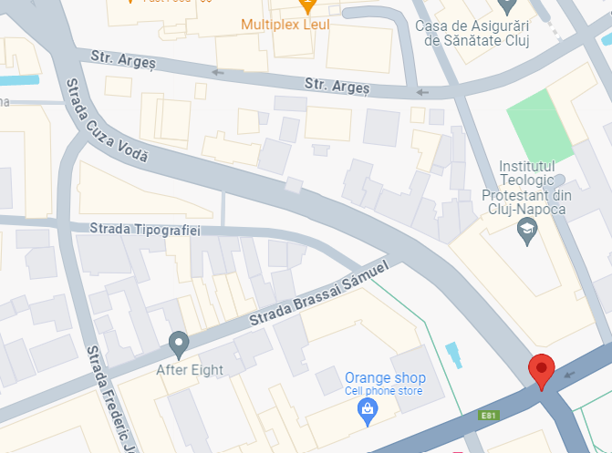


Simplified drawing of the intersection:
In order to facilitate an easier understanding of the intersection and help the workflow, we have made a graphic representation of the two intersections that only includes the important information that was needed for us to accomplish our task.
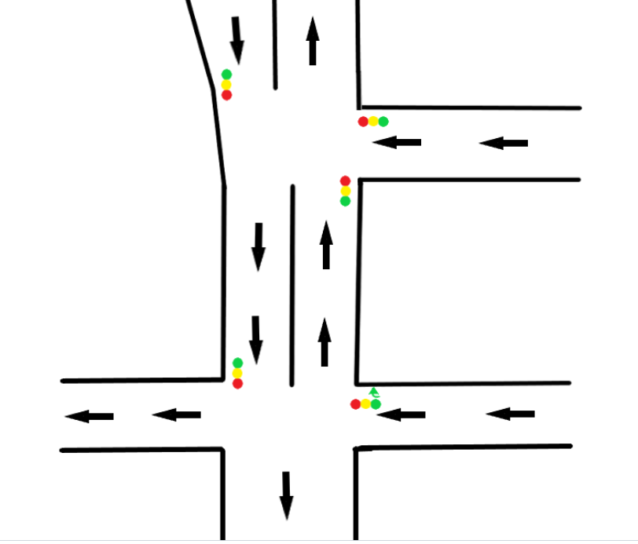

OETPN model for the plant (the intersection and the middle street)

Place types and grd&map for the entire OETPN

OETPN model for the controllers
The project has two semaphorized intersections, therefore we need two controllers. By analizing the functionality of the semaphors during the numerous times we have crossed the intersection, we decided to implement both controllers as two phase controllers. We can observe in the simplified drawing from section 2 that there are three semaphors in the first intersection and only two for the seciond intersection, which is reflected in the following OETPN’s.
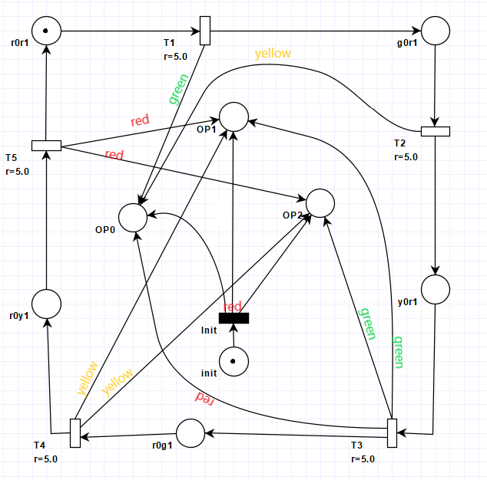
Controller for intersection 1
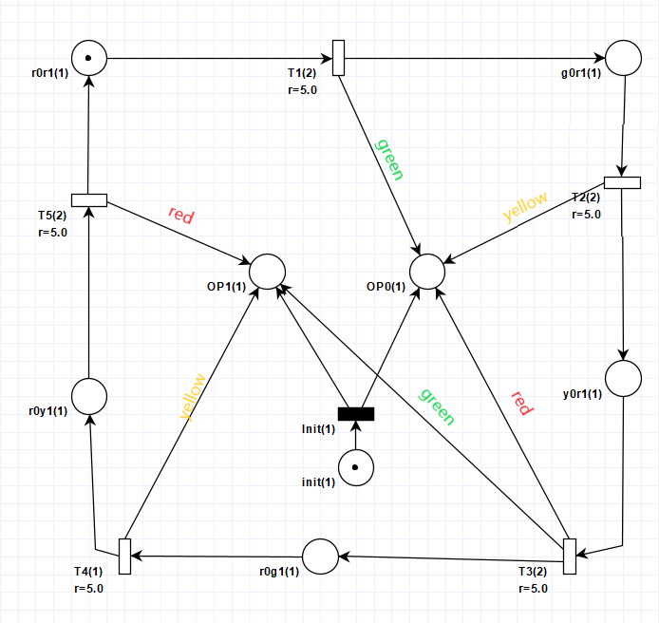
Controller for intersection 2

