

SAMPLE REPORT

Employee Engagement & Retention
Annual census, all-employee population.
Prepared for | Northgate Components, Inc. — a fictional mid-size US manufacturer (illustrative)
Prepared by | Andrei Akhtyrskii, PhD — Measure & Meaning Research

About this document
This is a sample deliverable. Every number, chart, organization name, and quotation in it is synthetic — generated to illustrate the structure, analysis standards, and decision framing of a Measure & Meaning employee census report. No real client data appear anywhere in this document.
Instrumentation: all survey items referenced here are original Measure & Meaning formulations (IP tier A).

Month, Year

01 Executive summary
The decision this study supports: voluntary turnover at Northgate rose from 14% to 21% in twelve months, concentrated in production roles. Leadership must decide where to spend a limited retention budget in FY-27. This census answers what actually predicts leaving — not what is loudest — and sequences the levers by cost.
- Engagement is uneven, not low. The organization averages 65 on a 0–100 index, but Warehouse & Logistics (61) and Production (64) sit meaningfully below Engineering (74). The problem is concentrated, so the response should be too. (Fig. 1)
- eNPS is −3 overall and −12 to −17 in the two frontline units — the workforce is closer to warning peers off than recommending. Small-unit scores carry wide confidence intervals and are flagged as such. (Fig. 2)
- Four conditions fall in the action zone — high importance, low satisfaction: pay fairness, sustainable workload, career growth, and communication. Team relationships and safety are strengths to protect, not investment targets. (Fig. 3–4)
- Burnout risk is demand-driven, not resilience-driven. 31% of the 3–6-year tenure band screens elevated; Production and Warehouse combine high demand with poor recovery. The fix is workload math — staffing, scheduling, overtime — not wellness programming. (Fig. 5–6)
- The driver model reorders the priority list. Stated importance puts pay and job security on top; the model of who actually intends to stay puts career growth first, with recognition, communication, and feedback — three low-cost levers — jointly explaining about 20% of retention variance. (Fig. 9–10)

Recommendation
Sequence the retention budget in three tiers:
(1) deploy the low-cost levers now — recognition practice, leadership communication rhythm, feedback clarity — in Production and Warehouse first;
(2) fund the structural fixes — staffing-model review for sustainable workload and visible technical career paths;
(3) commission a targeted pay-equity and market-benchmark study before making across-the-board pay moves. Re-measure with a 5-minute pulse in Q4 against this baseline.

02 Background and objectives
Northgate Components employs approximately 1,240 people across two production sites and a headquarters office. Exit interviews and manager escalations pointed to workload and pay as the causes of rising turnover — but exit data describe leavers, are collected at the worst possible moment, and cannot rank causes. Leadership commissioned a full census to establish a defensible baseline before allocating the FY-27 retention budget.
The study was designed to resolve five questions, each mapped to a survey module:
# | Objective (question the analysis resolves) | Module
1 | How engaged is the workforce, and where is engagement uneven? | CORE
2 | Would employees recommend Northgate as a place to work — and what moves that? | NPS
3 | Which working conditions matter most, and where do we under-deliver on what matters? | GAP
4 | Where is burnout risk concentrated — and is it demand-driven or recovery-driven? | BRN
5 | What actually predicts intent to stay, and which levers are cheapest per point of retention? | STAY
Open-ended responses (module OPEN) cut across all five objectives and are reported in §4.5.

03 Method and sample

Design and instrument
Anonymous online census of all employees; kiosk stations provided on production floors for employees without company email. Median completion time 13.4 minutes. The instrument combined six modules — CORE engagement, eNPS, an importance × satisfaction matrix, a burnout screen, retention intent, and open-ended questions — assembled from the Measure & Meaning employee item bank; the census is modular, and the fielded configuration is engagement-specific. All items are original Measure & Meaning formulations; item IDs, scales, and provenance are documented in Appendix A.
Scales. Agreement items use a 5-point Likert scale. Importance and satisfaction are each rated on 7-point, fully verbalized scales; satisfaction items offer an off-scale “Not applicable / no experience with this” option, excluded from means and reported as a coverage statistic (Appendix A explains the rationale). eNPS uses the canonical 0–10 scale.

Sample and coverage
Unit | Invited | Completed | After screening | Response rate | MoE (95%)
Production | 648 | 531 | 512 | 82% | ±2.0 pp
Warehouse & Logistics | 203 | 174 | 168 | 86% | ±3.1 pp
Engineering | 108 | 96 | 94 | 89% | ±3.6 pp
Sales & Customer Ops | 96 | 83 | 81 | 86% | ±4.2 pp
Quality | 61 | 54 | 52 | 89% | ±5.2 pp
Finance & Admin | 55 | 48 | 46 | 87% | ±5.8 pp
IT | 31 | 25 | 24 | 81% | ±9.5 pp
HR | 14 | 11 | 10 | 79% | ±16.6 pp
Total | 1,216 | 1,022 | 987 | 84% | ±1.3 pp
Exhibit 1. Achieved sample by unit
Weighting. Results are weighted to payroll records by department × tenure band × role level to correct nonresponse skew (production shift workers responded at a lower rate than office staff). Weights range 0.71–1.58; the scheme is documented in Appendix C. All figures in this report are weighted unless labeled otherwise.

Data-quality screening (applied before any analysis)
Screening rules were pre-registered in the technical appendix and applied uniformly. This disclosure is standard in every Measure & Meaning report:
Screen | Rule | Flagged | Excluded
Speeding | < ⅓ of median completion time flag; sustained < 2 s/item exclude | 41 | 17
Straightlining | Zero variance across all 18 ratings within a single GAP column (importance or satisfaction), per column flag; + speeding exclude | 26 | 11
Attention checks | 2 embedded items; one failure flag, two exclude | 23 | 7
Kiosk proxy review | Response-time clustering on shared devices reviewed manually | 6 | 0
Total excluded (unique respondents) |  |  | 35 (3.4%)
Exhibit 2. Screening funnel: 1,022 completed → 987 analyzed · straightlining flags by column: importance 15, satisfaction 8, both 3
Anonymity threshold
No result is reported for any group of fewer than 5 respondents. Suppressed cells are shown as “n/a (below reporting threshold)” — never silently dropped. Open-ended quotations are paraphrased where verbatim wording could identify the author.

04 Results by objective

4.1 · Engagement: uneven, and concentrated where turnover is (CORE)
The engagement index (mean of six agreement items, rescaled 0–100) averages 65.4 weighted. The story is not the average but the spread: Engineering (74) and the smaller office functions sit comfortably above it, while Warehouse & Logistics (61) and Production (64) — 69% of headcount and the locus of the turnover increase — sit below.
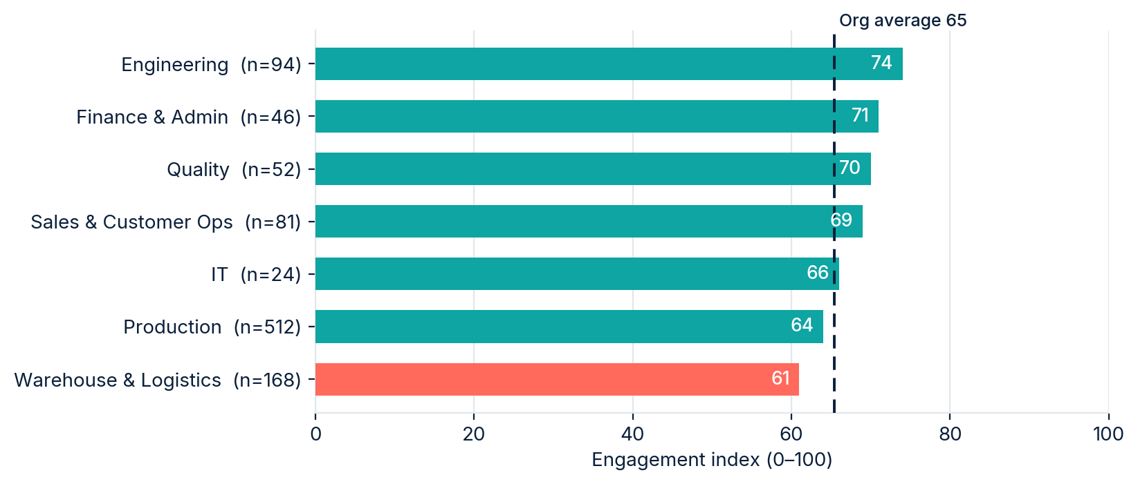
Fig. 1. Engagement index by unit vs. organization average (weighted, n=987)

4.2 · Willingness to recommend: eNPS −3, dragged by the frontline (NPS)
Employee Net Promoter Score is % promoters (9–10) minus % detractors (0–6) on the 0–10 recommendation scale. The organization scores −3: for every promoter there is slightly more than one detractor.
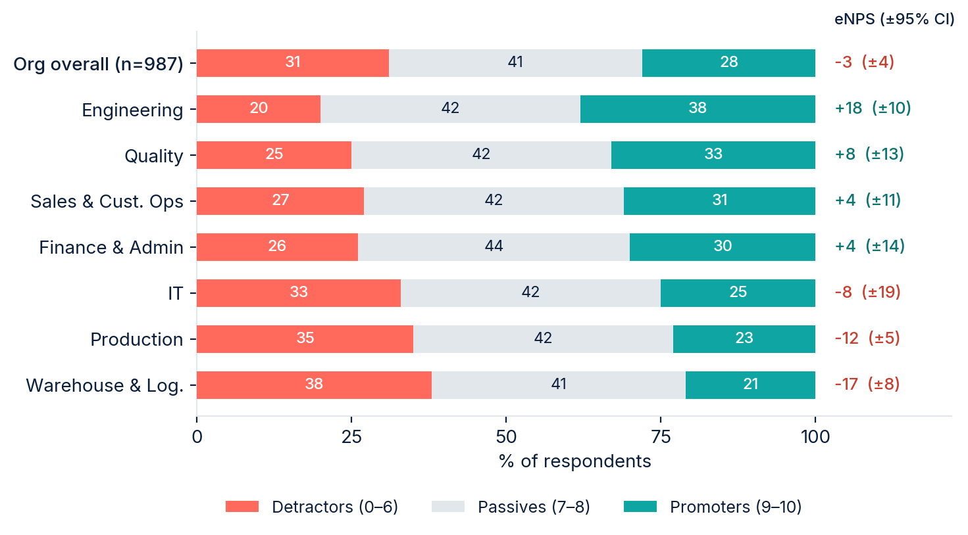
Fig. 2. Promoter / passive / detractor shares and eNPS by unit (weighted)
Two disclosures we make in every report. First, the mean score (6.4) is reported only as a secondary statistic — the mean and the index can move in opposite directions (detractors softening from 2 to 5 raises the mean and leaves eNPS unchanged), and any divergence is explained, not hidden. Second, small segments produce unstable eNPS: a 24-person unit moves ±8 points on one changed answer, which is why every segment score carries a confidence interval.

4.3 · What matters vs. what we deliver: the gap map (GAP)
Each of 18 working conditions was rated twice — importance when choosing an employer, and satisfaction in the current role (7-point scales; “not applicable” available on satisfaction and excluded from means). Plotting the two against each other separates what to fix from what to protect. Quadrant boundaries are the within-survey medians, not scale midpoints — this is disclosed because it affects interpretation: quadrants describe relative position in this workforce, this wave.
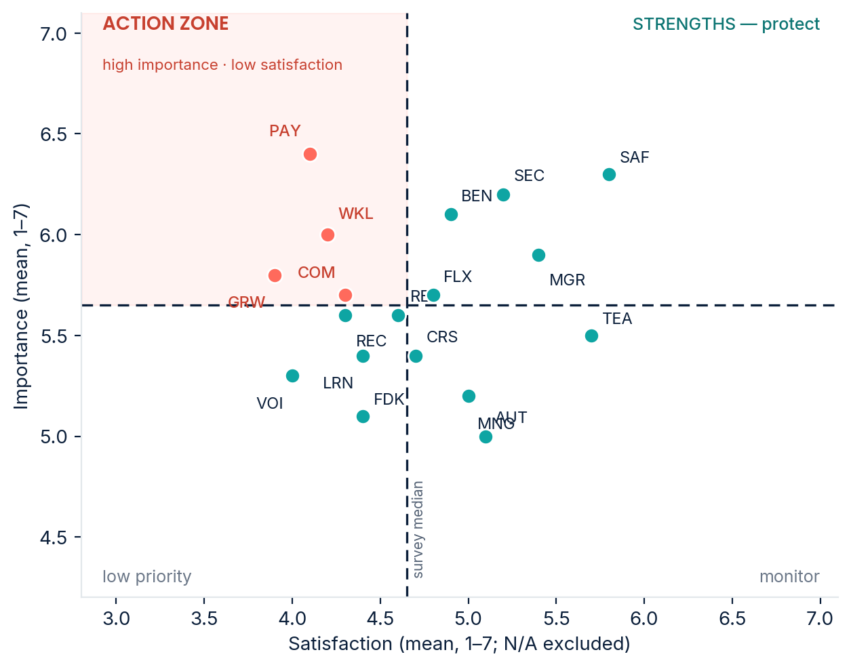
Fig. 3. Importance × satisfaction, 18 conditions (weighted means; codes in Appendix A)
Four conditions land in the action zone: pay fairness (PAY), sustainable workload (WKL), career growth (GRW), and communication & information (COM). Voice & participation (VOI) and recognition (REC) sit just outside it with below-median satisfaction. Team relationships (TEA), workplace safety (SAF), and the manager relationship (MGR) are strengths — the recommendation section treats them as assets to protect, not targets for new spending.
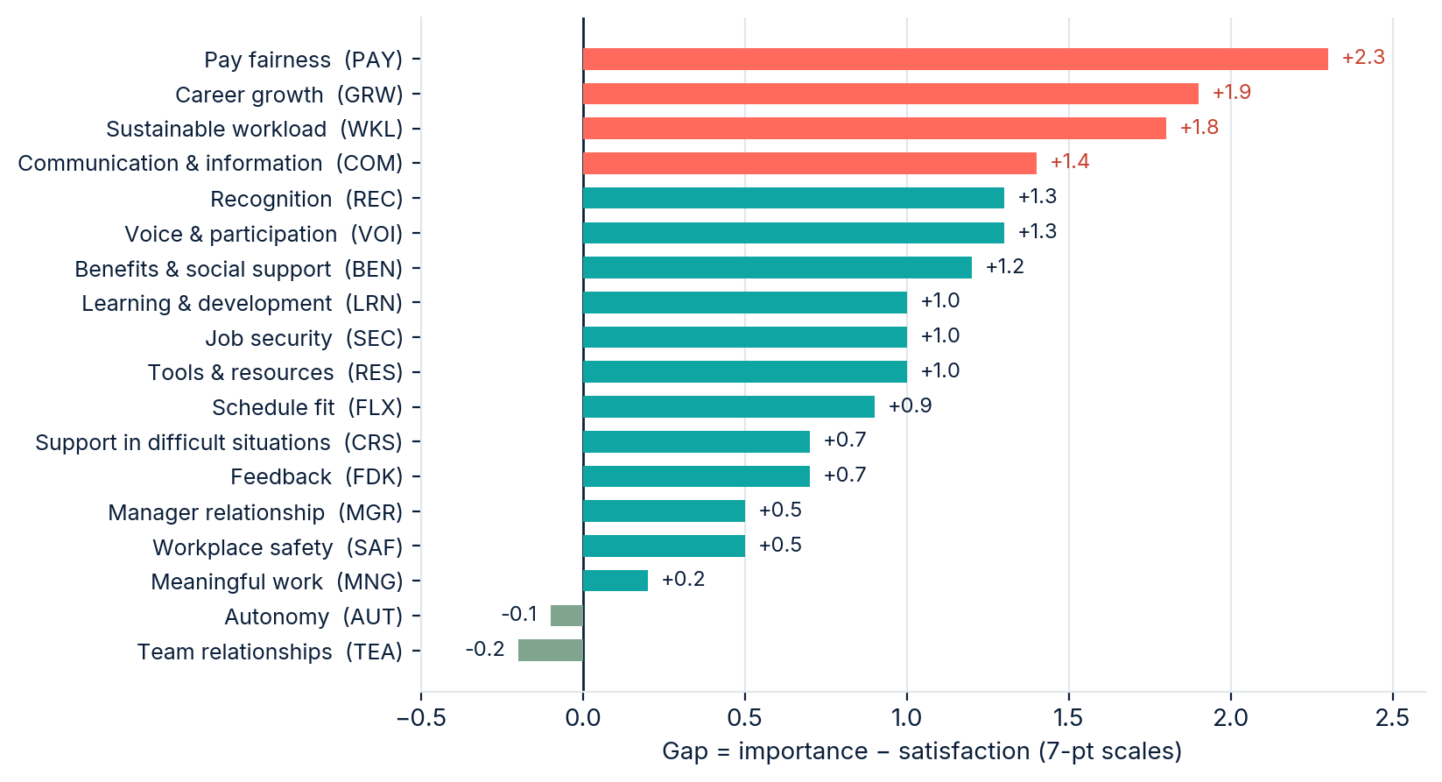
Fig. 4. Gap score (importance − satisfaction), ranked; gaps ≥ 1.3 highlighted
Coverage note: 8% of respondents selected “not applicable” on the benefits satisfaction item (mostly employees under 90 days, not yet benefits-eligible) and 3% on learning & development. These responses are excluded from the means above and reported here rather than recoded to the midpoint.

4.4 · Burnout risk: demand-driven, concentrated mid-tenure (BRN)
The burnout module is an organizational risk screen — six items covering exhaustion, recovery, disengagement, and sustainability — reported only at segment level. Respondents are assigned to low / moderate / elevated tiers by pre-set cutpoints on the burnout index (index and cutpoint logic in Appendix A).
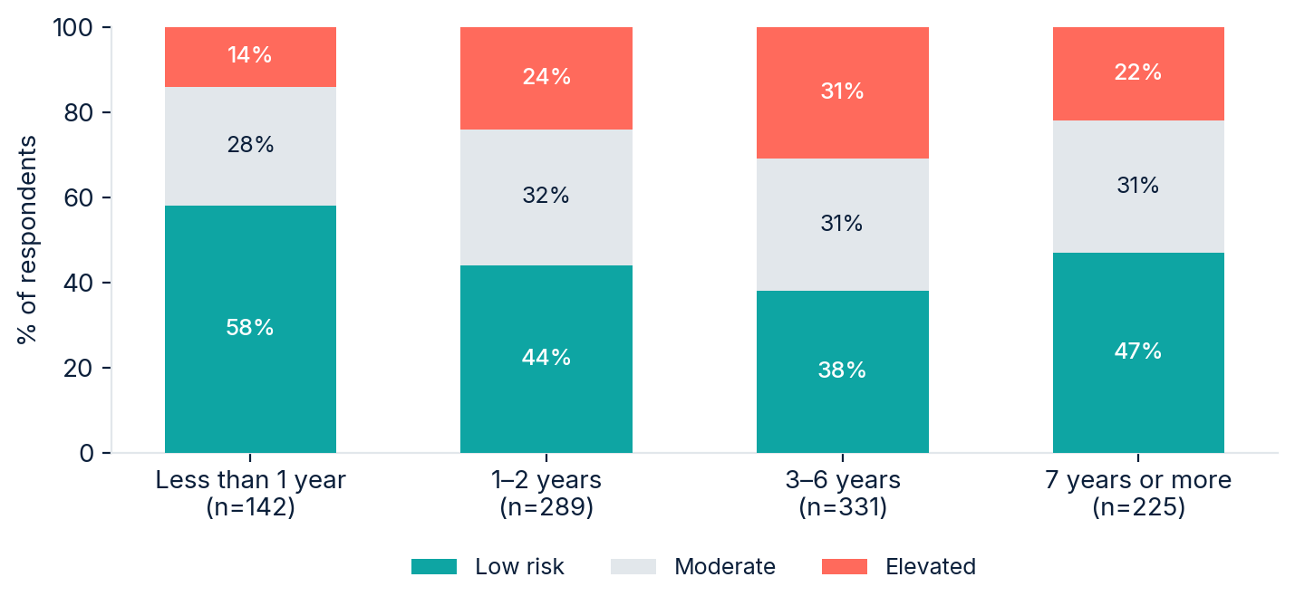
Fig. 5. Burnout risk tiers by tenure band (weighted)
Risk peaks at 3–6 years of tenure (31% elevated), not among newcomers — the employees who carry the most institutional knowledge and are most expensive to replace. By unit, elevated-tier share ranges from 12% (Finance & Admin) to 29% (Production); the night-shift Quality cell (n=4) is n/a (below reporting threshold).
The screen separates two mechanisms: demand (energy depletion, unsustainable workload) and recovery (whether normal rest restores capacity). Units in the lower-right of Fig. 6 need structural workload intervention; resilience or wellness programming does not fix a staffing-model problem.
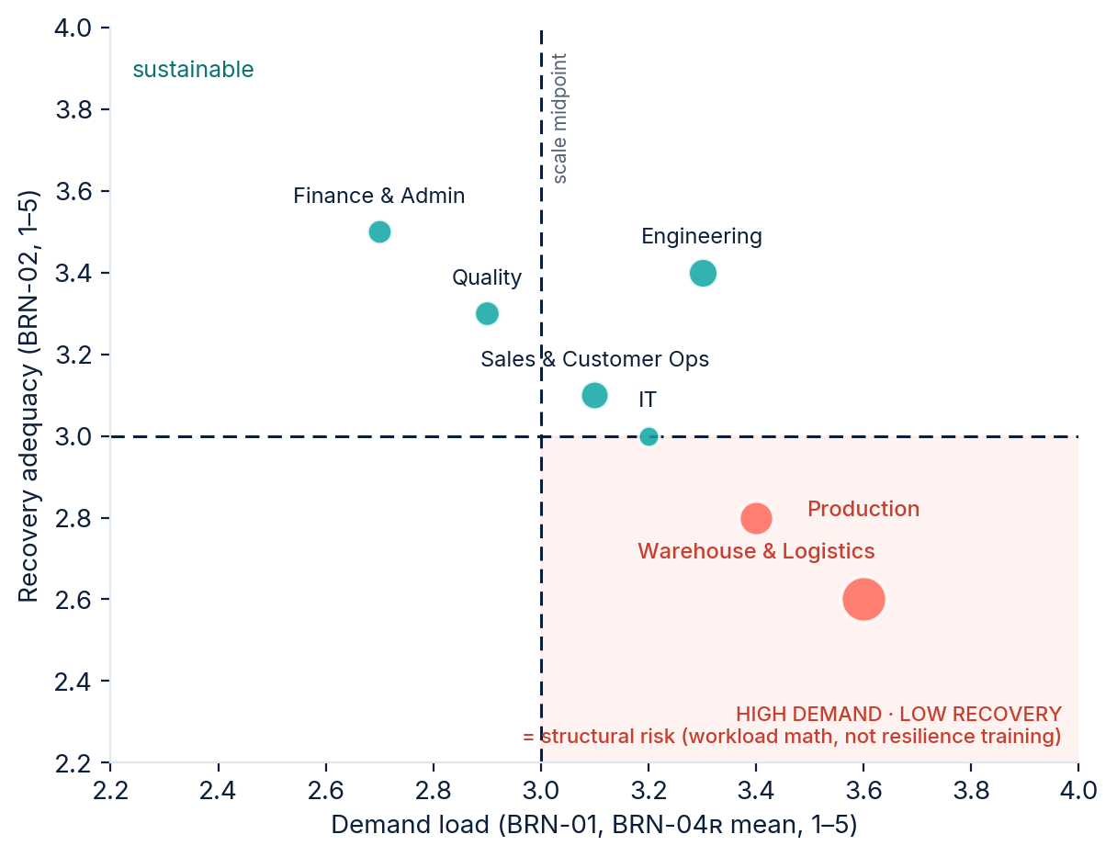
Fig. 6. Demand load vs. recovery adequacy by unit (bubble size = n)

4.5 · What employees say in their own words (OPEN)
Three open-ended items were coded thematically by two coders with adjudication (94% initial agreement). Themes are cross-tabulated by promoter class — what detractors want changed, and what promoters insist must not change:
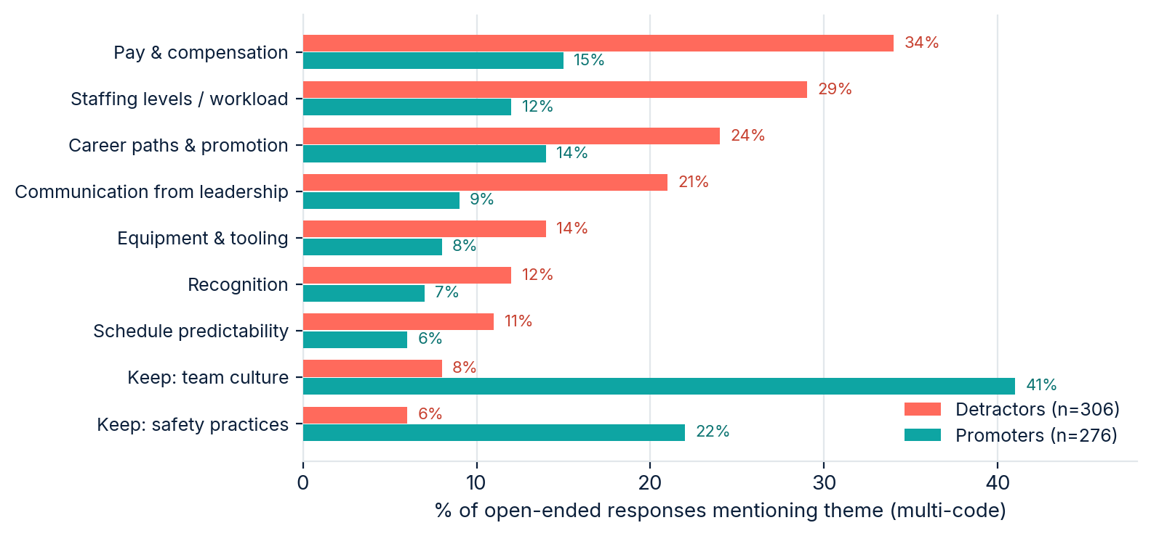
Fig. 7. Theme frequency among detractors vs. promoters (multi-code; “keep” themes from OPN-02)
Two paraphrased responses illustrate the dominant pair of themes (paraphrased to protect anonymity; role metadata shown only where the cell exceeds the reporting threshold):
From the open-ended responses (paraphrased, synthetic)
“We keep being asked to cover extra shifts because positions stay unfilled — the overtime pay is fine, the pace is not.” — Production, 3–6 yrs
“Whatever changes, don’t break the crews. The team is why people stay as long as they do.” — Warehouse & Logistics, 7+ yrs

05 Driver analysis: what actually predicts staying
This section is the differentiator of the report. The descriptive sections describe the workforce; this section models it. Three pre-registered models share one canonical predictor set: the headline model on intent to stay (STY-01, “I expect to still be working at this organization twelve months from now”) — the only model reported as a ranked priority list; the divergence model on “seriously considered leaving” (STY-02) — reported as a contrast exhibit and in prose; and the validation model on overall satisfaction (SAT-00) — a robustness check, never reported as a ranking.

The stay/leave landscape
Before any modelling, respondents are classified directly on the two retention items, using a pre-registered top-2-box rule held fixed across waves: “expects to stay” = Agree / Strongly agree on STY-01; “considered leaving” = Agree / Strongly agree on STY-02.
 | Did not consider leaving | Considered leaving
Expects to stay | Settled — 57% | Reluctant stayers — 15%
Does not expect to stay | Uncertain — 21% | Leaving — 7%
Fig. 8. Stay/leave typology (STAY_TYPE), weighted shares (n=987) · illustrative, synthetic data
The midpoint (“neither agree nor disagree”) is a real position, not a rounding error, and is reported separately for both items rather than collapsed into the negative side: 17% on the expect-to-stay item, 11% on the considered-leaving item. 1.6% of respondents answered fewer than both items and are excluded from the typology.
The cell to watch is the reluctant stayers. 15% of the workforce sits inside the healthy headline statistic — they answered “yes, I’ll be here in a year” — while having seriously considered leaving within the past six months. The cell is concentrated in Production and the 3–6-year tenure band, the same locus the burnout section flags: staying because of constraints, not because conditions are good, and gone the moment the constraint lifts. A conventional engagement report never surfaces this group.
The analysis proceeds in two disclosed steps. First, transparent bivariate rank correlations between each condition and intent to stay — readable by any stakeholder. Second, because the predictors are intercorrelated (pay fairness correlates with recognition; workload with schedule fit), raw correlations over-credit redundant drivers. A Shapley-value decomposition allocates the model’s explained variance fairly across correlated predictors.
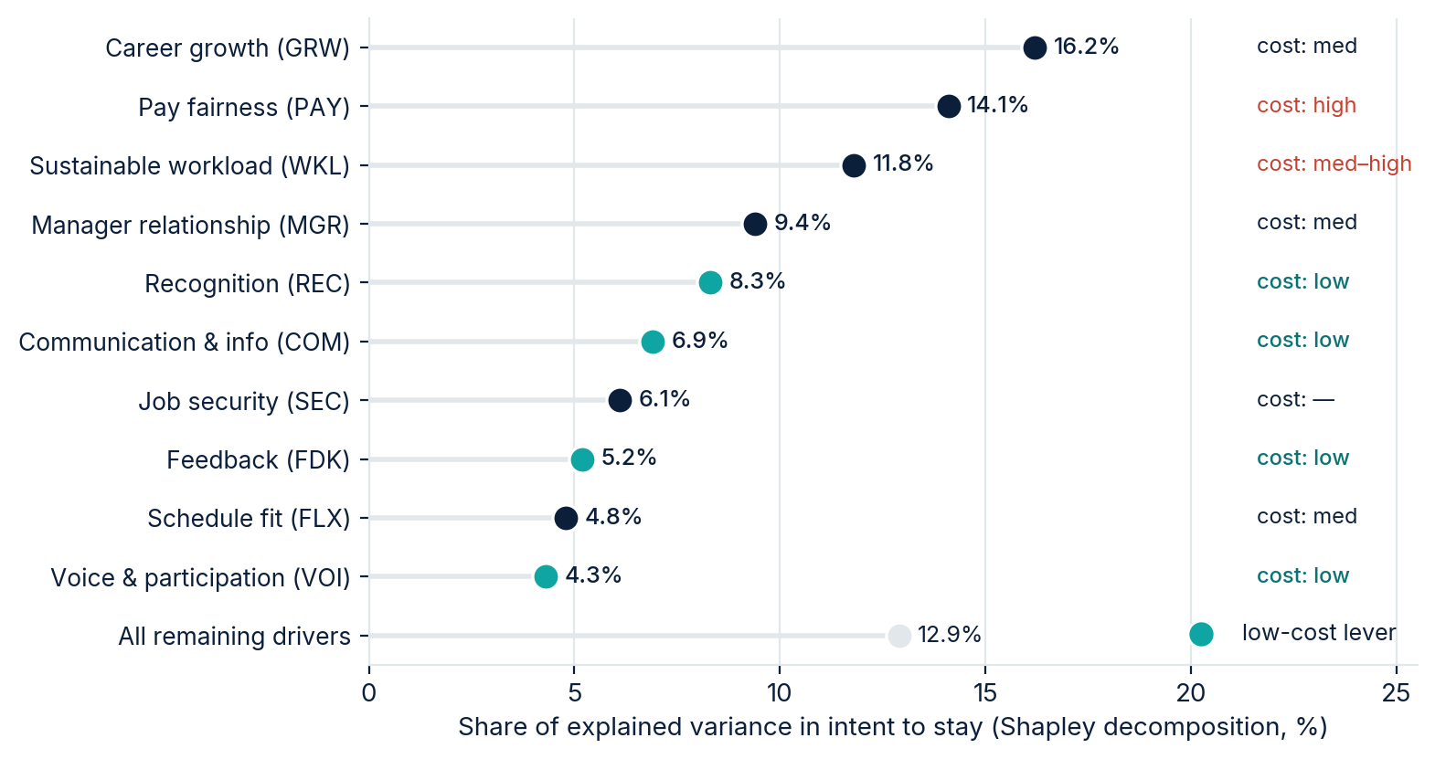
Fig. 9. Share of explained variance in intent to stay, with cost-to-address tags (model R² = 0.47)
Significance ≠ importance
At census scale (n=987), nearly every correlation is statistically significant — significance is a function of sample size, not practical relevance. This report therefore ranks drivers by effect size and never presents unadjusted significance matrices in client-facing sections; the full matrix, with a multiple-comparison note, lives in Appendix D.

Stated vs. derived importance disagree — and the disagreement is the finding. Asked directly, employees rank pay, safety, and job security highest. Modeled against actual intent to stay, career growth moves from 7th to 1st, and job security falls from 3rd to 7th — security matters enormously in the abstract but does not differentiate stayers from leavers at Northgate, where layoffs are not a live fear. Both rankings are shown because the divergence is informative, not an error:
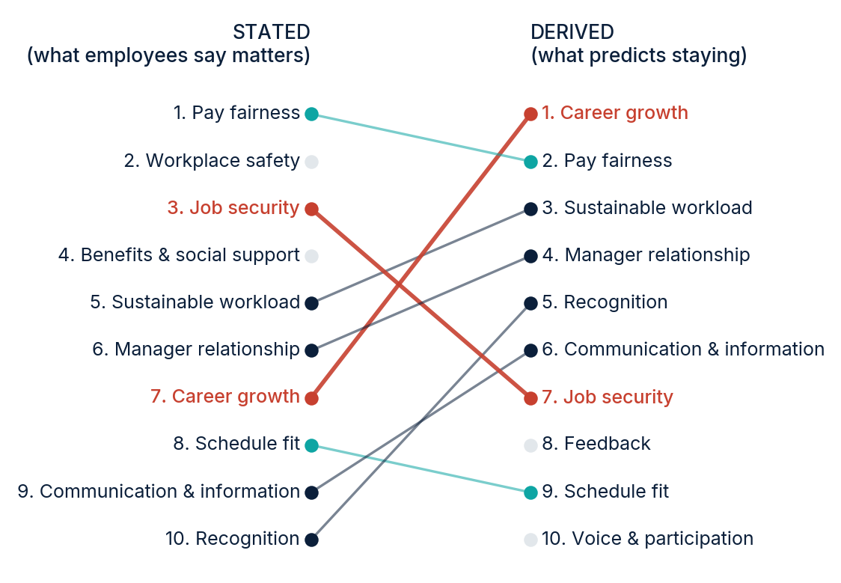
Fig. 10. Stated importance rank vs. model-derived driver rank (top 10)

Divergence check: pressure to leave vs. expectation to stay
A second model over the same 20 predictors takes “In the past six months, I have seriously considered leaving” (STY-02) as its criterion. The two criteria measure different things: considered-leaving is a retrospective emotional event driven by push factors (manager, workload, recognition, burnout); expect-to-stay is a forecast bounded by external constraints (labour market, alternatives). A condition that weighs heavily on considered-leaving but lightly on expect-to-stay reads as a source of quiet disengagement rather than imminent turnover — actionable, and invisible in a conventional report.
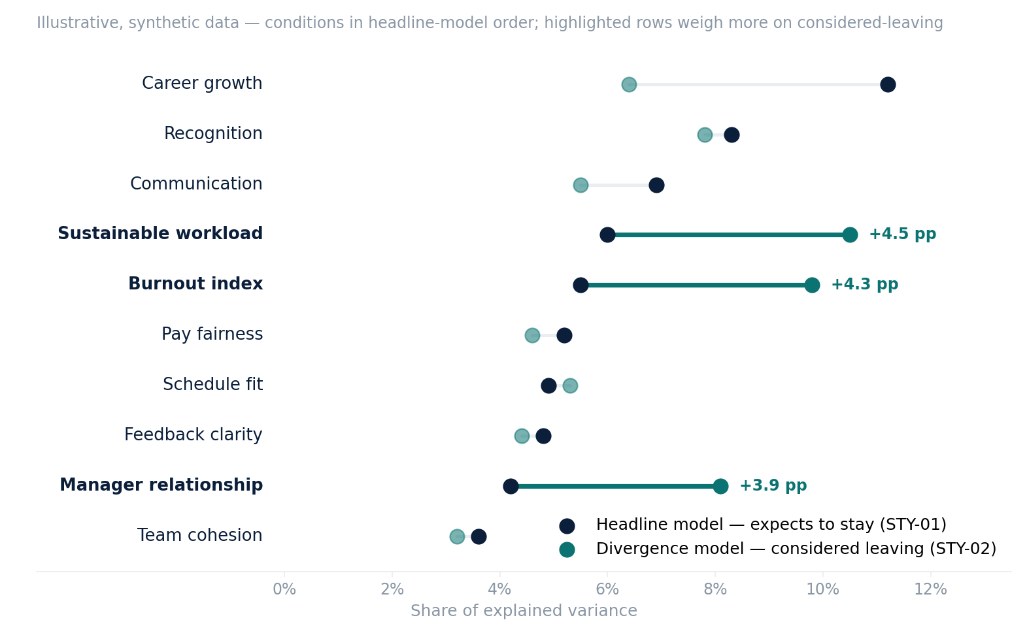
Fig. 11. Driver divergence: share of explained variance under STY-02 vs. STY-01, per condition (divergence model R² = 0.41)
The reading — in prose, because the priority list stays on STY-01. Three conditions carry markedly more weight on considered-leaving than on expecting to stay: sustainable workload (10.5% vs. 6.0% of explained variance), the burnout index (9.8% vs. 5.5%), and the manager relationship (8.1% vs. 4.2%). These are quiet-disengagement sources: they push people toward the door without yet changing their forecast of staying, and they sit in the same units the burnout mechanism split (Fig. 6) already flags. Career growth shows the opposite pattern (6.4% vs. 11.2%) — it anchors the forecast of staying more than it triggers thoughts of leaving. No action is re-prioritized on this model alone; it sharpens where the Now-tier levers land first.
The retention-leverage reading: recognition, communication, and feedback jointly account for roughly 20% of explained variance and are the cheapest levers on the board — process and management-practice changes, not budget lines. Career growth and workload are structural and mid-cost. Pay is a real driver but the most expensive lever per point; it warrants a targeted equity study, not an across-the-board adjustment on this evidence.

06 Recommended actions
Sequenced by retention leverage — driver strength weighed against cost-to-address — using the driver model (Fig. 9), the gap map (Fig. 3), and the burnout mechanism split (Fig. 6). Each action names its evidence.

Now — low-cost levers (this quarter)
- Stand up a structured recognition practice in Production and Warehouse (REC: 8.3% of driver variance, largest low-cost lever; detractor theme #6). Manager-led, specific, weekly cadence — not an awards program.
- Fix the leadership communication rhythm (COM: action-zone gap −1.4; 6.9% of variance; detractor theme #4). Monthly all-hands with a standing “what changed and why” segment; shift-start briefings on the floor.
- Make evaluation criteria explicit (FDK: 5.2% of variance). Every employee should be able to answer “how is my work judged and what would improve it.”

Next — structural fixes (2–3 quarters)
- Commission the staffing-model review for Production and Warehouse (WKL: action zone, 11.8% of variance; burnout is demand-driven in exactly these units — Fig. 6; staffing is detractor theme #2). Target: reduce sustained overtime dependence, not add resilience training.
- Publish technical career paths (GRW: #1 derived driver at 16.2%; action zone). Dual-ladder design so growth does not require leaving the tools or the site.

Then — evidence before spending (before FY-27 budget close)
- Run a targeted pay-equity and market-benchmark study (PAY: #2 driver, widest gap at −2.3, and the most expensive lever). The census shows pay fairness perception is a problem; it cannot show whether the fix is levels, structure, or transparency. Do not make across-the-board moves on perception data alone.
- Protect the strengths: team cohesion and safety practice are the top “do not change” themes among promoters. Any reorganization of crews should be tested against this finding.

Measurement follow-up
Re-field a 5-minute pulse (CORE-short + eNPS + one open-end) in Q4 2026 against this baseline. Identical wording, comparable fielding window. Movement of ±3 index points at org level is within noise; read direction at unit level.

07 Limitations
- Cross-sectional design: the driver model identifies predictive association at one point in time, not proven causation. The Q4 pulse and Wave 2 census will test whether movement on the levers precedes movement in intent to stay.
- Intent to stay is a proxy for retention. It is the strongest survey-measurable predictor of voluntary turnover, but linkage to actual exit records (a Wave 2 option, subject to the anonymity protocol) would strengthen the model.
- Self-report burnout screen: tiers indicate where organizational intervention should be prioritized; they are not diagnoses and are never reported below segment level.
- Stated importance reflects what employees can and will articulate; derived importance reflects statistical association. Both are shown; neither is treated as ground truth alone.
- Small units (IT n=24, HR n=10) carry wide intervals; their scores are directional. One cell (night-shift Quality, n=4) is suppressed under the reporting threshold.
- First wave: no internal trend exists yet. External benchmarks are not used — cross-vendor benchmark databases differ in items, scales, and populations, and comparisons against them are not defensible. The baseline standard here is internal comparison across units and waves.

A–D Appendices

Appendix A · Instrument provenance and scales (summary)
All items fielded in this study are original Measure & Meaning formulations.
Module | Items | Scale | Index rule (disclosed)
CORE | 6 | 5-pt agreement | Mean of 6, rescaled 0–100
NPS | 1 + open | 0–10 canonical | % promoters − % detractors; mean secondary
GAP | 18 × 2 + SAT-00 | 7-pt verbalized; N/A off-scale on satisfaction | Quadrants at within-survey medians; gap = I − S
BRN | 6 (2 reverse-keyed) | 5-pt agreement | Tiers by pre-set cutpoints on prorated index (≥ 5 of 6 items)
STAY | 3 | 5-pt / categorical | STY-01 headline; STY-02 divergence; STAY_TYPE typology
OPEN | 3 | open text | Dual-coder thematic coding, adjudicated
Why 7-point verbalized scales for the GAP matrix: satisfaction is bipolar — a neutral state is a real position, and forcing a direction manufactures signal; importance is unipolar — the fully labeled midpoint (“moderately important”) is a level, not an escape hatch. An odd scale also yields a stable within-survey median, which defines the quadrant boundaries; on an even scale those boundaries fall between categories and drift between waves. Midpoint share is monitored as a satisficing indicator alongside straightlining.
Burnout index and tier cutpoints (disclosed): the burnout index is the prorated mean of the six burnout items (reverse-keyed items rescored at scoring), multiplied by 6 — computed when at least five of the six items are answered, with a range of 6–30 for every valid case, and rounded to one decimal before tier assignment. Respondents are assigned to Low / Moderate / Elevated tiers by pre-set cutpoints on the index: 6–13 / 14–21 / 22–30. The bands are pre-set — equal thirds of the 6–30 score range — and are not normatively anchored: no external benchmark sample stands behind them. They are held fixed by design so that tiers remain comparable across waves and across organizations; the tiers indicate where organizational intervention should be prioritized and are not clinical diagnoses.

Appendix B · Screening rules (pre-registered)
Speeders: completion < ⅓ of median → flag; sustained < 2 s per item → exclude. Straightliners: zero variance across all 18 ratings within a single GAP column (importance or satisfaction), assessed per column → flag; combined with speeding → exclude. Attention checks: two embedded checks (“For data quality purposes, please select ‘Agree’”); one failure → flag, two → exclude. Shared kiosk devices: identical device signatures acceptable by design; response-time clustering reviewed for proxy completion. Funnel: 1,022 → 987 (3.4% excluded), reported by segment in Exhibit 2.

Appendix C · Weighting
Rim weighting to payroll records on department × tenure band × role level. Category sets mirror HRIS categories by design, which is what makes payroll weighting possible. Trimming bounds 0.4–2.5; realized weight range 0.71–1.58; design effect 1.06; effective n = 931. Unweighted results available in the crosstab workbook.

Appendix D · Statistical notes
Driver models. OLS on standardized predictors. Three pre-registered models share the canonical predictor set — the 18 GAP satisfaction items plus the engagement driver index (IDX_ENG_DRIVER) and the burnout index (IDX_BRN): 20 predictors, with the count computed at render time from the codebook’s machine-readable predictor list, never hard-coded. Headline model — criterion STY-01; R² = 0.47; Shapley decomposition of explained variance across the predictor set (10 shown, remainder pooled); the only model reported as a ranked list. Divergence model — criterion STY-02; R² = 0.41; reported as a contrast exhibit and in prose only (Fig. 11). Validation model — criterion SAT-00; robustness check, never reported as a ranking: overall satisfaction stands in a part-whole relationship with the 18 condition-satisfaction predictors, so its R² is structurally flattered and a ranking built on it would be circular.
Disclosures. (1) ENG-05 (“I can see a future for myself at this organization”) is conceptually adjacent to the criterion STY-01 and is therefore excluded from the engagement index used inside the models (IDX_ENG_DRIVER, five items, never reported as a number); including it would inflate the engagement index’s share of explained variance at the expense of the actionable conditions. The six-item headline index IDX_ENG is unchanged and remains the trend variable. (2) BRN-03 and BRN-05 sit conceptually closer to STY-02 than to STY-01 — not a tautology of the ENG-05 kind, but stated because the divergence model exists.
Full bivariate matrix with Holm-adjusted p-values in the crosstab workbook — omitted from the body per the significance ≠ importance standard. eNPS intervals: Wald 95% on the promoter–detractor difference. Suppression: all cells n < 5, with the complement check.

Measure & Meaning Research · measuremeaning.com · This sample report contains only illustrative, synthetic data and a fictional organization.

