Dashboard & Reports
Insights and Analytics for Your Business
AishaCRM — Version 1.0 — February 2026

1. Overview
AishaCRM gives you real-time visibility into your business performance through dashboards and reports. Dashboards provide at-a-glance metrics; reports let you dig deeper into the data.
Feature | Description
Live Dashboards | Real-time metrics and visual charts that update as data changes
Pre-Built Reports | Standard reports for common business questions, ready to run immediately
Custom Reports | Build your own reports with flexible filters, grouping, and calculations
Export Options | Download reports in Excel, CSV, or PDF format

2. Dashboard — Your Command Center
The dashboard is your home page in AishaCRM. It shows the metrics that matter most in visual charts and summary cards.
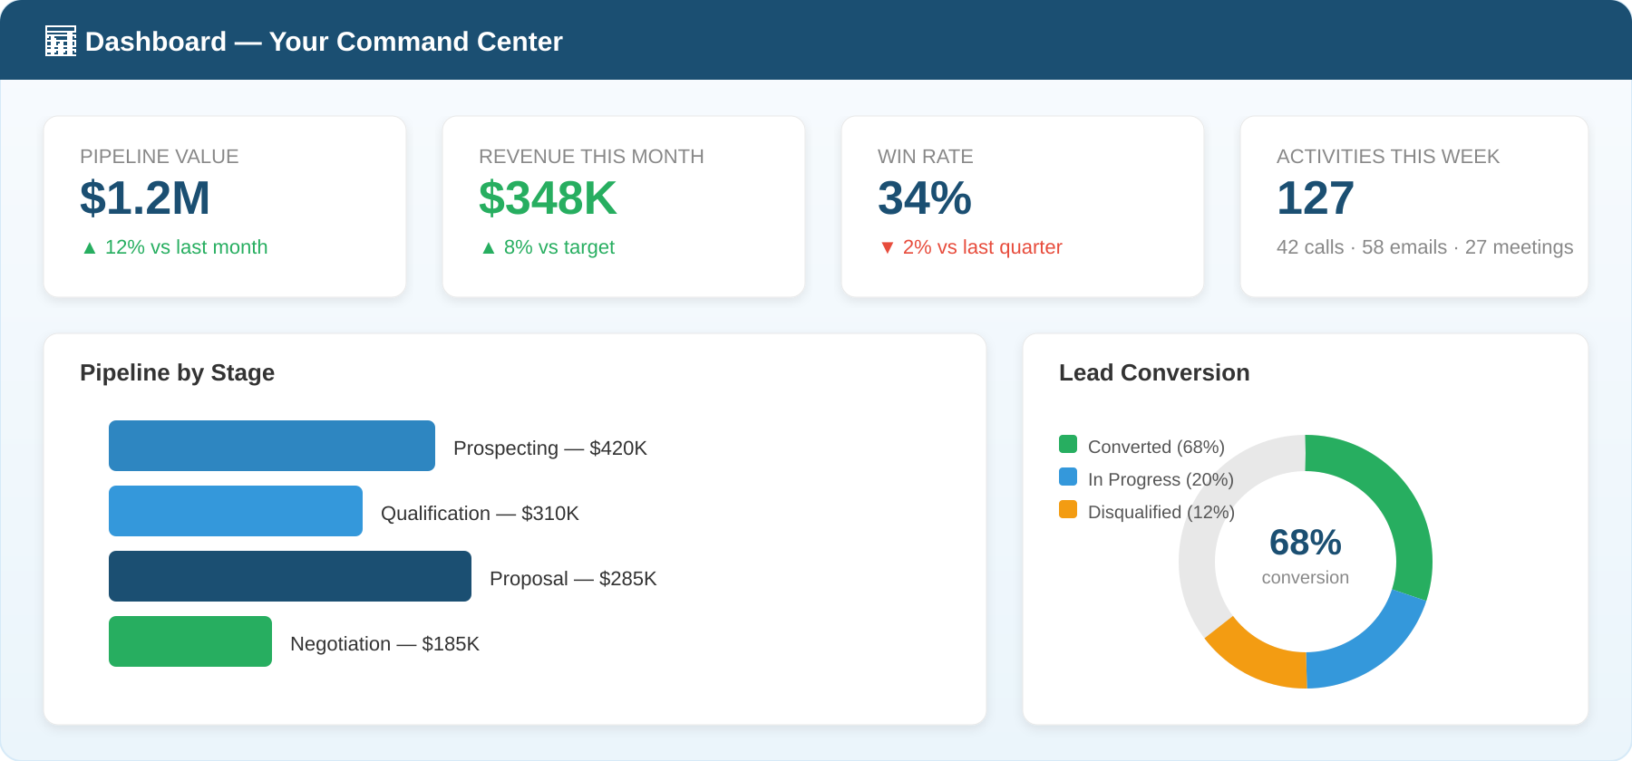

Default Dashboard Widgets
- Pipeline Overview — Total opportunity value broken down by stage
- Revenue This Month — Closed-won deals and revenue for the current month
- Win Rate — Percentage of opportunities that closed successfully
- Activities This Week — Volume of calls, emails, meetings, and tasks logged
- Lead Conversion — Rate at which leads convert to contacts and opportunities

Visibility Applies
Dashboard data respects team visibility settings. A member in hierarchical mode sees only their own metrics. Admins see tenant-wide numbers.

3. Standard Reports
AishaCRM includes pre-built reports for common business questions. These are ready to run immediately.

Lead Reports
Report | What It Shows
Leads by Source | Where your leads come from (web, referral, event, etc.)
Leads by Status | Distribution across pipeline stages (new, contacted, qualified, converted)
Lead Conversion Rate | Percentage of leads that convert to contacts/opportunities over time
Lead Aging | How long leads have been in each stage — highlights stale leads

Opportunity Reports
Report | What It Shows
Pipeline by Stage | Total value and count of opportunities at each stage
Win/Loss Analysis | Win rate trends and reasons for lost deals
Forecast | Projected revenue based on probability-weighted pipeline
Closed Won by Rep | Revenue credited to each sales representative

4. Custom Reports
When standard reports don’t answer your specific question, build a custom report with complete flexibility.
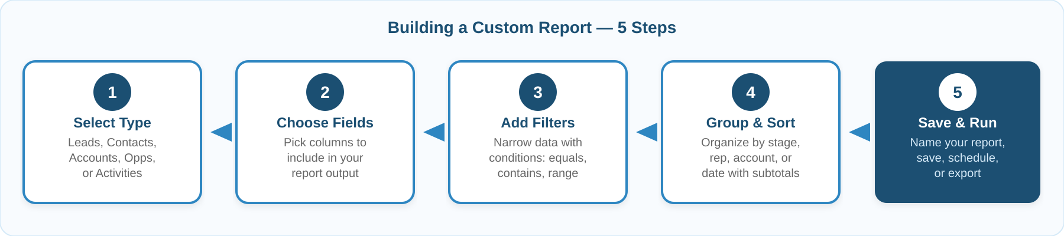

Creating a Custom Report
- Navigate to Reports and click "New Custom Report."
- Select the primary record type (leads, contacts, accounts, opportunities, or activities).
- Choose the fields to include as columns.
- Add filters to narrow the data.
- Configure grouping and sorting, then save.

Save and Share
Custom reports can be saved and shared with your team. Saved reports appear in the Reports list for quick access.

5. Report Filters and Grouping
Filters narrow your data to specific criteria. Grouping organizes records into categories and calculates subtotals.

Filter Operators
Operator | Use Case
Equals | Exact match — "Stage equals Proposal"
Contains | Partial text match — "Company contains Tech"
Greater / Less Than | Numeric comparison — "Amount greater than $50,000"
Between | Date or numeric range — "Close date between Jan 1 and Mar 31"
Is Empty / Not Empty | Check for missing data — "Email is not empty"

6. Exporting Data
Every report can be exported for use outside AishaCRM. Choose the format that matches your use case.
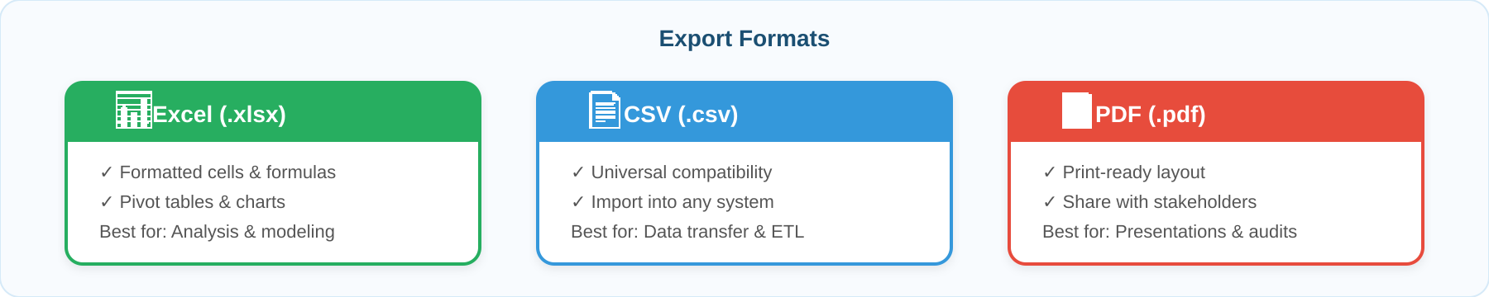
Format | Best For | Notes
Excel (.xlsx) | Analysis, pivot tables, charts | Preserves formatting and formulas
CSV (.csv) | Import into other systems | Plain text, universally compatible
PDF (.pdf) | Printing, sharing with stakeholders | Read-only, maintains layout

7. Scheduled Reports
Schedule reports to run automatically and email results to your team. Perfect for weekly pipeline reviews or monthly executive summaries.
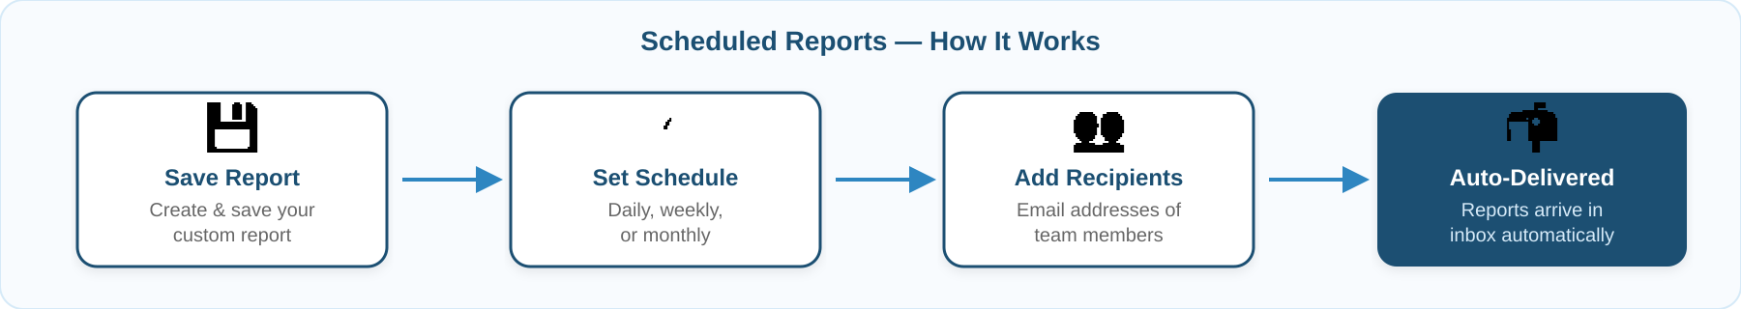

Setting Up
- Open any saved report and click "Schedule."
- Choose frequency: daily, weekly, or monthly.
- Add recipient email addresses.
- Select the export format (Excel, CSV, or PDF).
- Save the schedule.

Timezone Aware
Scheduled reports run based on your tenant’s configured timezone, so "weekly on Monday" means Monday morning in your timezone.

8. Frequently Asked Questions
Q: Do dashboards update in real time?
Yes. Dashboard widgets refresh automatically as data changes. There may be a brief cache delay of up to 30 seconds for heavy queries.
Q: Can I create a report combining multiple record types?
Custom reports can include related fields across record types through relationships. For example, an opportunity report can include account fields and contact fields.
Q: Do reports respect team visibility settings?
Yes. Reports show only data you have permission to see based on your CRM account role and team membership. Admin users see complete data in all reports.
Q: Can I share a report with someone outside the CRM?
Export the report as PDF or Excel and share the file. There is no direct link sharing for external users.

