# Franklin overview and Gatsby comparison

## 

| Embed | |
| --- | --- |
| <https://www.figma.com/embed?embed_host=share&url=https%3A%2F%2Fwww.figma.com%2Ffile%2FvqFykwyAfCKeFrS0U5EAl1%2FUntitled%3Ftype%3Ddesign%26node-id%3D0%253A1%26mode%3Ddev> | |

## Overview

| Columns | |
| --- | --- |
| Adobe Franklin  * Easy setup * Low code* * Fast * Uses Google Docs/Sheets as CMS with integrated browser extension for preview and deploy | Gatsby  * A bit more setup * Needs code to be written * Fast(not the build tho) * Uses anything as a data source, including google docs and sheets using extensions * A bit more complicated to preview and deploy |

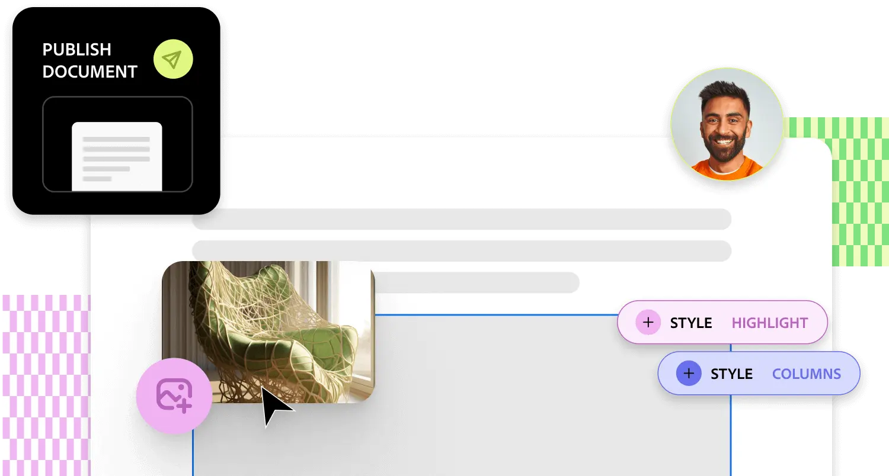

## Where it shines 🌟

### Easy to use CMS 🧠

**Content-driven sites**, such as blogs or documentation pages that have a simpler structure and do not use a lot of custom elements. These can be easily written in Google docs(if not already in that format) and easily ingested in the site. Basically **no learning curve for content creators**, unlike for example markdown or Contentful.

**Auto generates a development and a production website with a public domain**.

The browser extension also integrates with google docs and the above mentioned site and allows **easy** preview and publish

### Blocks 🧱

Out of the box way to structure content and create custom components using tables that enhance the content you can add. Decent library of pre-existing components + the possibility to create more.

### Forms 📃

Easy to create forms based on a Google Sheet with the structure of the form and easy to embed in the site.

## Can Franklin's selling points be reproduced in Gatsby or it’s too much Adobe magic? 🪄🤔

Let’s take the main ones one by one

### Using Google Docs/Sheets as CMS

Can be replicated using [gatsby-source-google-docs](https://www.gatsbyjs.com/plugins/gatsby-source-google-docs/) and [gatsby-source-google-sheets](https://www.gatsbyjs.com/plugins/gatsby-source-google-sheets/) + [gatsby-transformer-remark](https://www.gatsbyjs.com/plugins/gatsby-transformer-remark/?=gatsby-transformer-remark)(generating the HTML AST) + [rehype-react](https://github.com/rehypejs/rehype-react) (mapping react components to the HTML AST)  
  
Also Gatsby supports many other Data Sources and transformer plugins and also custom ones

### Blocks

Block functionality is quite easy to recreate in Gatsby. Map the table to a custom React component that checks the header for a custom component and use the rows to render the custom components

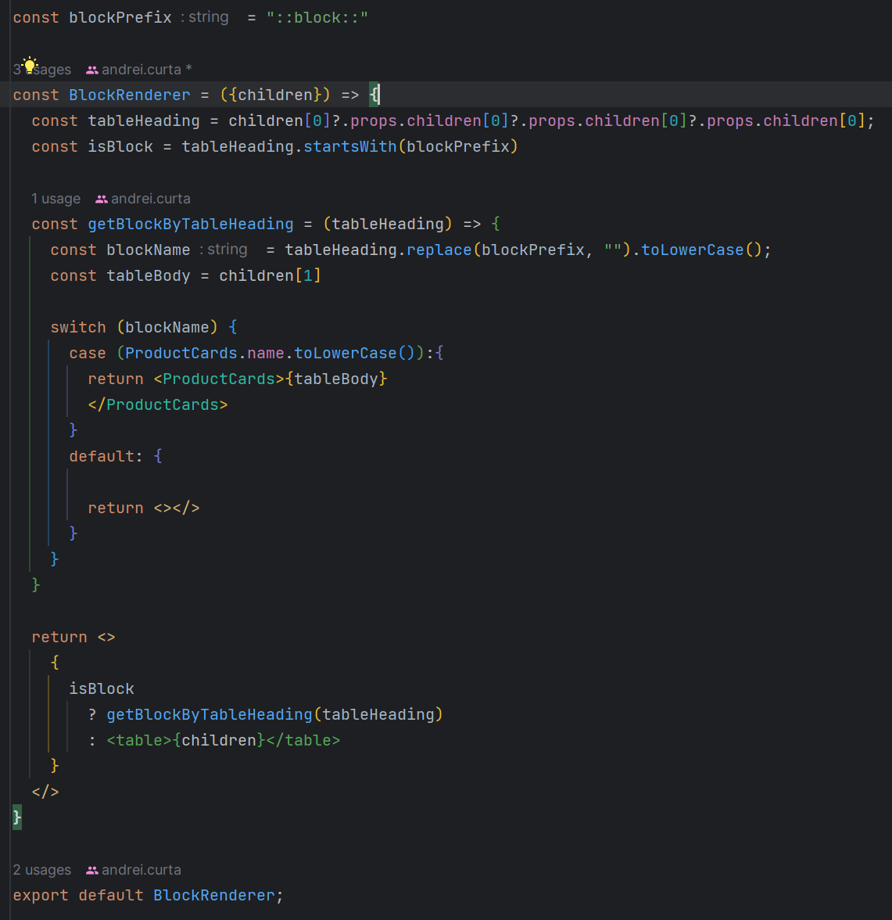

### 

### The extension + preview environment + publish

Can be replicated with another way of triggering some pipelines, but it is much more easy to use for the non technical users

**Previewing the site is very fast** ⏱️, unlike gatsby that needs a rebuild

### Forms

Dynamic forms easy to set up, I’ll give this one to Franklin

### Fast out of the box

AEM Franklin is that pages are extremely fast and well optimized with a [Lighthouse](https://developer.chrome.com/docs/lighthouse/overview/) score of 99 or 100

## 

## What we did not like from a developer perspective

The way you customize elements in order to create blocks relies on javascript to select and manipulate the html that is generated from the docs or by targeting elements using css. Not a nice experience at all. Also it’s hard to structure the data so that is’s easy to retrieve for the components

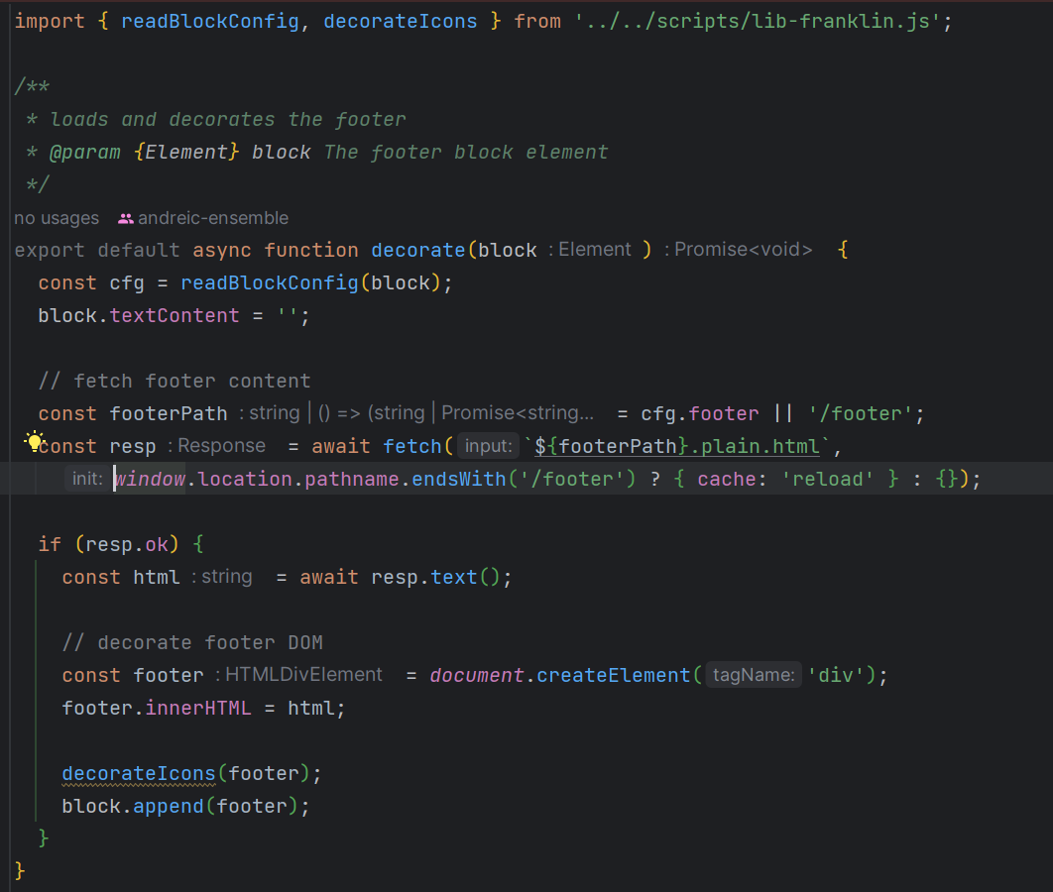

It does not follow the structure and the way of working we are used to in frameworks like React

| Metadata | |
| --- | --- |
| Title | Franklin vs Gatsby |
| Description | Franklin overview and Gatsby comparison |

|  | |
| --- | --- |
|  |  |
|  |  |