FACULTY OF AUTOMATION AND COMPUTER SCIENCE

COMPUTER SCIENCE DEPARTMENT

DISTRIBUTED SYSTEMS

Assignment 2

Request-Reply

Communication Paradigm

Online Energy Utility Platform

Clotan Andrei

Diagrama conceptuala

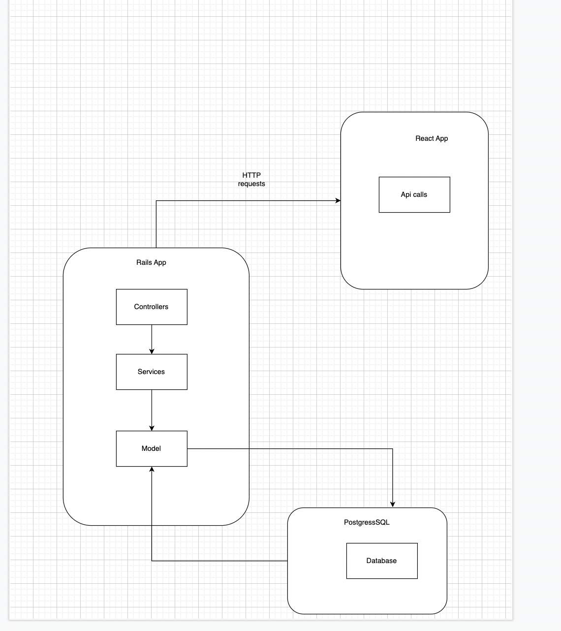

Diagrama bazei de date

* Bundle install
* Rails db:create
* Rails db:migrate

Diagrama de deployment

