FACULTY OF AUTOMATION AND COMPUTER SCIENCE

COMPUTER SCIENCE DEPARTMENT

DISTRIBUTED SYSTEMS

Assignment 3

Chat System for Client Support

Online Energy Utility Platform

Clotan Andrei

Diagrama conceptuala

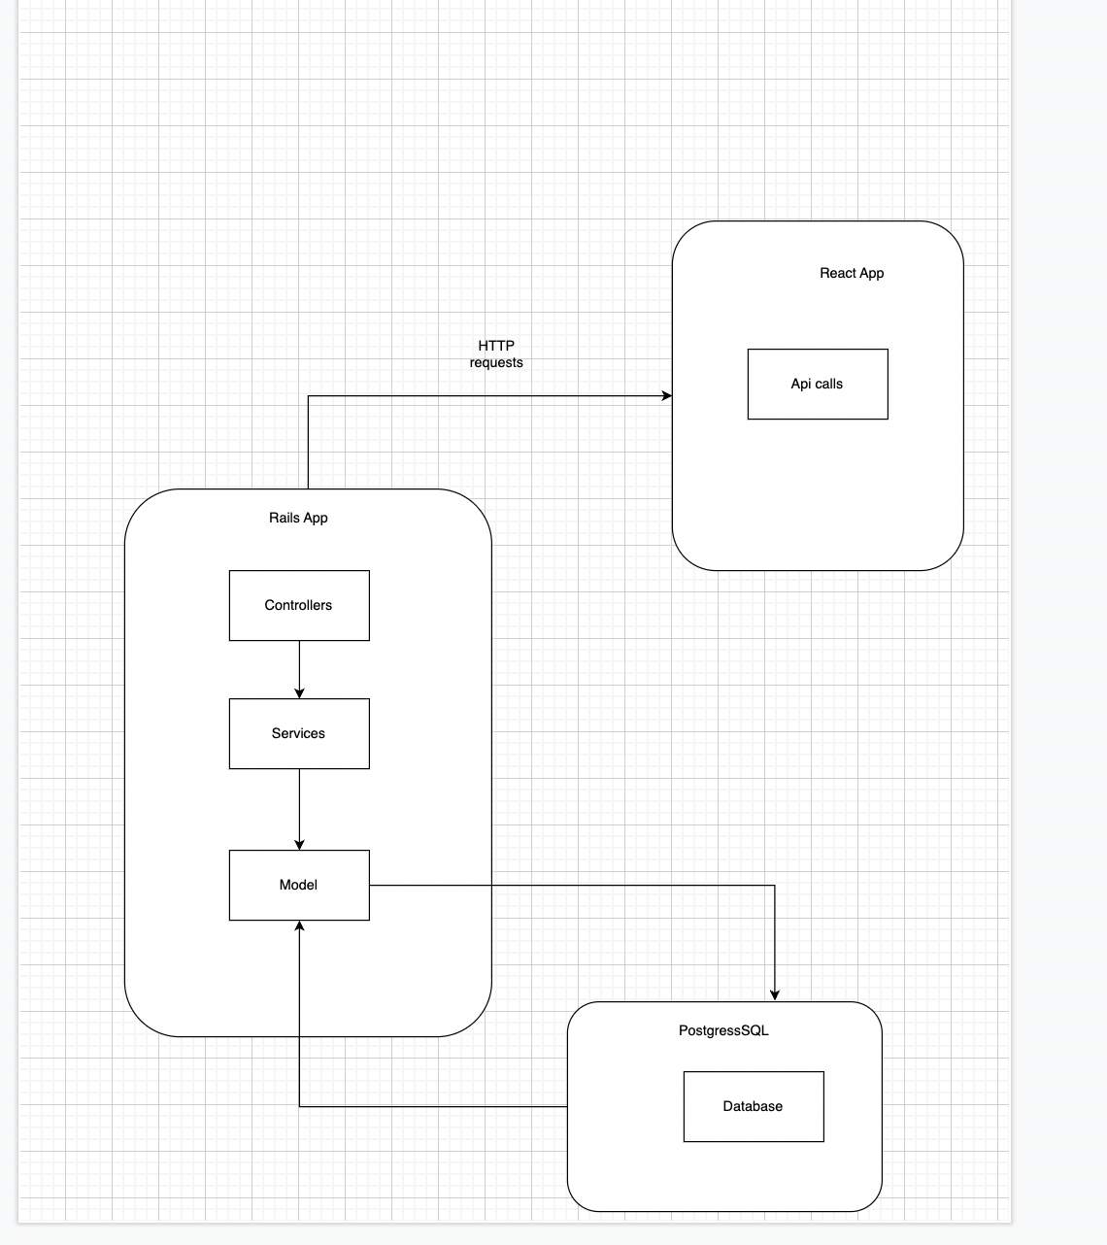

Diagrama bazei de date

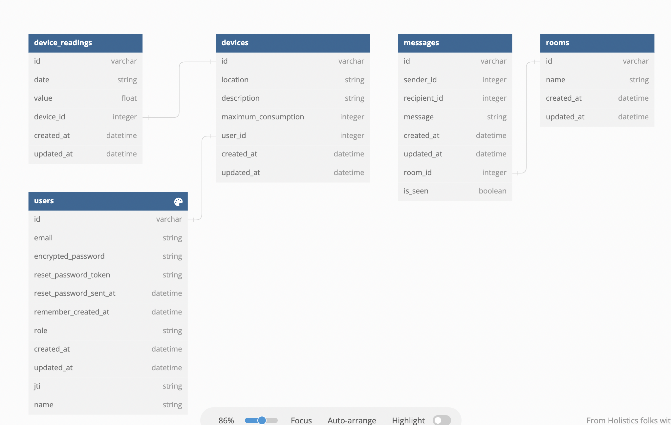

* Bundle install
* Rails db:create
* Rails db:migrate

Diagrama de deployment

