Name: Andrei Cruceru

Student ID: 21807459

Course Details: Data Science, year1

Module: Web Development CO556 20S1

Contents

References 18

Website Design

1. Index.html

Desktop layout:

Mobile layout:

1. About.html

Desktop layout:

Mobile layout:

1. What-is.html

Desktop layout:

Mobile layout:

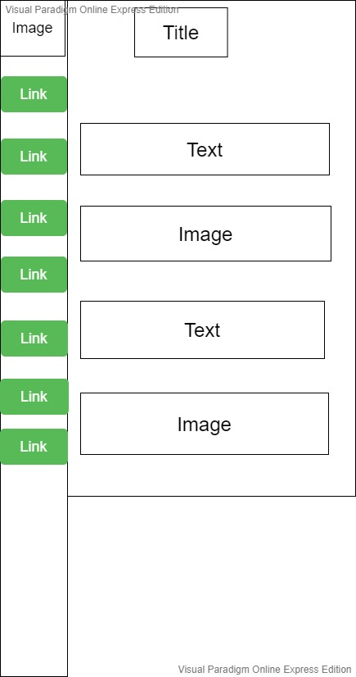

1. Visit-places.html

Desktop layout:

Mobile layout:

1. Zuul Game.html

Desktop layout:

Mobile layout:

1. Review.html

Desktop layout:

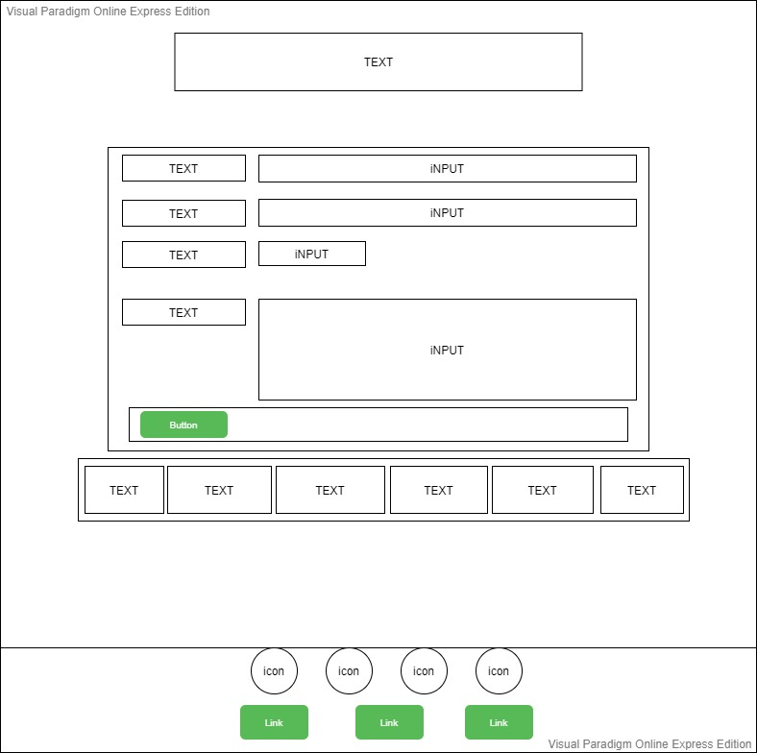

Mobile layout:

1. Contact.html

Desktop layout:

Mobile layout:

Target

Wireframe and Hierarchy

Links

Evaluation

The icon used were from (Font Awesome, 2020).

Images used are from (Unsplash, 2020) and (Shutterstock, 2020).

# References

Font Awesome, 2020. *Icons Gallery.* [Online]   
Available at: https://fontawesome.com/icons?d=gallery  
[Accessed 27 October 2020].

Shutterstock, 2020. *Photos.* [Online]   
Available at: https://www.shutterstock.com/photos  
[Accessed 5 November 2020].

Unsplash, 2020. *photos.* [Online]   
Available at: https://unsplash.com/  
[Accessed 3 November 2020].