***Finite Automata***

**Gabor Petru-Andrei**

**933/2**

Github: https://github.com/andreigabor21/Formal-Languages-and-Compiler-Design/tree/master/Labs/FiniteAutomata

**Finite Automata(FA)** is the simplest machine to recognize patterns. The finite automata or finite state machine is an abstract machine that has five elements or tuples. It has a set of states and rules for moving from one state to another but it depends upon the applied input symbol. Basically, it is an abstract model of a digital computer. The following figure shows some essential features of general automation.

Class Diagram

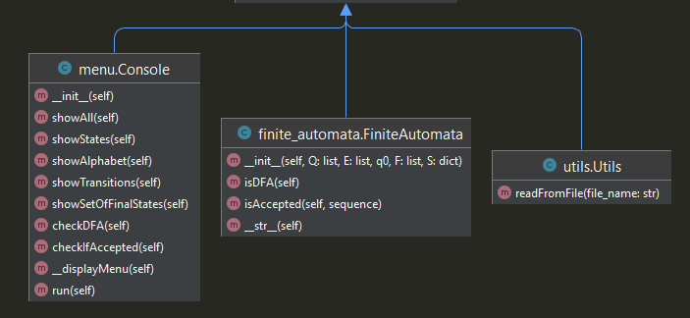

Checking that the Finite Automata is Deterministic is done by going through all the keys, and looking if there is any list with a length greater than one.

For example, the next representaion is Deterministic:

Q = A B C  
E = 0 1  
q0 = A  
F = A C  
S =  
 (A,0) => A  
 (A,1) => C  
 (B,0) => B  
 (C,1) => B

Checking that a sequence is accepted by the Finite Automata is done by going through each symbol from the given sequence and checking that the respective point can be reached in the corresponding graph.