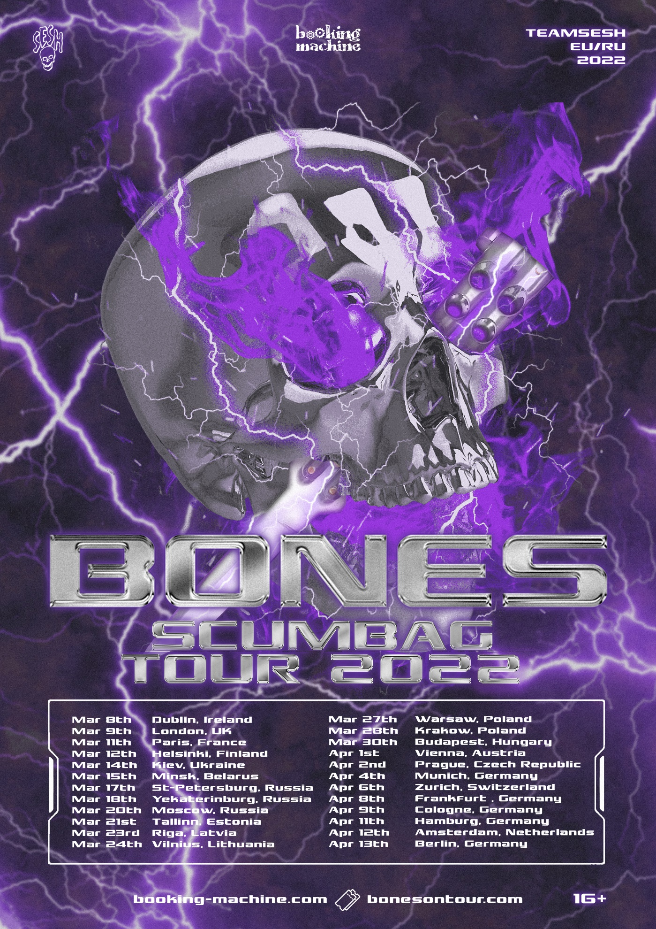

**DUBLIN @VOODOO LOUNGE**

*08 Mar 2022*

**LONDON @O2 ISLINGTON ACADEMY**  
*09 Mar 2022*

**PARIS @CABARET SAUVAGE**  
*11 Mar 2022*

**HELSINKI @TELAKKA**

*12 Mar 2022*

**KYIV @ATLAS**

*14 Mar 2022*

**MINSK @RE:PUBLIC**

*15 Mar 2022*

**SAINT-P @А2 GREEN CONCERT**

*17 Mar 2022*

**YEKATERINBURG @TELECLUB**  
*18 Mar 2022*

**MOSCOW @ADRENALINE STADIUM**

*20 Mar 2022*

**TALLINN @CATHOUSE**  
*21 Mar 2022*

**RIGA @PALLADIUM**  
*23 Mar 2022*

**VILNIUS @LOFTAS**

*24 Mar 2022*

**WARSAW @PROGRESJA**

*27 Mar 2022*

**KRAKOW @KWADRAT**

*28 Mar 2022*

**BUDAPEST @DÜRER KERT**

*30 Mar 2022*

**VIENNA @SIMM CITY**

*01 Apr 2022*

**PRAGUE @FORUM KARLÍN**

*02 Apr 2022*

**MUNICH @BACKSTAGE**

*04 Apr 2022*

**ZURICH @MASCOTTE**

*06 Apr 2022*

**FRANKFURT @ZOOM**

*08 Apr 2022*

**COLOGNE @DIE KANTINE**

*09 Apr 2022*

**HAMBURG @UEBEL & GEFÄHRLICH**

*11 Apr 2022*

**AMSTERDAM @MELKWEG**

*12 Apr 2022*

**BERLIN @HUXLEY'S NEUE WELT**

*13 Apr 2022*