My Mechanic Mobile Application

- Project Title and Description
MyMechanic is a cross-platform mobile application designed to bridge the gap between vehicle owners and auto mechanics. Built using Flutter for a seamless UI and Supabase for a robust backend, the app eliminates the friction of traditional phone booking. It allows users to find reliable mechanics, view services, history appoimnets with the problems, and book appointments in real-time, while providing mechanics with digital tools to manage their schedule and business operations efficiently.

- UML User Cases Diagrams
2.1 Mechanic/Client Sign In and Delete Account
This section details the critical security features for accessing the application and managing account existence. These use cases are universal and apply to the generic User actor (encompassing both Mechanics and Clients).
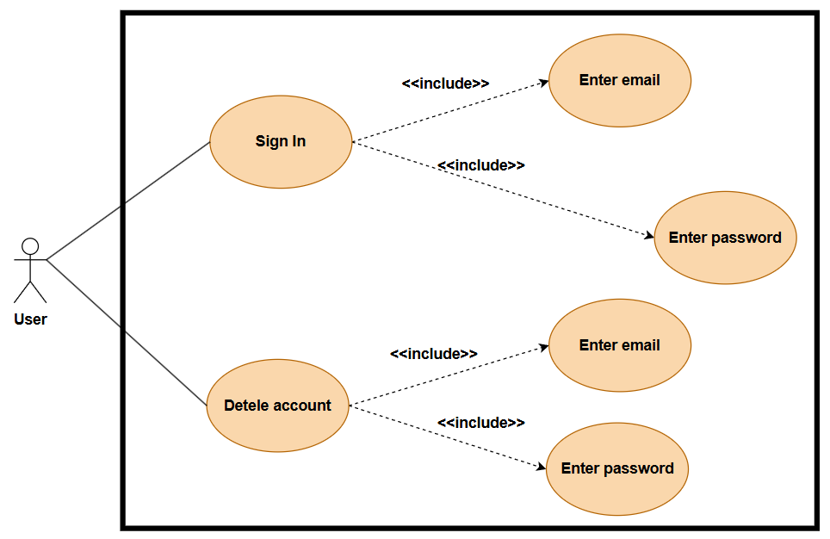
Actors
- User: Any registered entity (Mechanic or Client) attempting to access or remove their account.
Preconditions
- For Sign In: The user must have a registered account.
- For Delete Account: The user must be currently logged in or able to verify credentials.

Flow of Events
A. Sign In Flow
The login process ensures secure access to the application. To successfully authenticate, the system enforces the following mandatory inputs:
- Enter Email: The user must provide the email address associated with their account.
- Enter Password: The user must provide the matching security credential. The system validates the hash against the database.
B. Delete Account Flow
To prevent accidental data loss, the account deletion process requires a high-friction confirmation. As shown in the diagram, a simple button press is insufficient; the user must re-authenticate:
- Enter Email: The user confirms the identity of the account to be deleted.
- Enter Password: A mandatory security step to verify that the person requesting deletion is indeed the account owner.

2.2 Mechanic Sign Up
This use case describes the process by which a service provider (Mechanic) creates a new account within the MyMechanic application. The process distinguishes between critical identity information required for authentication and supplementary profile details used for business listing.
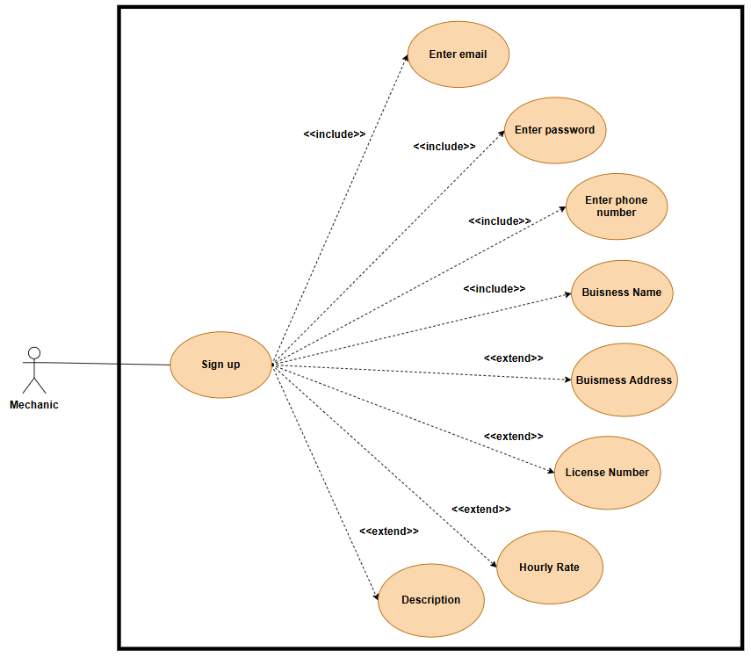
Actors
Mechanic: A service provider looking to list their services and accept appointments via application.
Preconditions
- The user has downloaded the application.
- The user is not currently logged in.

Flow of Events
A. Basic Flow (Mandatory Registration)
The "Sign Up" process includes the collection of essential credentials. The system shall not create an account record unless the following data points are provided and validated:
- Enter Email: Used as the unique identifier for the account.
- Enter Password: Used for secure authentication.
- Enter Phone Number: Required for two-factor authentication (if applicable) and contact purposes.
- Enter Business Name: The display name shown to customers.

B. Extended Flow (Profile Completion)
The registration process may be extended to include professional details. These fields enrich the mechanic's profile but are not strictly blocking for the initial account creation:
- Business Address: Geolocation data for the "Find Mechanic" map feature.
- License Number: Verification data to establish trust and validity.
- Hourly Rate: Pricing transparency for customers.
- Description: A text summary of services and expertise.

2.3 Mechanical Dashboard
This use case describes the mechanic's ability to monitor and manage their digital storefront. Upon accessing the main dashboard, the mechanic can view their public-facing shop profile and perform administrative updates.
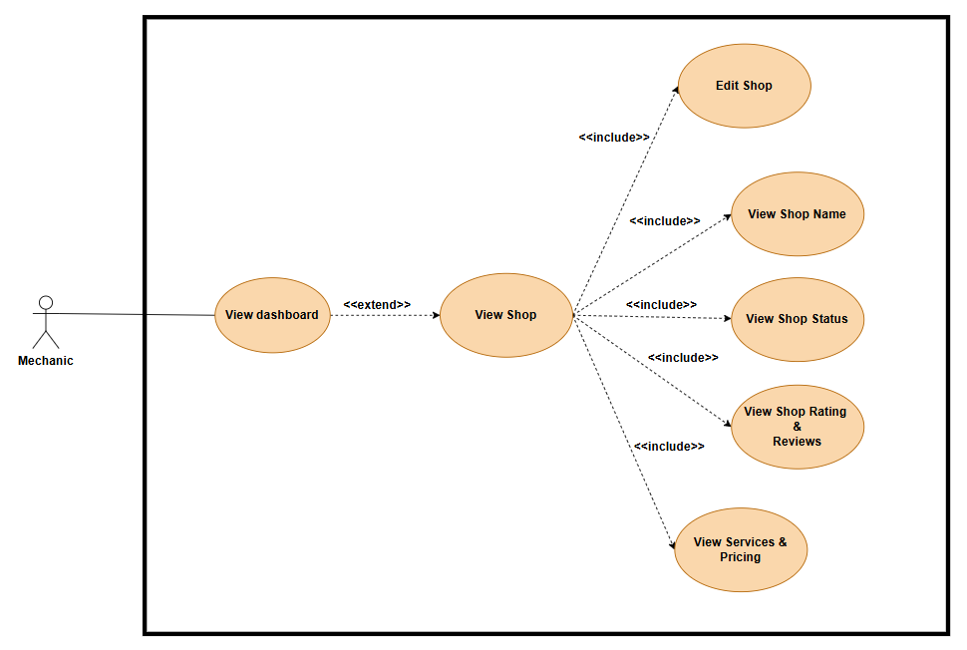
Actors
- Mechanic: The business owner managing their workshop profile and settings.
Preconditions
- The mechanic is logged into the application.
- The mechanic has completed the initial "Sign Up" and profile creation process.
Flow of Events
A. Dashboard Access
The user navigates to the "View Dashboard" section. This acts as the base use case.
B. Shop Profile Management (Extended Flow)
From the dashboard, the user accesses the "View Shop" interface. This action triggers the retrieval of several mandatory data points (<<include>>):
- View Shop Name: The system displays the registered business name.
- View Shop Status: The system indicates current availability (e.g., "Open for Booking" or "Closed").
- View Shop Rating & Reviews: The system aggregates and displays the average star rating and recent customer comments to help the mechanic track performance.
- View Services & Pricing: The system lists the active service catalog with associated costs.
- Edit Shop: The system provides controls to modify any of the above information (e.g., changing prices or updating the status).

2.4 Mechanic Edit Shop
This use case specifies the modification capabilities available to the Mechanic. It allows the service provider to keep their business information current, ensuring customers see accurate pricing, contact details, and service availability.
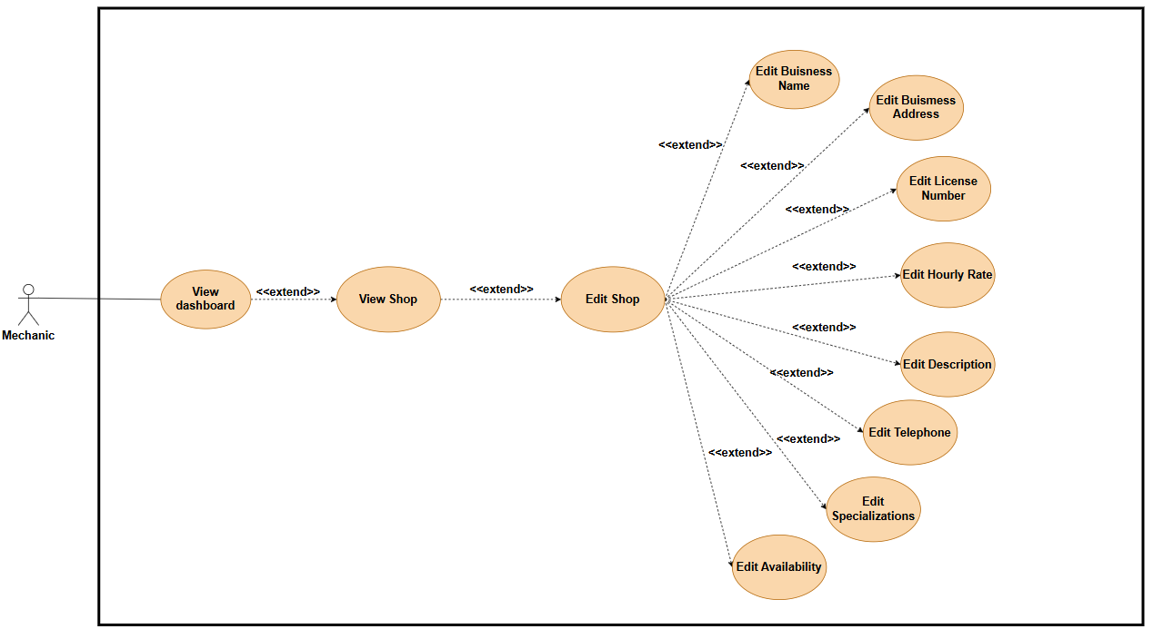
Actors
- Mechanic: The authorized user performing updates to their own workshop profile.
Preconditions
- The mechanic is currently viewing the "Shop Profile" screen (as defined in Use Case 3.4).
Flow of Events
A. Accessing Edit Mode
From the "View Shop" screen, the user initiates the "Edit Shop" action. This unlocks the profile form for modification.
B. Selective Updates (Extended Flows)
Once in edit mode, the Mechanic may trigger any combination of the following extended actions. Each action represents a specific data update request:
- Edit Business Name: Update the display name of the workshop.
- Edit Business Address: Update the physical location (which may trigger a map coordinate update).
- Edit License Number: Update certification details for compliance.
- Edit Hourly Rate: Adjust the base labor cost shown to customers.
- Edit Description: Modify the "About Us" text or bio.
- Edit Telephone: Update the contact number for bookings.
- Edit Specializations: Add or remove specific service tags (e.g., adding "Diesel Engine Repair").
- Edit Availability: Update working hours or toggle "Busy/Available" status.

2.5 Mechanic Appointments
This use case outlines the mechanic's ability to oversee and organize their schedule. It provides a centralized interface to view incoming service requests and track the status of ongoing jobs.
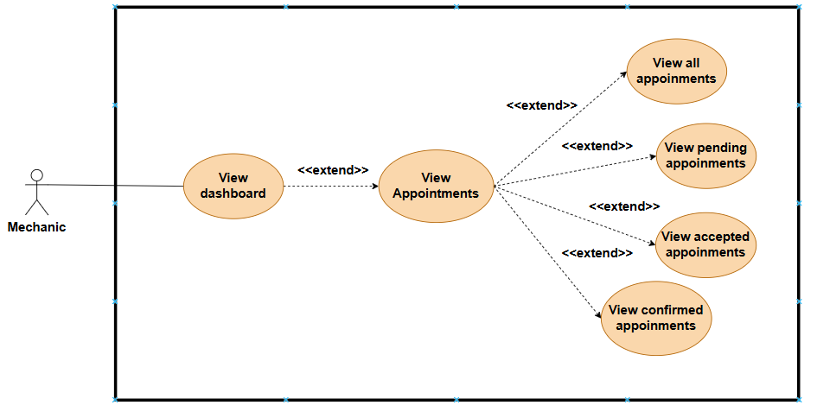
Actors
- Mechanic: The service provider responsible for accepting or tracking service requests.
Preconditions
- The mechanic is logged in and viewing the main Dashboard.
Flow of Events
A. Access Appointment Center
From the "View Dashboard" screen, the mechanic selects the "Appointments" option. This loads the main appointment interface.
B. Filter Views (Extended Flows)
Once in the appointment center, the mechanic can toggle between different lists based on the workflow state:
- View Pending Appointments: Displays new requests from customers that require immediate action (Accept/Decline).
- View Accepted Appointments: Displays jobs the mechanic has agreed to but has not yet started (often awaiting customer arrival).
- View Confirmed Appointments: Displays jobs where all parties are ready, parts are ordered, or work is effectively locked in.
- View All Appointments: A master history log showing every interaction, regardless of status.

2.6 Mechanic Profile

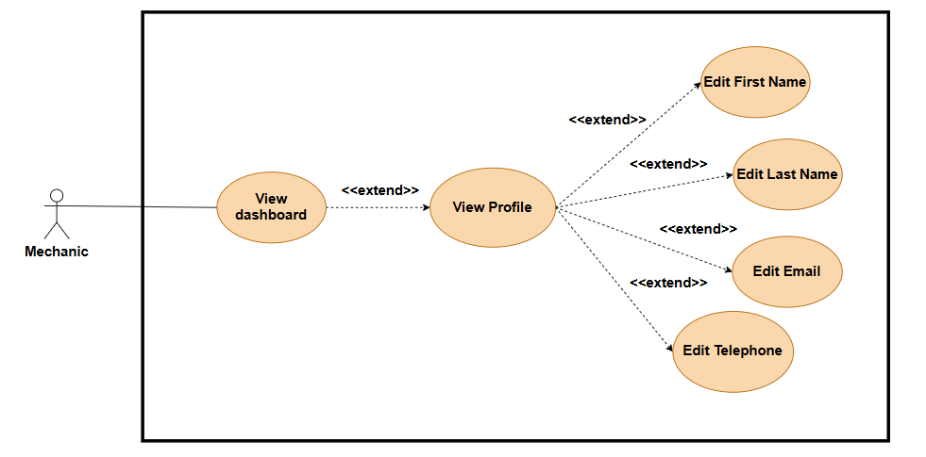
Actors
- Mechanic: The registered user managing their own account details.
Preconditions
- The mechanic is logged in to the application.
- The mechanic is viewing the main Dashboard.
Flow of Events
A. Access Personal Profile
From the Dashboard, the user selects the "My Profile" (or "Account Settings") option to view their current registration details.
B. Update Personal Information (Extended Flows)
From the profile view, the user may trigger the following update actions:
- Edit First Name: Updates the user's given name.
- Edit Last Name: Updates the user's family name.
- Edit Email: Updates the login email address (Note: This usually triggers a re-verification process).
- Edit Telephone: Updates the personal mobile number associated with the account.

2.7 Client Sign Up
This use case defines the streamlined process for a customer (Vehicle Owner) to create a new account. Unlike the Mechanic registration, the Client registration focuses solely on establishing identity and contact channels to facilitate quick appointment booking.
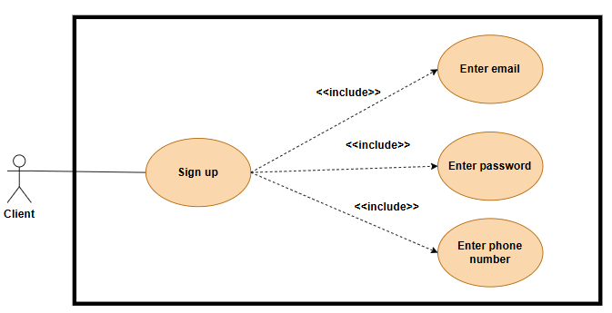

Actors
- Client: The vehicle owner who uses the application to search for mechanics and book repair services.
Preconditions
- The user has downloaded the application.
- The user is not currently logged in.
- The user has selected "I am a Vehicle Owner" (or similar) during the initial role selection.

Flow of Events
A. Basic Flow (Mandatory Registration)
As illustrated in the diagram, the Client sign-up process is strictly linear. All connected actions use the <<include>> relationship, indicating that every step is mandatory for the use case to be considered complete.
- Enter Email: The system requires a valid email address to serve as the user's login credential and for receiving booking confirmations.
- Enter Password: The user must establish a secure password for account protection.
- Enter Phone Number: The system collects a contact number to allow mechanics to reach the client regarding urgent repairs or appointment changes.
ASDAS
3. Design pattern and the motivation of using it
1. Singleton Pattern (Creational)
- Definition: This pattern ensures that a class has only one instance and provides a global point of access to it.
- Motivation for using it:
  - You need to control access to a shared resource (e.g., a database or a file).
  - You need a centralized place for global data, such as Configuration Classes or Logger Classes.
  - It is often used when creating other factories (like Abstract Factory or Builder).
2. Factory Pattern (Creational)
- Definition: This pattern allows you to create objects without exposing the instantiation logic to the client. It refers to the newly created object through a common interface.
- Motivation for using it:
  - Flexibility: It allows a system to be independent of how its products are created. You can add new types of objects without changing the code that uses them.
  - Frameworks: It is useful when a framework needs to delegate the creation of objects derived from a common superclass.
  - Example mentioned: Java XML parsers (DocumentBuilderFactory).
3. Observer Pattern (Behavioral)
- Definition: This defines a one-to-many dependency between objects so that when one object changes state, all its dependents are notified and updated automatically.
- Motivation for using it:
  - You need to maintain consistency between related objects without making them tightly coupled.
  - It is commonly used in event handling systems where an object needs to notify others about events (like a button click or a data update) without knowing who specifically is listening.
  - Example mentioned: A "News Publisher" system.
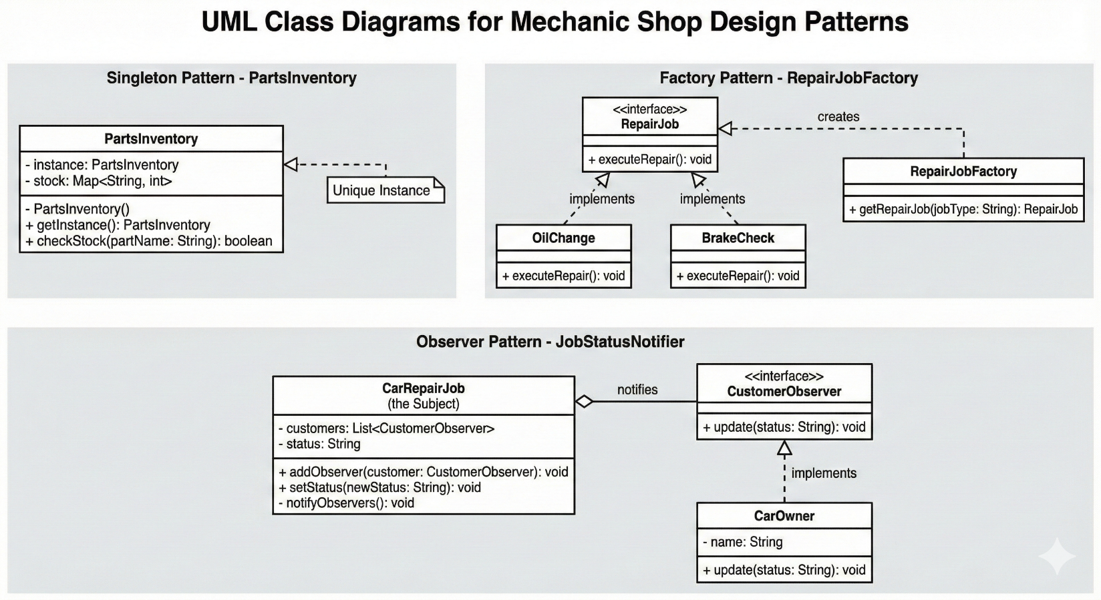

- UML Class Diagrams
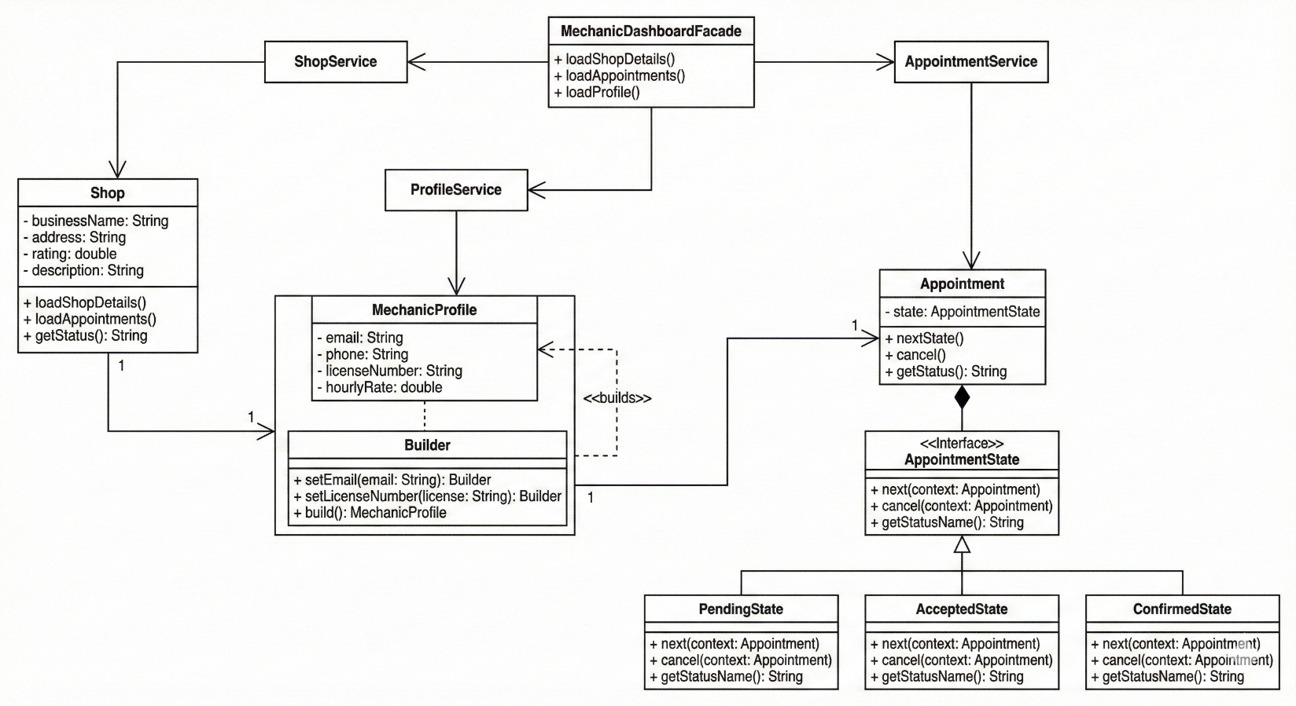

- UML Sequence diagrams
5.1 Mechanic/Client Sign Up and Delete Account
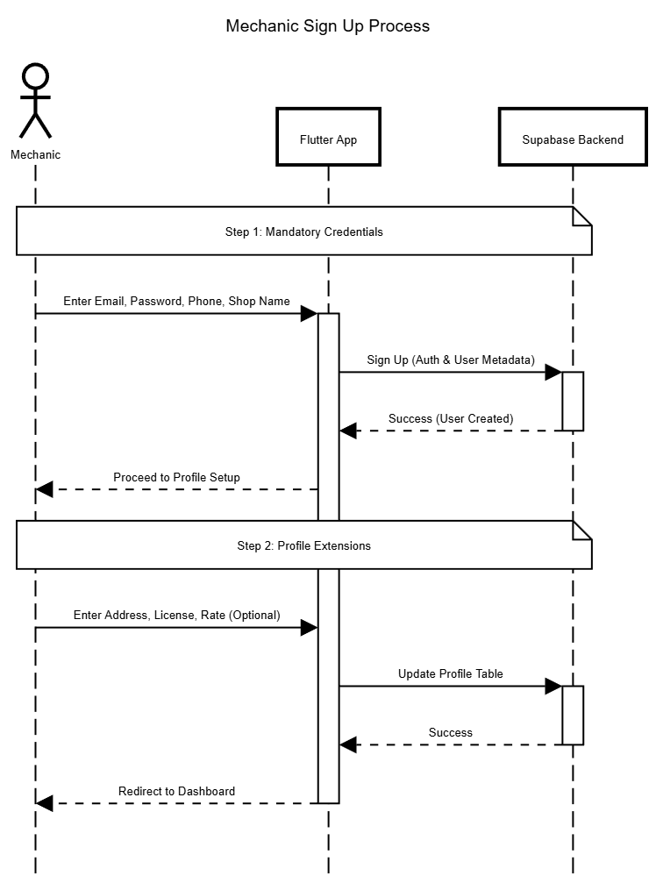
5.2 Mechanic Sign Up
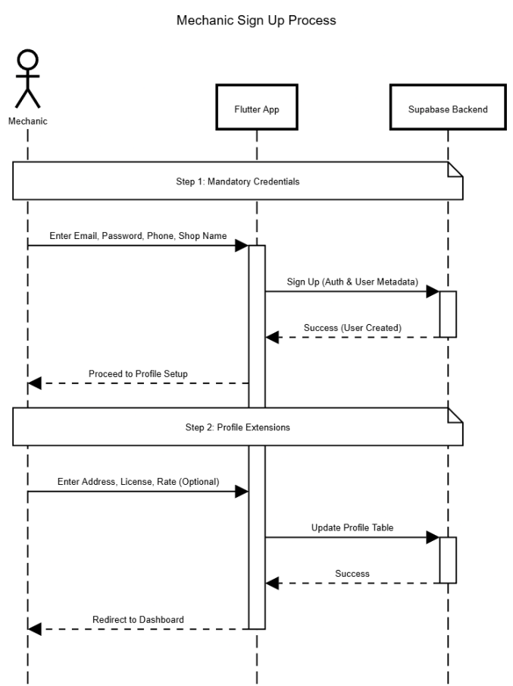
5.3 Mechanic Dashboard
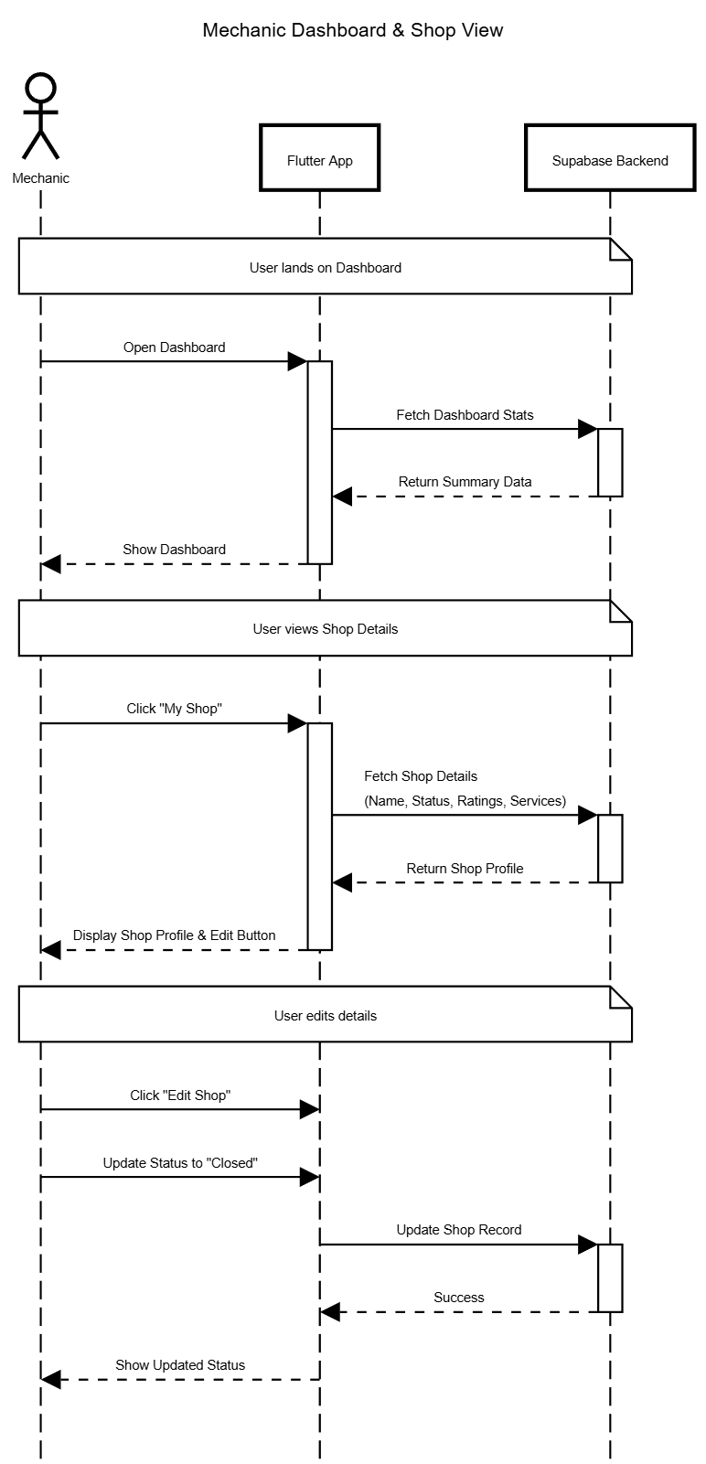
5.4 Mechanic Edit Shop
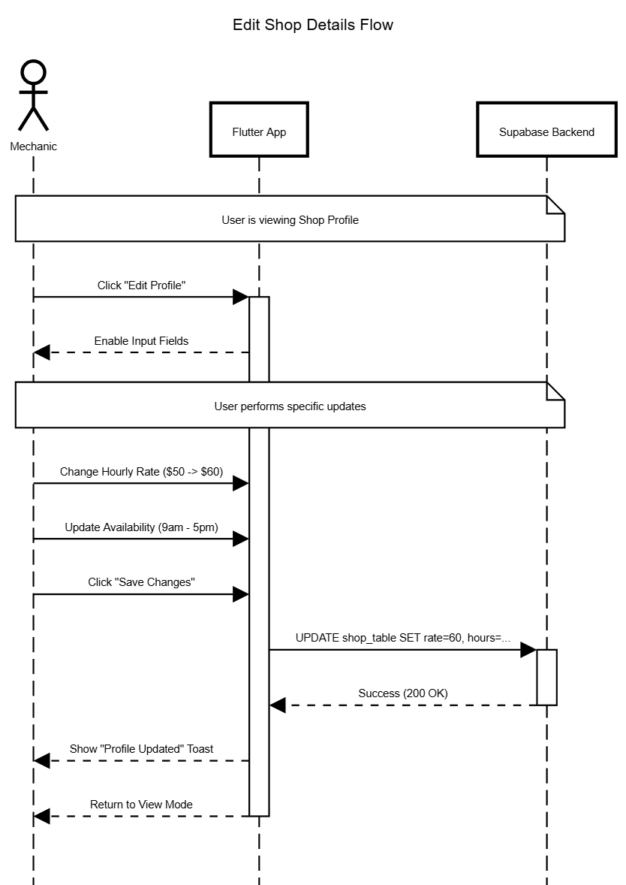

5.5 Mechanic Appointments
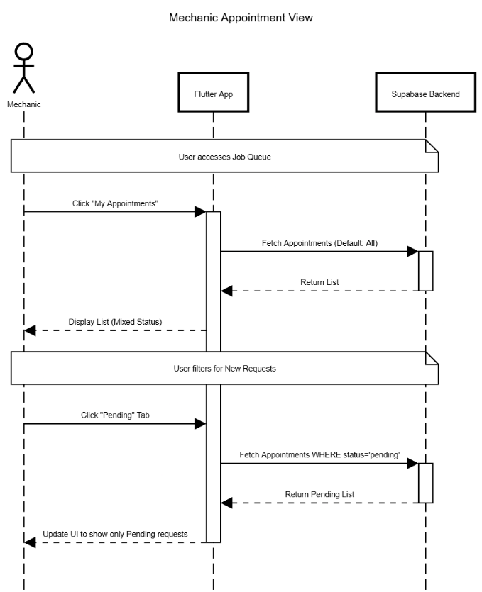
5.6 Mechanic Profile
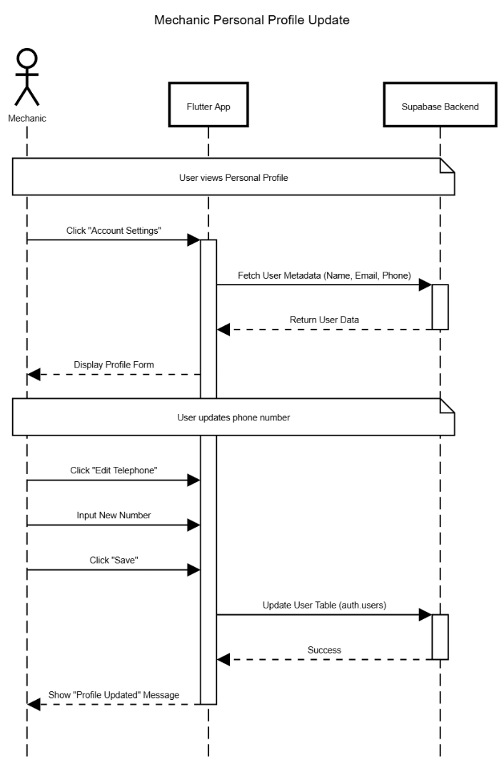
Interactions | Description
Interaction 1: Mechanic Sign Up | The process begins when the Mechanic initiates the Sign Up command from the system interface. As shown in the diagram, the system requires the user to input mandatory credentials, specifically their Email, Password, and Phone Number. Once the basic account structure is established, the interaction extends to allow the Mechanic to input professional details necessary for their business profile. This includes adding a Business Name, Business Address, License Number, and setting their Hourly Rate and Description. The system validates these inputs to create a complete Mechanic Profile.
Interaction 2: Mechanic Shop Details | This interaction starts with the Mechanic accessing the View Dashboard and navigating to the View Shop section to check current performance metrics like Shop Status, Rating & Reviews, and Services & Pricing. If updates are needed, the Mechanic proceeds to the Edit Shop function. From here, the system provides an extended menu of options, allowing the Mechanic to modify specific operational details such as the Business Address, Hourly Rate, Telephone, Specializations, and Availability. The interaction concludes when the system saves these modified business attributes to the database.
Interaction 3: Mechanic Appointment Review | To manage their schedule, the Mechanic navigates from the View Dashboard to the View Appointments module. The system initially retrieves the appointment data, which the Mechanic can then filter based on the current status of the jobs. The diagram illustrates that the Mechanic can specifically choose to View Pending Appointments to approve new requests, View Accepted Appointments to see upcoming work or View Confirmed Appointments to track finalizing jobs. This interaction allows the Mechanic to segregate their workflow based on the job's lifecycle stage.
Interaction 4: Mechanic Profile Update | This interaction focuses on the Mechanic's personal account information rather than the shop's business data. Starting from the View Dashboard, the Mechanic selects View Profile to see their registered personal details. If contact information has changed, the interaction extends to specific editing functions. The Mechanic can choose to Edit First Name, Edit Last Name, Edit Email, or Edit Telephone. The system captures these inputs and updates the Mechanic's personal record, ensuring that communication channels remain accurate.
- Application architecture and describing these modules
The application follows a modern Client-Server architecture utilizing a "Backend-as-a-Service" (BaaS) model. The system is divided into three primary layers: the User Layer, the Client-Side (Frontend), and the Server-Side (Backend).
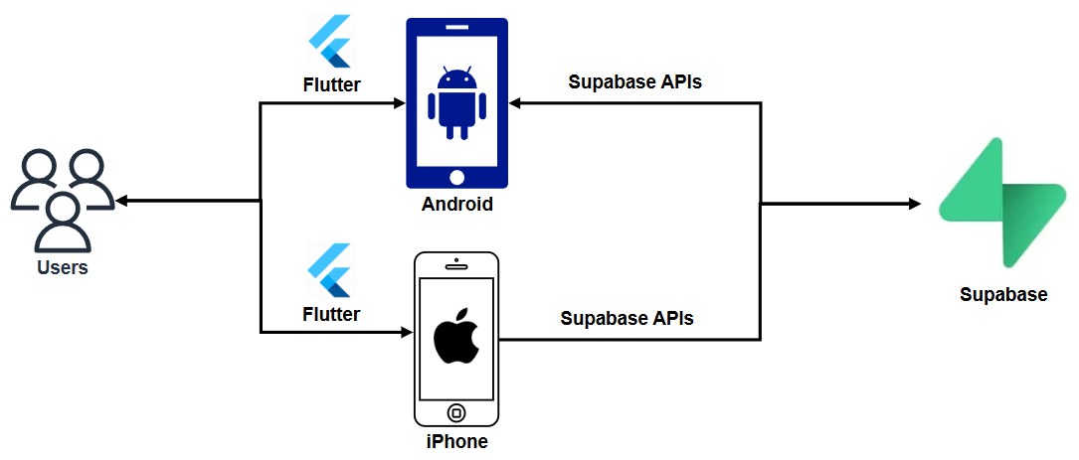
1. User Layer (The Actors)
- Visual Reference: The group of people icon on the far left.
- Description: This represents the end-users interacting with the system. For your specific auto mechanic project, this layer consists of two distinct roles:
  - Customers (Vehicle Owners): Users who browse services, book appointments, and track repair status.
  - Mechanics (Service Providers): Users who manage their schedules, accept booking requests, and update repair statuses.
2. Client-Side Module (Frontend)
- Visual Reference: The Android and iPhone devices marked with the Flutter logo.
- Description: This is the mobile application installed on the user's device.
  - Cross-Platform Framework (Flutter): As indicated by the Flutter logo, the app is built using a single codebase that compiles natively for both Android and iOS. This ensures a consistent UI and logic across different devices.
  - Responsibilities:
    - Rendering the UI (Booking forms, calendars, profile pages).
    - Handling local state management (e.g., keeping track of the currently selected service).
    - Validating user inputs before sending them to the server.
3. Communication Layer (The "Bridge")
- Visual Reference: The arrows connecting the mobile devices to Supabase, labeled "Supabase APIs".
- Description: This represents the data flow between the app and the backend.
  - Supabase Client: The Flutter app uses the supabase_flutter SDK to communicate with the backend.
  - Methods: It utilizes secure REST API calls for standard actions (like "Create Appointment") and WebSockets for Realtime features (like receiving an instant notification when a mechanic accepts a job).
4. Server-Side Module (Backend)
- Visual Reference: The green Supabase logo on the far right.
- Description: Supabase acts as the centralized backend infrastructure, replacing the need for a traditional custom server. It manages four key components:
  - Authentication: Handles secure user sign-up, login, and session management (JWT tokens) for both mechanics and customers.
  - Database (PostgreSQL): Stores all structured data, including user profiles, appointment slots, service lists, and review history.
  - Storage: Securely hosts binary files, such as profile pictures of mechanics or photos of vehicle damage uploaded by customers.
  - Realtime Engine: Listens for changes in the database (e.g., a status change from "Pending" to "Confirmed") and instantly pushes updates to the Flutter app.

