BGA Void Inspection Report
Quantitative & qualitative void analysis per IPC-A-610 / IPC-7095
Board / image | PCBA_TEMPLATE.jpg
Report generated | 2026-07-08 21:23
Inspection tool | BGA X-ray Void Inspection Tool
Standards applied | IPC-A-610 / IPC-7095
BGA grid / balls analyzed | 256 expected pads, 8 analyzed
IPC VERDICT: REJECT
1 ball(s) exceed the IPC-A-610 25% cumulative void area limit.

Key void metrics
Average void ratio | 9.575 %
Median void ratio | 8.75 %
Worst ball (total void) | 27.4 %
Worst single void | 21.0 %
Assessment split | 5 acceptable / 2 process indicator / 1 defect
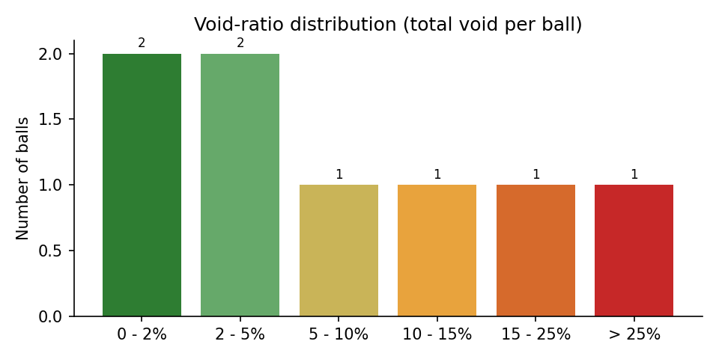

IPC criteria evaluation
Criterion | Source | Limit | Measured | Result
Cumulative void area per ball | IPC-A-610 (Class 1, 2, 3) | <= 25% of ball area | worst ball: 27.40% | FAIL (1 ball(s))
Process indicator band (total void 10-25%) | IPC-7095 process guidance | monitor, not a defect | 2 ball(s) in band | INFO
Largest single void per ball | IPC-7095 (dominant-void guidance) | review above 12.2% area (~35% diameter) | worst single void: 45.8% of ball diameter | INFO
Void location at pad interface | IPC-7095 (30% dia at land) | requires oblique/3D view | not measurable in one top-down 2D X-ray | NOT EVALUATED
Complete ball grid detected | detection integrity gate | all expected pads found | 8 / 256 | REVIEW

Worst 10 balls by total void
Ball ID | X (px) | Y (px) | Total void (%) | Largest void (%) | IPC assessment
7 | 1220 | 400 | 27.40 | 21.00 | DEFECT (IPC-A-610)
6 | 1100 | 400 | 18.60 | 14.10 | PROCESS INDICATOR
5 | 980 | 400 | 13.20 | 7.90 | PROCESS INDICATOR
4 | 860 | 400 | 8.75 | 5.40 | ACCEPTABLE
3 | 740 | 400 | 4.50 | 2.10 | ACCEPTABLE
8 | 1340 | 400 | 2.30 | 1.10 | ACCEPTABLE
2 | 620 | 400 | 1.85 | 1.20 | ACCEPTABLE
1 | 500 | 400 | 0.00 | 0.00 | ACCEPTABLE

Algorithm analysis - honest assessment

Detection integrity
- Balls detected: 8 of 256 expected grid slots
- Pads placed from grid estimation (no direct evidence): 1
- Mean detection confidence (evidence-backed pads): 0.95
- Ball quality split: 5 PASS / 2 REVIEW / 1 FAIL

Measurement pipeline (what actually produced these numbers)
- 1. CLAHE contrast enhancement + median denoising of the raw X-ray.
- 2. Solder-ball detection: Hough circles + dark-blob evidence, regularized onto the 16x16 BGA grid (affine + homography fit for oblique views, per-ball local snap with non-degradation gates).
- 3. Per-ball void segmentation: median-background subtraction (kernel > ball radius), bond-wire suppression by grayscale closing, residual threshold, then shape filtering.
- 4. Detected void blobs are rendered as fitted circles when they fill >= 45% of the fitted disc (physical voids are spherical gas bubbles); ragged non-circular structures keep their raw contour.
- 5. Component-level sanity filters remove rim arcs, trace stripes, bare-board bleed-through and empty-pad artifacts before metrics.

Classification thresholds applied
- Defect (FAIL): total void >= 25.0% of ball area (IPC-A-610).
- Process indicator (REVIEW): total void >= 10.0% (IPC-7095 guidance).
- Dominant single void (REVIEW): largest void >= 12.25% of ball area (~35% of ball diameter).

Measurement uncertainty - read before trusting decimals
- Projected-area measurement: one top-down 2D X-ray cannot separate package-interface, mid-ball and pad-interface voids; the 25% IPC-A-610 criterion is applied on the projection, exactly as the standard defines it for X-ray inspection.
- Analysis is restricted to the inner 82% of each ball radius; a void hiding exactly on the ball rim can be underestimated.
- Voids smaller than ~10 px^2 (about 0.15% of a ball) are below the detection floor and are intentionally ignored as noise.
- Fitted-circle rendering slightly increases void area versus the raw threshold blob (it includes the faded bubble edge); this is closer to the physical bubble size but adds ~0.3-0.6 percentage points to board averages compared to raw-contour reporting.
- JPEG compression artifacts and CLAHE amplification set a noise floor around 1-2% void ratio; differences below that level are not meaningful.
- On oblique views, perspective foreshortening distorts both ball and void areas; the ratio is partially self-correcting but not perfectly.

Known limitations of this analysis
- Components mounted on the opposite board side project dark shadows between and over balls; the detector anchors circles on grid geometry to resist this, but heavily shadowed balls have reduced void sensitivity.
- Grid slots occupied by vias (no ball populated) are still reported as balls when the slot must be filled; they show ~0% void and near-board brightness.
- Bond-wire suppression (morphological closing) can mask very thin elongated voids lying exactly under a wire.
- The tool measures voiding only; it does not assess head-in-pillow, non-wet opens, bridging or solder-ball shape defects.

Balls to verify manually first (worst 10 by total void)
- Ball # 7 at (1220, 400): total 27.40%, largest single 21.00% -> DEFECT (IPC-A-610)
- Ball # 6 at (1100, 400): total 18.60%, largest single 14.10% -> PROCESS INDICATOR
- Ball # 5 at (980, 400): total 13.20%, largest single 7.90% -> PROCESS INDICATOR
- Ball # 4 at (860, 400): total 8.75%, largest single 5.40% -> ACCEPTABLE
- Ball # 3 at (740, 400): total 4.50%, largest single 2.10% -> ACCEPTABLE
- Ball # 8 at (1340, 400): total 2.30%, largest single 1.10% -> ACCEPTABLE
- Ball # 2 at (620, 400): total 1.85%, largest single 1.20% -> ACCEPTABLE
- Ball # 1 at (500, 400): total 0.00%, largest single 0.00% -> ACCEPTABLE

Grid-estimated pads (verify visually)
- Ball # 8 at (1340, 400) - position estimated from the grid, no direct dark-pad evidence; its void metrics carry extra uncertainty
Generated automatically by BGA X-ray Void Inspection Tool on 2026-07-08 21:23. Verdicts follow IPC-A-610 (25% cumulative projected void area per ball) with IPC-7095 process guidance; they are based on a single top-down 2D X-ray projection and should be confirmed by an operator for boards flagged REVIEW or REJECT.

