# Setup device in Microsoft Intune using Portal

Give Intune license to the user which will own PC, either in Azure Portal or Office 365 Admin Center.

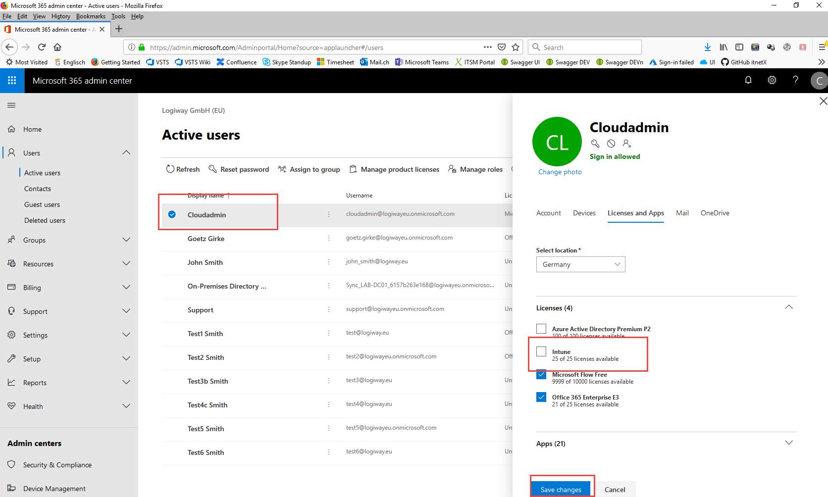

Check either in MDM or Azure Portal that all users are able to enroll Windows devices:

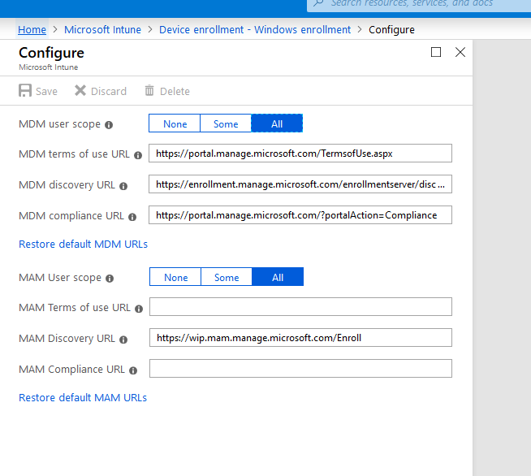

Create Intune profile in Azure Portal and configure desired settings:

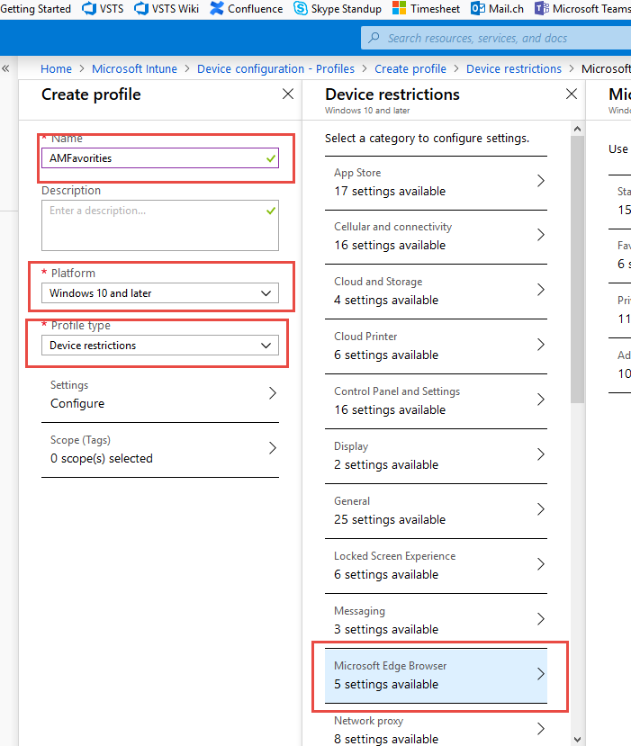

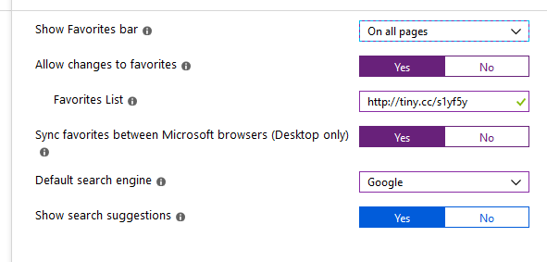

Create Azure AD Security Group for devices to be involved in Intune configuration.

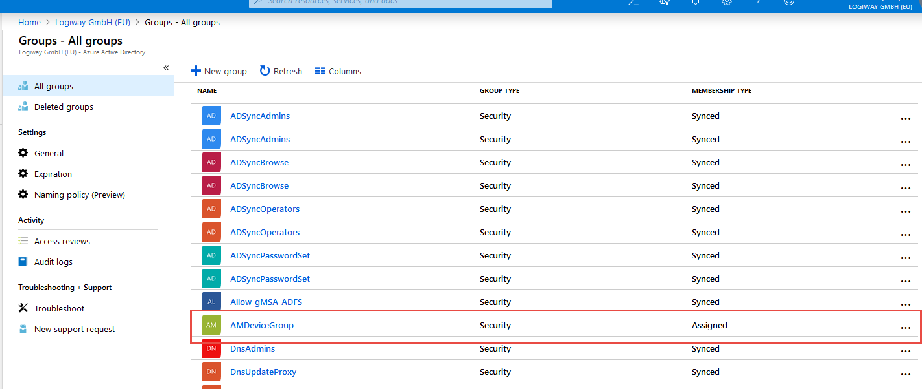

Assign Intune profile to security group:

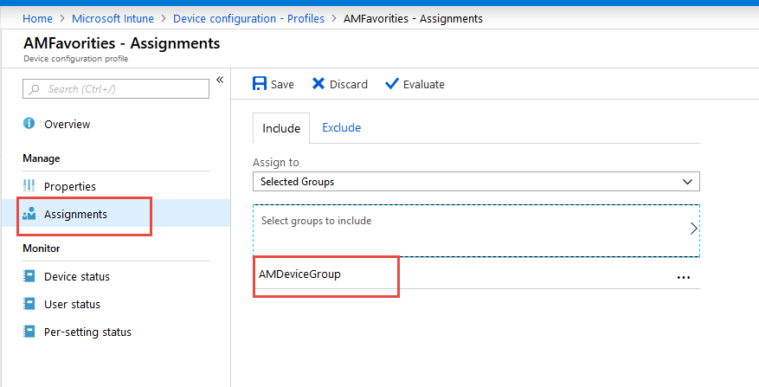

Create Windows 10 Machine (Windows Servers can not be configured by Intune)

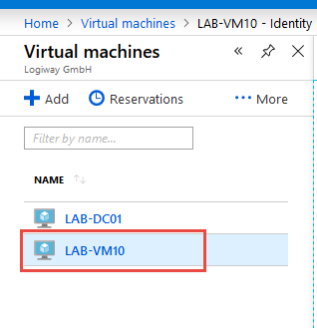

Don’t forget to allow port 3389 for RDP.

Connect to machine with RDP.

Click on Settings (in start menu), then Emails and Accounts.

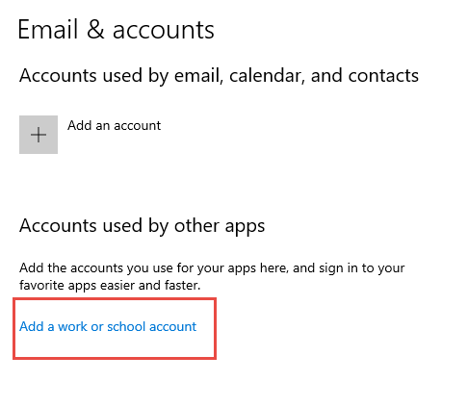

Enter user credentials.

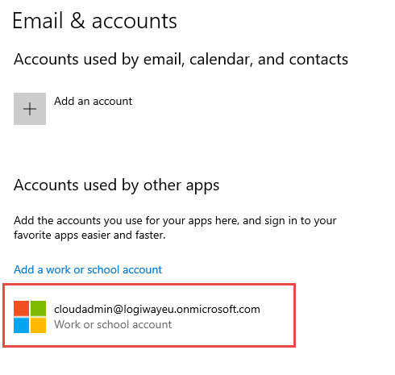

VM Appears now in Devices list

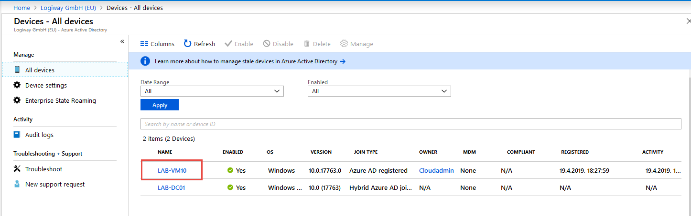

Add this device to Azure AD Security Group:

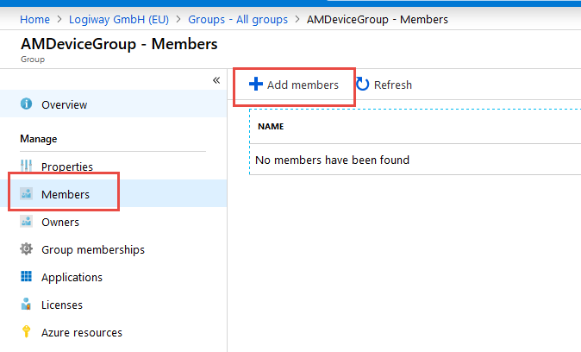

Intune settings are propagated to Windows 10 Computers every 8 hours:

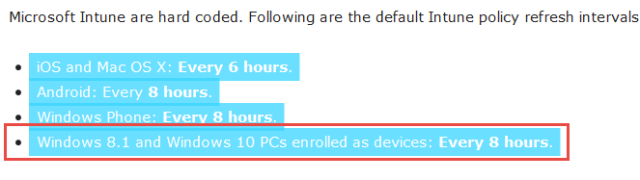

To force an update, install “Company Portal” App on PC (from Windows Apps Gallery).

<https://docs.microsoft.com/en-us/intune-user-help/sync-your-device-manually-windows>

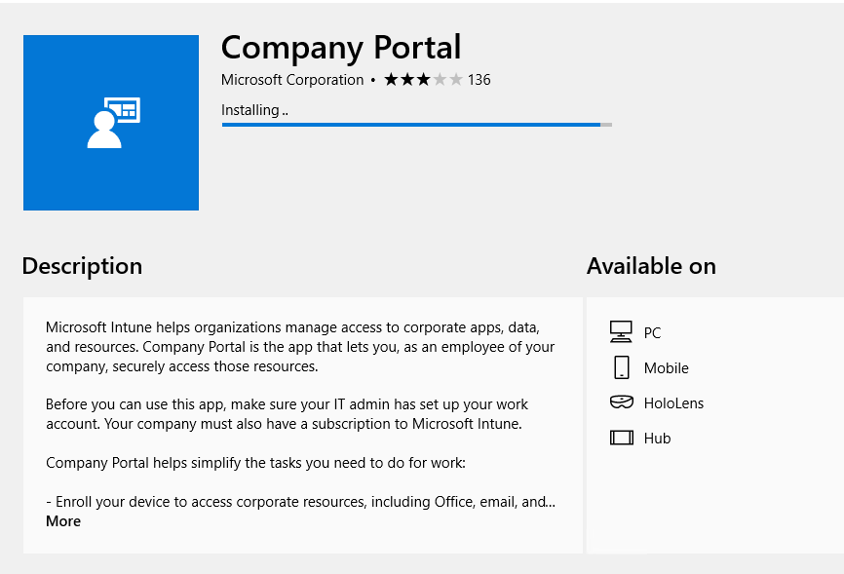

Authenticate again in the app:

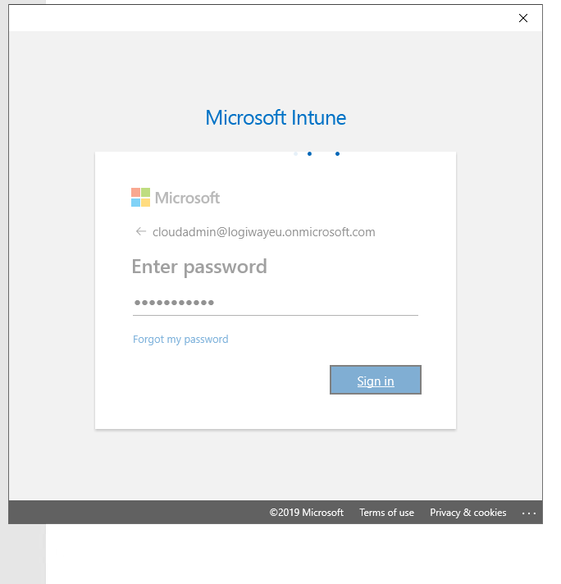

And in Settings (“gear” button) click on “Sync”.

Alternatively, settings can be pushed using Azure Portal: select a device in Intune (under all devices), click on its name and then “Sync”:

<https://docs.microsoft.com/en-us/intune/device-sync>

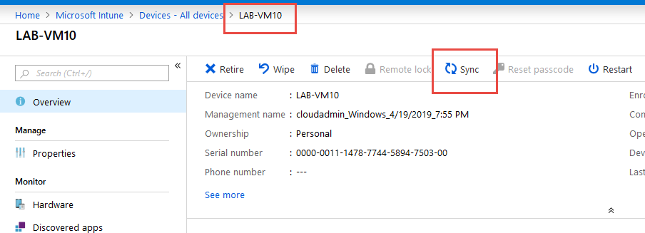

*Note. I didn’t succeed with setting Microsoft Edge Favorites to be set by Intune. Will be investigated.*

# PowerShell Tasks

1. Provision Device to AzureAD as described before, or use New-LwAzureDevice
2. Create Device Configuration policy in portal (it is too cryptic to do it programmatically). Retrieve it with Get-LwIntuneDeviceConfigurationPolicy
3. Create security group with New-LwAzureGroup
4. Add device to the group with Add-LwAzureGroupMember
5. Assign Device Configuration policy to security group with New-LwIntuneDeviceCompliancePolicyAssignment
6. Call Invoke-LwIntuneManagedDeviceSyncDevice to force sync