# Lab 3- Scanner

https://github.com/andreimsuciu/FLCD

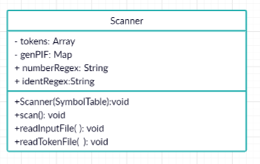

String numberRegex = "(?:[(])(?:[)])[1-9][0-9]*";

? means optional , and “:(“ / “:)” mean “- ” and “+”, so (?:[(]) and (?:[)]) has the meaning that + and – are optional for our number. Then, we have numbers from 1 to 9 so that it doesn’t start with 0 and then we have however many numbers from 0 to 9.

identRegex = "[_a-zA-Z][_a-zA-Z0-9]*";

identifiers must start with a lowercase or uppercase letter, followed by any number of such letters or numbers from 0 to 9.