

MeteoCal

Requirement Analysis

And

Specification Document

1. INTRODUCTION 4

2. ANALYSIS OF THE PROBLEM 5

2.1 Goals 5

2.2 Domain Properties 6

2.3 Glossary 6

2.4 Assumptions 6

2.5 Proposed System 7

2.6 Other Considerations 7

3 ACTORS IDENTIFYING 8

4. REQUIREMENTS 9

4.1 Functional Requirements 9

4.2 Non functional requirements 10

4.2.1 User interface 10

4.2.2 Documentation 13

4.2.3 Architectural considerations 14

5. SPECIFICATIONS 15

6 POSSIBLE SCENARIOS 17

7 UML MODELS 19

7.1 Use case diagrams 19

7.1.1 Register 19

7.1.2 Log In 21

7.1.3 Profile Managing 22

7.1.4 Calendar Managing 24

7.1.5 MANAGE EVENTS 30

7.1.6 Search of a Public Event or another User 43

7.1.7 Managing Default Event Types 47

8.Alloy Model 51

8.1 Assertions 54

8.2 Predicates and Worlds Generated 55

8.2.1 World Generated By OneEventTwoInvites 56

8.2.2 World Generated by Notifications 57

8.2.3 World Simulation 57

# 1. INTRODUCTION

In these document we have discussed some features regarding our project called MeteoCal, which is a weather-based calendar.

After this short introduction, we have analyzed the problem, providing a rather detailed description of it, followed by two sections containing the list of goals and domain properties. Then we have inserted a glossary to make easier to the readers of this document to understand it. After that, we have explained what assumptions we have made about the specification and some considerations about the system that we are going to realize.

In the third part of this document we have identified the actors that will interact with our system and we have listed them providing a short description.

In the fourth part we have discussed about functional and non-functional requirements.

# 2. ANALYSIS OF THE PROBLEM

We will project and implement for the X software house MeteoCal, an online weather based calendar, that will allow people to schedule their events and receive constant notifications about the forecasted weather conditions on the time of the event.

The user, once registered and logged in, will be able to create or join events and calendars. When an event is created the type and location of such event must be specified, based on this information the system will provide the right weather notifications (for instance an indoor event doesn’t need a rain notification). An event can be public or private, if it is public other people will be able to see and join it. A user can also invite people to his private events making them restricted. A calendar can be public too, allowing other users to see when the owner of the calendar is busy, but they won’t see what event he is attending unless they are attending it too.

If the forecasted weather conditions aren’t suitable for an event the user has in his calendar the system will notify him by mails and on-site notifications and, if asked, will provide a new date for it in which the weather will be more adapt.

An initial set of events types will be created by the administrator of the system, the users can also create some personalized types and use them.

## 2.1 Goals

* At the end of the implementation the site will allow the visitor to:
* Sign up or log in
* Create a calendar
* Make a calendar public
* Share a calendar with another user
* Create an event
* Make an event public
* Invite people to his events
* Join a public event
* Accept an invite to a restricted event
* Receive notifications about the weather conditions before his events
* Modify information about an event he has created

## 2.2 Domain Properties

We take these properties for granted in the analyzed environment:

* The forecasted weather conditions are accurate
* The user really attends every event he declares
* Every event takes place in the specified location, and that location exists

## 2.3 Glossary

**Event Type:** A brief description of the event and, most important, it is associated with the weather conditions in which it can be attended.

**Guest:** A visitor who’s either not logged in as a user or not registered; he can access a limited number of functions, he basically can only sign up or log in.

**User:** A visitor  registered in the system who’s already logged in, he can access all the functions described in this document, except for the ones specified for the administrator.

**Administrator:** A special type of user who can add new default events types.

**Event:** A planned occasion or activity (such as a social gathering).

**Public Event:** An event that can be attended and added to the calendar by anyone, as long as they know its name.

**Restricted Event:** An event that can be attended only by the user who created it and the users he decides to invite to it. The invited users are also able to see it but not to modify it.

**Private Event:** An event that can be seen and attended only by the user who created it. If the creator decides to invite someone else it becomes restricted.

## 2.4 Assumptions

* Bad weather conditions means different things based on the event type: for a soccer game snow is a bad weather condition, meanwhile for a skiing trip it may not be a problem.
* Reading the specifications it wasn’t clear if a user could have more than one calendar. We assumed that a user can have more than one calendar, we thought this could be useful for separating events related to different aspects of the user’s life (such as a work-related and a family-related calendar)
* The definition of public event wasn’t clear enough in the specifications. For this reason we decide to distinguish between public and private events. In particular, in order to participate to a public one, the owner’s invitation is not mandatory. On the contrary, the only way in which a user can add a private event to his calendar is by accepting the invitation sent by the event’s creator.

## 2.5 Proposed System

We propose a web platform that will provide users the following features.

Users can easily create and manage events and calendars. They will also be able to see notifications, sent by the system, about weather conditions. Our platform will allow every user to see invitations sent by other user to him; they can accept or decline them.

The page of the administrator will be different in order to allow him to add new type of events suggested by metocal’s users.

## 2.6 Other Considerations

We think the final result will have a look and feel similar to the market solutions already available (such as Google Calendar or Apple Calendar), because it seems the best solution to make the site really easy to use and understandable for a novice user.

# 3 ACTORS IDENTIFYING

The relevant actors in the system that we are going to develop are three:

* + - **Guest:** a guest is a visitor who is not registered or not already logged in. He can only exploit the functionalities provided by the system to sign in, if not register yet, or to log in.
    - **User:** a user is a visitor who is not only registered, but also already logged in. He can exploits all the functionalities develop.
    - **Administrator:** the administrator is the supervisor of the system and he is the only person who can add new type of events into the system, making them available to all the users.

# 4. REQUIREMENTS

Combining the goals and the assumptions we made about the system we can derive this requirements the final system is going to provide:

1. **Registration of a new user in the system**
2. **Authentication of a visitor as a registered user**
3. **Managing of personal information**
4. **Creation of a new calendar**

* Choice between public and private

1. **Creation of a new event**

* Choice between public and private
* Choice among the default and personalized types
* Creation of a new personalized event type
* Choice of the optimal weather conditions
* Choice of the location of the event

1. **Managing of an owned event**

* Option to invite other users
* Change the event type
* Change the location of the event
* Change the date of the event

1. **Managing invitations**

* Decline an invitation
* Add the event to a calendar

1. **Consultation of notifications**

* Postpone an event to a suggested date

## 4.1 Functional Requirements

Now that we know what the system will allow to do, we are going to state which of these functionalities every actor will be able to access:

* **Guest**:
* Sign up
* Log in

**User:**

* Create a calendar
* Change a calendar privacy settings
* Delete a calendar
* Create an event
* Create an event type
* Change the information about an event he created
* Delete an event he created
* Accept an invitation
* Decline an invitation
* Search for public events
* Add a public event to one of his calendars
* Remove an event from one of his calendars
* See his notifications
* Update profile information

**Administrator:**

* Create a new default event type

## 4.2 Non functional requirements

### 4.2.1 User interface

We will develop a web application and for this reason the user interface will be well suited for this kind of application. Our purpose is to realize a nice and user-friendly interface in order to make as easy as possible to understand how to use MeteoCal and to attract the largest number of people. In this section, through some mockup, we will show a first sketch of our application.

*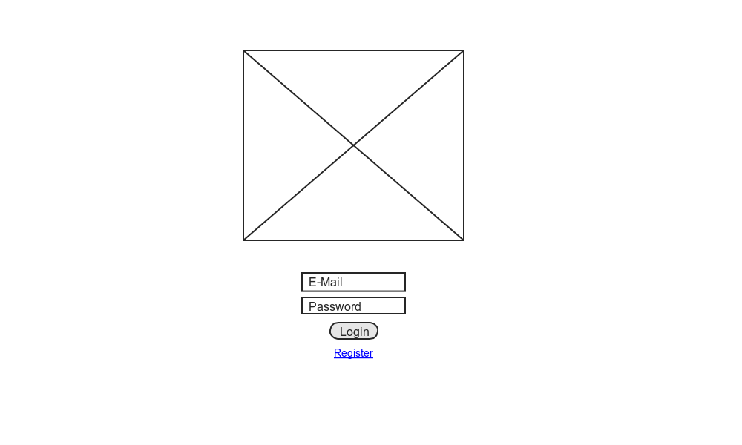Fig. 1: Login and registration page*

In Fig. 1 is represented the page where a visitor can either login or sign in through the apposite link. In the center of the page there is the logo of MeteoCal. It’s very simple and intuitive to understand how to use the functions provided by this page.

We have decided to provide to MeteoCal’s users the possibility to decide the style of their calendar. In particular they will be able to see the calendar organized per month, per week or focus on a single a day. In Fig. 2,3,4 are shown these three layouts. They have some common elements such as the upper bar where there is the MetoCal’s logo, a field that allows user to look for events or other users, the icon of notifications with a badge present only in case of new notification, the profile picture of the user and his name. On the left part there is section that allows selecting one ore more calendars and a button to create a new calendar. Under the main bar there are some buttons that allows navigating among months, days or weeks and a button to create a new event. There is also the possibility to change the layout of the calendar.

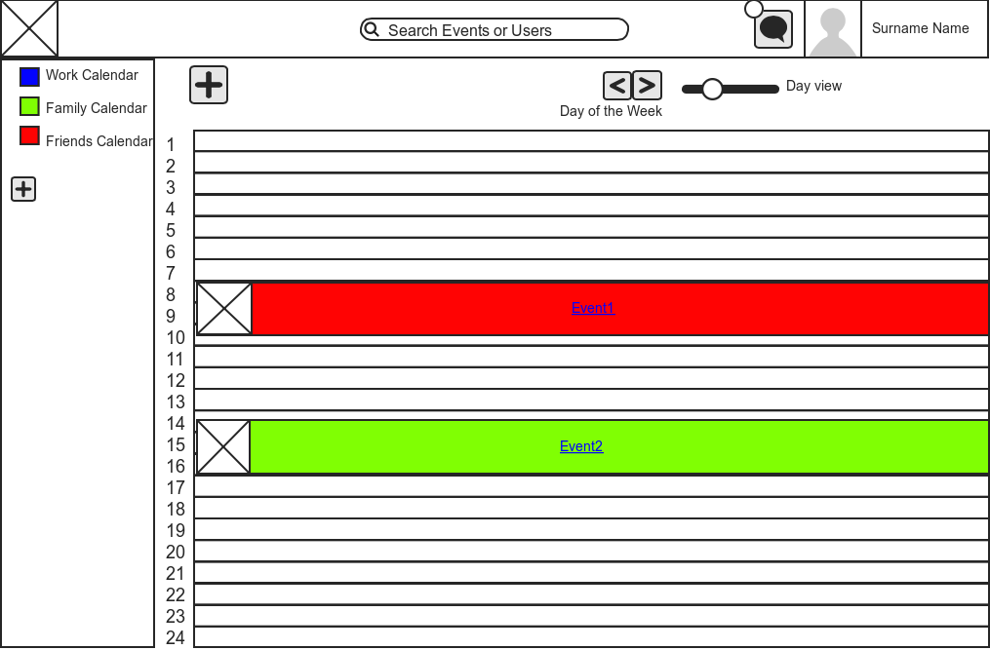

*Fig. 2: Day Layout*

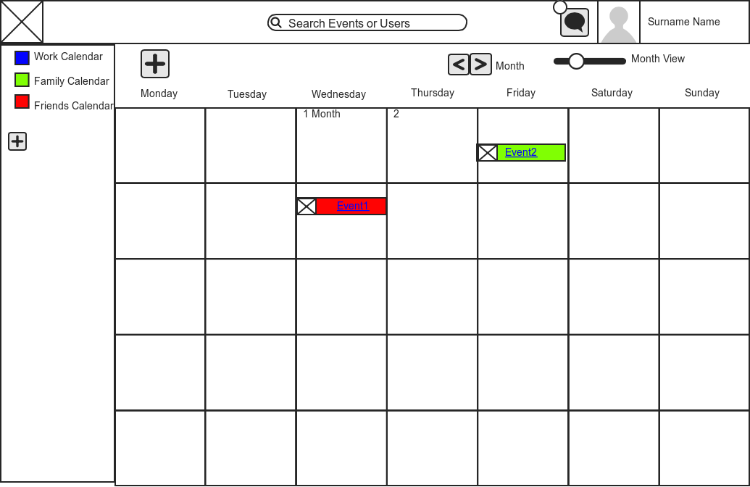

*Fig. 3: Month Layout*

The event colors are not casual in fact it correspond to the color of the calendar in which the event is contained. Every event has a small image that represents the forecasted weather, if available. Clicking on the event it is possible to see some details regarding the event itself.

### Macintosh SSD:Users:Andrea:Desktop:homeweekcut.png

*Fig. 3: Week Layout*

To give our users a simply way to manage their events we will include an agenda layout that is a sort of agenda.

### 

*Fig. 4: Agenda Layout*

In Fig. 5 is illustrated how a user will see his notifications. In the notifications fields there some link useful to perform action related to the notification received. Also for this menu our purpose is to make it easily understandable and usable by users.

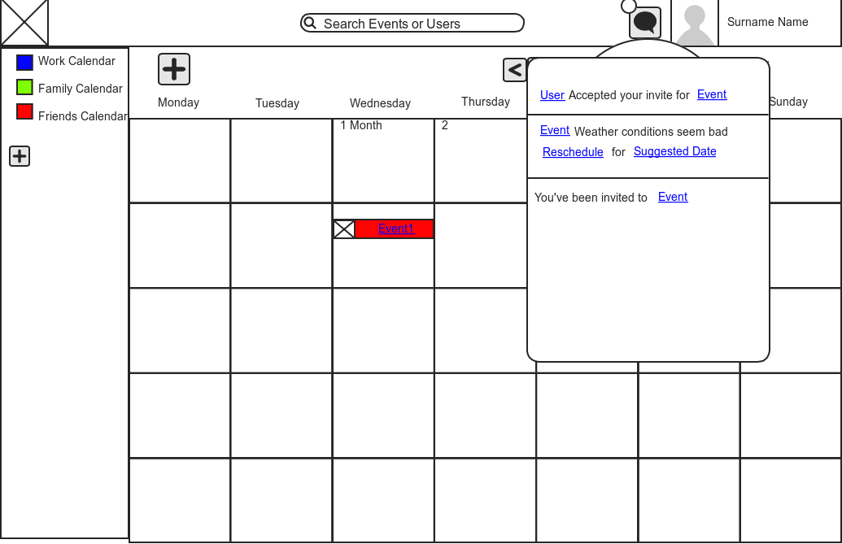

*Fig. 5: Notification Menu*

### 4.2.2 Documentation

We will draft the following documents that will help us to organize our work and to make our project as good possible.

* **Project plan:** to well organize the project phases in order to achieve the goals, respecting all the deadlines.
* **Requirement Analysis and Specification Document (RASD):** to analyze the requirements and explain the domain, the goals and the system to be develop.
* **Design Document (DD):** to provide a written description of our project, especially describing the structure of our web application and its division in tiers.
* **JavaDoc:** to make our code understandable in order to make easier future modification or maintenance.
* **Installation Manual:** a guide to install MeteoCal.
* **User Manual:** a guide to use MeteoCal.
* **Testing Document:** report regarding tests of another MeteoCal project.

### 4.2.3 Architectural considerations

We will use Java Platform Enterprise Edition.

Of course, some information will be stored in a database. We will provide more details about information in the class diagram because it may be consider as a first sketch of our database, but the precise structure of our database (ER diagram), will be specified in the design document.

In order to use MeteoCal an Internet connection and a recent web browser are needed.

# 5. SPECIFICATIONS

In this chapter we will provide a detailed explanation about the functionalities of our platform:

* The administrator will log in the same way the normal users do, but will be redirected to a reserved page.
* From the administrative page he will have the possibility to add new event types that will be visible to all the users.
* A not registered user won’t be able to see anything apart from the welcome page, where he will be able to register or log in.
* While registering the visitor will be asked for some mandatory personal information such as his name.
* A user, once logged in, will be redirected to his own personal calendar page, where he will be able to see his planned events and his notifications.
* A user can search for another user using his name or his e-mail address.
* Every user can access a page showing the personal information of another user.
* Every user can access his personal information page and update it.
* The system will periodically check the forecasted weather conditions before an event and notify the user if they drastically changed either in a better or worse way.
* If the forecasted conditions for an event are not compatible with it, the system will suggest, within the notification, some new dates for the given event with a better weather prediction.
* Every user can find and add a public event to his calendar just by searching it by its name.
* Every user can see the list of participant of a public event.
* A user can invite every other user to one of his restricted events.
* An invite will show up in the invited user’s notifications section when another user invites him to an event.
* When creating an event with active weather notifications the user will be forced to enter a location for it.
* If the event a user wants to create is an indoor one, he will just need to check the indoor checkbox while creating it and the weather notifications will be disabled.
* If the user can’t find a suitable event type for his event among the default ones, he can create one. He will be asked which weather conditions are compatible with the event type and, after he saves it, it can be reused every time he needs it.
* If an event is postponed by its owner a notification stating the new date will be sent to all the participants, and they will be asked to accept or decline the invite as like as it was a new event.

# 6 POSSIBLE SCENARIOS

Here we are going to explain some possible scenarios that can occur.

* Bob is a very busy man, but when it is possible he loves organizing excursion. He needs something that helps him to organize all his activities and, above all, something that can suggest him the best day to schedule his excursions in order to avoid rainy and foggy days. For all these reasons he decides to try MeteoCal: he goes on the MeteoCal home page and he uses the dedicated form to perform the registration to the platform.
* A week ago, Ann planned a bike ride for the following Sunday. But, three day before her trip, the forecasted weather conditions are not good: on Sunday it is likely to rain. Due to this fact the system notifies Ann proposing her another day, the closest with better weather conditions, when she can perform her activity. She decides to postpone her events.
* David decides to organize a soccer game with his friends at the local pitch for the following Friday, so he create the event in his MeteoCal page specifying Sport Event as event type and proceeds to invite 9 of his friends. During the following days David receives notifications for every accepted invite, and by Tuesday everyone replied positively. On Wednesday the system checks the forecasted weather conditions, it’s predicted to be snowing on Friday, and, since snow is listed as not compatible with the type Sport Event, the system sends a notification to David. David reads the notification on Thursday and decides to postpone the game to Saturday as the system is suggesting, since Saturday is predicted to be a sunny day. A notification regarding the date change is sent to all the participants, who need to confirm their presence again. Unfortunately George, one of David’s friends, has another game scheduled for the same date and must decline the invitation, so the event is deleted from his calendar. David accesses his MeteoCal again on Friday and checks his notifications, 8 accepted the change of date but George declined it, so he needs to find another player. Luckily he knows a lot of soccer players and sends a last minute invite to Eric, whom he knows to be free on Saturday. Eric promptly replies affirmatively and a notification is sent to David. David reads his notification and is glad to know that finally he has a full roster.
* A famous singer is going to play at the Giuseppe Meazza Stadium in two months, so his manager decides to publicize it creating an event accessible to all the users of MeteoCal. He proceeds to log in with his account and creates a new event of type Outdoor Music Concert located in Milan and he makes it public. Bruce really likes this singer and has already bought a ticket for his concert, now he can also add the official event to his calendar and he will be notified promptly if the concert will be postponed due to bad weather conditions.

# 7 UML MODELS

## 7.1 Use case diagrams

### 7.1.1 Register

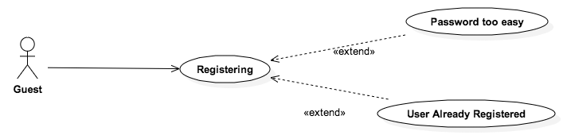

|  |  |
| --- | --- |
| **Name** | **Registering** |
| **Actors** | Guest |
| **Entry Conditions** | The visitor must be in the MeteoCal Home Page. |
| **Flow of Events** | * The Guest clicks on the “Register” link in the Home Page. * The Guest is redirected to a form where he’ll be able to enter all the information needed by the system. * The Guest correctly compiles the form. * The Guest pushes the button “Register”. |
| **Exit Conditions** | The Guest is redirected to MeteoCal’s Home Page where he will now be able to login. A new user is registered in the database |
| **Exceptions** | * If one of the information entered by the Guest is unacceptable an error message is shown. * If the password chosen by the guest doesn’t respect the System standards an error message is shown. |

### 7.1.2 Log In

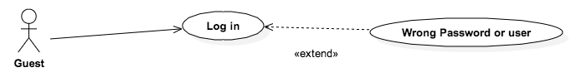

|  |  |
| --- | --- |
| **Name** | **Log In** |
| **Actors** | Guest |
| **Entry Conditions** | The guest must be in the MeteoCal Home Page. |
| **Flow of Events** | * The guest inserts his e-mail and password in the appropriate fields and clicks submit. * The system checks the correctness of the data inserted. |
| **Exit Conditions** | None. |
| **Exceptions** | If the guest inserts incorrect e-mail or password an error page is loaded. |

### 7.1.3 Profile Managing

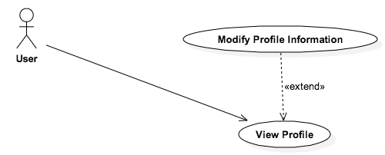

|  |  |
| --- | --- |
| **Name** | **View Profile** |
| **Actors** | User |
| **Entry Conditions** | The user must be in his Home Page. |
| **Flow of Events** | * The user clicks on his name in his home page. * The system loads the profile page of the user. |
| **Exit Conditions** | None. |
| **Exceptions** | None. |

|  |  |
| --- | --- |
| **Name** | **Modify Profile Information** |
| **Actors** | User |
| **Entry Conditions** | The user must be in his profile page. |
| **Flow of Events** | * The user clicks on the button in charge of allowing the modification of profile information. * The system reloads the profile page of the user allowing the modification of user’s information. * The user changes his personal information such as name, surname, e-mail, password etc. * The user clicks save. * The system uploads the user’s information. |
| **Exit Conditions** | The profile page of the user is reloaded with the new information. |
| **Exceptions** | If the user inserts some wrong information or forgets to complete some fields the system an error message is loaded. |

### Mac OS X:Users:Filippo:Documents:Calendar Managing.png7.1.4 Calendar Managing

|  |  |
| --- | --- |
| **Name** | **Change the calendar view** |
| **Actors** | User |
| **Entry Conditions** | The user must be in his Home Page. |
| **Flow of Events** | * The User chooses the view he wants to see through the slider upon the calendar. * The System reloads the calendar with the chosen view. |
| **Exit Conditions** | None. |
| **Exceptions** | None. |

|  |  |
| --- | --- |
| **Name** | **Select the visible calendars** |
| **Actors** | User |
| **Entry Conditions** | The user must be in his Home Page. |
| **Flow of Events** | * The User chooses the calendars he wants to be shown in the calendar main page through the checkboxes in the left bar of the page. * The System reloads the calendar hiding and showing the proper events. |
| **Exit Conditions** | None. |
| **Exceptions** | None. |

|  |  |
| --- | --- |
| **Name** | **Change a calendar privacy settings** |
| **Actors** | User |
| **Entry Conditions** | The user must be in his Home Page. |
| **Flow of Events** | * The User clicks on the name of one of his calendar in the checkboxes list in the left bar. * The System redirects the user to a page that shows the information about that calendar. * The user changes the privacy settings through a radio button in the page (choosing public or private). * The user pushes the “Save” button. |
| **Exit Conditions** | * The System redirects the user to his Home Page and the new information is stored. |
| **Exceptions** | * The user exits the page without pushing the “Save” button. In this case the information is discarded. |

|  |  |
| --- | --- |
| **Name** | **Delete a Calendar** |
| **Actors** | User |
| **Entry Conditions** | The user must be in his Home Page. |
| **Flow of Events** | * The User clicks on the name of one of his calendar in the checkboxes list in the left bar. * The System redirects the user to a page that shows the information about that calendar. * The User pushes the “Delete Calendar” button. * The System asks the user, using a popup, if he’s sure he wants to delete that calendar and drop all the events on it. * The user selects “Yes”. |
| **Exit Conditions** | * The System redirects the user to his home page, the calendar is deleted from the database and all the events attached to it are removed, notifying the other participant users if necessary. |
| **Exceptions** | * The user exits the page without pushing the “Delete Calendar” button. In this case nothing changes in the system. * The user selects “No” when asked if he’s sure. In this case he remains in the calendar information page and the calendar is not deleted. |

|  |  |
| --- | --- |
| **Name** | **Create a Calendar** |
| **Actors** | User |
| **Entry Conditions** | The user must be in his Home Page. |
| **Flow of Events** | * The User clicks on the plus sign under the last calendar checkbox in the left bar. * The User is redirected to a form where he will insert the information about the new calendar. * The User inserts all the information needed. * The User clicks on the “Create” button. |
| **Exit Conditions** | The user is redirected to his Home Page, the new calendar is created and it will be visible in the left bar. |
| **Exceptions** | * The user exits the page without pushing the “Create” button. In this case the information is discarded. |

### 7.1.5 MANAGE EVENTS

# Macintosh SSD:Users:Andrea:Desktop:Event Managing.png

|  |  |
| --- | --- |
| **Name** | **Create Event** |
| **Actors** | User |
| **Entry Conditions** | The user must be in his home page. |
| **Flow of Events** | * The user clicks on the button that allows creating event. * The system shows him the page in charge of creating events. * The user must choose the event type, invoking the Choose Event Type use case, the privacy settings, invoking the Choose Privacy Settings use case, and the calendar, which the event belongs to, invoking the Choose Calendar use case. * The user clicks create. * The system adds the event to the user’s calendar. |
| **Exit Conditions** | The user is redirected to his home page. |
| **Exceptions** | In case the user does something wrong, such as not select an event type, the privacy preferences or the calendar, an error message is displayed. |

|  |  |
| --- | --- |
| **Name** | **Change Event Information** |
| **Actors** | User |
| **Entry Conditions** | The User must be in his home page or in the notification menu. |
| **Flow of Events** | * If the user is in his home page he must select one of the events from one of his calendar. If he is the notification menu he must clicks on postpone, invoking the Postpone From Notification use case. * The system shows a page that allows the user to modifying event information. * The user can change the event information. In particular, he can change the privacy preferences, invoking Choose Privacy Setting use case, the event type, invoking the Choose Event Type use case, and the calendar, which the event belongs to, invoking the Choose Calendar use case. He can also delete an event invoking the Delete Event use case. * The user clicks save or delete. * The system modifies the event information in the database. * The system notifies all the participants of the event about the modification or the deletion. |
| **Exit Conditions** | The user’s home page is loaded. |
| **Exceptions** | In case the user commits something wrong, such as not select an event type, the privacy preferences or the calendar, an error message is displayed. |

|  |  |
| --- | --- |
| **Name** | **Choose Privacy Settings** |
| **Actors** | User |
| **Entry Conditions** | The User must be in the page that allows creating or modifying event. |
| **Flow of Events** | * The user chooses the privacy preferences of the event he is creating. * The user clicks save. * The system sets the privacy settings according to the user’s preferences. |
| **Exit Conditions** | The home page of the user is loaded. |
| **Exceptions** | None. |

|  |  |
| --- | --- |
| **Name** | **Choose Calendar** |
| **Actors** | User |
| **Entry Conditions** | The User must be in the page that allows creating or modifying event. Otherwise, he must have received an invitation and click on accept in the notification menu. Or he must be in the searching event page, clicking on a public event. |
| **Flow of Events** | * The user chooses the calendar, which will contains the event he is creating, adding or modifying. * The user clicks save. * The system adds the event to the selected calendar. |
| **Exit Conditions** | The user’s home page is loaded. |
| **Exceptions** | If no calendar is selected an error message is shown. |

|  |  |
| --- | --- |
| **Name** | **Choose Event Type** |
| **Actors** | User |
| **Entry Conditions** | The User must be in the page that allows creating or modifying event. |
| **Flow of Events** | * The user chooses the event type among the default ones or he creates a new event type, invoking the create event type use case. * The user clicks save. * The system associates the selected event type to the event. |
| **Exit Conditions** | The user’s home page is loaded. |
| **Exceptions** | If no event type is selected an error message is shown. |

|  |  |
| --- | --- |
| **Name** | **Create New Event Type** |
| **Actors** | User |
| **Entry Conditions** | The User must be in the page that allows creating or modifying event and he is adding an event type to the event. |
| **Flow of Events** | * The user chooses to insert a personalized event type. * The system loads a list of event type already created by the user and a form that allows creating new event type. * The user must complete the following fields: event type name and best weather conditions. * The user clicks create * The system adds the new event type to the event type available when the user is creating an event. |
| **Exit Conditions** | The form is closed and the user is in the page where he was before: creation event page or modifying event page. |
| **Exceptions** | If the user put some incorrect information in one of the fields such as an already existent event name, a not valid name or he forgets to select the best weather conditions the system shows an error message. |

|  |  |
| --- | --- |
| **Name** | **Postpone From Notification** |
| **Actors** | User |
| **Entry Conditions** | The User must be in the notification menu. |
| **Flow of Events** | * The user clicks on the link postpone or on the link select another, which is present in a notification about bad weather conditions. * If the user has clicked select another date the system loads a form where the user can change the event date. * The user clicks postpone. * The system modifies the event sending a notification to all the participants. |
| **Exit Conditions** | The user’s notification menu is reloaded. |
| **Exceptions** | If the user selects an invalid date an error message is shown. |

|  |  |
| --- | --- |
| **Name** | **Delete Event** |
| **Actors** | User |
| **Entry Conditions** | User home page. |
| **Flow of Events** | * The user must select one of his events. * The system loads the page that allows modifying events. * The user clicks on delete. * The system notifies all the participants about the deletion. * The system deletes the event from the user’s calendar. |
| **Exit Conditions** | The user’s home page is loaded. |
| **Exceptions** | None |

|  |  |
| --- | --- |
| **Name** | **Decline Event Invite** |
| **Actors** | User |
| **Entry Conditions** | The user must be in the notification menu. |
| **Flow of Events** | * The user clicks on the decline option in the notification menu. * The system notifies the one who has invited the user about the decision. |
| **Exit Conditions** | The notification menu is reloaded. |
| **Exceptions** | None. |

|  |  |
| --- | --- |
| **Name** | **Accept Event Invite** |
| **Actors** | User |
| **Entry Conditions** | The user must be in the notification menu. |
| **Flow of Events** | * The user clicks on the accept option in the notification menu. * The system loads a menu that allows choosing the calendar where the user wants to add the event. * The user choose a calendar, invoking the choose calendar use case. * The system notifies the one who has invited the user about the decision. |
| **Exit Conditions** | The notification menu is reloaded. |
| **Exceptions** | If the user does not select a calendar an error message is shown. |

|  |  |
| --- | --- |
| **Name** | **Join Public Event** |
| **Actors** | User |
| **Entry Conditions** | The user must be in the search page. |
| **Flow of Events** | * The user clicks on one of event, which he wants to add to one of his calendars. * The system loads a page that allows selecting the calendar where the user wants the event to be added. * The users must select one of his calendars. * The system adds the selected event to the selected calendar. |
| **Exit Conditions** | The user’s home page is loaded. |
| **Exceptions** | If the user doesn’t select the calendar an error message is shown. |

### 7.1.6 Search of a Public Event or another User

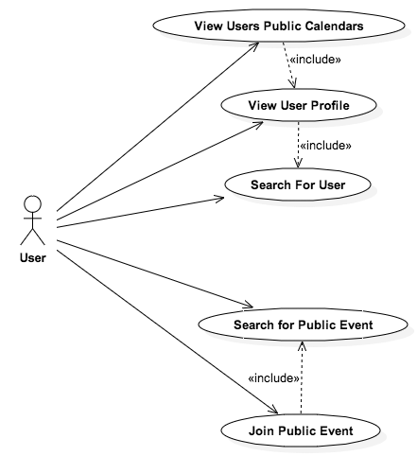

|  |  |
| --- | --- |
| **Name** | **Searching for another User’s Profile Page** |
| **Actors** | User |
| **Entry Conditions** | The User must be in a page where the search bar is visible. |
| **Flow of Events** | * The User types the name or the email of the user he wants to find. * As the User types the System provides him possible matches in a box under the search bar. |
| **Exit Conditions** | The user is redirected to the selected user’s profile page. |
| **Exceptions** | None. |

|  |  |
| --- | --- |
| **Name** | **Viewing another User’s Public Calendars** |
| **Actors** | User |
| **Entry Conditions** | The User must be in the selected user’s profile page. |
| **Flow of Events** | * In the selected user’s profile page the User selects, if available, the public calendar he wants to see by clicking on it in the list provided. |
| **Exit Conditions** | The user is redirected to a page that shows the public calendar in the way previously descripted. |
| **Exceptions** | None. |

|  |  |
| --- | --- |
| **Name** | **Searching for a public event** |
| **Actors** | User |
| **Entry Conditions** | The User must be in a page where the search bar is visible. |
| **Flow of Events** | * The User types the name of the Event he wants to find. * As the User types the System provides him possible matches in a box under the search bar. * When the wanted Event shows up in the box the user clicks on its name. |
| **Exit Conditions** | The Event will eventually show up in the designated box. |
| **Exceptions** | None. |

### Mac OS X:Users:Filippo:Documents:Managing Default Event Types.png7.1.7 Managing Default Event Types

|  |  |
| --- | --- |
| **Name** | **Creating a new Default Event Type** |
| **Actors** | Administrator |
| **Entry Conditions** | The Administrator just logged in and he’s in his home page. |
| **Flow of Events** | * The administrator select the option “Create new Default Event Type” * The System redirects him to a form he can fill with all the information needed. * The Administrator fill in the form, choosing the good and bad weather conditions for the new type of event. * The administrator pushes the “Create” button. |
| **Exit Conditions** | The Administrator is brought back to his default page; the new Default Event Type is saved and is now visible to all the users. |
| **Exceptions** | * The Administrator exits the page without pushing the “Create” button. In this case the information is discarded. |

|  |  |
| --- | --- |
| **Name** | **Modifying an existing Default Event Type** |
| **Actors** | Administrator |
| **Entry Conditions** | The Administrator just logged in and he’s in his home page. |
| **Flow of Events** | * The administrator selects the option “Modify existing Default Event Type”. * The System shows him a list of the existing Default Event Types. * The Administrator chooses the one he wants to modify by clicking on it. * The System redirects him to a page showing the information of the selected Event Type. * The Administrator makes the changes he wants. * The Administrator pushes the “Save” button. |
| **Exit Conditions** | The Administrator is brought back to his default page; the new information about the Default Event Type is stored. |
| **Exceptions** | * The Administrator exits the page without pushing the “Save” button. In this case the information is discarded. |

|  |  |
| --- | --- |
| **Name** | **Removing an existing Default Event Type** |
| **Actors** | Administrator |
| **Entry Conditions** | The Administrator just logged in and he’s in his home page. |
| **Flow of Events** | * The administrator selects the option “Remove Default Event Type”. * The System shows him a list of the existing Default Event Types. * The Administrator chooses the one he wants to remove by clicking on it. * The System asks him a confirmation using a popup. * The Administrator selects “Yes”. |
| **Exit Conditions** | The Administrator is brought back to his default page, the Default Event Type is removed from the Database, all the events using it are changed to an indoor Event Type and the owners are notified. |
| **Exceptions** | * The Administrator clicks “No” when asked if he’s sure. In this case nothing changes in the System. |

# 8.Alloy Model

In this chapter we will analyze our model with the Alloy Analyzer to be sure that it is consistent. Here follows the code used to describe our model in Alloy :

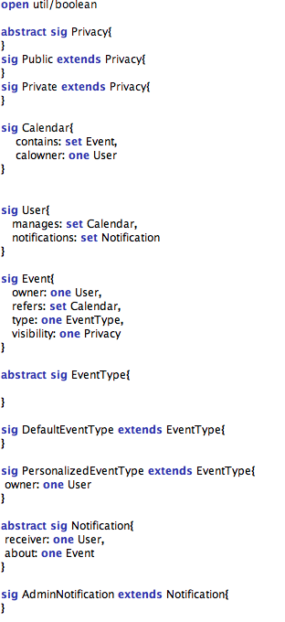

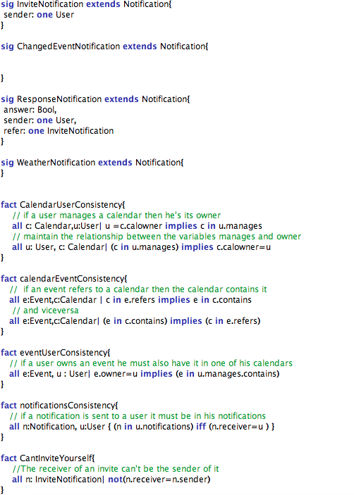

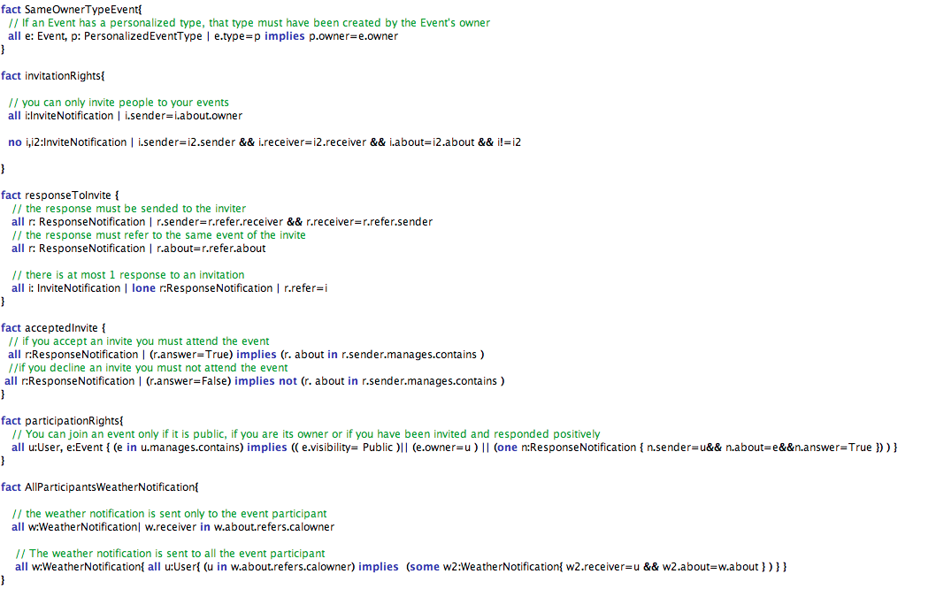

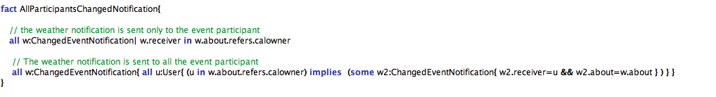

## Assertions

Here are reported some Assertions we made to verify that our model respects its constraints.

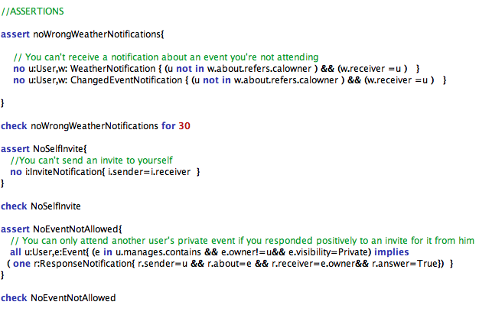The Analyzer as shown verified all of these Assertions:

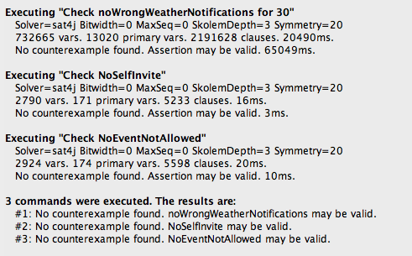

## Predicates and Worlds Generated

Here are stated the few predicates we tried to run in the Analyzer to verify that our model is consistent.

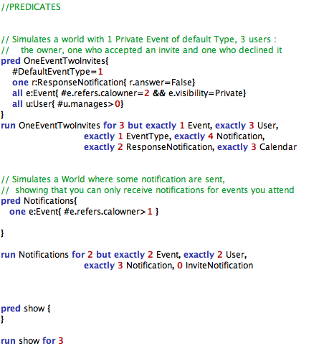

And these are the results:

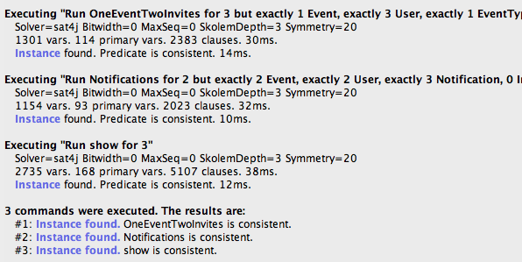

Now the world generated by this predicate will be shown, in these images some of the arrows that indicates the associations have been hidden to make them more understandable.

### World Generated By OneEventTwoInvites

This is the Result of the simulation ran on the predicate OneEventTwoInvites:

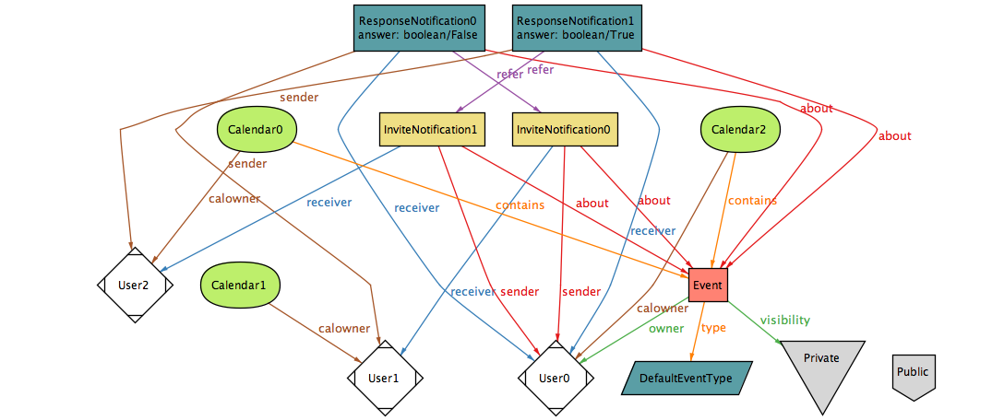Here is shown how a user can be invited to a private event and how only the owner and the user who accepted the invite can add the event to their calendar.

### World Generated by Notifications

In this world we can see how a user can receive only notifications regarding events he is attending: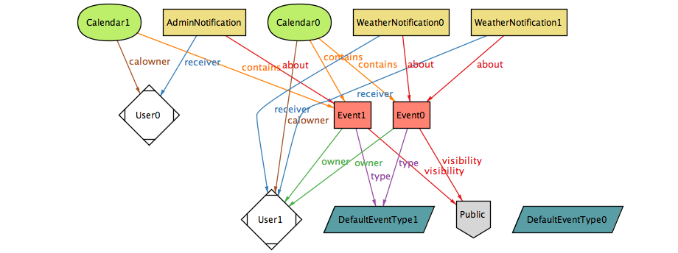

### World Simulation

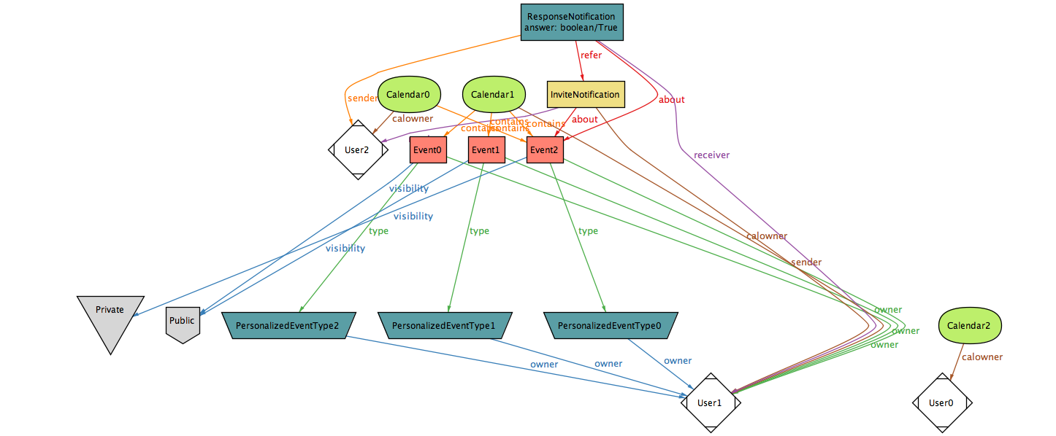And at last this is a small simulation of a possible complete world, the number of instances simulated is quite small because the whole world grows exponentially with respect to them:

Just for completeness the last page is a world generated with a maximum of only 7 instances per object.

