SENG 360 – Assignment 3 - Cryptography

**Introduction to how to use the program:**

**On server side, invoke:**

java SecureChat –server

After starting up, the server will ask for the desired configuration of security options (None, Confidential, Integrity, Authentication).

After waiting for client, enter the message. In this example the message is “Hello World!”

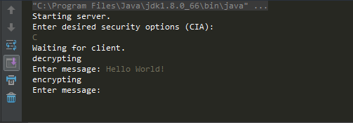

**On client side, invoke:**

java SecureChat –client

After starting up, the client will ask for the desired configuration like above. Enter the configuration

After establishing the connection, the client will receive a message from server and attempt to decrypt it. In this example, it successfully decrypted String “Hello World!”

