**Temă: Aplicație mobilă pentru evidență facturi de achitat**

# DATABASE

## MySQL:

### Database Model

Tabele:

* Bill
* Supplier
* BillType

Bill 🡨MANY-TO-ONE-- Supplier

O firma poate sa emita una sau mai multe facturi si o factura poate sa fie emisa de o singura firma.

Bill 🡨MANY-TO-ONE – BillType

O factura are un singur tip, un tip poate fi detinut de mai multe facturi.

## Firebase

AppUser entity

# DATA MODELS

**Clasa AppUser:**

1. Long id
2. String name
3. String email
4. String password

**Clasa Bill:**

1. Long id
2. Supplier supplier
3. Date dueTo
4. Float sum
5. Boolean payed
6. Boolean recurrent
7. **Enum type**
   1. GAS
   2. ELECTICITY
   3. WATER
   4. RENT
   5. Entertainment
   6. Conectivity
   7. Education
   8. Miscellaneous

**Clasa Supplier:**

1. Long id
2. String name

# ACTIVITIES/FRAGMENTS:

## Login Activity:

1. Login Fragment
2. Register Fragment

<https://www.youtube.com/watch?v=lNx7Rj-HnJ0&t=11s>

<https://github.com/EdvinM/Tutoriale-Android/tree/5b011a3638ed7dc8babd543daa4d29ce7b502b67>

## Main Activity (blue border)

**With NavigationBottomBar :**

### HomeFragment

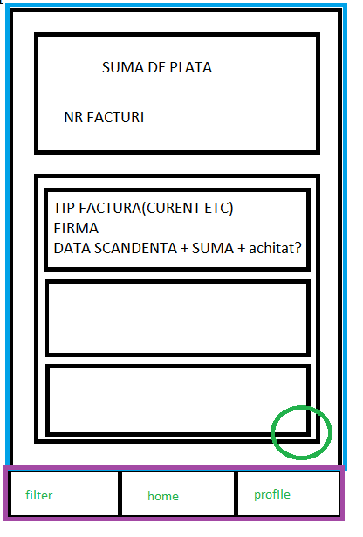

* SumarBox
  + Suma totala de plata pentru facturile neachitate
  + Nr de facturi neachitate
* FacturiListView (se afiseaza doar elementele cu boolean achitat ==false)
  + -> Element:
    - Tip factura
    - Firma / furnizor
    - Data scadenta
    - Suma
    - SLIDER
  + Order by dueTo
  + DREAPTA – STANGA -> achitat/neachitat
  + STANGA-DREAPTA -> Add/Edit Bill Activity
* Button “Mai mult” :
  + Repopuleaza List View cu toate facturile(nu mai tine cont de boolean achitat)
  + Se transforma in “Mai putin” -> Back to initial state
* Button “Adauga factura” deschide Add/Edit Bill Activity:

### FilterFragment

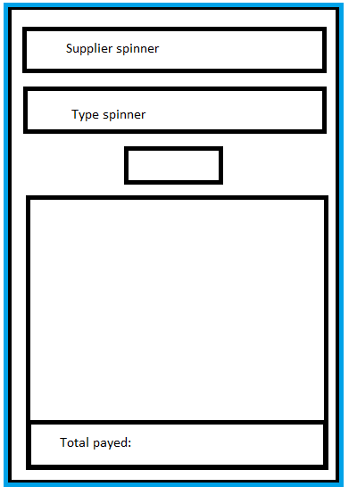

* 1. Supplier spinner -> DEFAULT ALL
  2. Type Spinner -> DEFAULT ALL
  3. Sum slider?
  4. Button Filter
  5. ListView -> created by filters.

### ProfileFragment

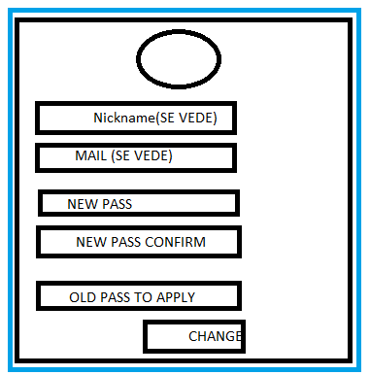

## Add/Edit Bill Activity

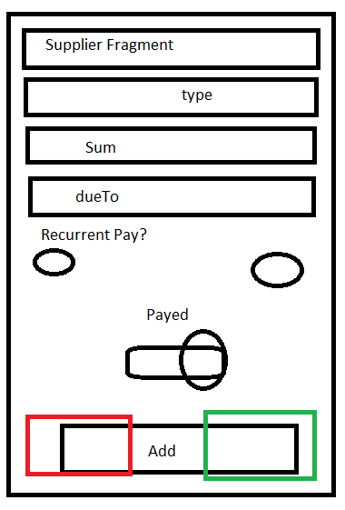

* + Are un ??? **3. Supplier fragment**:

Y/N:

Y-> Insert new name -> Create Supplier

N -> Select supplier from spinner

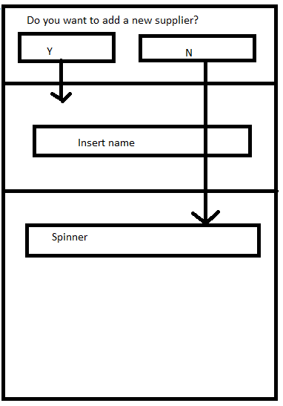

* + BillType Spinner
  + Sum
  + dueTo (date Picker)
  + radio button (Recurrent)
  + sliding button (payed)
  + Add Button (Add Activity)
  + Delete/Confirm buttons (Edit Activity)