iQuest People Resource Allocation
Vision document

Authors: Ovidiu Pop (Ovidiu.Pop@cs.utcluj.ro)
Document Number: 1
Version: 1.0
Publish Date:

Record of Processing
No. | Version | Date | Status | Who | Description
1 | 1.0.1 | 2017-01-19 |  | OP | Document first draft
2 | 1.0.2 | 2017-01-21 |  | OP | Features description and draft completion
3 | 1.0.3 | 2017-01-27 |  | OP | Revision for baseline 1.0
4 | 1.0.4 | 2017-02-09 |  | OP | Added search search after unvalidated and desired skills feature
5
6
7

Record of Approval
No. | Version | Date | Who | Description
1 | … | … | …
2
3
4
5
6
7

Recipients of Document
No. | Version | Date of Distribution | Recipients
1 | … | …
2
3
4
5
6
7
Table of Contents
1. Introduction 4
1.1 References 4
2. Positioning 4
2.1 Problem Statement 4
2.2 Product Position Statement 4
3. Stakeholder and User Descriptions 5
3.1 Stakeholder Summary 5
3.2 User Summary 5
3.3 User Environment 6
3.3.1 Users 6
3.3.2 Time limits 7
3.3.3 Collaboration 7
3.3.4 Infrastructure 7
3.4 Summary of Key Stakeholder or User Needs 7
3.5 Alternatives and Competition 7
4. Product Overview 7
4.1 Product Perspective 8
4.2 Assumptions and Dependencies 8
5. Product Features 8
5.1 FEAT HR01: Skill Matrix Management 8
5.2 FEAT HR08. Skill Types 8
5.3 FEAT HR09 Search 8
5.4 FEAT HR02: Clients Management 8
5.5 FEAT HR03: Project Management 9
5.6 FEAT HR04: Project resource allocation 9
5.7 FEAT HR05: Scenarios 9
5.8 FEAT HR06: Resources allocation forecasts 9
5.9 FEAT HR07: Reporting 9
6. Other Product Requirements 9
6.1 High Visual Application 9
6.2 Usability 9
6.3 Open 9
6.4 PASSME Requirements Brief 10
6.4.1 Performance 10
6.4.2 Availability 10
6.4.3 Security 10
6.4.4 Scalability 10
6.4.5 Maintainability 10
6.4.6 Extendibility 10
6.5 Documentation 10

Vision document

Introduction
The purpose of this document is to collect, analyze, and define high-level needs and features of the Human Resources Allocation (HR henceforward) It focuses on the capabilities needed by the stakeholders and the target users, and why these needs exist. The details of how the HR fulfils these needs are detailed in the use-case and supplementary specifications.

References
This document references
- HR Stakeholder Requests
- HR Requirements Glossary
- HR Business Rules and Entities
- HR Use Case Model.mdl

Positioning

Problem Statement
As the company grows towards an enterprise the resource allocation problem and resources statistics for evaluating future requirements become a bottleneck in company operations as more and more effort is required for this task.
The problem of | Resource allocation per project and resources timesheets
affects | Company CEO and operation department
the impact of which is | Difficult resource allocation, identification of skills and occupation statistics
a successful solution would be | Able to keep project attributes and to keep track of resources skills  Easy to use  Easy to maintain  Leverage the existing systems, i.e. Human Resource Management System  Allow multiple allocation scenarios in a project centric manner  High visual information

Product Position Statement
The HR project is evolving towards a full Human Resource Management system for large enterprises.
In this context an extension that supports resource allocation for a project and timesheet evidence is becoming necessary.
The ABC Ltd. company is encountering difficulties and spending unnecessary overtime in resource allocation per project task and in identifying resources with the right skills for a project. This results in delays and potential business loss.
For | ABC Ltd.
Who | Needs and easy to use resource allocation per project utility, timesheets and resource skills tracking
The HR Resource Allocation | is an extension to Human Resource Management System that supports resource allocation on projects according to the project profile and user configured criteria
That | Helps managing resources and facilitates resource allocation on projects
Unlike | Manual resource allocation
Our product | Will be easy to use and accurate

Stakeholder and User Descriptions

Stakeholder Summary
Name | Description | Responsibilities
John Smith | CEO, technical and business background, is interested in having a user friendly application to manage resources | Project sponsor and main stakeholder  He is responsible for company management and client account management
George Dole | Software Department Manager, technical, is interested in an on line resource allocation system | Software Development Director  Responsible for managing the operation of the Software Development Department
Project Manager | Technical, manages project activities and allocated resources | Responsible for delivering project on time and within budget
Human Resource Manger | n/a | Responsible for managing human resources and to ensure that
Alex Johnson | HR Project Manager. Technical, leads the development effort of the current application. | Responsible for delivering the right features of the current module within time and budget

User Summary
The users discussed in the Vision document are presented in the bellow diagram (from Use Case Model).
It can be observed that all users extend the Authenticated User which is the user with login rights.
In addition the module users have access rights to the specific Use Cases.
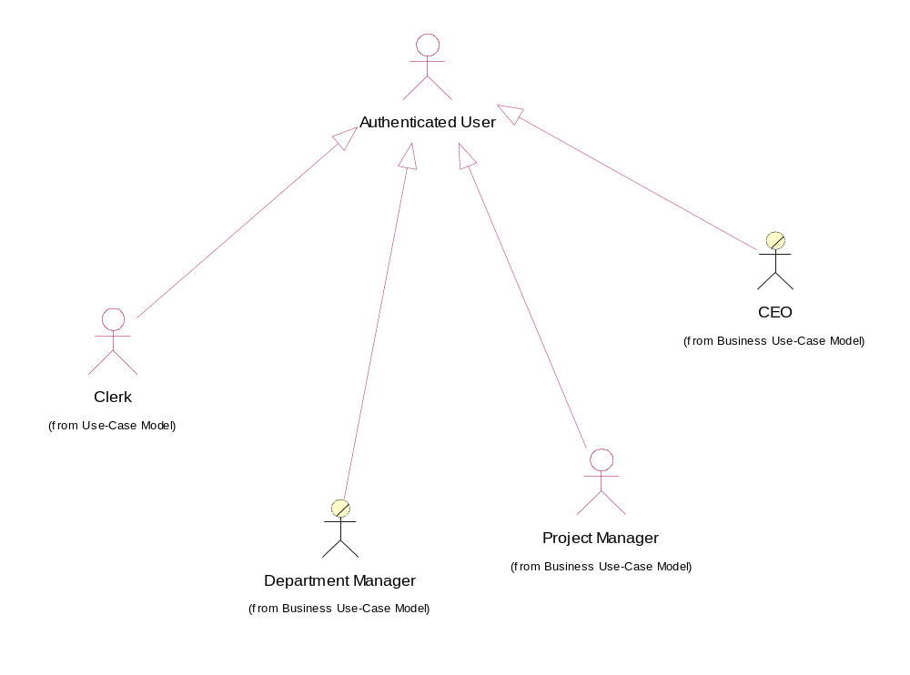
Name | Description | Responsibilities | Stakeholder
Authenticated User | User with login credentials to use the system | Is always extended by other roles | HR Project Manager
Clerk | User with minimum rights | Shall input and maintain data and capture details | HR Project Manager
Department Manager | Performs resource allocation tasks and resource planning | Coordinates department activities and manages the department resources | George Dole
Project Manager | Technical person who manages the resources allocated to the project he is leading | Responsible for delivering projects on time and within budget | PM
CEO | Has technical and business background, is interested in having a user friendly application to manage resources | Project sponsor and main stakeholder  Responsible for company management and account management | John Smith

User Environment

Users
The module will be operated by an average of 25 concurrent users.

Time limits
For the resource allocation task there is no predictable time limit. The operation can be done in several iterations.

Collaboration
Several people can be involved in the tasks that could be performed through this application module, i.e. Projects could be added by the CEO and detailed by a clerk.

Infrastructure
The OS Platforms on the user side are various versions of Windows with the latest service packs. The application will run on IE 5.0 or greater with the latest service packs.
In the future, mobile client compatibility shall be offered.
On the server side, the module should run on any platform supporting MS SQL Server 2000 and the .NET Framework.
It is ABC Ltd. goals to keep compliance with future developments of the OS and to provide compatibility with more browsers according to their market presence.

Summary of Key Stakeholder or User Needs

Need | Priority | Concerns
Skill Matrix | 2 | CEO, HR
Resource Allocation | 0 | CEO, PM
Project Progress Monitoring | 2 | CEO, PM
Project Staffing Monitoring | 1 | CEO, PM
Resources Forecast | 1 | CEO
Usability | 0 | CEO
Reporting | 2 | All
Clients Invoicing and Contract Management | 1 | CEO

Alternatives and Competition
External competition is represented by all existing HRM systems.

Product Overview
The HR module should provide functionality for easy resource allocation to projects and projects staffing management.
It should be designed as a stand alone application.

Product Perspective
The product will extend the existing features,making it more usable and attractive to potential customers.

Assumptions and Dependencies
Server side;
.NET Framework 1.1 or later
IIS 5.1 or later
MS SQL Server
MS Internet Explorer Web Controls
Client side
IE 5.5 or later

Product Features

FEAT HR01: Skill Matrix Management
The product shall contain the skill matrix for the human resources available in the company. It should be able to import the resources and their skill matrix from other applications.

FEAT HR02: Clients Management
The application will store client general information and will offer CRUD (Create/Read/Update/Delete) functionality for this entity. This includes also address information and contacts.
Client management should be able to accommodate future tracking of contracts and invoicing and integration with a financial system.

FEAT HR03: Project Management
The application will store the current projects as workflows in the existing system and the HR will offer CRUD functionality for projects. The resources allocation and scenarios are project centric.
Project flows can be linked to financial flows that will keep invoicing information related to projects and clients.

FEAT HR04: Project resource allocation
The application will keep a list of all projects in the company with required resources and skills as well as with forecasted resources required.
Resources shall be allocated per project, as a pool, and shall be further grouped on project phases according to specific phase requirements.

FEAT HR05: Scenarios
The system should be able to support the configuration of complex allocation scenarios, including resources allocation/de-allocation, save scenarios in intermediate states, open older scenarios, update old scenarios according to actual allocation data, and do recursive resource allocation and de-allocation.

FEAT HR06: Resources allocation forecasts
Per project and per client a pool of forecasted resources and skills should be kept. This will enable the company HRM to take the appropriate actions for either recruitment or training.

FEAT HR07: Reporting
Various reporting capabilities should be supported.
Reports should be detail able to resource level and project level and should consolidate up to corporate level.

FEAT HR08. Skill Types
The skill matrix should allow more skill types:
- Validated = skill proven during the project activity
- Claimed = skills claimed by the resource but not validated in the development porcess
- Desired = skills a resource would like to develop in project activity

FEAT HR09 Search
The system should permit search for resources using several crteria:
- Category and level
- Skills and ranks
- Availability
- Claimed skills
- Desired skills

Other Product Requirements

High Visual Application
The application UI should be very suggestive, i.e. project status from the staffing point of view should be visualized in different colours

Usability
The user interface shall be very easy to use and intuitive. Two goals should be strived for:
  - one click away functionality
  - intuitive interface – zero training

Open
The module shall preserve an open architecture and the ability to include further enhancement requirements.
It should be designed to work with the next extension, the Timesheets module and to integrate with future systems like a FIS and other future corporate application.

PASSME Requirements Brief

Performance
The application performance shall be measured in:
- Response times
- Revenue from increased control in Resource Allocation
- Better planning and estimations of future resources requirements

Availability
The application should be available during the company’s working hours. Maintenance tasks and application downtime shall not exceed 2hours per week and shall be outside working hours.

Security
Data stored in the system is highly sensitive and of personal nature. The system shall provide both data integrity and confidentiality at state of the art level.
This will include transactional data processing, backup policy guidelines and sensitive information encryption.

Scalability
The HR module shall be able to accommodate more resources and additional demands without changing the application.

Maintainability
HR shall have common administration with the existing system. Ideally, future integrated security shall be developed.

Extendibility
The application should be able to accommodate more functionality as the company expectations grow.

Documentation
An Administration Guide and a User Guide should be developed in both .pdf and .chm formats.

