**WHAT IS OOP**

OOP is a style of programming or paradigm centered around objects rather than functions.

There are several programming languages that support this style: C#, Java, Python, JavaScript.

**4 Pillars of Object-oriented Programming:**

**Encapsulation,**

**Abstraction,**

**Inheritance,**

**Polymorphism.**

**BENEFITS OF OOP**

Using Encapsulation we group related variables and functions together and this way we can reduce complexity.

With Abstraction we hide the details and the complexity and show only the essentials.

With Inheritance we eliminate redundant code.

With Polymorphism we refactor ugly switch case statements.

**Encapsulation**

Before OOP, we had procedural programming that divided a program into a set of functions. As your program grows, you end up with a bunch of functions and you might find yourself copying and pasting lines of code repeatedly. That's what we call **spaghetti code.**

OOP solves this problem by combining a group of related variables and functions into a unit, called object. We refer to these variables as properties and the functions as methods.

In OOP we group related variables and functions that operate on them into objects. This is what we call **encapsulation.**

**Commit - procedural-vs-oop**

**GetWage** from employee object has no parameters, this is because all the parameters are modeled as properties of this object. These properties and getWage function are related and so part of one unit.

**Abstraction**

**ABSTRACTION -** is the process of hiding the details and showing only the essentials.

This gives us a couple of benefits.

1. Simpler Interface. Understanding an object with a few properties and methods is much simpler.

2. Reduce the impact of change. You can make changes and none of those changes will have an impact on the application.

**Inheritance**

**Inheritance** is a mechanism in which one object acquires all the properties and behaviors of a parent object. When you **inherit** from an existing class, you can reuse methods and fields of the parent class.

**Polymorphism**

**Polymorphism** means many forms. It's a technique that allows you to get rid of long if and else or switch and case statements.

With OOp we can implement a render method in each of these objects, and this method will behave differently depending on the object we are referencing.

**Object Literals - slide**

Object literal is a simple way to define an object. But we can also define objects using factories and constructors.

**Factories - slide**

Imagine we want to create another circle. With the current implementation we have to duplicate all this code.

If an object has one or more methods, we say that that object has behavior. So, if an object has behavior it’s an issue to create it using object literal syntax.

The solution is to use a factory or a constructor function.

**Constructor functions -slide, then code**

There’s another way to create an object, using a constructor function. It’s like defining a class in other languages, but in JS we don’t have classes.

Inside we use “this” keywork to set the properties of this object. We use the “new” keyword to create an object and this refers to that object.

When using new a few things happen under the hood. (1) New creates an empty object, then (2) it will set this to point to that object, and finally (3) it will return that object from Circle function. We don’t have an explicit return statement.

If you don’t use the new keyboard when creating an object from a constructor function, then this defines those variables on the global object (window object).

If we return an object from a function, we refer to that function as a factory function.

In contrast, if we use this keyword with the new operator, we refer to that function as a constructor function.

As a developer you should be familiar with both those patterns.

**Constructor property**

Every object in JS has a property called constructor, and that references the function that was used to construct or create that object.

Object is a built in constructor function. When creating an object using the object literal syntax, internally JS engine uses this constructor function.

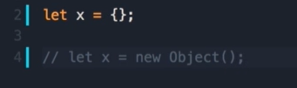

**Functions are objects**

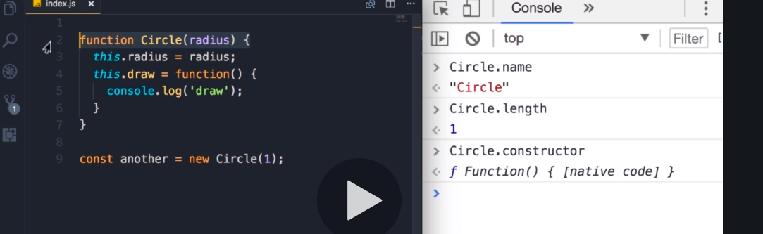

Here we see another built-in constructor called Function. When we declare a function using **“function name() {}”** syntax, internally JS engine will use this function constructor to create this object (Circle).

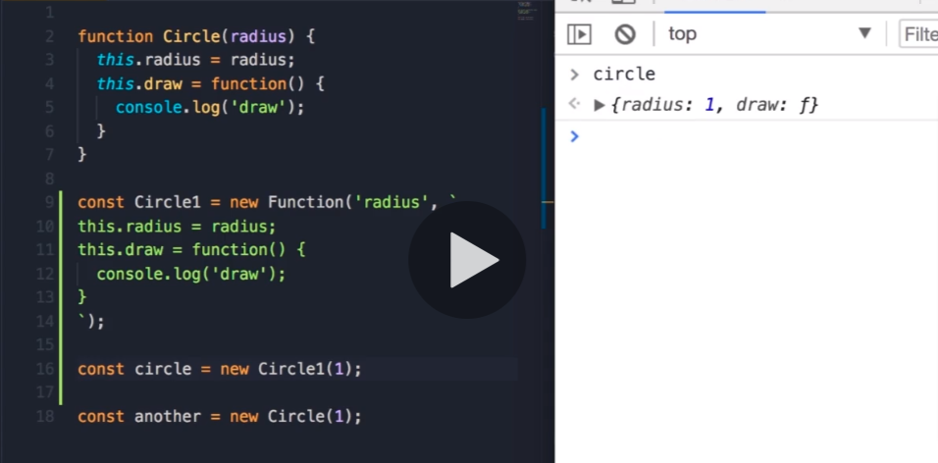

By using new operator, internally it will create a new object and pass it as the first argument to the call method. And this object will determine the context (this).

If you’re not using the new operator, then this will reference the global object window.

**The take away is, in JS functions are objects.**

**Adding or removing properties**

Every object created by the constructor functions is dynamic, which means that after creation you can add or delete properties from them. And you can do that whenever you like. This makes JS very powerful and easy to work with. For such scenarios to work in Java you have to go back and change your class.

Use the bracket notation when you want to access dynamically a property name.

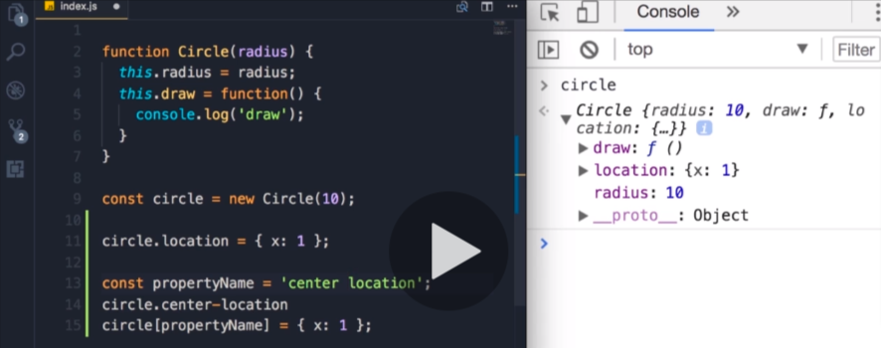

Another use-case is when you have property names that are not valid notation identifiers.

You can also delete properties. For example, when you have on the server a certain object that contains properties you don’t want to send to the client.

delete circle.location

**Abstraction**

Abstraction means, we should hide the details and show only the essentials.

**Code.... abstraction.js**

In this example, we should hide defaultLocation and computeOptimumLocation. These are implementation details, part of the complexity of this object. We must hide them from the consumer of this object.

If you refuse to comply with this concept, you’ll encounter a number of issues:

Every time you change the implementation of that object, you have to modify many different places in your code.

**Private Properties and Methods**

By defining local variables and methods, you can easily hide them from the outside.

**Code... privatePropsMeths.js**

So, the public interface of this object is simpler to work with.

**Getters and setters - gettersSetters.js**

defaultLocation and computeOptimumLocation are not private members of the circle object, they are just local variables. But what if somewhere in our application we want to access those variables?

One way is using Object.defineProperty.

! Check positive and negative for setting a value.

**Inheritance - createInheritance.js**

Inheritance is one of the core concepts of OOP. It enables an object to take on the properties and methods of another object. Inheritance enables code reusability.

We can create a new class called Shape, put this method there and have Circle and Square classes inherit this method from the Shape class.

IS-A relationship – We say Circle is a Shape or Square is a Shape.

This is the classical definition of inheritance. But in JS we don’t have classes.

This is when prototypical inheritance comes into picture.

We refer to shape object as the prototype. So, a prototype is a parent of another object.

When you hear the word prototype, just think, parent.

Every object created in JS inherits from Object. Object is the root of all objects in JS and it doesn’t have a prototype/parent.

By calling x.toString() JS engine searches for this method on our object itself. If it cannot find it, it will look at the prototype of that object all the way up to the object base. So JS walks the prototype chain to find that method.



**Multi-level inheritance - slide**

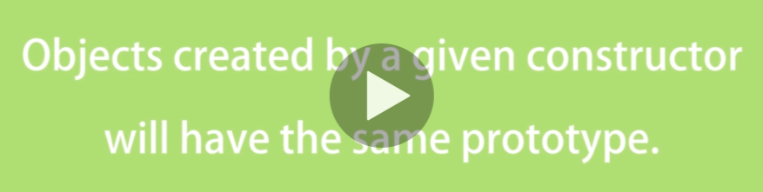

All circle objects created by the circle constructor will have the same prototype.

Circle object inherits from Circle base and Circle base inherits from Object base.

(another example is by creating an array, which inherits from Array, which itself inherits from root Object);

**Prototype vs Instance members**

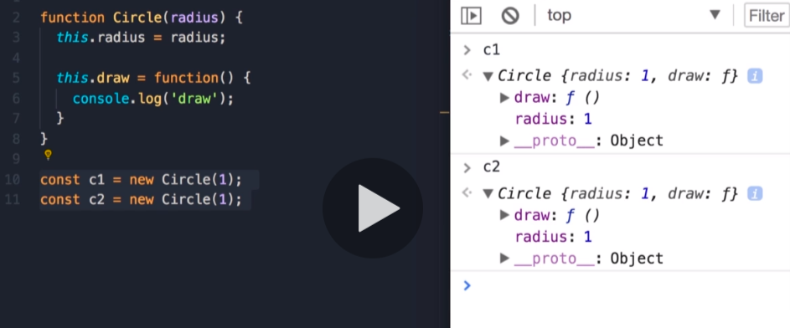

Both c1 and c2 have a draw method. If we have 1000 circle objects in memory, we are going to have 1000 copies of the draw method. You are wasting a lot of memory by keeping copies of this method.

You know how prototypical inheritance works. When we access a property or a method on an object, JS engine looks up the object itself. If it cannot find that property/method, it will look at the prototype of that object.

So, we can take this draw method out of the Circle object and put it in its prototype. We are going to have a single instance of this method in memory.

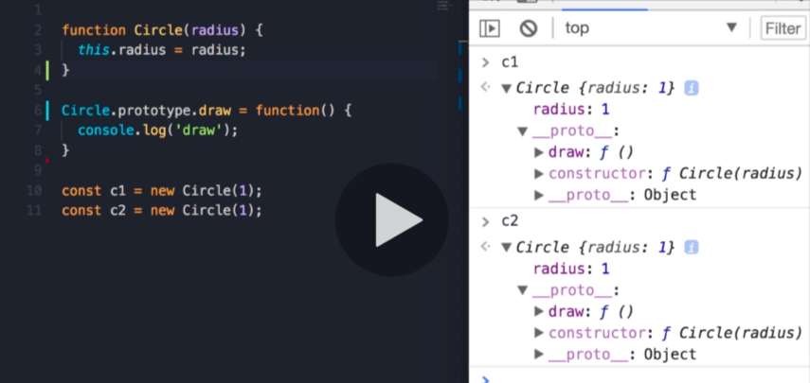

So, we have two kinds of properties and methods in JS:

Instance members, and prototype members.

**Create your own prototypical inheritance. - createInheritance.js**

Add another method duplicate to the prototype of Circle. Let’s say we need another object square which needs duplicate method with exact same implementation. We don’t want to repeat the same method. Instead, we want to use inheritance. We create a Shape object and put the duplicate method there and then have Circle and Square inherit from it.

**Code... - createInheritance.js**

Object.create creates and object which inherits from Shape base. Before this change, the prototype of Circle was Circle.prototype = Object.create(Object.prototype).

This is prototypical inheritance in action. When you reset the prototype, make sure to reset the constructor as well.

**Calling the super constructor**

Let’s assume that Shape receives a property called color. How do we set that property to each new instance of Circle constructor?

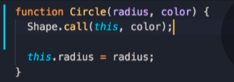

**Polymorphism**

Another very important and powerful concept in oop is Polymorphism.

**Code... polymorphism.js**

So, now in the hierarchy we have on the top the Shape and two derivatives/child objects (Circle, Square). Each object will provide a different implementation of the duplicate method. So, we have many implementations/forms of the duplicate method. That’s what we call polymorphism.

If we create an array with different shapes and iterate over it, depending on the type of the shape object a different implementation/form of the duplicate method will be called.

**When to use inheritance? - slide**

You have to be careful about using it. It can make your code complex and fragile. Start with simple objects, then if you see a number of these objects share similar features, then you can encapsulate those features inside a more generic object and have your other objects inherit from it.

There’s another technique to enable code reuse called **composition**.

We have Animal object with two methods eat and walk. And we have two objects that derive from Animal: Person and Dog. If we add a new object Goldfish that derives also from Animal. We break our code, because Goldfish cannot walk. It can swim.

To solve this problem, we need to **change out hierarchy**. **- slide**

On top should be the Animal object with eat method. Under that Mammal and Fish. Mammals can walk, Fish can swim. And then Person and Dog derive from Mammal and Goldfish derive from Fish.

What would happen if we had 10 different types of animals? The hierarchy will get more and more complex, and we would have to go back and forth to determine the right place to implement a method.

**Favor composition over inheritance - slide**

Instead of inheritance we can define various features for our animals as independent objects.

**Mixins**

In JS we can use Mixins to achieve composition. We can combine these objects together to create a Person that can eat and walk. If we have a Goldfish object, then we can compose canEat and canSwim together to produce it. So, composition or mixin gives us great flexibility.

**Code... mixins.js**

To make the code more readable, we can extract this logic into a function called mixin.

**Es6 Classes**

**ES2015** is a modern version of JS. There is a new way to create objects and implement inheritance using classes. But they are different than classes in Java or C#. In JS classes are syntactic sugar over prototypical inheritance. That’s why we learned about PI first.

**Code... classes/classes.js**

methonds are declared in the body of this class. To demonstrate that Circle is not a class we can use typeof keyword.

**Static methods**

In classical OOP languages we have two types of methods: Instance methods and static methods.

**Code... classes.static.js**

Instance because those methods are available on an instance of a class.

In contrast we have static methods. Static methods are available on the class itself, not the instance. So, to call static methods, we don't need to create an instance of a class. They are used to create utility functions, that are not specific to a given object.

**Getters and Setters**

To implement a getter we create a method which receives the keyword **get** in front of it. It looks like a method, but we can access it like a regular property.

**Code... classes/gettersSetters.js**

**Inheritance**

To have the Circle inherit from the Shape class, all we have to do is add extends Shape. We don’t have to reset the prototype and the constructor.

**Code... classes/inheritance.js**

Let’s imagine all our shapes need a color. If you have a constructor in the Parent class and also have one in the child class, then inside the child constructor you should make sure to call the parent constructor first to initialize the base object. By using the super keyword we reference the parent object.

**Code... classes/inheritance.js (below base example)**

We inherited color from our parent class and we have radius on the circle class itself.