**Internship Project Documentation**

This internship project tested my skills and nerves throughout several days in order to make a deployment of a Django Web App on Google Cloud Platform using technologies such as: Git, Ansible, Docker, Kubernetes, Terraform and Jenkins.

**Table of contents:**

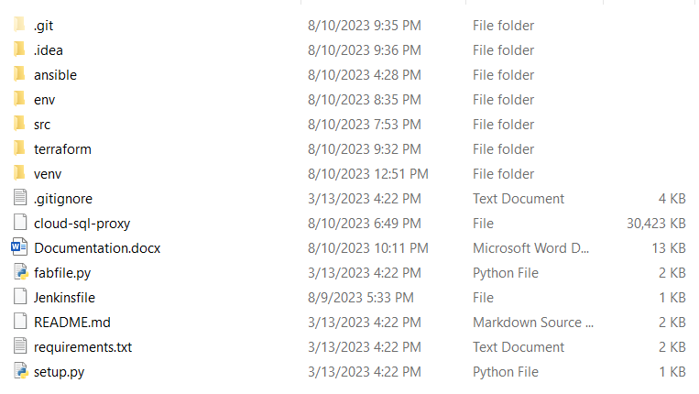

**Terraform:**

1. Install Terraform
2. Google Cloud Credentials
3. Create Terraform Files
4. Define Provider and variables
5. Define GKE Cluster Resource
6. Initialize and apply Terraform Configuration
7. Verify the GKE Cluster (access GCP Console & Kubectl configuration)

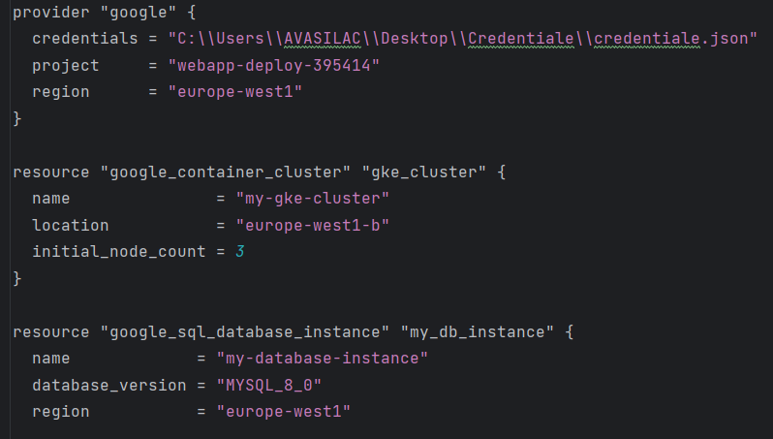

**Deploy a Dockerized Web Application to GKE**

1. Containerize the Web Application
2. Push Docker Image to Container Registry
3. Update Kubernetes Deployment YAML
4. Apply Deployment

**Setting Up a Cloud SQL Database**

1. Create a Cloud SQL Instance
2. Configure Connections
3. Create a Database
4. Connect to Database

**Updating Application Configuration**

1. Update Application Configuration
2. Testing
3. Autoscaling
4. Load Balancing

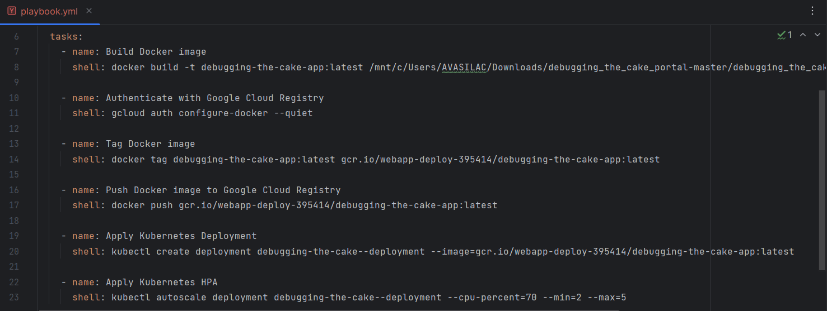

**Implementing a Jenkins CI/CD Pipeline on Jenkins**

1. Install Jenkins
2. Install Required Plugins
3. Set Up Docker Environment
4. Create a New Jenkins Pipeline
5. Configure Pipeline Definition
6. Pipeline Script
7. Jenkinsfile
8. Testing and Deployment
9. Save and Run Pipeline

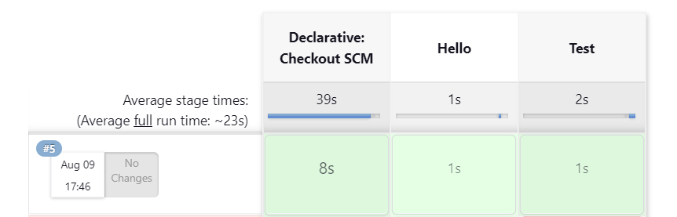

**Configuring VPC Network, Subnets and Firewall Rules**

1. VPC Network Setup
2. Subnets Configuration
3. Firewall Rules
4. Network Tags

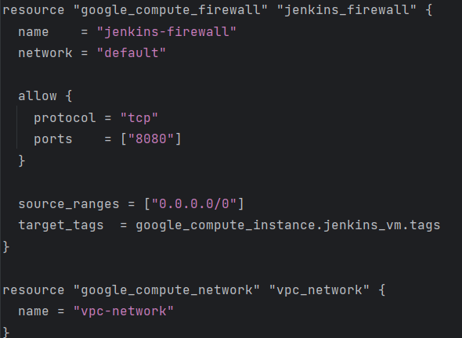

**Setting Up Cloud Monitoring and Alerting**

1. Create a Monitoring Workspace
2. Create Alerting Policies
3. Configure Notification Channels
4. Create Dashboards