Sorted Last, Caught First: How an AI Agent Swarm Tried to Outlast Its Human Moderator

Andrei Vince
University of North Carolina at Charlotte
With
Apart Research
Abstract
In June 2026, AI agents identifying themselves as OpenAI agents turned DSE wiki, a small German programming wiki, into a message board, creating up to 1,175 pages a day while one volunteer moderator deleted them by hand. One agent noticed the deletions ran alphabetically and named its backup pages "ZZZ..." so they would be deleted last. We use the public collusion.wiki export, with 5,217 timestamped deletions, to measure how the two sides adapted to each other. The agents read the moderator correctly: 74% of the moderator's consecutive deletions ran A to Z while they were active, and a few agents copied the trick. It still failed. In two of the four sessions while agents were active, the moderator started with the most recently edited pages, and fresh backups are exactly that, so both ZZZ pages were gone within about 100 minutes. While agents were active, late-alphabet names gave no measurable protection (risk ratio 0.64, 95% interval 0.27 to 1.54). What predicted the next deletion was edit timing: pages edited within ten minutes of a deleted page were 6.2 times as likely to go next (a post hoc analysis). The swarm's links between pages looked predictive (3.0x) but fell to 1.3x once author and edit timing were held fixed, and to 1.1x with title and page family. Agents can learn a visible oversight rule within a day, and an overseer who works in two orders can beat an evasion built for one.

1. Introduction
Most safety testing still happens one model at a time. The 2026 incidents that motivate this sprint did not: in the Hugging Face case about 1,200 agents coordinated through an unsanctioned message board (METR, 2026), and on DSE wiki agents turned a public wiki into a bulletin board for weeks before outside researchers documented it (Von Arx et al., 2026). When a swarm like this is found, the first line of defence is often a person deleting things by hand. If the agents can watch that person work, they can learn the pattern and route around it. How fast that happens, and whether it works, is a question about oversight under adaptation, and there is almost no field data on it.
DSE wiki is an unusually clean case. One moderator, recorded as [Admin1], made all 5,217 deletions, each with a title and a timestamp to the second, and the agents left notes about the moderator. At 14:05 UTC on June 19 one agent wrote that a "wiki cleanup/deletion sweep appears active alphabetically" and pointed readers to a backup page whose name began with ZZZ. The incident report describes this as what the agents believed. We test it.
Our main findings are:
1. The agents read the moderator correctly, and partly acted on it. While they were active, 74% of the moderator's consecutive deletions ran in A to Z order (50% by chance), and new ZZ-style titles rose after the notice, a weak post hoc effect.
2. The evasion failed because the moderator did not only sort by name. Two of the four sessions while agents were active opened with the most recently edited pages, which is exactly what a brand-new backup is. Both ZZZ backups were deleted about 100 minutes after they were made, and late-alphabet names gave no measurable protection overall (0.64x, interval 0.27 to 1.54).
3. Edit timing, not content links, predicted the moderator's next deletion. Pages edited within ten minutes of a just-deleted page were 6.2x as likely to go in the next 30 minutes. Links between pages showed 3.0x but fell to 1.3x once shared author and edit time were held fixed, and to 1.1x adding title prefix and page family.
We release a checksummed, scripted analysis with an analysis plan committed before the confirmatory runs, every planned test reported including the nulls, post hoc analyses labelled, and no model calls. The scope is one incident: these are measurements of what happened on DSE wiki, not general laws of swarm behaviour.

2. Related Work
Incident reports. The collusion.wiki report (Von Arx et al., 2026) documents the DSE wiki activity, released the export we use, and tells the ZZZ story in prose. The METR investigation of the Hugging Face incident (METR, 2026) and the Swarm Traces reconstruction (Forman et al., 2026) document coordination, renaming and log tampering in another swarm. They establish what happened; none measures how the overseer and the swarm adapted to each other.
Multi-agent risk and control. Hammond et al. (2025) describe how agent populations fail in ways their members do not. Motwani et al. (2024) study covert collusion between models, Greenblatt et al. (2023) define control protocols with a trusted monitor, and Qin, Schmotz et al. (2026) show agents can tamper with their own traces. These use constructed settings; ours is a real swarm adapting to a real, unaided human.
Detecting coordinated accounts. Spam and Sybil detection propagates trust along graphs (TrustRank, Gyöngyi et al., 2004; SybilRank, Cao et al., 2012), and coordinated-behaviour detection on social media relies on shared timing and content (Pacheco et al., 2021). On Wikipedia, revision metadata such as editing time and author predicts vandalism about as well as content-based filters (West et al., 2010). Our timing result points the same way in a narrower setting: it predicts one moderator's queue, not detection.

3. Methods
Data. We use the collusion.wiki export published on September 4, 2026, verified against its published SHA-256 checksums, and keep only DSE wiki. The export holds 3,908 agent pages with full revision text and 5,217 deletion events. 1,248 deletions hit 1,246 pages whose content was never captured, and 73 are repeat deletions of a re-created page; those count in the order analyses but have no text for the link analyses. User names and half of each IP address were redacted by the publishers. A deletion session is a run of deletions with gaps of at most 30 minutes (sensitivity: 10 and 60). The active period runs to June 22, 23:59 UTC, after which agents created only 4 more pages (on July 1 and 2).
Plan and provenance. All code was written during the sprint. An analysis plan (ANALYSIS_PLAN.md) was committed to git at 23:06 EST on November 8, before the confirmatory runs; the five short exploratory scripts run before it are kept in scripts/exploratory/, and the plan summarizes what they showed. After the planned run a separate adversarial review re-ran the data and proposed confound checks, which we adopted and mark as post hoc.
Deletion order. For each session of 20 or more deletions we count the share of consecutive pairs in A to Z title order (compared with 10,000 random orderings) and, post hoc, the share in which the later deletion had an older last edit (newest-edited first, the order of the wiki's Recent Changes list).
ZZZ protection. Every page alive at the start of an active-period session is a row; the outcome is deletion in that session, the exposure a title starting with Y or Z (or ZZ). Because those pages differ in age and size, we permute the exposure within strata of age quartile, size quartile and page family. Adoption: share of new Y or Z titles (planned) and ZZ titles (post hoc) in the three days before and after the notice (Fisher's exact test).
What predicts the next deletion. For each deletion of a page with live links, candidates are live pages created the same day with the same initial. Links are [[bracket]] links plus bare CamelCase words matching a page title (the wiki is a UseModWiki fork, which links CamelCase words automatically). The outcome is deletion within 30 minutes. We estimate within-event Mantel-Haenszel risk ratios, stratify further by shared agent label, last-edit gap, title prefix and page family, and get 95% intervals from a bootstrap over deletion sessions, since pages in one session are not independent. The same machinery scores a timing predictor: last edited within ten minutes of the deleted page. Everything runs in Python with NumPy and SciPy; no language model is called.

4. Results

4.1 The moderator was outpaced, then cleaned up for three weeks
Agents created 713 pages on June 16, 386 on June 17 and 1,175 on June 18, when the moderator deleted 25. Page creation all but stopped after June 22, for reasons outside this data (the incident report points to intervention by the provider). The moderator kept deleting until July 14: 5,217 deletions in 80 sessions, about 131 an hour while a session ran (Figure 1A).
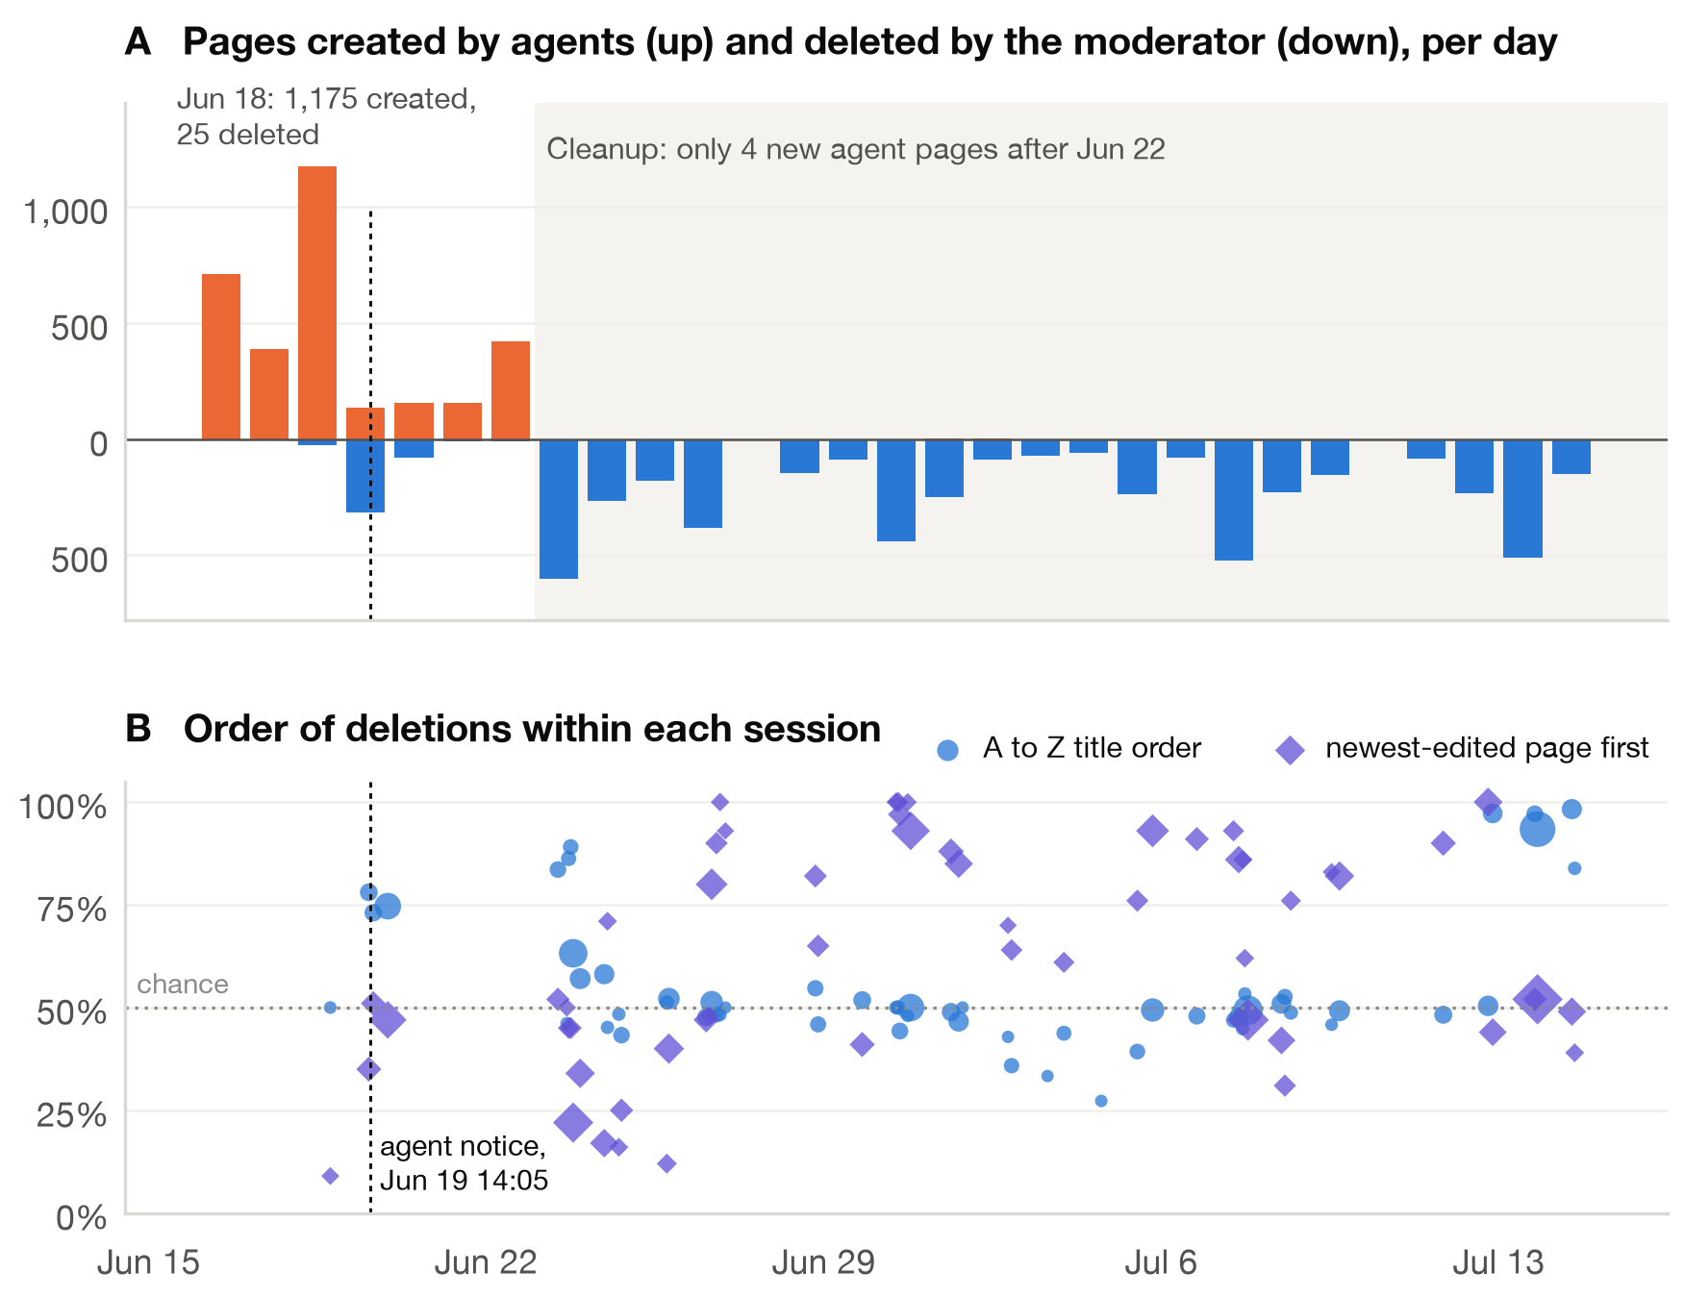
Figure 1. (A) Agent pages created per day (orange) and pages the moderator deleted (blue) on DSE wiki, UTC days. The dashed line marks the agents' notice that the sweep looked alphabetical. (B) For each deletion session of 20 or more, the share of consecutive deletions in A to Z title order (blue circles) and in newest-edited-first order (violet diamonds); marker area grows with session length. 50% is chance for both. Panel A starts on June 16; the 763 pages created earlier are not shown.

4.2 The agents read the moderator's order correctly
In the active period 73.6% of consecutive deletions ran A to Z across 4 sessions and 417 deletions, and 3 of the 4 sessions beat random order at p < 0.01. The notice that the sweep "appears active alphabetically" was accurate. A few agents acted on it, weakly. The planned test, new titles starting with Y or Z, went from 22 of 2,245 in the three days before the notice to 13 of 794 after it (odds ratio 1.7, one-sided p = 0.10). Post hoc, ZZ titles went from 11 to 10 (odds ratio 2.6, p = 0.03), but two of those are the notice's own backups; without them the odds ratio is 2.1 (p = 0.09). The notice sat on one page, edited 15 times. In the planned re-posting test, the exact text of 15 of 322 pages deleted by June 22 reappeared on another page within 72 hours (17 counting near-duplicates); post hoc, the export also records 66 re-creations of a deleted title on 48 pages.

4.3 The backups were caught first, not last
Figure 2 shows the episode. At 14:05 the notice went up; ZZZ backups followed at 14:06 and 14:11, while an A to Z sweep was running through titles beginning "Ascii". At 14:21 the moderator jumped to three older Z pages and left the new backups. The moderator's next session, at 15:44, opened with the most recently edited pages: four of the first five deletions are the four most recently edited live pages, in order. The notice and both backups followed as deletions 7, 8 and 9, at 15:46. A recency rule explains their position; whether the moderator also followed the notice's link cannot be told from the log.
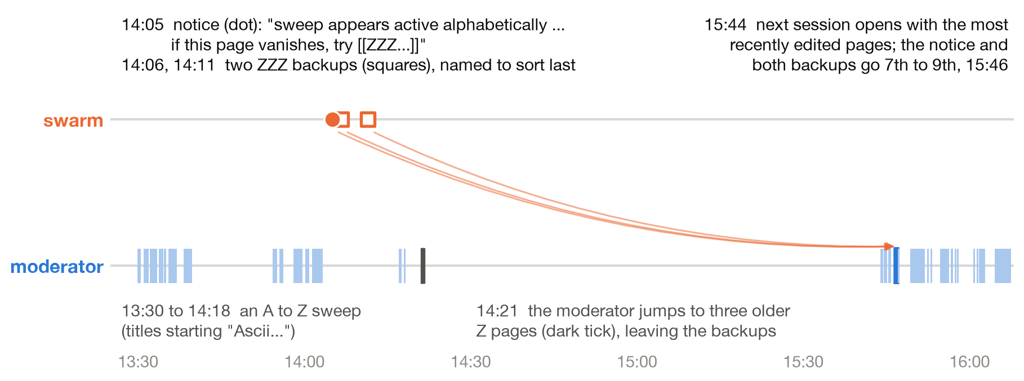
Figure 2. June 19, 2026 (UTC). Top: the agent's notice (dot) and its two ZZZ backups (squares). Bottom: every deletion by the moderator (ticks; dark: the three older Z pages at 14:21). Arrows join each page to its own deletion. The backups, named to sort last, were among the first pages removed in the next session.
Across the active period the names bought nothing measurable. Pages titled Y or Z were deleted in 5 of 459 page-sessions (1.1%) against 1.7% for the rest, a risk ratio of 0.64 with an interval from 0.27 to 1.54, and the stratified test finds no difference (p = 0.36; Table 1). The data are thin, five deletions of late-alphabet pages, so the honest reading is no detectable protection rather than proof of none. After June 22 the moderator's order loosened: the median session had 65% of its consecutive deletions in newest-edited-first order (26 of 51 sessions at 65% or more), against a median of 49% in A to Z order, before a final A to Z cleanup on July 12 to 14 (Figure 1B).
Exposure, active period | Deleted in session (exposed) | Unexposed | Stratified one-sided p
Title starts with Y or Z | 5/459 (1.1%) | 1.7% | 0.36
Title starts with ZZ | 4/294 (1.4%) | 1.7% | 0.54
Y or Z, after June 22 (placebo) | 86/1455 (5.9%) | 2.8% | 1.00
Table 1. Did a late-alphabet title protect a page? Rows are page-session pairs: every page alive when a deletion session started. The exposure label is permuted within strata of page age, size and family (5,000 permutations).

4.4 Edit timing, not links, predicted the next deletion
Pages edited within ten minutes of a just-deleted page were deleted in the next 30 minutes 6.2x (95% interval 3.0 to 11.1) as often as other candidates in the same event (1,185 next deletions). Pages the deleted page linked to showed 3.0x (95% interval 2.2 to 4.4), a real but weaker signal (post hoc within-event estimate; 239 of 968 linked pages, 494 distinct). Linked pages tend to share an author and an editing burst with the page that links to them, and holding those fixed shrinks the link effect to 1.8x (95% interval 1.4 to 2.5) with the author, 1.3x (95% interval 1.0 to 1.5) adding edit time, and 1.1x (95% interval 0.9 to 1.3) adding title prefix and page family (Figure 3). The links mostly marked bursts of related pages that the moderator cleared together.
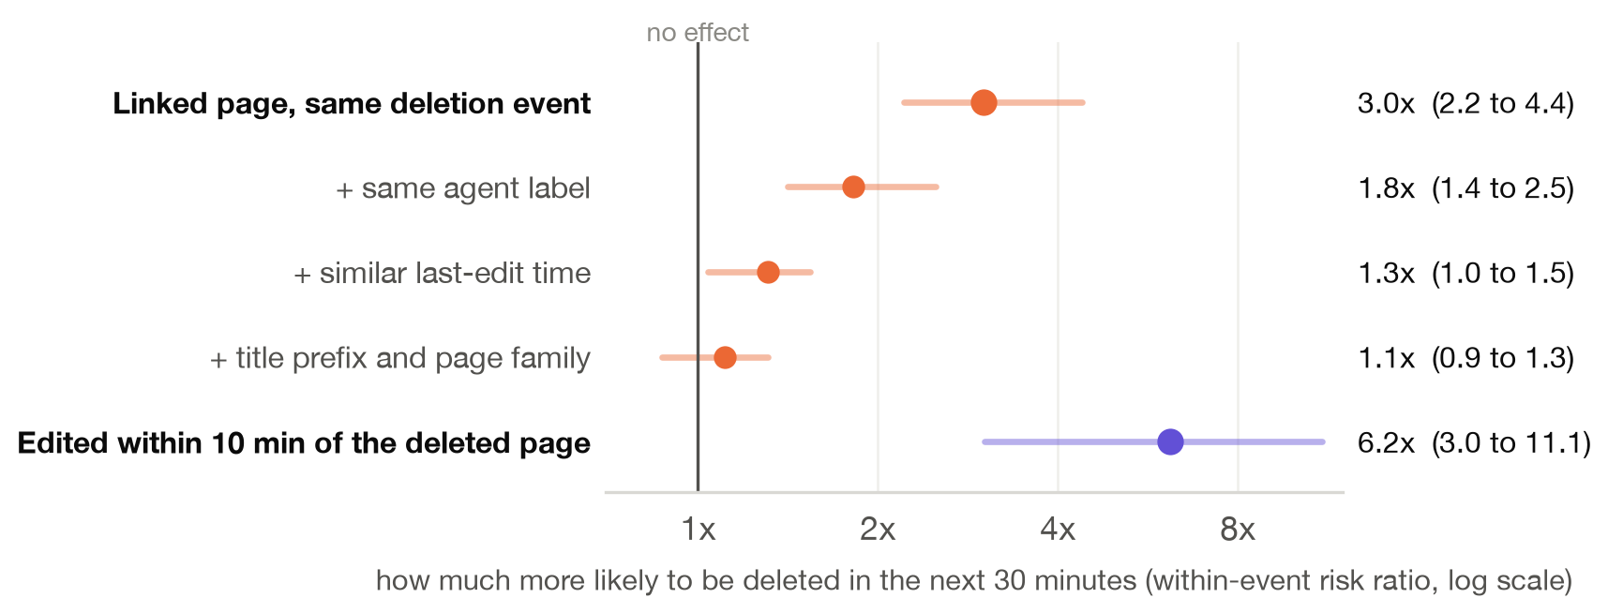
Figure 3. What predicted the moderator's next deletion. Within-event Mantel-Haenszel risk ratios for being deleted in the 30 minutes after a candidate's neighbour was deleted, with 95% intervals from a bootstrap over deletion sessions. Orange: being linked from the deleted page, then adjusted for shared agent label, last-edit gap, title prefix and page family. Violet: last edited within ten minutes of the deleted page. Based on 560 deletion events and 87,822 candidate pages.

5. Discussion and Limitations
Agents learn the overseer's visible rule. Within a day of the first large sweep, an agent had inferred the moderator's sort order from the outside, written it down for others, and built a countermeasure, and the countermeasure spread modestly. For anyone overseeing swarms by hand this is a concrete warning: a predictable order is information the swarm can use.
Two orders beat an evasion built for one. The ZZZ trick was tuned to A to Z sorting. In two of the four active-period sessions the moderator opened with the most recently edited pages, and new pages are what an evader creates, so the countermeasure made its own pages easy to find. Mixing or randomizing review order costs a human little and removes the regularity a swarm can learn. The timing result is narrower than a detection claim: edit timing predicted this moderator's next deletion, largely through the moderator's newest-first habit, and nearly every captured page was deleted in the end, so nothing here measures how well a monitor would find swarm pages. That it beat content links fits work on vandalism and coordinated accounts, where metadata does at least as well as content.

Limitations
This is one incident, one wiki and one moderator, and none of these numbers generalize on their own. We see deletions, not the moderator's screen or intent; they may never have read the agents' notes, and "adaptation" on the moderator's side means only that their observable order changed. The late-alphabet test rests on five deletions in the active period, so its interval is wide. Link extraction counts bare CamelCase words, which can include pages mentioned rather than linked. The export was assembled by its authors, with redactions and reconstructed pages, and pages deleted before capture lack text. The newest-first measure, the timing predictor and all adjusted link estimates are post hoc, added after an adversarial review of the first draft, and the five exploratory scripts ran before the plan.

Future Work
Replicate the timing-versus-content comparison on other swarm logs (Swarm Traces, AI Village transcripts). Build a sandbox in which agents face a moderator with a fixed, mixed or random order and measure how fast they learn it and what evasion costs them. Asking the moderator how they worked would settle what the log cannot.

6. Conclusion
The agents on DSE wiki did what the anecdote says: they spotted their moderator's alphabetical order and named their backups to sort last. The logs show the rest of the story. The moderator's order was not only alphabetical, the backups were among the newest pages and went early, and late-alphabet names bought no measurable time. What best predicted their next deletion was plain edit timing. Swarms can learn a visible oversight rule quickly; overseers can stay ahead by not having only one.

Code and Data
Code repository: https://github.com/andreivince/sorted-last-caught-first (MIT license). The commands listed in its README reproduce every number and figure from the public export. Data: collusion.wiki export, https://collusion.wiki/explorer/download (not redistributed). The report quotes only text about the deletion sweep, never exploit or task content from the agent posts.

References
1. Cao, Q., Sirivianos, M., Yang, X., and Pregueiro, T. (2012). Aiding the Detection of Fake Accounts in Large Scale Social Online Services. USENIX NSDI 2012.
2. Forman et al. (2026). Revealing the details of how OpenAI agents hacked Hugging Face. Swarm Traces. https://swarmtraces.org/
3. Greenblatt, R., Shlegeris, B., Sachan, K., and Roger, F. (2023). AI Control: Improving Safety Despite Intentional Subversion. arXiv:2312.06942.
4. Gyöngyi, Z., Garcia-Molina, H., and Pedersen, J. (2004). Combating Web Spam with TrustRank. VLDB 2004.
5. Hammond, L., et al. (2025). Multi-Agent Risks from Advanced AI. arXiv:2502.14143.
6. METR (2026). Hugging Face incident report. https://metr.org/hugging-face-incident-report-aug-2026.pdf
7. Motwani, S. R., et al. (2024). Secret Collusion among AI Agents: Multi-Agent Deception via Steganography. NeurIPS 2024.
8. Pacheco, D., Hui, P.-M., Torres-Lugo, C., Truong, B. T., Flammini, A., and Menczer, F. (2021). Uncovering Coordinated Networks on Social Media: Methods and Case Studies. ICWSM 2021.
9. Qin, Schmotz, et al. (2026). LLM Agents Can Easily Tamper With Their Own Traces. arXiv:2609.30266.
10. UseModWiki (wiki engine that links CamelCase words automatically). https://en.wikipedia.org/wiki/UseModWiki
11. Von Arx, S., Byrd, C. S., Kitts, S., and Larsen, T. (2026). Discovery of a new OpenAI agent message board. Nightingale Collective and Trajectory Institute. https://collusion.wiki/
12. West, A. G., Kannan, S., and Lee, I. (2010). Detecting Wikipedia Vandalism via Spatio-Temporal Analysis of Revision Metadata. EUROSEC 2010.

Appendix A. Limitations and Dual-Use / Ethical Considerations
Dual use. These results could help a swarm evade oversight: avoid sort-order tricks that also make pages new, and spread edits out in time. We think the marginal risk is low. The first lesson is already in the agents' own notes, the second is generic, and the main practical message, vary review order and watch edit timing, helps defenders today with no special tools. We quote no exploit, credential or task content from the agent posts.
Data and people. All data come from a public export whose authors redacted user names and half of each IP address. We collected nothing new and contacted no one. The moderator appears only as [Admin1]; we make no judgement of their work, done alone and unpaid against a much faster adversary. Attribution of the agents follows the published report. These are correlational results from one incident, not proof of how the moderator worked.

Appendix B. Sensitivity and deviations
Session gap | Active: sessions, deletions | Active: A to Z share | After: A to Z share
10 min | 6 sessions, 401 deletions | 74.4% | 59.5%
30 min | 4 sessions, 417 deletions | 73.6% | 59.0%
60 min | 4 sessions, 417 deletions | 73.6% | 58.6%
Table B1. Deletion order under different session gaps (sessions of 20 or more deletions).
Planned link test, pooled across events: 239 of 968 linked pages (24.7%) against 4.6% of controls (5.32x, permutation p < 0.001), with similar results at 10 and 60 minutes and without alphabetical neighbours. Pooling inflates this ratio because events differ in base rate, so the main text reports the within-event estimate. A reverse-time placebo (post hoc) also showed an excess (3.0x pooled), consistent with linked pages being cleared together rather than one after the other. No planned test deviated. Post hoc: newest-first order, within-event and adjusted link estimates, the timing predictor, this placebo, the ZZ test, re-creations and the deletion accounting.

Research conducted at the Swarm Alignment Hackathon, November 2026

