

**Software Requirements**

**Specification**

**for**

**Distributed computing system for managing the activity for ‘Street Art Utopia’**

**Version 1.0**

**Prepared by Căpriceană Andrei Vlăduț**

**Spinu Cristian**

**Ruxanda Gabriel**

**Vodită Ionuț**

**Prepared for university project**

**12.03.2017**

# Table of Contents

[Table of Contents 1](#_Toc477090253)

[Revision History 1](#_Toc477090254)

[1. Introduction 2](#_Toc477090255)

[1.1 Purpose 2](#_Toc477090256)

[1.2 Product Scope 2](#_Toc477090257)

[1.3 Intended Audience and Reading Suggestions 2](#_Toc477090258)

[1.4 Definitions, Acronyms, and Abbreviations 2](#_Toc477090259)

[1.5 References 2](#_Toc477090260)

[2. Overall Description 3](#_Toc477090261)

[2.1 Product Perspective 3](#_Toc477090262)

[2.2 Product Functions 3](#_Toc477090263)

[2.3 User Classes and Characteristics 3](#_Toc477090264)

[2.4 Operating Environment 3](#_Toc477090265)

[2.5 Design and Implementation Constraints 3](#_Toc477090266)

[2.6 User Documentation 3](#_Toc477090267)

[2.7 Assumptions and Dependencies 4](#_Toc477090268)

[3. External Interface Requirements 4](#_Toc477090269)

[3.1 User Interfaces 4](#_Toc477090270)

[3.2 Hardware Interfaces 4](#_Toc477090271)

[3.3 Software Interfaces 4](#_Toc477090272)

[3.4 Communications Interfaces 4](#_Toc477090273)

[4. System Features 5](#_Toc477090274)

[4.1 System Feature 1 5](#_Toc477090275)

[4.2 System Feature 2 (and so on) 5](#_Toc477090276)

[5. Other Nonfunctional Requirements 5](#_Toc477090277)

[5.1 Performance Requirements 5](#_Toc477090278)

[5.2 Safety Requirements 6](#_Toc477090279)

[5.3 Security Requirements 6](#_Toc477090280)

[5.4 Software Quality Attributes 6](#_Toc477090281)

[5.5 Business Rules 6](#_Toc477090282)

[6. Other Requirements 6](#_Toc477090283)

[Appendix A: Glossary 6](#_Toc477090284)

[Appendix B: Analysis Models 6](#_Toc477090285)

[Appendix C: To Be Determined List 7](#_Toc477090286)

# 

# Revision History

|  |  |  |  |
| --- | --- | --- | --- |
| **Name** | **Date** | **Comments** | **Version** |
|  |  |  |  |
|  |  |  |  |
| Căpriceană Andrei Vlăduț  Spinu Cristian  Ruxanda Gabriel  Vodită Ionuț | 12.03.2017 | First Revision | 1 |
| Căpriceană Andrei Vlăduț  Spinu Cristian | 4.6.2017 |  | 2 |

# 1. Introduction

## 1.1 Purpose

The purpose of this document is to define the system requirements for a distributed system

that manages the activities of an art-enthusiasts club. It will explain the features of the system, the interfaces of the system and what the system will do.

## 1.2 Product Scope

This software system will be a web application for an art club. The computer system includes a user interface (Web browser) a database server that will store information about the association activity, application server. The user only has access to the service through the user interface

Management system will enable members of the association membership fees payment and management of resources (eg. conference rooms, exhibition halls)

Depending on the type of authentication (admin / user), the user is allowed managing members, adding payments for dues, adding resources.

## 1.3 Intended Audience and Reading Suggestions

This document is intended for both the users of the application and the developers of the system.

## 1.4 Definitions, Acronyms, and Abbreviations

## 1.5 References

*IEEE.IEEE Std. 830-IEEE Recommended Practice for Software Requirements*

*Web Engineering The Discipline of Systematic Development of Web Applications* **Edited by Gerti Kappel, Birgit Proll, Siegfried Reich, ¨ Werner Retschitzegger.**

# 2. Overall Description

## 2.1 Product Perspective

2.1.1

Activity diagrams

Figure 1 represents the actions that an admin can do in the application.

## C:\Users\andre\Downloads\Admin.jpg

Figure 2 represents the actions that a user can do in the application.

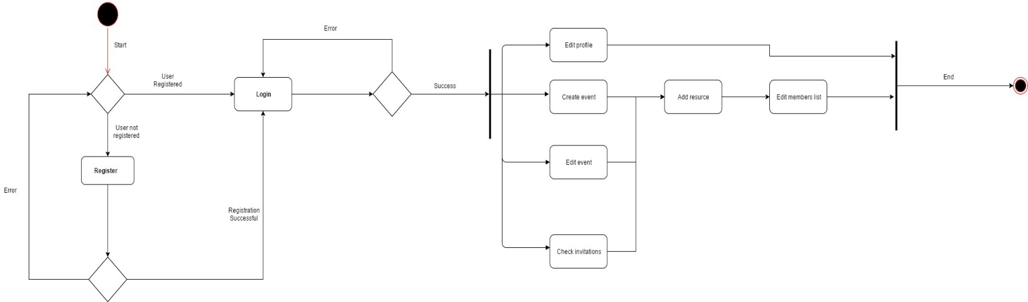

2.1.2

Use-Cases

Figure 1 shows the use case diagram of the interaction between the four distinct users (user ,guest and admin) .C:\Users\andre\AppData\Local\Microsoft\Windows\INetCache\Content.Word\Untitled Diagram.png

2.1.3

Class Diagrams

C:\Users\andre\Downloads\Class_Diag.png

## 2.2 Product Functions

The product will have the following main functions:

* New user registration
* New admin registration
* Set a profile and /or edit it
* Setting up conferences
* Setting up art exhibitions
* Managing payment
* Managing membership status
* Generating reports

## 2.3 User Classes and Characteristics

The application users will be art lovers which will have regular accounts and some of them will have administrator privileges chosen by the majority of them.

## 2.4 Operating Environment

The application supports all web browsers. (Google Chrome, Mozilla Firefox, Opera, Safari etc.)

## 2.5 Design and Implementation Constraints

Backend language: ASP.NET

Frontend: HTML, CSS, JavaScript

Framework: Bootstrap

## 2.6 User Documentation

The application will be released together with the Software Requirements Specifications documents and the testing documents.

## 2.7 Assumptions and Dependencies

*The application will be fully available only to those who have an account, and will be password protected. If the data is not introduced correctly, an error message will pop up.*

# 3. External Interface Requirements

## 3.1 User Interfaces

Home Page: 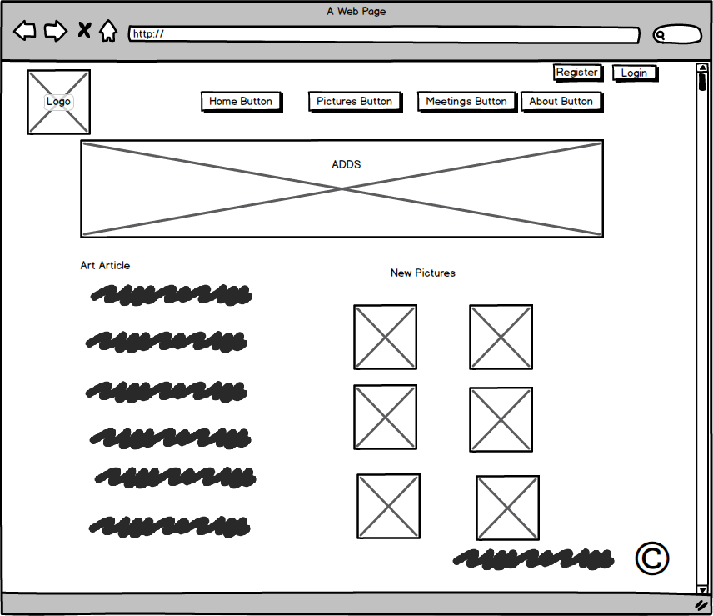

Login Page: 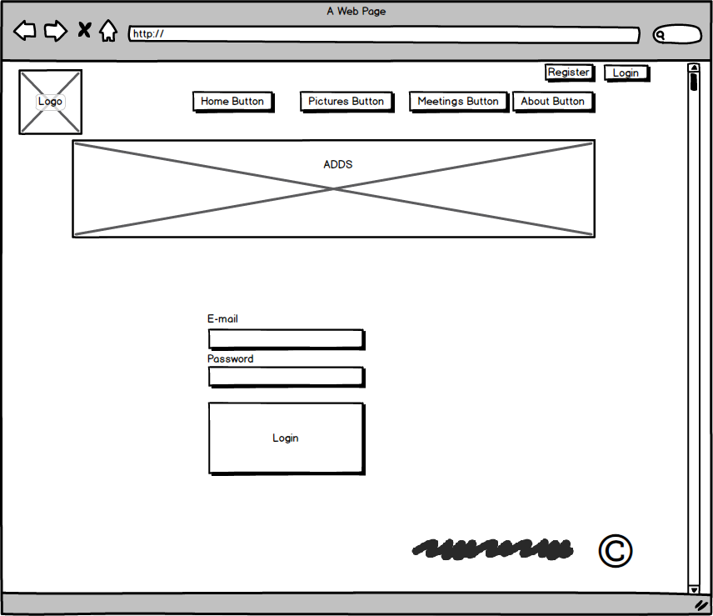

Registration Page: 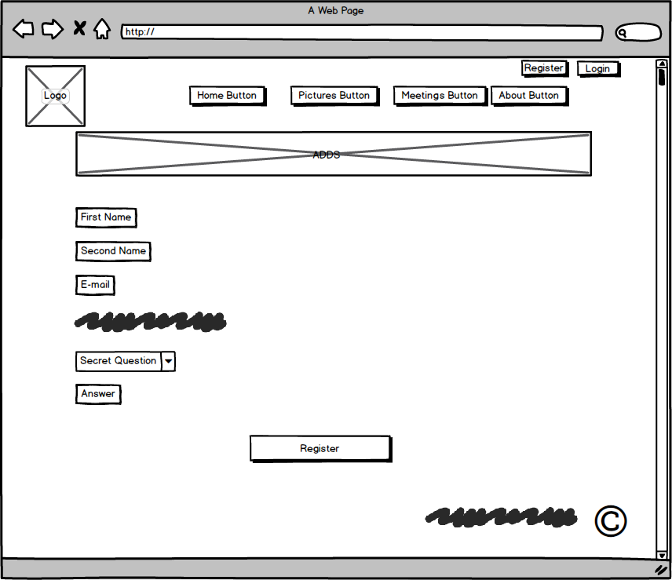

User Main Page: 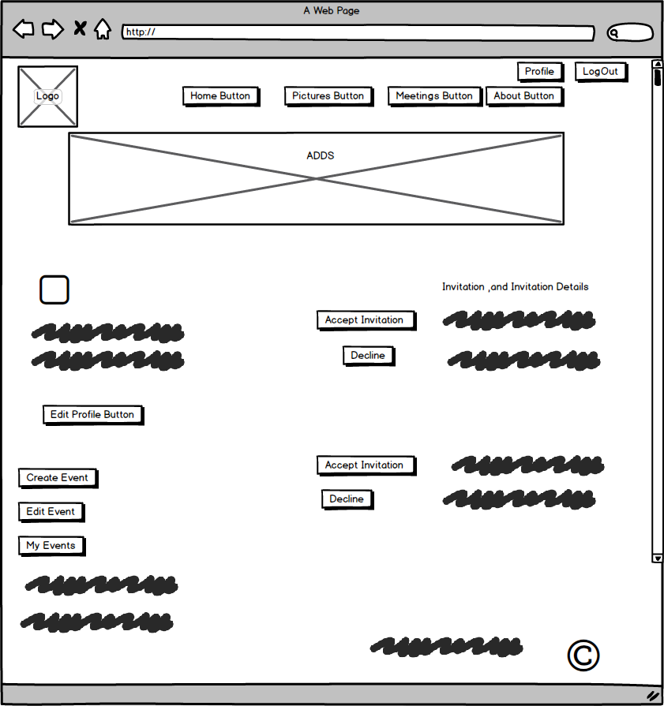

Admin Page: 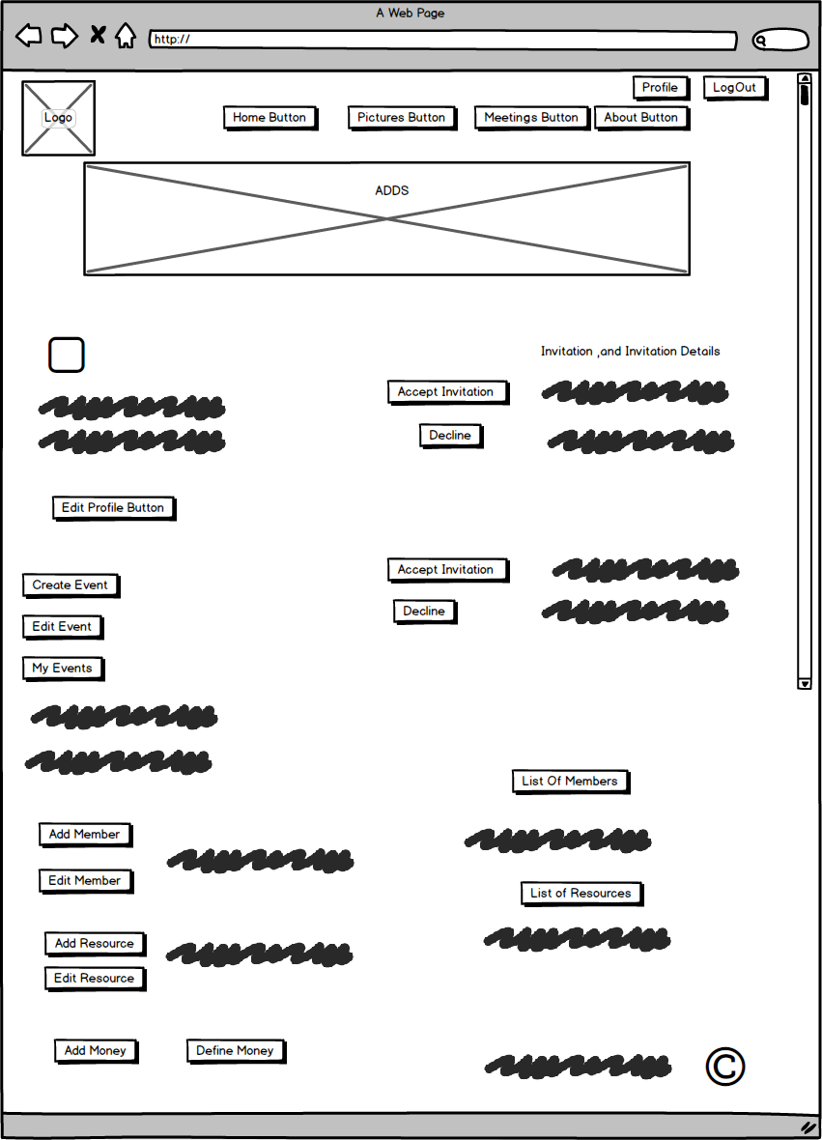

## 3.2 Hardware Interfaces

*Not Applicable.*

## 3.3 Software Interfaces

*This product’s development requires support of the following products: mySql, JDK and HTML editors, Windows Operating System.*

## 3.4 Communications Interfaces

*Client (system user) on Internet will be using HTTP/HTTPS protocol.*

# 4. System Features

## 4.1 System Feature 1

***Login Features***:

-the application will have a registration option in order to access it

-in order to access the application, you will need a valid username and password

-the system will have change password feature

-the application will have a lost password recovery system

-the application will have the possibility to be accessed in the same time by multiple users

***Administrators Features:***

-Administrators will be able to - add new members

-Administrators will be able to - edit members

-Administrators will be able to – add money

-Administrators will be able to -modify the available resources

-Administrators will be able to – add new resources

-Administrators will be able to – define payment amounts for subscriptions

-Administrators will be able to – cancel any events

-Administrators will be able to – add members to any event

-Administrators will be able to – do any activity a normal user can

***User Features:***

-Users will be able to- edit profile description

-Users will be able to- edit profile picture

-Users will be able to- change password

-Users will be able to- create events

-Users will be able to- edit events

-Users will be able to- cancel events

-Users will be able to- reserve resources for an event

-Users will be able to- add members to an event

-Users will be able to- edit members to an event

-Users will be able to-check invitations to an event

***System Features:***

It will generate a report of amounts receivable from members.

It will generate an income and expenditure report for a given month.

It will generate a report with the resources available in a given timeframe

It will generate a report for the calendar booking of certain resources.

***Resources Features and Limitations:***

A resource can be booked for an event only if the period of the event is not reserved for another event

For each new booking, the resource becomes unavailable for other reservations the day before the event and after the event.

For each resource registered will be retained when available and when it is already reserved.

A resource can be reserved by a person who is not a member by paying a fee of 400 Lei / day

A resource can be booked anytime by an administrator, if not already occupied

For each new booking, the resource becomes unavailable for other reservations the day before the event and after the event.

Any event that requires a resource created will generate spending 200 Lei / day / resource for the club.

We can no longer make any reservation of resources in a given month by members if the amount of expenditure exceeds revenues.

# 5. Other Nonfunctional Requirement

## 5.2 Safety Requirements

*Not Applicable.*

## 5.3 Security Requirements

*Users Profile are public.*

*Only the payment status is private knew only by the user and the admins.*

## 5.4 Software Quality Attributes

*Rule 1 (required): Insert one space between the comment delimiter (//) and the comment text*

*Rule 2 (required): No identifier in one name space should have the same spelling as an identifier in another name space, with the exception of structure member and union member names.*

*Rule 3 (advisory): Write only one declaration per line.*

*Rule 4 (advisory): Add at least one blank line between method definitions and property definitions.*

*Rule 5 (advisory): Place the comment on a separate line, not at the end of a line of code.*

## 5.5 Business Rules

*Not Applicable.*

# 6. Other Requirements

# Appendix A: Glossary

# Appendix B: Analysis Model

# Appendix C: To Be Determined List