Weather data statistics

# Introduction

The statistics were calculated based on the collected weather data in a time span of a year between 2016-10-09 and 2017-10-09.

# Quick look at the data

Barometric pressure

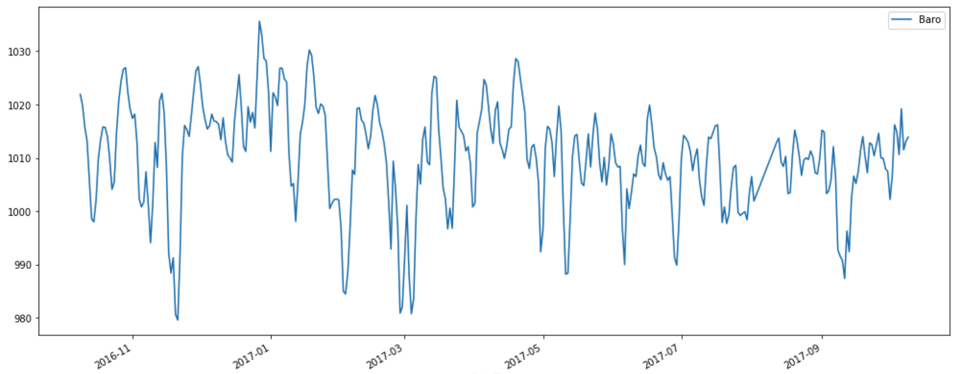

|  |  |
| --- | --- |
|  | Baro |
| count | 355 |
| mean | 1.010 |
| std | 10 |
| min | 980 |
| 25% | 1.005 |
| 50% | 1.011 |
| 75% | 1.016 |
| max | 1.036 |

Indoor temperatures

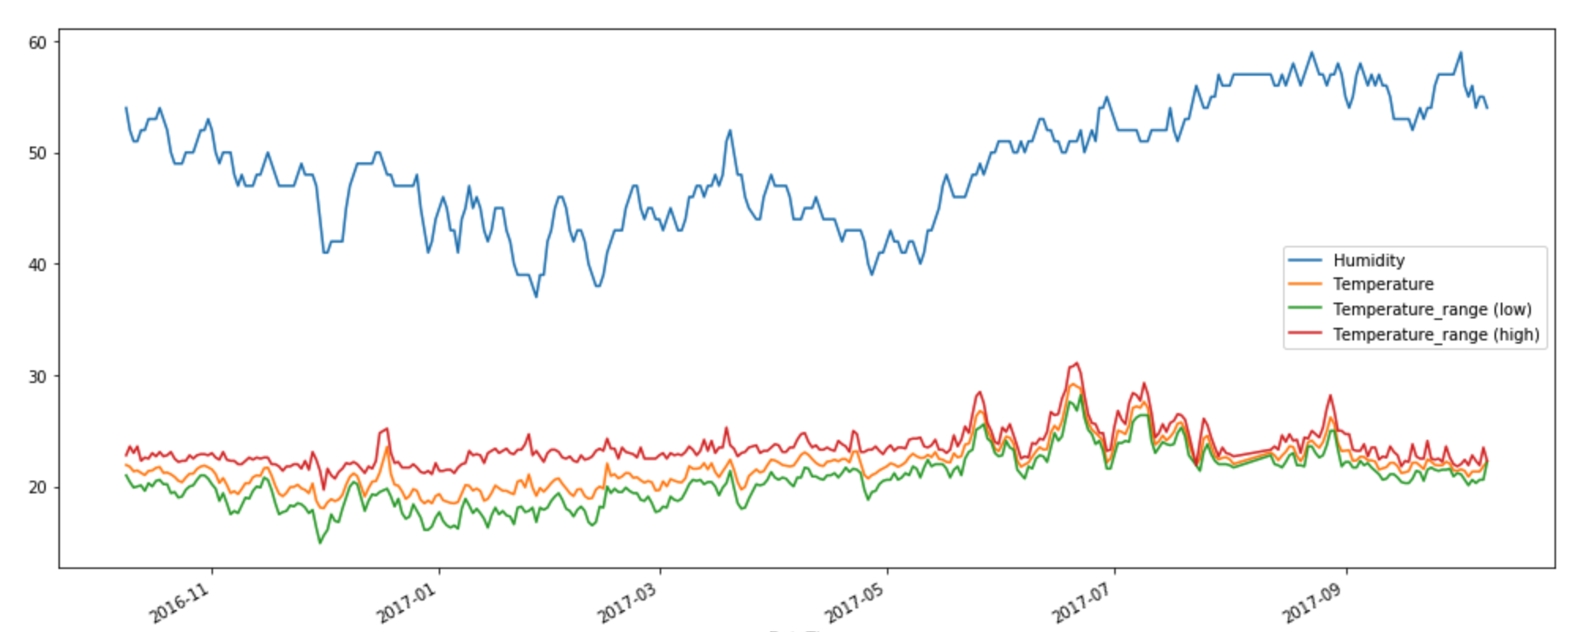

|  |  |  |  |  |
| --- | --- | --- | --- | --- |
|  | Humidity | Temperature | Temperature_range (low) | Temperature_range (high) |
| count | 354 | 354 | 354 | 354 |
| mean | 48,520 | 21,828 | 20,556 | 23,534 |
| std | 5,189 | 2,058 | 2,405 | 1,701 |
| min | 37 | 18,040 | 14,900 | 19,700 |
| 25% | 44 | 20,345 | 18,725 | 22,500 |
| 50% | 48 | 21,710 | 20,600 | 23,200 |
| 75% | 52 | 22,710 | 21,900 | 24,100 |
| max | 59 | 29,210 | 28,200 | 31,100 |

Outdoor temperatures

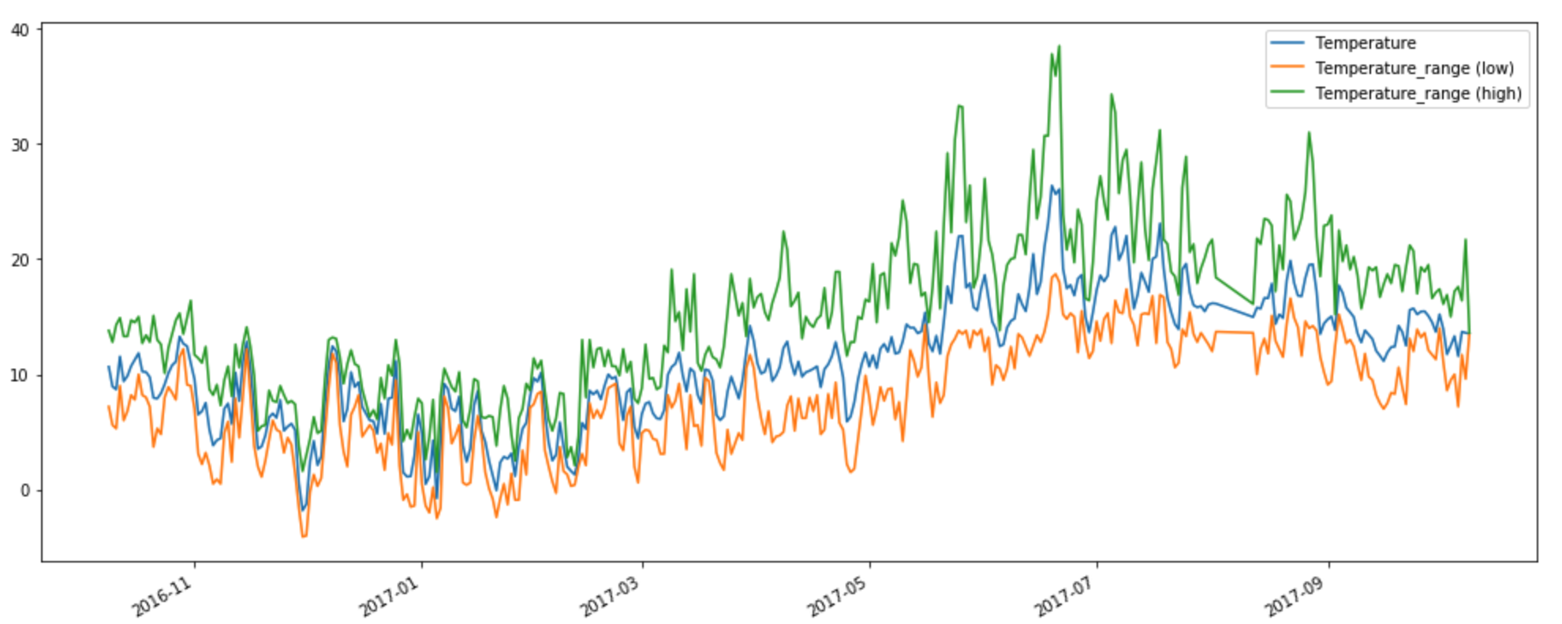

|  |  |  |  |
| --- | --- | --- | --- |
|  | Temperature | Temperature_range (low) | Temperature_range (high) |
| count | 355 | 355 | 355 |
| mean | 11,139 | 7,866 | 15,520 |
| std | 5,355 | 4,879 | 7,034 |
| min | -1,810 | -4,100 | 1,500 |
| 25% | 7,390 | 4,350 | 10,250 |
| 50% | 10,960 | 8 | 15,100 |
| 75% | 15,050 | 12,050 | 19,850 |
| max | 26,38 | 18,7 | 38,500 |

Rain fall

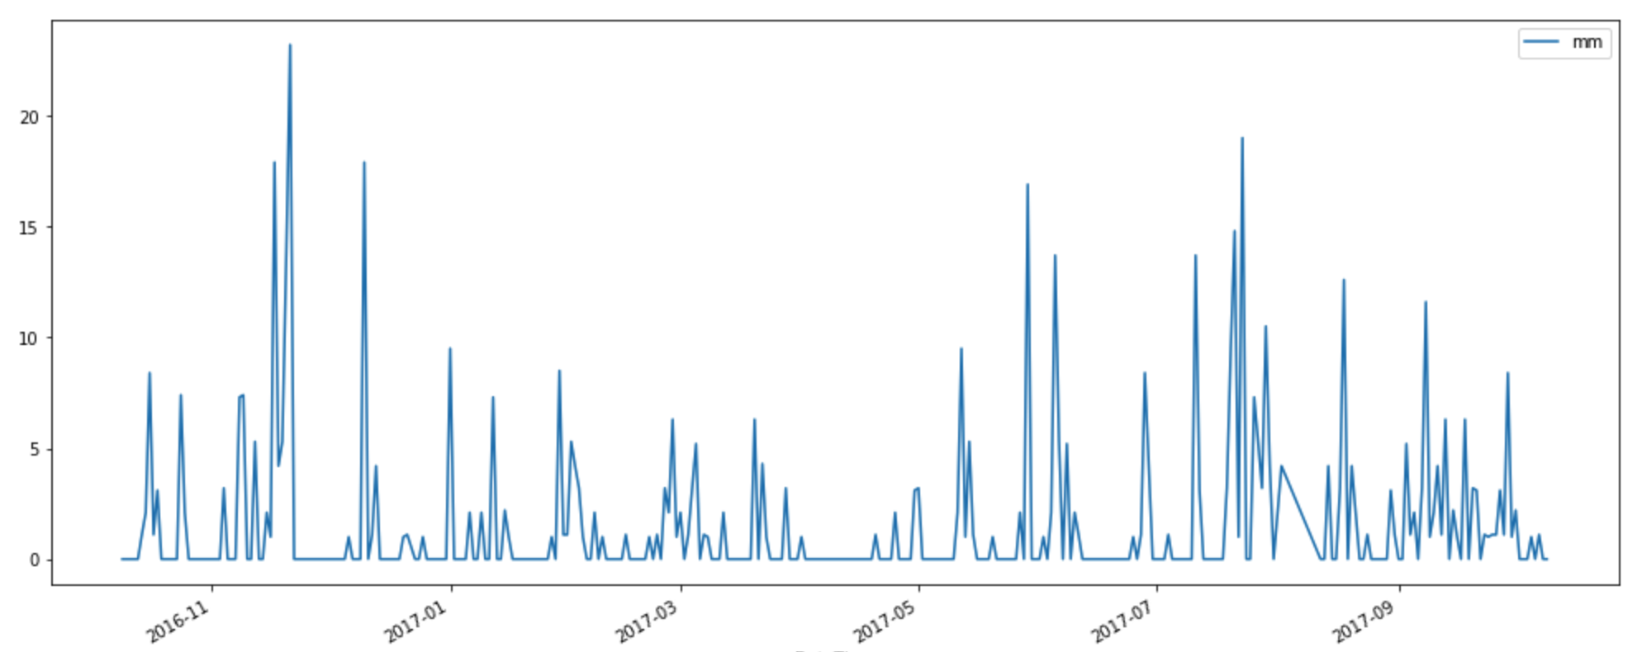

|  |  |
| --- | --- |
| count | 353 |
| mean | 1,549 |
| std | 3,325 |
| min | 0 |
| 25% | 0 |
| 50% | 0 |
| 75% | 1,100 |
| max | 23,200 |

# Adding outliers to the indoor temperatures data

The indoor temperatures data has been modified with some false values, which could happen in case of sensor malfunction or human error:

The first 5 lines of data were modified for columns humidity, temperature and temperature low range:

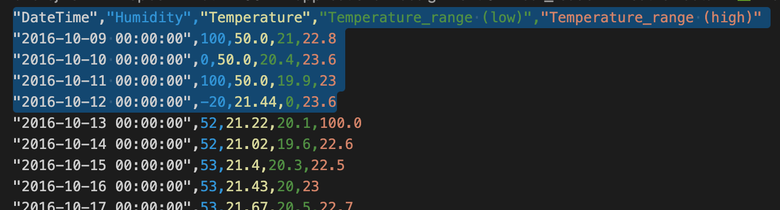

The outliers can be easily spotted just by plotting the data again:

