

Design
Description and Implementation

Vessels Tracks API
Revision 1.0

Introduction

Purpose
This document describes the design implementation of a “vesseltracker” web application API as part of the interview process for the position of Backend Engineer at MarineTraffic.

Project Description
This project is a REST API with requirements as provided here:
https://github.com/mantzouranisc/backend-assignment/blob/master/README.md

The implementation uses the Slim Framework (https://www.slimframework.com) version 3.7.0+. The code is PHP 7.0+ compliant, i.e. it executes under the PHP7.0+ interpreter without any modification..

Setup

System Environment
The application has been tested on a Win7 OS system with Xampp Apache server and
php -version : PHP 7.2.4.

App Installation
- Extract the zipped folder “vesseltracker” and place all included files under C://xampp/htdocs/vesseltracker.
- To install slim framework and all project dependencies run from app folder the cmd:
php composer.phar install
The composer.phar file is included in the app folder.

System configuration
- Adjust hosts file. Add bellow line at the end of the file C:\Windows\System32\drivers\etc\hosts
127.0.0.1 vesseltracker
- Adjust httpd-vhosts.conf. Add at the end of the file C:\xampp\apache\conf\extra\httpd-vhosts.conf
<VirtualHost *:80>
ServerAdmin andrekiri@gmail.com
DocumentRoot "C:/xampp/htdocs/vesseltracker "
ServerName vesseltracker
<Directory "C:/xampp/htdocs/vesseltracker ">
Require all granted
</Directory>
ErrorLog "C:/xampp/htdocs/vesseltracker/logs/error.log"
CustomLog " C:/xampp/htdocs/vesseltracker/logs/access.log" common
</VirtualHost>

Note that the path on above files should be consistent and point to the root directory where the application root folder is located C:/xampp/htdocs/vesseltracker.
The server name will be used to perform the http requests.
The application does not provide logging service but apache will write all errors and their stack trace on file
C:/xampp/htdocs/vesseltracker/logs/error.log
Also all incoming request will be logged in file
C:/xampp/htdocs/vesseltracker/logs/access.log
This file will be used to read incoming requests and reject if more than 10 request were answered successfully (20x) for the same ip address in the last hour. This is as per requirement. To access again the API manually delete the contents of file C:/xampp/htdocs/vesseltracker/logs/access.log .

App Configuration and Start
- This API is using a MySQL database (as it is installed by xampp). You need to create the database manually. To do it first start MySQL via Xampp control panel. Then browse http://localhost/phpmyadmin/server_databases.php and create a database with the name: vesseltrackerdb. Then go to import->Choose File-> select the provided file in the root directory vesslestracks.sql->Go.
- Start/Restart Xampp server to start the application.
- With your browser send the hello world request http://vesseltracker/api/v1/hello/marinetraffic
The .htaccess file is nessessary in order the system to be able to translate the http://vesseltracker to http://127.0.0.1:80/index.php

Test

Unit TEST
The unit test are located in ..vesseltracker/test folder. For the purpose of the application only some basic get request test are created. Ideally tests for all API calls and function should be created

To execute the suite run from app folder command line:
vendor\bin\phpunit --debug tests
Note that you may have to delete ./logs/access.log file contents (not the file itself).
Run these before manual test because some entries in the tables my be deleted after manual test.

Manual Test
As the browser supports only GET request by the user it is recommended to use postman application https://www.getpostman.com/ to perform basic usage and manually test the API’s GET, POST, PUT, DELETE requests. There is also a postman collection included “vesselTrackerPostmanCollection.json” in the app folder which can easily imported in postman and executed. This collection includes bellow requests
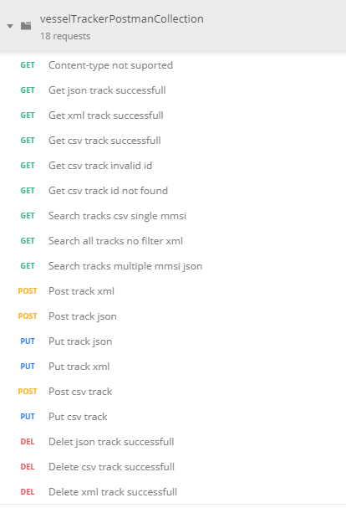

Design

Architecture
The index.php file handles all received application request and upon reception initializes the app instance via the file initApp.php. This file defines the container components and it functions and binds the API controllers to the application route paths.

The container holds the needed objects such as an instance of each third party provider objects. Upon HTTP request to the urls http://vesseltracker/api/v1/.. the VesselTracker class validates the request parameters and uses the appropriate function instance of container to perform the action.

Frontent

Simple Frontend
A simple frontend is created using a data table. The files used are frontend.html and frontend.js. To use it browse the url http://vesseltracker/frontned.html.

