About Me

Andre Lucas Simoes Araujo

Table of Contents

# Who I am and where I came from

I am from Brazil, and I was born in a city called Nova Iguacu, in Rio de Janeiro state. I always lived with my parents and my brothers. I have one twin brother and an older one. Since when I was kid, I really liked plants, I remember when I was around 8 years old, and I usually planted some randomly seeds in my grandma pots of ornamental plants - They got mad by the way.

In addition, to my passion for plants and biology, I liked also things related to architecture and design. During my high school, I took a technical course related to building. In my third year I had an opportunity to take an internship in a private company. I was 17 years old by that time. During my internship I noticed that architecture or civil engineering was not for me since it was a stressful moment of my life, and I was definitely not enjoying it. I learned a lot along though.

After finishing my high school, I pursue for college. As I mentioned I always loved biology and plants, then I decided to take Agriculture and Environmental engineering at [Universidade Federal Rural do Rio de janeiro](https://portal.ufrrj.br/). In the beginning I enjoyed the course, although calculus classes were very stressful. In my second semester, I applied for an internship in the weed lab group from my university. By that time, I knew that they had some research involving phytoremediation of soil which I thought was very interesting, and it was the reason that I applied for the group. I had my own experiment related and it was a lot of learning. However, I noticed that I was more attracted for the weed science research than the environmental. As consequence, I took the national exam again to switch my major to Agronomy.

By the end of my undergraduate program, I had the opportunity to go to United States to take an internship in the weed science group of [Colorado State University](https://www.colostate.edu/). It was an amazing experience. I learned a lot while I was helping the graduate students with their experiments. During my time in the weed lab, I had also the chance to possess my own experiment. It was very important to me once the data obtained from that I used in my final project to finish my Agronomy bachelors in Brazil. It was the first time that I used R with the goal to analyze the statistics from my experiment, and to create a graph of dose-response - I used drc and ggplot2 packages. The equation the had the best fit to my data was the 3 parameter log-logistic, as followed:

I spent one year and three months in Fort Collins and after that I returned to Brazil to finish my bachelor degree. When I graduated, I had the opportunity to go back to Fort Collins, to take my Master in the same weed lab group.

Here, it is a photo of myself in one of the place that I spend most of my time at work: at the greenhouse.

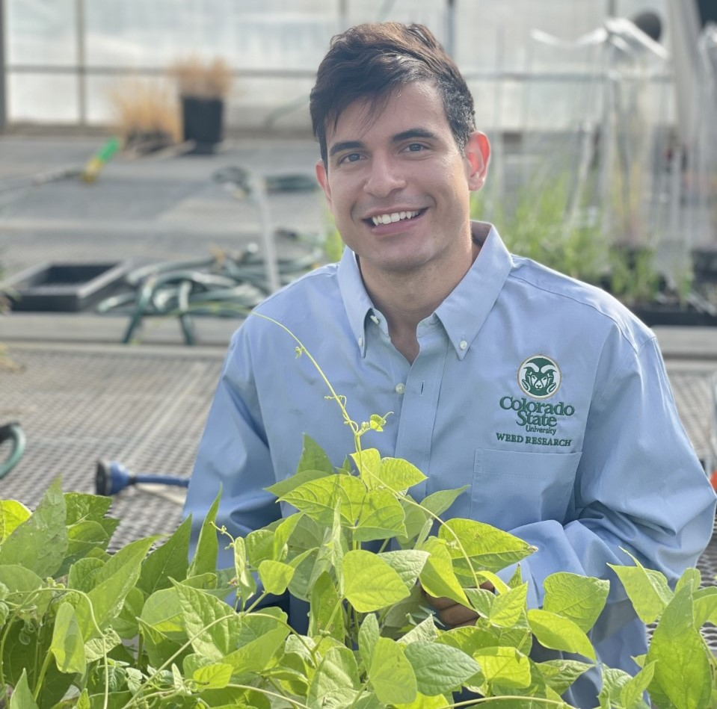

Outside of work I love to get together with friends, go to the gym, cooking, playing either card games or online games, to watch TV show and movies.

# Research Interests

I’m interested in weed resistance and the mechanism of resistance related to it. I have been working in a weed resistance survey in which I have been applying different herbicides mode of action to check possible resistant candidates.