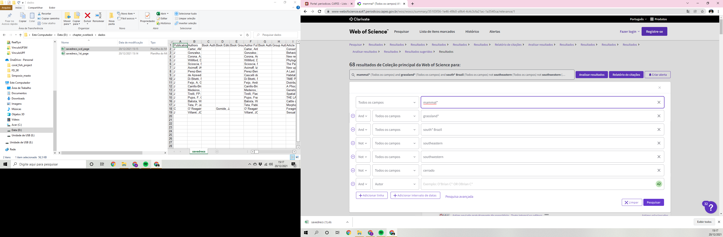

Main collection clarivate analytics wos

20-12-2021