# Appendix S6: Supplementary results

### Output of the model with $ψ{\left(.\right)}_{p}\left(.\right)$

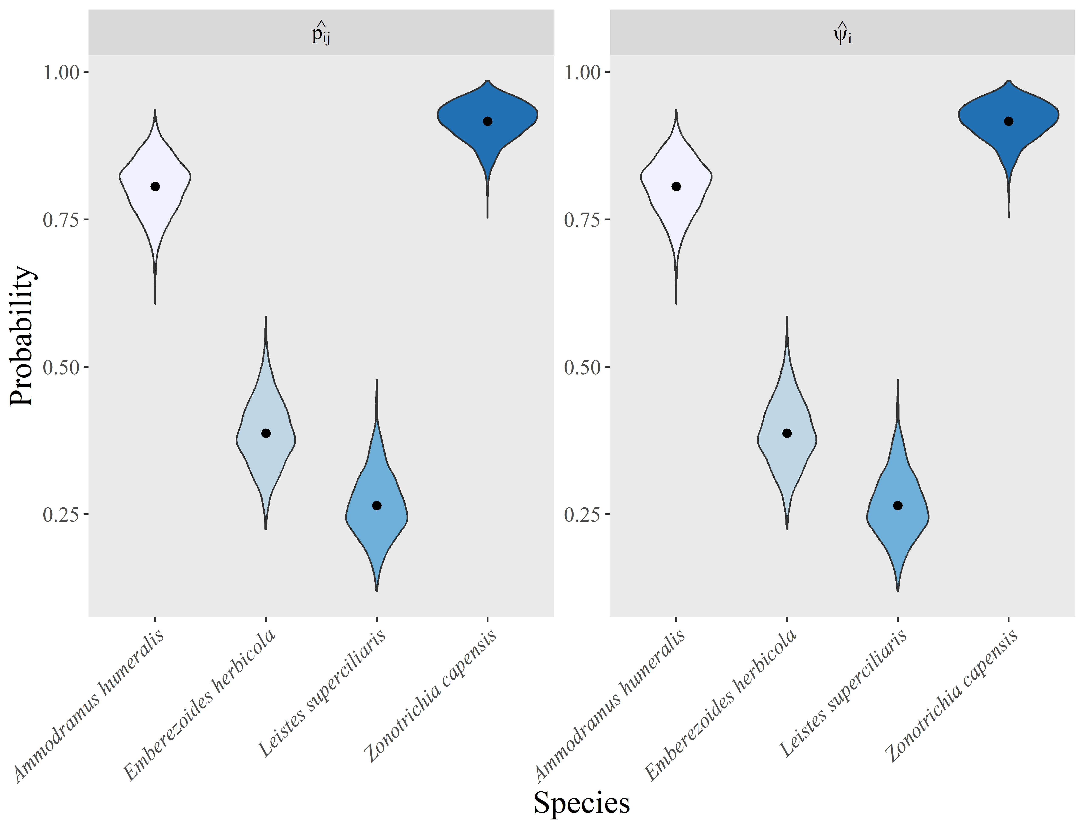

Fig. S6.1: Detection and site occupancy probability of grassland birds in 69 sites located in the Pampa Biome, Southern Brazil. The point indicates the point-estimate (posterior distribution average across 1.500 draws) of each parameter. The violins depict estimates of each posterior distribution draw.