# Appendix S8: Supplementary results

### Output of the model with $ψ{\left(.\right)}_{p}\left(Tu\right)$

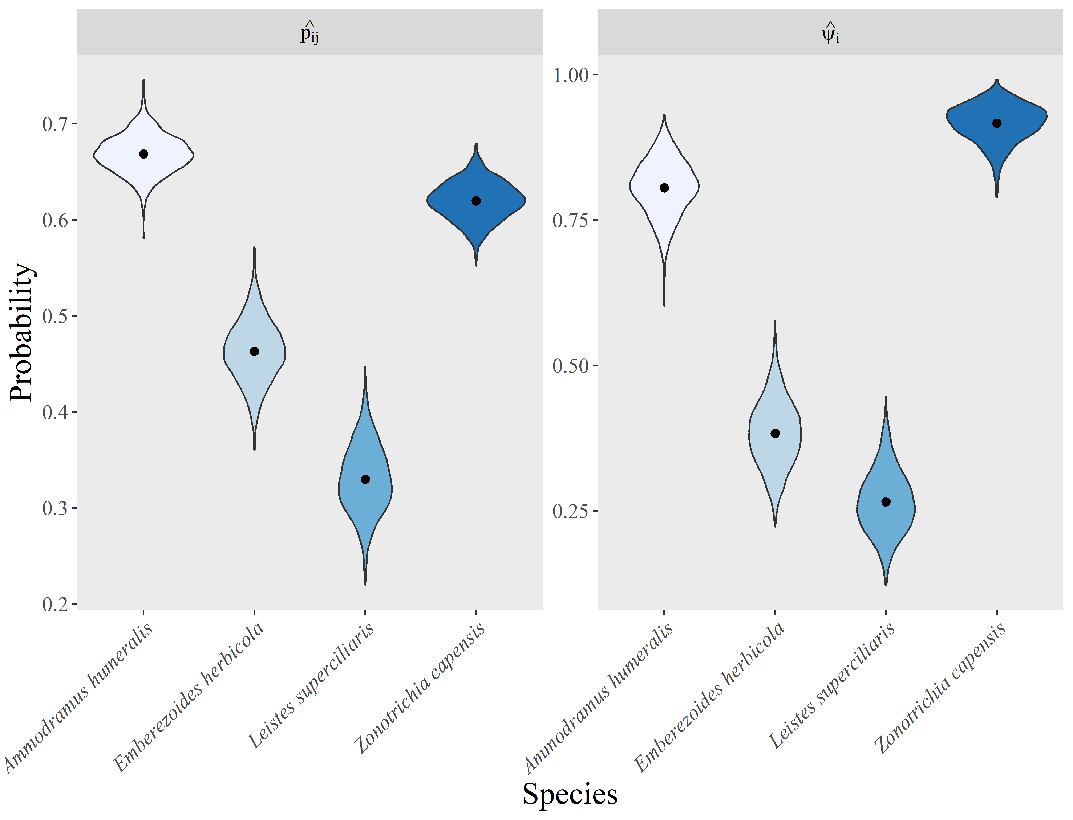

Fig. S8.1: Detection and site occupancy probability of grassland birds in 69 sites located in the Pampa Biome, Southern Brazil. The point indicates the point-estimate (posterior distribution average across 1.500 draws) of each parameter. The violins depict estimates of each posterior distribution draw.

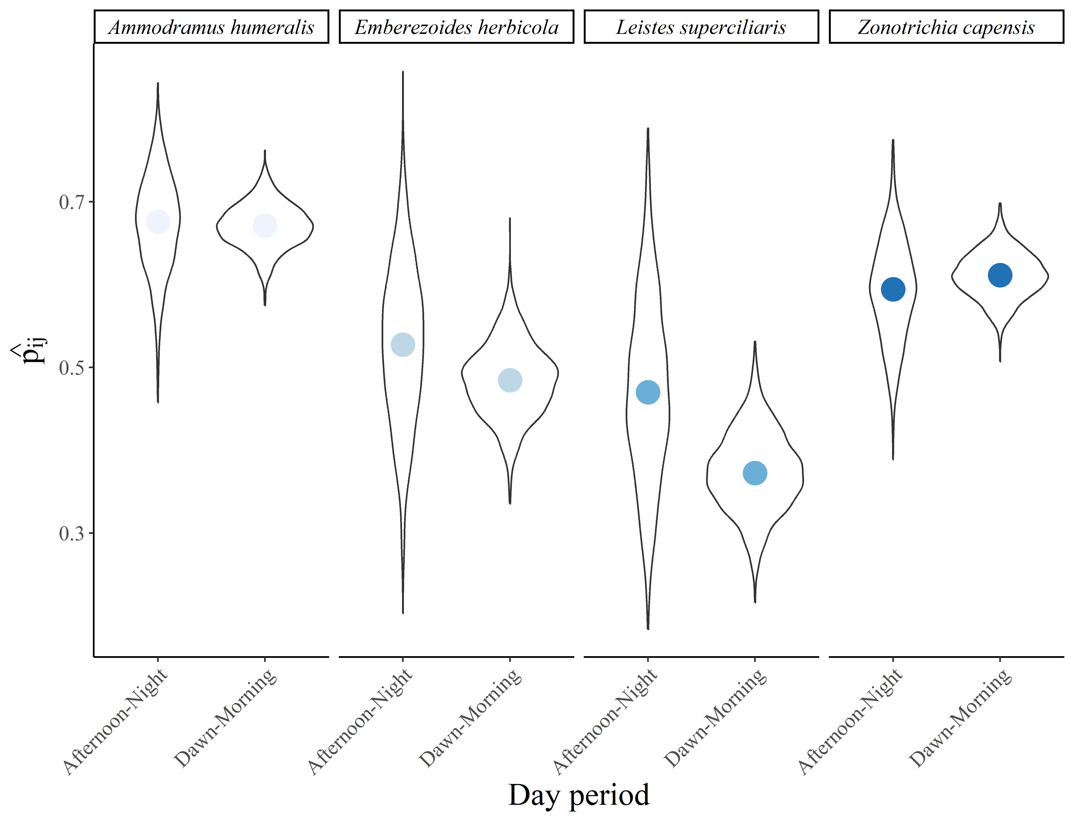

Fig. S8.2: Relationship between day period and the detection probability of each species. The blue points depict the average detection per period across the 1,500 posterior distribution draws of model parameters for each species, and the violin depict the relationship across all posterior distribution draws.