**Coping with Collapse: Functional Robustness of Coral-Reef Fish Network to Simulated Cascade Extinction**

André L Luza1,2, Mariana G Bender1, Carlos EL Ferreira3, Sergio R Floeter4, Ronaldo B Francini-Filho5, Guilherme O Longo6, Hudson T Pinheiro5, Juan P Quimbayo7, Vinicius A G Bastazini8,9

**Affiliation**

1 Department of Ecology and Evolution, Universidade Federal de Santa Maria, Santa Maria, Rio Grande do Sul, Brazil

2 UMR Biodiversité Gènes et Communautés INRAE. Université de Bordeaux, Bât. B2 - Allée Geoffroy St-Hilaire, 33615 Pessac, France

3 Department of Marine Biology, Universidade Federal Fluminense, Niterói, Rio de Janeiro, Brazil

4 Department of Ecology and Zoology, Universidade Federal de Santa Catarina, Florianópolis, Santa Catarina, Brazil

5 Centre for Marine Biology (CEBIMar), Universidade de São Paulo, São Sebastião, São Paulo, Brazil

6 Department of Oceanography and Limnology, Universidade Federal do Rio Grande do Norte, Natal, Rio Grande do Norte, Brazil

7 Department of Biology, University of Miami, Coral Gables, FL 33146, USA.

8 Mediterranean Institute for Agriculture, Environment and Development (MED), Global Change and Sustainability Institute (CHANGE), Institute for Advanced Studies and Research (IIFA), University of Evora, Evora, Portugal

9 Rui Nabeiro’ Biodiversity Chair, University of Evora, Evora, Portugal

**Corresponding author:** André Luza. [luza.andre@gmail.com](mailto:luza.andre@gmail.com)

**ORCID**

André Luís Luza: 0000-0003-0302-529X

Mariana Bender 0000-0001-5912-5471

Carlos Ferreira: 0000-0002-4311-0491

Sergio Floeter 0000-0002-3143-1474

Ronaldo Francini-Filho 0000-0002-7678-6797

Guilherme Longo 0000-0003-2033-7439

Hudson T. Pinheiro 0000-0002-3143-1474

Juan P. Quimbayo 0000-0001-5346-3488

Vinicius A. G. Bastazini: 0000-0001-5270-0621

**Funding**

ALL received post-doctoral fellowships from CNPq (#153024/2022-4, #164240/2021-7, #151228/2021-3, #152410/2020-1) and CAPES (PDPG-POSDOC, #88887.800011/2022-00). GOL, RBFFi and SRF are grateful to their research productivity scholarships provided by CNPq (#308072/2022-7; 309651/2021-2; 310906/2023-7, respectively). HTP thanks São Paulo Research Foundation (FAPESP) for funding and fellowship (grants #2019/24215-2 and 2021/07039-6). We acknowledge funding by the Brazilian Synthesis Institute (Sinbiose, CNPq; grant number #442417/2019-5; PI: MGB), PPBIO IntegraMar (CNPq #441226/2023-0, PI: MGB), and Portuguese National Funds through FCT – Foundation for Science and Technology under the Project UIDB/05183/2020 (to VAGB).

**Conflict of Interest Statement**

We have no conflict of interest to declare.

**Abstract**

Human activities and climate change have accelerated species losses and degradation of ecosystems to unprecedented levels. Both theoretical and empirical evidence suggest that extinction cascades contribute substantially to global species loss. The effects of extinction cascades can ripple across levels of ecological organization, causing not only the secondary loss of taxonomic diversity, but also functional diversity erosion. Here, we take a step forward in coextinction analysis by estimating the functional robustness of reef fish communities to species loss. We built a tripartite network with nodes and links based on a model output predicting reef fish occupancy (113 species) as a function of coral and turf algae cover in Southwestern Atlantic reefs. This network comprised coral species, coral-associated fish (site occupancy directly related to coral cover), and co-occurring fish (occupancy indirectly related to coral cover). We used Attack-Tolerance Curves and estimated network robustness () to quantify the cascading loss of reef fish taxonomic and functional trait diversity along three scenarios of coral species loss: degree centrality (removing first corals with more coral-associated fish), bleaching vulnerability and post-bleaching mortality (most vulnerable removed first), and random removal. Degree centrality produced the greatest losses (lowest ) in comparison with other scenarios. In this scenario, while functional diversity was robust to the direct loss of coral-associated fish (=0.85), the taxonomic diversity was not robust to coral loss (=0.54). Both taxonomic and functional diversity showed low robustness to indirect fish extinctions (=0.31 and =0.57, respectively). Projections of 100% coral species loss reduced 69% of the regional trait space area. The effects of coral loss in

Southwestern Atlantic reefs went beyond the direct coral-fish relationships. Ever-growing human impacts on reef ecosystems can cause extinction cascades with detrimental consequences for fish assemblages that benefit from corals.

**Keywords:** cascading extinctions, coextinction, coral-fish association, ecological networks, species-habitat interactions

**Introduction**

We are facing an unprecedented biodiversity crisis, with species extinction occurring at a much faster rate than those inferred from fossil records (Ceballos et al., 2015; Pimm et al., 2014). Understanding the processes driving species extinction could help us anticipate and mitigate the anthropogenic impacts eroding ecosystems (Ceballos et al., 2015). For example, ecologists have long recognized that the primary loss of species might trigger cascading effects that ripple across ecological communities, through waves of secondary extinctions (e.g., Bastazini et al., 2022; Doherty et al., 2023; Estes et al., 1998; Strona and Bradshaw, 2022). This occurs because species in natural communities are linked to one another based on different kinds of ecological interactions (e.g., predator-prey, cleaner-clients, host-parasites, plant-pollinators) forming multi-dimensional networks (Estes et al., 2011). Thus, coextinctions will likely be common in future ecosystems if we keep the pace of ecosystem exploitation and the broad scale of impacts (Strona and Bradshaw, 2022). The extinction of large terrestrial mammals during the Pleistocene, for instance, resulted in the loss of fundamental ecological interactions, triggering a reorganization of ecological networks and the restructuring of terrestrial ecosystems (Pires, 2024). This process had far-reaching effects on ecosystem-scale processes such as energy flow and nutrient cycling (Pires, 2024). In marine ecosystems, there are notable examples of cascading extinctions following the loss of apex predators on trophic networks (Estes et al., 2011). Despite being under high human-induced threats (Blowes et al., 2019), knowledge on coextinctions in coral and rocky reef ecosystems is still incipient. Reefs hold intricate networks of interactions among species and between species and their habitat (Cantor et al., 2018; Capitani et al., 2022; Strona et al., 2021; Wilson et al., 2006), yielding one of the most diverse and productive ecosystems on Earth (Sheppard et al., 2018). Thus, determining how reef communities will respond to the current environmental crisis is crucial to accurately forecast reef functioning and resilience (Hughes et al., 2018).

Reef fish are connected to their habitat to different degrees, which can include the use of reef corals and macroalgae for sheltering, breeding, and foraging (Sheppard et al., 2018). Other fish can in turn associate or co-occur with coral-associated fish due to predator-prey relationships (Capitani et al., 2022), facilitation cascades, habitat engineering, and mutualistic interactions (Quimbayo et al., 2018). Reefs and the interactions they host are under threat due to global-scale climate change (Burke et al., 2023; Giglio et al., 2023), and numerous local impacts from unregulated exploitation to pollution (Bellwood et al., 2004; Giglio et al., 2023). Recent global estimates of the cumulative effect of these impacts show a striking 36% decline in global-scale coral cover from 1997 to 2018 (Tebbett et al., 2023). Complex reef architecture provides important habitat and refuge for many fish and invertebrates, and the erosion of reef complexity has important consequences for critical reef functions and processes (Alvarez-Filip et al., 2011). The degradation of reef habitats might impair the ecosystem's robustness to extinctions creating cascading effects that could lead the entire system to collapse (Strona and Bradshaw, 2022). Despite this scenario, the consequences of coextinction cascades caused by coral loss are virtually unknown.

A useful approach to determine how coral loss can lead to cascading extinctions in reef ecosystems are the widely used "knockout extinction models”, which are simulations of species or area removal aiming to estimate the robustness of ecological networks either formed by intraspecific interactions (Bane et al., 2018) or by species-habitat associations (Evans et al., 2013; Marini et al., 2019). Cascading extinctions were unveiled through multi-taxa species-habitat networks from tropical forests facing deforestation, whereby forest species declined to extinction when deprived from their preferred habitat (Palmeirim et al., 2022). Following the species-habitat approach (Marini et al., 2019), corals are distributed as habitat patches to which fish species are linked. While corals are not predominantly distributed in homogeneous patches — they rather coexist with a number of taxa such as algae, sponges, ascidians (Aued et al., 2018) — they do constitute critical habitat structures adding heterogeneity and resources to reef organisms, most notably to reef fish (Anderson et al., 2022; Coker et al., 2014; Luza et al., 2022; Wilson et al., 2006). The coral-fish association can be so specialized that coral mortality, cover loss and local species extinction causes direct population decline and even local extinction of coral-associated fish (Coker et al., 2014; Wilson et al., 2006). Yet, the strength of this relationship is still debated (recently reviewed by Muruga et al., 2024), and geographic variations underlying fish sensitivity to coral extinction were recently uncovered (Luza et al., 2022; Parravicini et al., 2014; Strona et al., 2021). In this context, the examination of potential cascading effects, i.e. the indirect fish extinctions that may happen as a consequence of direct fish extinctions caused by coral species loss, is a topic that remains virtually unexplored to date.

The effects of coextinction cascades can ripple across levels of ecological complexity, causing not only the loss of taxonomic diversity, but also the erosion of functional diversity (Bastazini et al., 2022; Srivastava et al., 2009; Valiente‐Banuet et al., 2015), affecting ecosystem functioning and the provision of services that we depend upon (Giglio et al., 2023). The simulated loss of all coral species from tropical reefs could cause the decline of 50% of fish species and 23% of functional entities, indicating significant changes to taxonomic and functional diversity (Strona et al., 2021). However, these analyses excluded Southwestern (SW) Atlantic reefs. For these reefs, the total loss of coral species caused the loss of 37% of fish species and 5% of its functional diversity (Luza et al., 2022). Both studies involved the removal of either single coral species or all coral species simultaneously, which limited their ability to assess the potential influence of cascading extinctions on the structure of reef fish communities. Climate change will likely affect coral species differently and perhaps sequentially along a gradient of bleaching vulnerability and post bleaching mortality, with a more deleterious impact expected for branching corals (acroporids) and hydrocorals (milleporids) (Hughes et al., 2018; McWilliam et al., 2018). These coral groups confer exceptionally high habitat complexity and heterogeneity to reefs, and their decline could lead to the loss of several reef fish species (Coker et al., 2014; Wilson et al., 2006). Also, secondary extinctions can happen because other fish can interact indirectly with corals through predator-prey (Capitani et al., 2022) and /or mutualistic interactions (Quimbayo et al., 2018) established with coral-associated fish.

Here, beyond using a tripartite network to estimate direct and indirect effects of coral loss to taxonomic diversity, we move beyond coextinction analysis and design an algorithm that evaluates network functional robustness. We applied this approach for corals and fish of Southwestern Atlantic reefs, and considered three scenarios of coral (habitat) species loss: degree centrality, vulnerability to bleaching and post-bleaching mortality, and random removal. The degree centrality scenario reflects a deterministic loss entirely based on the network structure, where the most connected species are considered more critical for network stability (Bastazini et al., 2019). The bleaching vulnerability scenario, where corals more susceptible to bleaching events are removed first, introduces a mechanistic influence on network robustness, considering real-world observations of coral vulnerability in Southwestern Atlantic reefs (Braz et al., 2022; Corazza et al., 2024; Pereira et al., 2022; Teixeira et al., 2019). Finally, corals were removed randomly, without imposing a specific order. Thus, the random scenario represents situations where corals might be lost due to unpredictable events or unknown factors, providing a baseline to compare against the other more realistic scenarios. We expected that the degree centrality scenario would result in the lowest network robustness to coral loss, since coral species with the highest degree centrality might provide the preferred habitat for reef fish. We anticipated identifying functional robustness following the removal of fish directly and indirectly associated with corals, as the diversity of functions within the assemblage could be maintained through functional redundancy among species (Luza et al., 2022; Mouillot et al., 2013).

**Material and Methods**

We used the species-habitat network approach (Marini et al. 2019) coupled with Attack-Tolerance Curves (ATC; Albert and Barabási, 2002) and the Reduction in Functional Space approach (RFS, Luza et al., 2022) to quantify the cascading loss of reef fish species and functions as a response to coral loss. More specifically we tested the robustness, defined as the area under the ATC (Burgos et al., 2007), of the species-habitat network by building a tripartite network composed of two bipartite subnetworks. Then we simulated three scenarios of coral extinction and used the ATCs to show how many species and functions (trait space area) would persist in the network following coral species removal, and used a trait-based approach (Mammola and Cardoso, 2020) to explore the consequences of cascading extinctions on trait space area (or functional diversity (FD), Villéger et al., 2008) and occupancy (Carvalho and Cardoso, 2020; Mammola and Cardoso, 2020). The illustrated framework is shown in Fig. 1.

**Model predictions and the ecological network**

The tripartite network structure was build using data and estimates of a Bayesian community occupancy model produced by Luza et al. (2022). This model was used to gauge the relative influence of coral and turf algae cover on 113 reef fish species detected in video plots deployed in 36 sites distributed throughout the Brazilian Province (Fig. S1.1) (data from Aued et al., 2018; Longo et al., 2019). In essence, these community models are a class of hierarchical models consisting of two interconnected Generalized Linear Mixed Models (GLMMs). These models simultaneously estimate site occupancy probability, denoted as (i.e., the probability that a species *k* will occupy site *i* based on its environmental conditions, specifically cover of corals and turf algae), and detection probability (i.e., the probability of detecting species *k*, on occasion *j* and site *i* where it truly exists) (Kéry and Royle, 2016). In this model, the 113 reef fish species were treated as random effects via random slopes and intercepts, ensuring that estimates for all species conform to a common statistical distribution. One relevant aspect not considered in this model is the spatial configuration of coral or turf patches and their effects on fish occupancy. Although we did not estimate the exact size or isolation of the sampled reefs, all sampled reefs are considered large and well-connected environments. Therefore, we assumed that each sample for each site had an equal chance of capturing the full spectrum of species co-occurrence and network dynamics, as well as the influence of benthic characteristics.

Using the estimates in the model output, we built the two bipartite subnetworks composing the tripartite network (Fig. 2). We classified species into two groups. The “coral-associated fish” group comprised fish positively influenced by coral cover on their site occupancy probability. The relationship between fish species occupancy and coral () and turf cover () was characterized using the regression coefficients. Fish species were categorized as 'coral-associated' if were positive and their 95% Credible Intervals of did not overlap zero, and if they exhibited either a neutral (= 0) or negative (< 0) association with turf algae cover. “Co-occurring fish” were those whose site occupancy probabilities were correlated (at Pearson's correlation coefficient *⍴* ≥ 0.8) with the site occupancy probabilities of coral-associated fish.

Based on this classification, the first subnetwork comprised corals and coral-associated fish, and the second one comprised coral-associated fish and co-occurring fish (Fig. 2). The thickness of the links connecting the nodes (species) in subnetwork 1 (partities A and B) was determined by predicting site occupancy probabilities based on coral cover variation while holding turf algae cover constant. To make these predictions, we used the model's intercept and regression coefficients to predict site occupancy probabilities at four standard deviations from the mean coral cover (which translates to approximately 10% cover for more abundant corals like *Siderastrea* spp. and *Millepora alcicornis*, and around 1% cover for less abundant species such as *Agaricia* spp., *Porites astreoides*, and *Favia gravida*) and zero standard deviations from the mean for turf algae cover (about 18% cover). In essence, this yielded one predicted site occupancy probability by fish species *k* in site *i.* This value represents the expected proportion of sites occupied by each fish species given the coral cover.

To establish the links between nodes in subnetwork 2 (partites B and C), we computed the Pearson’s correlation coefficient (*⍴*) between site occupancy probabilities for each coral-associated fish (42 species) and the remaining species (71 species) at the site level (n=36 sites). We then applied a correlation threshold of *⍴* ≥ 0.8 to define co-occurring species. In total, 21 species met this criterion. To understand the nature of the connections in subnetwork 2, we tested whether co-occurring fish belonged to higher trophic levels and had larger body sizes than coral-associated fish using ANOVA. Co-occurring fish belonged to higher trophic levels than coral-associated fish (*β*=0.58, F1,61= 7.66, P=0.007) (Fig. S1.2), indicating that nodes in subnetwork 2 are connected through trophic relationships. No differences in body size were found between partities (Fig. S1.2).

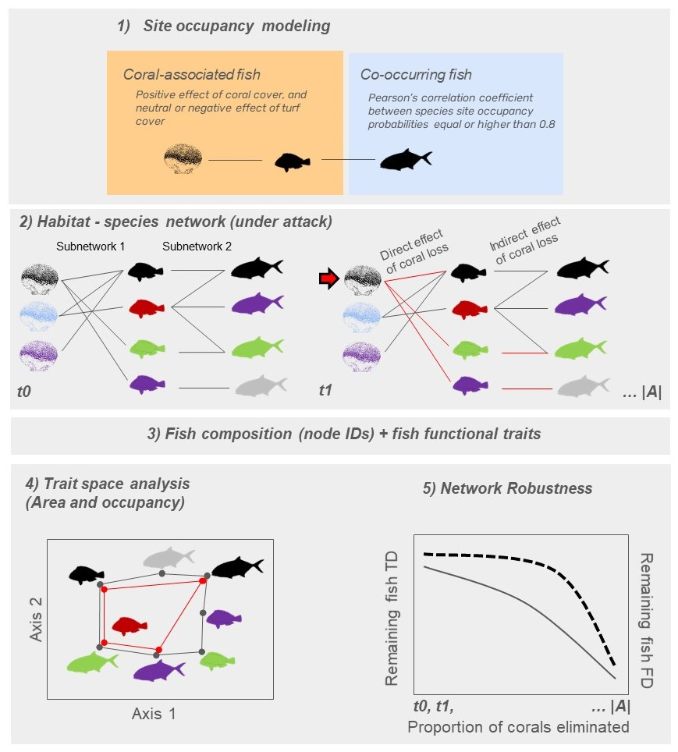

*Fig. 1: Study framework. In step (1), we modelled the occupancy probability of fish as a function of coral and turf algae cover using site occupancy modeling. Based on the model output, we classified species as either coral-associated or co-occurring fish. In step (2), coral and fish species were connected based on the predicted site occupancy probability of each coral-associated fish (fish with different colors in the center of the network) relative to the cover of each coral species (corals with different colors, in the left). Then, coral-associated and co-occurring fish in subnetwork 2 were connected based on Pearson’s correlation values between fish site occupancy probability. With the networks established, we applied a removal algorithm that eliminated corals and subsequently calculated the direct and indirect effects of coral species removal on network robustness at each elimination step (t0, t1, to |A|). Lost links are shown in red. In step (3), we related fish species composition and species traits at each elimination step. In step (4) we computed the loss in trait space area following corals and fish removal. The area delimited by the black polygon depicts the trait space area at t0, and the area delimited by the red polygon depicts the trait space area at t1. Finally, in step (5), we applied a hyperbolic function (non-linear model) to the robustness data, analyzing both the remaining taxonomic diversity (TD, represented on the first y-axis with a solid curve) and functional diversity (FD, represented on the second y-axis with a dashed curve) along the gradient of coral elimination (x-axis).*

**Attack-tolerance curves, removal algorithm, and robustness analyses**

We measured/assessed the direct and indirect effects of coral loss in reef fish communities using the tripartite network. Robustness () was estimated based on the area below the attack-tolerance curves (; Albert and Barabási 2002, Burgos et al. 2007). This metric reflects the network’s potential to maintain its structure under attack, with values ranging from 0 to 1. A value of 1 indicates maximum network robustness, meaning that fish taxonomic and functional diversity are highly tolerant to coral species removal. To assess this, we simulated coral species extinctions within the network and evaluated the direct and indirect effects using the following algorithm:

1. Let be a bipartite network (subnetwork) with two sets of nodes each:
   1. Subnetwork 1: coral species () and coral-associated fish ()
   2. Subnetwork 2: Coral-associated fish and co-occurring fish ()

The links between and were defined by , and the Pearson's correlation coefficient *⍴* was used to connect and (Fig. 2).

1. Let be the function to estimate taxonomic and functional diversity for species in the set given losses . Let be the function to estimate taxonomic and functional diversity for species in given losses in the set .
2. Reduction in taxonomic diversity (TD) is the proportion of fish species being lost in and along eliminations of coral species in .
3. The Reduction in Functional Space (RFS) of partites and is then calculated using traits and node identities (see below **Trait space area and occupancy**):

Time is defined in terms of coral removal order, where represents the baseline time step with no coral removal. depicts the number of corals in the partite .

From onwards, the algorithm will run while . In other words, the algorithm will run while there are nodes remaining in the subnetwork as follows:

1. Select a species in based on one specific criterion (see **Scenario analyses**), and remove it from the network at time ;
2. Update the network by removing the links associated with species :
3. Estimate the taxonomic and functional diversity for species in the partites and ( and , respectively);
4. Add the values of and to the cumulative sum of the area under the attack curve (ATC):

or

1. Increment the time step until . The algorithm then ends when all coral species from subnetwork 1 have been removed from the network.

To measure the decay of taxonomic and functional robustness following coral loss, we fitted a hyperbolic function to data obtained across the time steps. This step involves attempting to fit a non-linear least squares’ model of the form to the data, represented as . The variable depicts the time (from to ), and the exponent is the decay function to be estimated by the model. If the fitting fails, we added a small amount of random noise () to to enable the fitting process to converge, and set as the starting value of the maximum likelihood algorithm.

Finally, robustness was quantified for taxonomic and functional diversity of node sets and separately by integrating (summing up) infinitesimally small values of the spline interpolation of the fitted hyperbolic function applied over the interval (, no coral removed) to (, all corals removed):

To simulate extinctions, we worked in parallel with the two subnetworks. Operationally, the subnetworks were represented as matrices, whose manipulation of rows and columns represented the consequences of losing nodes in each subnetwork. The first matrix had corals as rows (partite A) and coral-associated fish as columns (partite B). A coral-associated fish could be eliminated after the elimination of coral in time step if its column sum being zero (i.e., no positive site occupancy probability remains). In the second matrix, with coral-associated fish as rows (partite B) and co-occurring fish as columns (partite C), a co-occurring fish could be removed if the removal of a coral-associated fish in time step results in its column sum being zero (i.e., no positive correlation between site occupancy probabilities of these fish remains).

Taxonomic diversity (TD) was measured as the ratio of the number of columns (fish species) in each matrix at each time step , relative to the total number of columns at . As with the taxonomic counterpart, our functional ATC is constrained within the unit square, starting at a value of 1 in the *y*-axis when there is no area loss and the fish trait space is intact. As coral removal proceeds, the hyperbolic curve decreases monotonically to 1 on the *x*-axis as the functional space shrinks with the removal of all corals.

**Scenario analyses**

We ran analyses using different criterion of coral removal in subnetwork 1 (step 1 of the algorithm). In the first scenario, coral species were removed according to their degree centrality, which was measured as the number of links between each coral and fish species. In this scenario, coral removal followed a decreasing order, from the highest to the lowest degree centrality. Therefore, coral with the largest number of associated fishes were the first to be eliminated.

The second scenario involved the random removal of coral species in step 1, where we shuffled the rows in partite one thousand times. Then, we ran the algorithm steps 2-7 as described above for each random data set. Further, we obtained the average robustness and associated 95% Confidence Intervals.

The third scenario involved the removal of corals based on their vulnerability to bleaching and post-bleaching mortality. The key drivers of coral mortality and eventual loss are their vulnerability to bleaching and ability to recover from bleaching events (Bleuel et al., 2021; Freeman et al., 2013; Hoegh-Guldberg et al., 2007). Nonetheless, bleaching vulnerability and post-bleaching mortality vary with biological species traits such as occurrence depth, symbiotic association, growth rate and competitive ability (to endure against competition with algae and zoanthids). Using this background information, we gathered data from the literature to build a vulnerability-based scenario, in which corals with higher bleaching probability and post-bleaching mortality and lower growth rates and competitive ability were removed first from the network. The vulnerability-based scenario respected the following order:

1- *Mussismilia harttii* - high bleaching levels, high post-bleaching mortality levels (see Corazza et al., 2024; Pereira et al., 2022; Teixeira et al., 2019), low recovery rates leading to colony erosion (Braz et al., 2022);

2- *Millepora alcicornis* - high bleaching levels, high post-bleaching mortality levels (see Corazza et al., 2024; Pereira et al., 2022; Teixeira et al., 2019). The species has high competitive ability and growth rates, often considered a weedy species in the Caribbean (Cramer et al., 2021), therefore with a higher recovery potential compared to *M. harttii*;

*3- Agaricia* spp. - high bleaching levels and post-bleaching mortality (Corazza et al., 2024; Pereira et al., 2022; Teixeira et al., 2019), and low recovery potential (Longo unpublished data; Cramer et al., 2021).

4 - *Mussismilia hispida* - high bleaching levels, low post bleaching mortality (Banha et al., 2020), slow growth and recovery rates (Corazza et al., 2024);

5 - *Montastraea cavernosa* - medium bleaching levels and low post bleaching mortality (Teixeira et al., 2019), considered a stress tolerant species (Cramer et al., 2021). This species is very important for the benthic community structure in turbid and deeper reefs in SW Atlantic (Santana et al., 2023).

6 - *Porites astreoides* - medium bleaching levels and low post bleaching mortality, considered a weedy coral in the Caribbean with a high reproductive output (Cramer et al., 2021).

7 - *Favia gravida* - high bleaching levels and post-bleaching mortality (Corazza et al., 2024; Pereira et al., 2022; Teixeira et al., 2019). The species is a monthly spawner with good recovery potential (Longo unpublished data; Pereira et al., 2020).

*8 - Siderastrea* sp., - high bleaching levels but extremely low post-bleaching mortality (Mello et al., 2023), considered a stress tolerant species (Cramer et al., 2021).

**Trait space area and occupancy**

We applied a trait-based approach to assess the direct and indirect effects of coral species loss on the functional structure of reef fish assemblages for the scenario with lowest network robustness. The trait-based approach considers the relationship between fish species composition (node identities) and traits to produce a measurement of diversity (the trait space area) (Villéger et al., 2008) and frequency/density (trait space occupancy) of species across trait combinations (Mammola and Cardoso, 2020) (Fig. 1).

Functional robustness to cascading extinctions was measured through the Reduction in Functional Space approach (RFS, cf. Luza et al. 2022). The taxonomic and functional diversity at comprised the number of fish species and trait-space area occupied by coral-associated and co-occurring fish, respectively (*n*= 63 species). For trait space occupancy analysis, a Provincial trait space (*n*=113 species, all species in the fish data set) was built, as we were aiming to detect which portions of the Provincial trait space could be most affected by fish loss with coral species removal. Based on this, subsequent spaces (polygons) were built for the following set of species:

1) coral-associated fish (*n*=42);

2) coral-associated + co-occurring fish (*n*=63 species);

3) all fish except coral-associated + co-occurring (*n*=50);

4) vulnerable species (*n*=5), based on IUCN status and price value (data from Quimbayo et al., 2021).

We used six fish ecological traits in trait space analysis: total length (cm), trophic level (the position in the food web, unitless), fin aspect ratio (unitless), group size (categories from solitary to large sized groups), maximum tolerated temperature (TºC), and depth (m). All traits, except for total body length which was obtained directly from the video estimates (Longo et al., 2019), were gathered from Quimbayo et al. (2021). These traits were chosen not only due to their availability and affordability (data set compiled by one of the authors (J.P. Quimbayo)) but also for their relevance for fish species and reef ecosystems (Hadj-Hammou et al., 2021).

Total length informs on fitness variation across species, reflecting their metabolism, growth, reproduction, and mortality (Parravicini et al., 2021). Trophic level represents species' food web position and informs on species’ diets, while group size denotes gregariousness, which can influence predation rates on the benthos and other organisms . Collectively, these traits shape reef habitats and impact ecosystem-scale processes such as energy flow, nutrient cycling and storage (Tavares et al., 2019). Fin aspect ratio indicates mobility and dispersal capacity, affecting species distribution and their ability to exploit different habitats, thereby influencing gene flow and ecosystem resilience (Tavares et al., 2019). Maximum tolerated temperature and depth represent preferred habitats and water column position, informing on the distribution of species (Tavares et al., 2019) and energy cycles across water layers (Silva et al., 2023). Also, these traits can indicate a species' vulnerability to temperature fluctuations and habitat degradation (Silva et al., 2023). While these traits capture significant aspects of ecosystem function, it is acknowledged that other traits, such as metabolic rates, energy transfer, and nutrient excretion, might be needed to fully capture ecosystem functioning (Luza et al., 2023b; Tavares et al., 2019). However, as for other taxa (Luza et al., 2023b), these data are currently unavailable for most of the studied species.

Using these traits, we performed a Principal Coordinate Analysis (PCoA) to project, in a quasi-Euclidean multidimensional space, the matrix of trait dissimilarities (Gower distance applied to scaled trait values, using the daisy function of the ‘cluster’ R package, Maechler et al., 2023) between pairs of species, using the dudi.pco function (‘ade4’ R package, Dray and Dufour, 2007). Total body length, aspect ratio, trophic level, maximum preferred temperature and depth were treated as quantitative traits, whereas group size was treated as an ordered trait (schooling fishes had higher ranks than solitary fishes). Functional trait space area was calculated using the convex-hull approach of (Cornwell et al., 2006) and (Villéger et al., 2008), the first two ordination axes. The correlation of each trait with each PCoA axis was calculated through the Pearson’s regression coefficient, and projected in the trait space to explore the relationship between traits and ordination axes.

Trait space occupancy (density) was estimated by applying a Kernel Density Estimation (KDE) (Duong, 2007) to the eigenvectors of the two first PCoA axes, which revealed areas of high and low species density in the trait space. We estimated the KDEs for each period using the ‘kde’ function (‘ks’ package), and produced plots using the ‘ggplot2’ R package, (Wickham, 2016). We used unconstrained bandwidth selectors for building the KDE, once the results depend on the choice of bandwidth used for smoothing kernels (Duong, 2007). The selected bandwidths were 0.5, 0.9, and 0.99 quantiles, representing 50%, 90%, and 99% probability of species occupancy in different portions/zones of the trait space. Finally, we used histograms (plotted along the PCoA axes) to depict the density of species in the PCoA area. All analyses were run in the R programming environment (R Core Team, 2023).

**Results**

Out of 113 reef fish, 37% (*n*=42) were coral-associated fish and 19% (*n*=21) were co-occurring fish (Fig. 2). In total, the probability of site occupancy of 56% of the fish species (*n*=63) had both direct and indirect relationship with coral cover. Thus, the tripartite network comprised 71 species (eight corals, 63 reef fish species). The corals establishing more links with fish were *Millepora alcicornis* and *Mussismilia hispida* (13 and 12, respectively), and coral-associated fish establishing links with more coral species were *Acanthurus coeruleus*, *Sparisoma axillare*, and *Scarus zelindae* (6, 5 and 5, respectively) (Fig. 2). Co-occurring fish establishing more links with coral-associated fish were *Lutjanus analis*, *Amblycirrhitus pinos*, and *Sphyraena barracuda* (8, 7 and 5, respectively)(Fig. 2).

Coral removal based on degree centrality produced the lowest network robustness, considering both its direct and indirect effects on fish taxonomic (TD) and functional diversity (FD) (Figs. 3 and 4). In the case of TD, these effects (direct and indirect) were lower than 75% and 76% of the robustness resulting from the random removals of coral species, and for FD, robustness was lower than 67% and 58% of random removals (Fig. 3). In contrast, the robustness of TD and FD under the vulnerability-based scenario was generally higher when contrasted with robustness to random removals (Fig. 3). We hereby focus the forthcoming results on the degree centrality scenario that yielded the lower robustness to coral loss.

Despite the overlap with the confidence interval of random removals, robustness of TD considering direct and indirect effects was lower than 75% and 76% of the robustness produced by the random removals, and the robustness of FD was lower than 67% and 58% of the random removals considering the direct and indirect effects of coral species loss (Fig. 3).

Despite the removal of corals and of 42 directly-associated fish species, functional diversity of the fish assemblage showed greater robustness (*R*) (*R*=0.82) to coral loss when compared with taxonomic diversity (*R*=0.52). Additionally, the removal of corals and of 63 fish species directly and indirectly related to corals resulted in limited robustness of both taxonomic and functional diversity (*R*=0.31 and *R*=0.57, respectively) (Fig. 4).

Along a gradient of coral species removal, the loss of 25% of the coral species reduced 50% of the TD of coral-associated fish, but did not affect FD. The steepest decline in the FD of coral-associated fish followed the loss of 40% of the coral species (Fig. 4). The curves showed a 50% decline in fish FD from 40% to 87% of coral species loss (Fig. 4). For secondary extinctions, the loss of corals caused a linear decrease in the TD and FD of co-occurring fish (Fig. 4), showing overall low network robustness to indirect effects of coral species removal.

Our trait-space analysis reveals that the complete loss of coral species could decrease/reduce the provincial trait area of fish assemblages by 69% (Fig. 5A). However, this estimation only considers total trait space area, and does not account for the trait redundancy observed between coral-associated and co-occurring fish species (n=63) and the remaining fish species (n=50). Specifically, coral-associated and co-occurring fish occupy 69% of the provincial trait space area, while the remaining fish occupy 87% of provincial trait space area, with a significant overlap (Fig. 5A). An area of 11% of the provincial trait space area is exclusively occupied by coral-associated and co-occurring fish. Furthermore, our analyses also show that 43% of the provincial trait space is occupied by species that are vulnerable to extinction, including *Epinephelus marginatus*, *Lutjanus cyanopterus*, *Mycteroperca interstitialis*, *Rhomboplites aurorubens*, and *Scarus trispinosus* (which is also a coral-associated fish). Notably, these species are situated in peripheral areas of the trait space occupied by few species (Fig. 5A).

Beyond the effects on trait space area (FD), cascading extinctions lead to less densely filled trait spaces (Fig. 5-B3). There is a high concentration of species in the core of the trait space (hot colors, Fig. 5-B3). The direct and indirect effects of coral loss affected fish species distributed within and along the edge/limits of this core, resulting in lower functional variation among species (as shown by the marginal histograms). Regarding the traits per se, coral loss would directly affect species belonging to low trophic levels, with both small and large body sizes, occupying shallow and warm waters, and with small group sizes and aspect ratios (red areas in Fig. 5C, 1 vs 2). While also affecting species in similar trait space zones, the indirect effect additionally influenced species with large body sizes and aspect ratios (red areas in Fig. 5C, 2 vs 3).

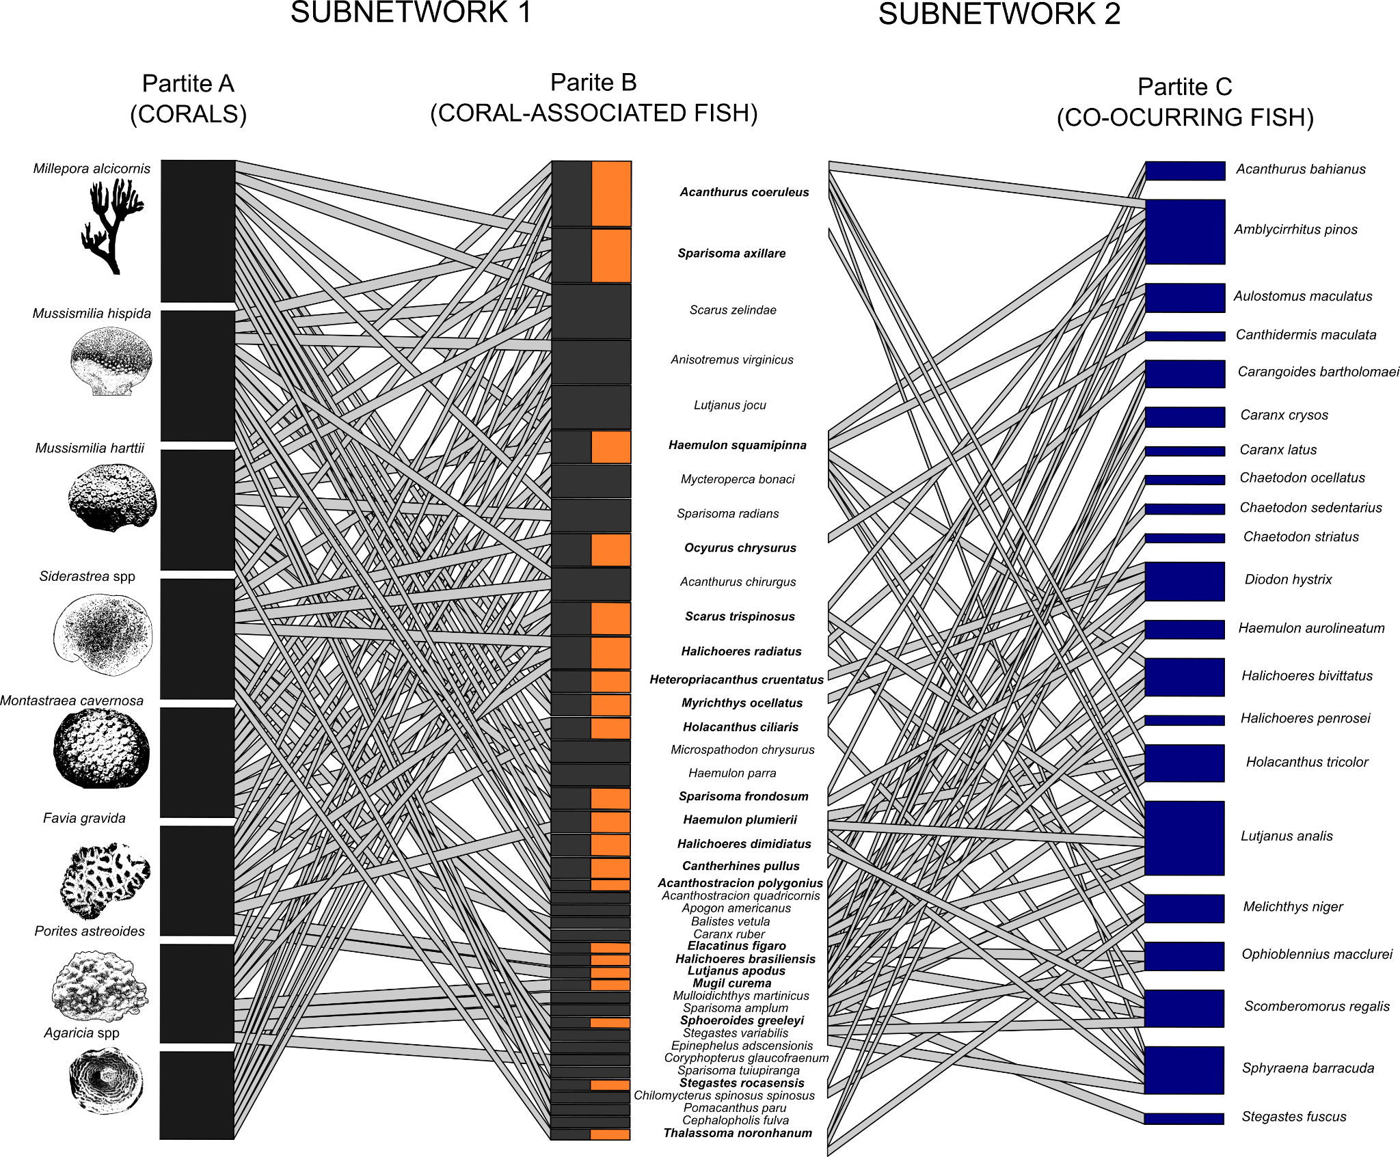

*Fig. 2 – Corals and fish tripartite network, its two subnetworks and their partites. The network is organized in a descending order of fish species richness associated with different coral species. In subnetwork 1, link width denotes the predicted site occupancy probability of fish species (*) *as a function of coral cover (while maintaining turf algae cover constant), and in subnetwork 2 it represents the correlation between the site occupancy probability of coral associated fish and co-occurring fish. In Partite A, bar height (black) depicts the number of fishes associated with each coral species. In Partite B, bar height (grey) represents the number of corals that each fish was associated with, and orange bars and bold scientific names highlight coral-associated fish that establish relationships with co-occurring fish. Finally, in Partite C, blue bars denote the number of coral-associated fish that each co-occurring fish is associated with (only pairwise correlations ρ* ≥ *0.8 were projected in the figure and used in data analysis).*

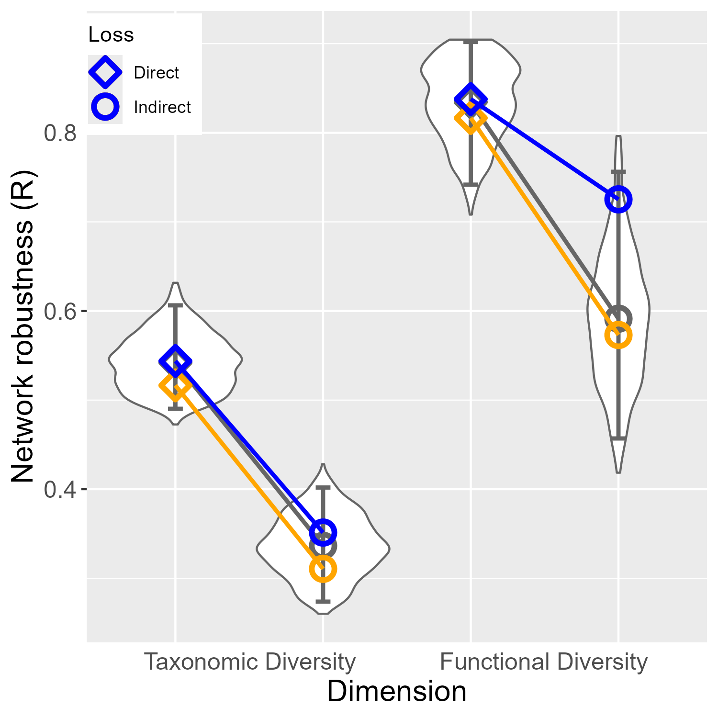

*Fig. 3 - Comparison of network robustness (y-axis) considering direct and indirect effects of coral loss (shapes) and diversity dimensions (x-axis), following the three scenarios of coral removal: degree centrality (orange), random (gray), and vulnerability (blue). and associated 95% Confidence Intervals are shown for the random removal scenario. Direct effects comprise the loss of fish taxonomic and functional diversity directly caused by coral species removal. Indirect effects comprise the loss of fish whose number of occupied sites was correlated with the number of sites occupied by coral-associated fish.*

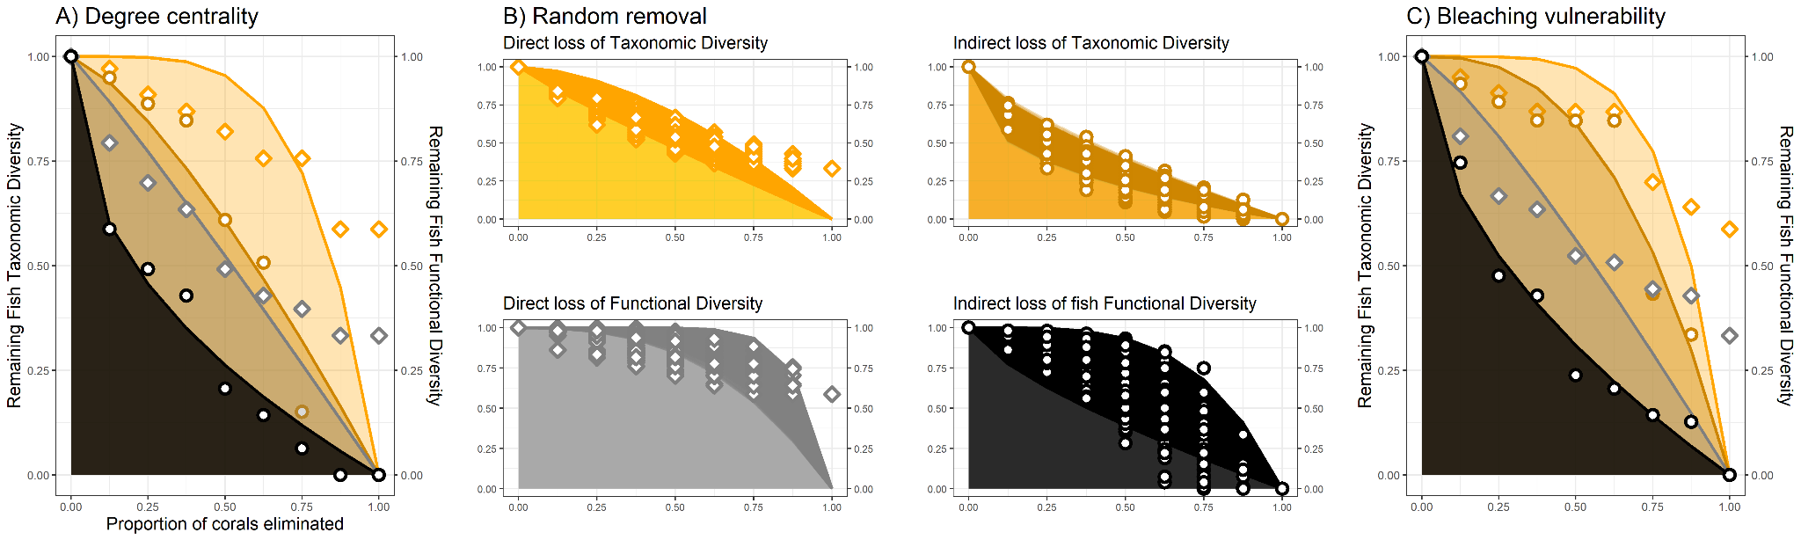

*Fig. 4 - Attack Tolerance Curves (ATC) depicting direct and indirect effects of coral loss on fish taxonomic and functional diversity along three scenarios of coral loss: A) degree centrality, B) random, C) bleaching vulnerability. The shaded area below each curve depicts the hyperbolic function curve fitted to the data shown in the two Y-axes. Direct effects comprise the loss of fish taxonomic and functional diversity caused by coral loss. Indirect effects comprise secondary losses of fish species whose number of occupied sites was correlated with the number of sites occupied by coral-associated fish. Yellow tones represent losses in taxonomic diversity, while grey and black represent losses in functional diversity. Diamonds and circles denote the direct and indirect effects of coral species extinction on such biodiversity dimensions.*

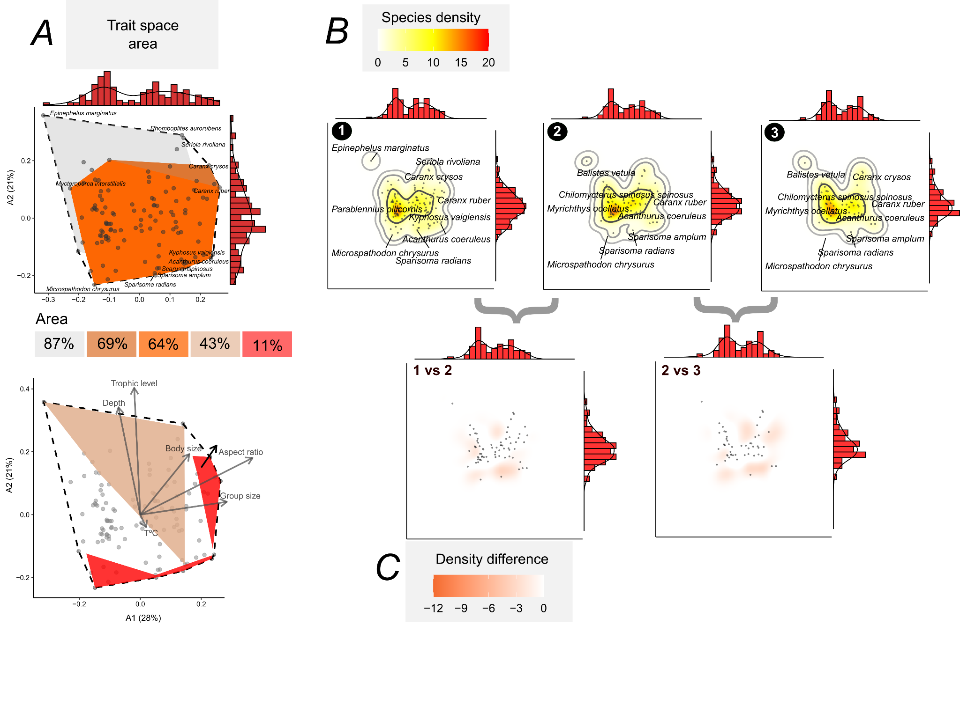

*Fig. 5 - The occupancy of trait space by Brazilian reef fishes. In (A), the first trait space depicts all Brazilian Province fish (n=113 species, white polygon with dashed line), coral-associated fish (n=42, orange, 64% of the trait space area), coral-associated + co-occurring fish (n=63, dark orange, 69% of the trait space area), remaining species (n=50, inner light gray polygon, 87% of the trait space area). The bottom panel in (A) depicts the correlation*

*of each trait with the first two ordination axes, along with polygons representing threatened species (brown polygon, 43% area) and areas vulnerable to cascading extinctions (red polygon, 11% area). Panel (B) illustrates the Provincial trait space occupancy (1), and the trait space occupancy after simulating the direct (2) and indirect effects of coral loss according to the degree centrality scenario (3). Density (trait space occupancy) is visualized using kernel density estimation, with contours depicting 50%, 95%, and 99% density bands. Panel (****C)*** *shows the changes in trait space occupancy after simulating the direct (comparison of 1 vs 2) and the indirect effects (comparison of 2 vs 3) of coral loss. Marginal histograms (with density curves) in all plots illustrate the distribution of species concentrations within trait spaces. The trait space was produced by summarizing trait data with a Principal Coordinate Analysis (PcoA) with the variance explained by the axes indicated in panel (A).:*

**Discussion**

Coextinctions are difficult to observe in nature as they are hard to detect or unfold over long time scales (Estes et al. 2011). Using simulations and a tripartite species-habitat network approach coupled with Attack-Tolerance Curves (ATC), we showed that cascading loss of reef fish species and functions can occur as a response to coral species loss in Southwestern Atlantic reefs. Network and ecological trait space had limited robustness to the direct and indirect influence of coral loss. By assessing network robustness across a gradient of coral species loss, our co-extinction analyses represent a more realistic scenario in terms of conservation when compared with previous results deriving from direct extinction scenarios (Luza et al., 2022). Notably, fish TD and FD was more robust to the removal of sensitive corals, showing a weak relationship between coral bleaching vulnerability and fish assemblage vulnerability. The removal of corals with more associated fish (highest degree centrality, *Millepora alcicornis, Mussismilia hispida*) caused the largest direct and indirect impacts on network's robustness. This has also been revealed for a seed dispersal network where species with a high degree centrality confer network robustness and stability (Bastazini et al., 2019). Such results are particularly useful for management and conservation actions, informing on key conservation targets considering the major coral loss scenarios projected over the next 76 years (Bleuel et al., 2021; Freeman et al., 2013; Hoegh-Guldberg et al., 2007).

**Robustness of coral-fish species-habitat network**

Reefs comprise the most biodiverse and threatened marine ecosystem, and much of their biodiversity is due to the central role that corals play in building tridimensional reef habitats that support diverse communities of other organisms (Coker et al., 2014; McWilliam et al., 2018; Sheppard et al., 2018; Wilson et al., 2006; Woodhead et al., 2019). Coral survival and persistence in the Anthropocene are uncertain (Bleuel et al., 2021; Freeman et al., 2013), posing threats to the complex network of species relying on corals (Bellwood et al., 2004; Strona et al., 2021; Tebbett et al., 2023; Woodhead et al., 2019). Cascading loss of reef fish species and functions as a response to coral loss in Southwestern Atlantic reefs revealed by the Attack-Tolerance Curves (ATC) is a worrisome scenario. Southwestern Atlantic reefs are overlooked marginal reefs, characterized by low coral cover (Aued et al., 2018; Kleypas et al., 1999; Schoepf et al., 2023), and are typically excluded from discussions and analyses addressing biodiversity loss resulting from coral decline (Giglio et al., 2023). This exclusion can have multiple causes, including the lower diversity of corals and fish when compared to coral reefs found in other biogeographic regions, and the generalist relationships between corals and fish in the region. Despite this, the loss of habitat patches with low overall coverage can have a disproportionate impact on ecological networks, as shown in other systems such as plant-insect networks in farmlands (Evans et al., 2013). The steep declines in taxonomic diversity (for direct and indirect scenarios) and functional diversity (only the indirect scenario) inferred from the shape of ATC curves depict two interesting aspects concerning the network robustness.

The studied fish assemblages demonstrated some ability to sustain functional diversity even in the face of direct losses of coral-associated fish. This might indicate functional resistance of coral-associated fish to direct coral losses. Coral-associated fish may exhibit a limited and generalized reliance on coral habitats (Muruga et al., 2024; Wismer et al., 2019), showcasing redundancy in their ecological traits (Luza et al., 2022) and functions (Brandl et al., 2019) when compared to other fish. Theoretically, such low specificity in the interactions between corals and fish might prevent co-extinctions (Brodie et al. 2014). Therefore, the loss of a single species does not necessarily exclude the presence of certain combinations of fish traits in reef sites and the delivery of a particular function. Alternatively, fish communities may present extinction debt, with the potential for relationships to weaken and species, as well as their functions, to be lost over time (Anderson et al. 2022). These characteristics may endow the network with resilience and confer, at least in the short term, robustness to reef ecosystems.

Our comprehensive analysis of the tripartite network, including both direct and indirect links with corals, revealed a concerning low robustness of fish assemblages in the Brazilian Province. The loss of coral species had a profound impact on the network structure, with indirect losses proving to be even more detrimental to the fish assemblage than direct ones. Remarkably, the influence of coral loss extends beyond mere taxonomic diversity, affecting even those fish indirectly related to coral cover. We attribute this to two key factors: firstly, most fish with a higher likelihood of inhabiting areas with high coral cover often present a set of ecological traits (e.g., small body size, low trophic level, small group size) that are well distributed in the assemblage and not taxonomically constrained. These traits define a resilient core group of species within the trait space (i.e. functionally redundant) that remains relatively stable with the propagation of disturbances (here imposed by simulations). Secondly, this core group plays essential roles in forging vital links, connecting peripheral fish within the network, with species having a more restricted set of traits (few species sharing similar combinations) which then become susceptible to coral loss. As such, these core species that interact with vulnerable links are themselves theoretically susceptible to exhibit declines (Brodie et al., 2014). This dual function of coral-associated fish is crucial for maintaining ecosystem integrity, bridging benthic community-level processes (like carbon accretion and prey populations control) with broader nutrient cycling facilitated by mobile organisms (Brandl et al., 2019).

**Network structure and ecosystem functioning**

We observed that the low estimated robustness to coral loss signals a potential threat to ecosystem functioning. It is important to recognize that direct and indirect drivers of environmental change do not act in isolation; rather, they interact, creating synergies and antagonisms (Giglio et al., 2023; Hernández Ruiz et al., 2021; Soares et al., 2021). For example, ocean warming and acidification can lead to significant coral mortality (Sully et al., 2019; Tebbett et al., 2023). In conjunction with overfishing, they can adversely affect fish populations by altering habitat structures and the abiotic environment, as well as trait composition within an assemblage (Silva et al., 2023). These synergistic stressors can destabilize the trophic structure of ecological communities, exerting intense pressure on species that play a disproportionate role in maintaining network structure. This impact is observed in both land (Vidal et al., 2014) and marine networks (Bascompte et al., 2005; Márquez-Velásquez et al., 2021). A case in point comprises the Tropical Eastern Pacific food webs (coast of Colombia), where key species such as the hammerhead shark (*Sphyrna* spp.), which faces a high extinction risk and interacts with small-scale fisheries, have an expressive impact on the network structure (Márquez-Velásquez et al., 2021). Similarly, in the Caribbean, sharks and groupers, both threatened by fisheries, engage in the strongest interactions within food webs (Bascompte et al., 2005). While distinct from food webs, the species-habitat network approach is a valuable tool in identifying vulnerable links within the ecosystem, as it allows us to estimate the importance of habitat patches to the maintenance of local and regional biodiversity (Marini et al., 2019).

In the Southwestern Atlantic reefs, species like the endemic and endangered greenbeak parrotfish (*Scarus trispinosus*), the near-threatened yellowtail snapper (*Ocyurus chrysurus*) and the mutton snapper (*Lutjanus analis*),and the black grouper (*Mycteroperca bonaci*), fulfill crucial ecological roles and occupy regions of the trait space with low species density. Serving as major biomass consumers, they actively circulate nutrients and materials throughout the ecosystem. The former species, which feeds on turf and endolithic algae on the reef matrix, and the three latter species, which primarily feed on vertebrates and invertebrates, show increased site occupancy (and likely greater abundance) with greater coral cover (Luza et al., 2022; Moura et al., 2013; Roos et al., 2019). Furthermore, these species are heavily targeted by fisheries in Brazil and exhibit marked population declines across their geographical range (Eggertsen et al., 2024; Roos et al., 2019). Their extinction, severing links between corals and co-occurring fish, could affect coral health and reef structure (McCook et al., 2001), while potentially easing competition for smaller predators and removing a vital food source for larger ones. This suggests that redundancy, concentrated in the densely populated core of the trait space, may not suffice to sustain ecosystem functionality if these at-risk network nodes are lost. This is particularly concerning given the synergistic threats posed by coral loss, overfishing, and climate change, which exacerbate the situation.

**Assumptions, potential caveats, and perspectives**

In evaluating network robustness, we relied on broad generalizations. First, the primary dataset was designed to elucidate feeding interactions between reef fish and benthic organisms (Inagaki et al., 2020; Longo et al., 2019), which may not fully capture the nuances of fish-to-fish interactions (but see Fontoura et al., 2020). Similarly, pairwise correlations of site occupancy probability between species may not capture the full spectrum of fish-to-fish relationships. Relying on these correlations demand cautious interpretation (reviewed by Blanchet et al., 2020) even in species-habitat networks. For instance, two species may be linked because they prefer or avoid the same factor not included in the model (i.e., they like or dislike a factor beyond coral and turf cover, such as temperature, pollution), or because they are interacting with other species present in the system (Blanchet et al., 2020). However, we lack data to measure the relevance of these caveats.

We revealed processes at the regional scale, integrating data from various species and sites across the entire Brazilian marine biogeographical province. At this scale, extinctions are expected to be less frequent, as some populations of threatened species can persist locally. This means that a function might persist regionally, albeit in a significantly reduced capacity in small to large geographic scales (i.e. functional extinction, Brodie et al., 2014; Valiente‐Banuet et al., 2015). As the goal here was to evaluate robustness and present a new algorithm for functional robustness evaluation, the possibility of adaptive rewiring (i.e., interaction partner switch through time) was not accounted for. The redundancy between removed and remaining species may partially alleviate the loss of functional diversity caused by cascading extinctions from coral-associated to co-occurring fish, despite significant declines in taxonomic diversity (Mouillot et al., 2013). The ability of species to adapt to the absence of the interaction, or even interact with a different habitat or species, is an important component of the resistance to cascading extinctions (Brodie et al., 2014; Vizentin‐Bugoni et al., 2020). Indeed, the majority of fishes inhabiting the Brazilian Province tropical and subtropical reefs, besides being broadly distributed (Pinheiro et al., 2018), have a large level of trophic generalism (Cardozo-Ferreira et al., 2023; Liedke et al., 2016). Further examination of rewiring potential is warranted, as many fish species that were not associated with corals persisted following simulated extinctions. Hence, we emphasize that the 11% reduction should not be disregarded, as it assumes that the remaining species will fulfill similar interactions and ecological functions as those directly and indirectly impacted by coral removal. This is not guaranteed, because despite its similar functional diversity, fish assemblages not associated with corals could not provide the same ecological functions (Bellwood et al., 2019). Furthermore, we still do not fully understand the mechanisms underlying the reorganization of ecological networks in response to species loss (Bastazini et al., 2019). Thus, our approach provides a useful and conservative scenario, ignoring species rewiring. Future developments in our understanding of the nature of ecological interactions and the driving mechanisms of network reorganization in coral systems will certainly improve our ability to forecast the effects of species loss and provide more accurate scenarios of network robustness and resilience in a changing ocean.

Despite such generalizations, our inference about species-habitat links derives from fine-scale resolution and the close matching of fish and coral sampling (Aued et al., 2018; Longo et al., 2019), considered a positive remark/point (Blanchet et al., 2020). These insights underscore the need for future research with sampling designs tailored to detect multi-level interactions (Bascompte et al., 2005; Márquez-Velásquez et al., 2021), and emphasize the importance of local-scale assessments of species-habitat networks.

**Concluding Remarks**

Tropical and subtropical reefs of the Brazilian Province are nominally marginal compared to the nearby Caribbean, with different evolutionary histories (Pinheiro et al. 2018), and with environmental conditions considered suboptimal for most tropical coral species (Schoepf et al., 2023), including high turbidity and nutrient-rich waters (Mies et al., 2020; Santana et al., 2023). These reefs hold a relatively species-poor coral fauna with low redundancy, which makes coral-fish associations less obvious when compared to the Great Caribbean and for the Indo-Pacific realm, but still existent (Coni et al., 2013; Luza et al., 2023a). Despite offering numerous functions and ecosystem services, Brazilian reef environments are increasingly under the strain of escalating anthropogenic pressures at various scales (Soares et al., 2021). Here we detected a limited ability of reef fish assemblages to endure one of the main changes of the Anthropocene: the possible loss of coral diversity. We observed higher levels of robustness of functional diversity to direct species loss, yet the indirect effects of coral loss on the species-habitat network structure were expressive when considering indirect effects of coral species loss. Such coral loss stems from both global-scale factors such as ocean warming, and local impacts, including pollution and overfishing (Tebbett et al., 2023). Coral-associated fishes exhibit a resilient functional structure in healthy reefs, potentially due to adaptation to marginal conditions (Wismer et al., 2019). However, it remains an open question whether this resilience holds in scenarios where coral loss is driven by anthropogenic impacts. Human influence in the Brazilian province has been long-standing (Eggertsen et al., 2024; Fogliarini et al., 2022), and there is scant historical data on what may have already been lost (Fogliarini et al., 2022; 2024). Furthermore, many coral-associated and co-occurring fishes are also directly affected by overfishing or the aquarium trade (Carvalho et al., 2022; Gasparini et al., 2005). This combination of factors can lead to additive effects, potentially setting off a cycle of extinction capable of eroding critical ecological processes mediated by unique species and functional entities. Our study represents a significant conceptual advancement in coextinction analysis for two reasons: it evaluates network robustness within a biodiverse, complex, and threatened ecosystem, and it delves deeper than just the taxonomic facet of biodiversity to include a functional perspective. Overall, ecological networks offer a rich theoretical and empirical basis for grappling with the complex implications of the Anthropocene crisis.

**Data availability statement**

This project is on GitHub: <https://github.com/andreluza/species_habitat_interactions.git>. Basic data supporting analyses will be made public after the acceptance of the manuscript.

**References**

Albert, R. and Barabási, A.-L.: Statistical mechanics of complex networks, Rev. Mod. Phys., 74, 47–97, https://doi.org/10.1103/RevModPhys.74.47, 2002.

Alvarez-Filip, L., Gill, J. A., and Dulvy, N. K.: Complex reef architecture supports more small-bodied fishes and longer food chains on Caribbean reefs, Ecosphere, 2, art118, https://doi.org/10.1890/ES11-00185.1, 2011.

Anderson, L., McLean, M., Houk, P., Graham, C., Kanemoto, K., Terk, E., McLeod, E., and Beger, M.: Decoupling linked coral and fish trait structure, Mar. Ecol. Prog. Ser., 689, 19–32, https://doi.org/10.3354/meps14023, 2022.

Aued, A. W., Smith, F., Quimbayo, J. P., Cândido, D. V., Longo, G. O., Ferreira, C. E. L., Witman, J. D., Floeter, S. R., and Segal, B.: Large-scale patterns of benthic marine communities in the Brazilian Province, PLoS ONE, 13, e0198452, https://doi.org/10.1371/journal.pone.0198452, 2018.

Bane, M. S., Pocock, M. J. O., and James, R.: Effects of model choice, network structure, and interaction strengths on knockout extinction models of ecological robustness, Ecology and Evolution, 8, 10794–10804, https://doi.org/10.1002/ece3.4529, 2018.

Banha, T. N. S., Capel, K. C. C., Kitahara, M. V., Francini-Filho, R. B., Francini, C. L. B., Sumida, P. Y. G., and Mies, M.: Low coral mortality during the most intense bleaching event ever recorded in subtropical Southwestern Atlantic reefs, Coral Reefs, 39, 515–521, https://doi.org/10.1007/s00338-019-01856-y, 2020.

Bascompte, J., Melián, C. J., and Sala, E.: Interaction strength combinations and the overfishing of a marine food web, Proc. Natl. Acad. Sci. U.S.A., 102, 5443–5447, https://doi.org/10.1073/pnas.0501562102, 2005.

Bastazini, V. A., Debastiani, V. J., Azambuja, B. O., Guimarães, P. R., and Pillar, V. D.: Loss of Generalist Plant Species and Functional Diversity Decreases the Robustness of a Seed Dispersal Network, Envir. Conserv., 46, 52–58, https://doi.org/10.1017/S0376892918000334, 2019.

Bastazini, V. A. G., Debastiani, V., Cappelatti, L., Guimarães, P., and Pillar, V. D.: The role of evolutionary modes for trait-based cascades in mutualistic networks, Ecological Modelling, 470, 109983, https://doi.org/10.1016/j.ecolmodel.2022.109983, 2022.

Bellwood, D. R., Hughes, T. P., Folke, C., and Nyström, M.: Confronting the coral reef crisis, Nature, 429, 827–833, https://doi.org/10.1038/nature02691, 2004.

Bellwood, D. R., Streit, R. P., Brandl, S. J., and Tebbett, S. B.: The meaning of the term ‘function’ in ecology: A coral reef perspective, Functional Ecology, 33, 948–961, https://doi.org/10.1111/1365-2435.13265, 2019.

Blanchet, F. G., Cazelles, K., and Gravel, D.: Co‐occurrence is not evidence of ecological interactions, Ecology Letters, 23, 1050–1063, https://doi.org/10.1111/ele.13525, 2020.

Bleuel, J., Pennino, M. G., and Longo, G. O.: Coral distribution and bleaching vulnerability areas in Southwestern Atlantic under ocean warming, Sci Rep, 11, 12833, https://doi.org/10.1038/s41598-021-92202-2, 2021.

Blowes, S. A., Supp, S. R., Antão, L. H., Bates, A., Bruelheide, H., Chase, J. M., Moyes, F., Magurran, A., McGill, B., Myers-Smith, I. H., Winter, M., Bjorkman, A. D., Bowler, D. E., Byrnes, J. E. K., Gonzalez, A., Hines, J., Isbell, F., Jones, H. P., Navarro, L. M., Thompson, P. L., Vellend, M., Waldock, C., and Dornelas, M.: The geography of biodiversity change in marine and terrestrial assemblages, Science, 366, 339–345, https://doi.org/10.1126/science.aaw1620, 2019.

Brandl, S. J., Rasher, D. B., Côté, I. M., Casey, J. M., Darling, E. S., Lefcheck, J. S., and Duffy, J. E.: Coral reef ecosystem functioning: eight core processes and the role of biodiversity, Frontiers in Ecol & Environ, 17, 445–454, https://doi.org/10.1002/fee.2088, 2019.

Braz, G. B., Lacerda, C. H. F., Evangelista, H., Güth, A. Z., Rumbelsperger, A. M. B., Capel, K. C. C., Dall’Occo, P. L., and Mies, M.: Unprecedented erosion of Mussismilia harttii, a major reef-building species in the Southwestern Atlantic, after the 2019 bleaching event, Coral Reefs, 41, 1537–1548, https://doi.org/10.1007/s00338-022-02303-1, 2022.

Brodie, J. F., Aslan, C. E., Rogers, H. S., Redford, K. H., Maron, J. L., Bronstein, J. L., and Groves, C. R.: Secondary extinctions of biodiversity, Trends in Ecology & Evolution, 29, 664–672, https://doi.org/10.1016/j.tree.2014.09.012, 2014.

Burgos, E., Ceva, H., Perazzo, R. P. J., Devoto, M., Medan, D., Zimmermann, M., and María Delbue, A.: Why nestedness in mutualistic networks?, Journal of Theoretical Biology, 249, 307–313, https://doi.org/10.1016/j.jtbi.2007.07.030, 2007.

Burke, S., Pottier, P., Macartney, E. L., Drobniak, S. M., Lagisz, M., Ainsworth, T., and Nakagawa, S.: Mapping literature reviews on coral health: A review map, critical appraisal and bibliometric analysis, Ecol Sol and Evidence, 4, e12287, https://doi.org/10.1002/2688-8319.12287, 2023.

Cantor, M., Longo, G. O., Fontoura, L., Quimbayo, J. P., Floeter, S. R., and Bender, M. G.: Interaction Networks in Tropical Reefs, in: Ecological Networks in the Tropics, edited by: Dáttilo, W. and Rico-Gray, V., Springer International Publishing, Cham, 141–154, https://doi.org/10.1007/978-3-319-68228-0_10, 2018.

Capitani, L., De Araujo, J. N., Vieira, E. A., Angelini, R., and Longo, G. O.: Ocean Warming Will Reduce Standing Biomass in a Tropical Western Atlantic Reef Ecosystem, Ecosystems, 25, 843–857, https://doi.org/10.1007/s10021-021-00691-z, 2022.

Cardozo-Ferreira, G., Ferreira, C., Choat, J., Mendes, T., Macieira, R., Rezende, C., Joyeux, J., and Clements, K.: Seasonal variation in diet and isotopic niche of nominally herbivorous fishes in subtropical rocky reefs, Mar. Ecol. Prog. Ser., 722, 125–143, https://doi.org/10.3354/meps14442, 2023.

Carvalho, J. C. and Cardoso, P.: Decomposing the Causes for Niche Differentiation Between Species Using Hypervolumes, Front. Ecol. Evol., 8, 243, https://doi.org/10.3389/fevo.2020.00243, 2020.

Carvalho, L. M., Mies, M., Inagaki, K. Y., Sanches, E. G., Souza, M. R., Longo, G. O., and Tomás, A. R. G.: The marine ornamental market in Brazil (Southwestern Atlantic) frequently trades prohibited and endangered species, and threatens the ecosystem role of cleaning mutualism, Marine Policy, 146, 105305, https://doi.org/10.1016/j.marpol.2022.105305, 2022.

Ceballos, G., Ehrlich, P. R., Barnosky, A. D., García, A., Pringle, R. M., and Palmer, T. M.: Accelerated modern human–induced species losses: Entering the sixth mass extinction, Sci. Adv., 1, e1400253, https://doi.org/10.1126/sciadv.1400253, 2015.

Coker, D. J., Wilson, S. K., and Pratchett, M. S.: Importance of live coral habitat for reef fishes, Rev Fish Biol Fisheries, 24, 89–126, https://doi.org/10.1007/s11160-013-9319-5, 2014.

Coni, E. O. C., Ferreira, C. M., De Moura, R. L., Meirelles, P. M., Kaufman, L., and Francini-Filho, R. B.: An evaluation of the use of branching fire-corals (Millepora spp.) as refuge by reef fish in the Abrolhos Bank, eastern Brazil, Environ Biol Fish, 96, 45–55, https://doi.org/10.1007/s10641-012-0021-6, 2013.

Corazza, B. M., Lacerda, C. H. F., Güth, A. Z., Marcançoli, R. K. M., Bianchini, A., Calderon, E. N., Capel, K. C. C., Conceição, E., Faria, S. C., Francini-Filho, R. B., Garrido, A. G., Guebert, F. M., Kitahara, M. V., Longo, G. O., Lotufo, T. M. C., Salvi, K. P., Segal, B., Sumida, P. Y. G., Zilberberg, C., and Mies, M.: No coral recovery three years after a major bleaching event in reefs in the Southwestern Atlantic refugium, Mar Biol, 171, 114, https://doi.org/10.1007/s00227-024-04432-3, 2024.

Cornwell, W. K., Schwilk, D. W., and Ackerly, D. D.: A TRAIT-BASED TEST FOR HABITAT FILTERING: CONVEX HULL VOLUME, Ecology, 87, 1465–1471, https://doi.org/10.1890/0012-9658(2006)87[1465:ATTFHF]2.0.CO;2, 2006.

Cramer, K. L., Donovan, M. K., Jackson, J. B. C., Greenstein, B. J., Korpanty, C. A., Cook, G. M., and Pandolfi, J. M.: The transformation of Caribbean coral communities since humans, Ecology and Evolution, 11, 10098–10118, https://doi.org/10.1002/ece3.7808, 2021.

Doherty, S., Saltré, F., Llewelyn, J., Strona, G., Williams, S. E., and Bradshaw, C. J. A.: Estimating co‐extinction threats in terrestrial ecosystems, Global Change Biology, 29, 5122–5138, https://doi.org/10.1111/gcb.16836, 2023.

Dray, S. and Dufour, A.-B.: The **ade4** Package: Implementing the Duality Diagram for Ecologists, J. Stat. Soft., 22, https://doi.org/10.18637/jss.v022.i04, 2007.

Duong, T.: **ks** : Kernel Density Estimation and Kernel Discriminant Analysis for Multivariate Data in *R*, J. Stat. Soft., 21, https://doi.org/10.18637/jss.v021.i07, 2007.

Eggertsen, L., Luza, A. L., Cordeiro, C. A. M. M., Dambros, C., Ferreira, C. E. L., Floeter, S. R., B. Francini-Filho, R., Freire, K. M. F., Gasalla, M. A., Giarrizzo, T., Giglio, V. J., Hanazaki, N., Lopes, P. F. M., Longo, G. O., Luiz, O. J., Magris, R. A., Mendes, T. C., Pinheiro, H. T., Quimbayo, J. P., Reis-Filho, J. A., Vila-Nova, D. A., and Bender, M. G.: Complexities of reef fisheries in Brazil: a retrospective and functional approach, Rev Fish Biol Fisheries, 34, 511–538, https://doi.org/10.1007/s11160-023-09826-y, 2024.

Estes, J. A., Tinker, M. T., Williams, T. M., and Doak, D. F.: Killer Whale Predation on Sea Otters Linking Oceanic and Nearshore Ecosystems, Science, 282, 473–476, https://doi.org/10.1126/science.282.5388.473, 1998.

Estes, J. A., Terborgh, J., Brashares, J. S., Power, M. E., Berger, J., Bond, W. J., Carpenter, S. R., Essington, T. E., Holt, R. D., Jackson, J. B. C., Marquis, R. J., Oksanen, L., Oksanen, T., Paine, R. T., Pikitch, E. K., Ripple, W. J., Sandin, S. A., Scheffer, M., Schoener, T. W., Shurin, J. B., Sinclair, A. R. E., Soulé, M. E., Virtanen, R., and Wardle, D. A.: Trophic Downgrading of Planet Earth, Science, 333, 301–306, https://doi.org/10.1126/science.1205106, 2011.

Evans, D. M., Pocock, M. J. O., and Memmott, J.: The robustness of a network of ecological networks to habitat loss, Ecology Letters, 16, 844–852, https://doi.org/10.1111/ele.12117, 2013.

Fogliarini, C. O., Longo, G. O., Francini-Filho, R. B., McClenachan, L., and Bender, M. G.: Sailing into the past: Nautical charts reveal changes over 160 years in the largest reef complex in the South Atlantic Ocean, Perspectives in Ecology and Conservation, 20, 231–239, https://doi.org/10.1016/j.pecon.2022.05.003, 2022.

Fontoura, L., Cantor, M., Longo, G. O., Bender, M. G., Bonaldo, R. M., and Floeter, S. R.: The macroecology of reef fish agonistic behaviour, Ecography, 43, 1278–1290, https://doi.org/10.1111/ecog.05079, 2020.

Freeman, L. A., Kleypas, J. A., and Miller, A. J.: Coral Reef Habitat Response to Climate Change Scenarios, PLoS ONE, 8, e82404, https://doi.org/10.1371/journal.pone.0082404, 2013.

Gasparini, J. L., Floeter, S. R., Ferreira, C. E. L., and Sazima, I.: Marine Ornamental Trade in Brazil, Biodivers Conserv, 14, 2883–2899, https://doi.org/10.1007/s10531-004-0222-1, 2005.

Giglio, V. J., Aued, A. W., Cordeiro, C. A. M. M., Eggertsen, L., S. Ferrari, D., Gonçalves, L. R., Hanazaki, N., Luiz, O. J., Luza, A. L., Mendes, T. C., Pinheiro, H. T., Segal, B., Waechter, L. S., and Bender, M. G.: A Global Systematic Literature Review of Ecosystem Services in Reef Environments, Environmental Management, https://doi.org/10.1007/s00267-023-01912-y, 2023.

Hadj-Hammou, J., Mouillot, D., and Graham, N. A. J.: Response and Effect Traits of Coral Reef Fish, Front. Mar. Sci., 8, 640619, https://doi.org/10.3389/fmars.2021.640619, 2021.

Hernández Ruiz, L., Ekumah, B., Asiedu, D. A., Albani, G., Acheampong, E., Jónasdóttir, S. H., Koski, M., and Nielsen, T. G.: Climate change and oil pollution: A dangerous cocktail for tropical zooplankton, Aquatic Toxicology, 231, 105718, https://doi.org/10.1016/j.aquatox.2020.105718, 2021.

Hoegh-Guldberg, O., Mumby, P. J., Hooten, A. J., Steneck, R. S., Greenfield, P., Gomez, E., Harvell, C. D., Sale, P. F., Edwards, A. J., Caldeira, K., Knowlton, N., Eakin, C. M., Iglesias-Prieto, R., Muthiga, N., Bradbury, R. H., Dubi, A., and Hatziolos, M. E.: Coral Reefs Under Rapid Climate Change and Ocean Acidification, Science, 318, 1737–1742, https://doi.org/10.1126/science.1152509, 2007.

Hughes, T. P., Kerry, J. T., Baird, A. H., Connolly, S. R., Dietzel, A., Eakin, C. M., Heron, S. F., Hoey, A. S., Hoogenboom, M. O., Liu, G., McWilliam, M. J., Pears, R. J., Pratchett, M. S., Skirving, W. J., Stella, J. S., and Torda, G.: Global warming transforms coral reef assemblages, Nature, 556, 492–496, https://doi.org/10.1038/s41586-018-0041-2, 2018.

Inagaki, K. Y., Pennino, M. G., Floeter, S. R., Hay, M. E., and Longo, G. O.: Trophic interactions will expand geographically but be less intense as oceans warm, Global Change Biology, 26, 6805–6812, https://doi.org/10.1111/gcb.15346, 2020.

Kéry, M. and Royle, J. A.: Applied hierarchical modeling in ecology: analysis of distribution, abundance and species richness in R and BUGS, Elsevier/AP, Academic Press is an imprint of Elsevier, Amsterdam ; Boston, 2016.

Kleypas, J. A., Mcmanus, J. W., and Meñez, L. A. B.: Environmental Limits to Coral Reef Development: Where Do We Draw the Line?, Am Zool, 39, 146–159, https://doi.org/10.1093/icb/39.1.146, 1999.

Liedke, A. M. R., Barneche, D. R., Ferreira, C. E. L., Segal, B., Nunes, L. T., Burigo, A. P., Carvalho, J. A., Buck, S., Bonaldo, R. M., and Floeter, S. R.: Abundance, diet, foraging and nutritional condition of the banded butterflyfish (Chaetodon striatus) along the western Atlantic, Mar Biol, 163, 6, https://doi.org/10.1007/s00227-015-2788-4, 2016.

Longo, G. O., Hay, M. E., Ferreira, C. E. L., and Floeter, S. R.: Trophic interactions across 61 degrees of latitude in the Western Atlantic, Global Ecol Biogeogr, 28, 107–117, https://doi.org/10.1111/geb.12806, 2019.

Luza, A. L., Quimbayo, J. P., Ferreira, C. E. L., Floeter, S. R., Francini-Filho, R. B., Bender, M. G., and Longo, G. O.: Low functional vulnerability of fish assemblages to coral loss in Southwestern Atlantic marginal reefs, Sci Rep, 12, 17164, https://doi.org/10.1038/s41598-022-20919-9, 2022.

Luza, A. L., Aued, A. W., Barneche, D. R., Dias, M. S., Ferreira, C. E. L., Floeter, S. R., Francini‐Filho, R. B., Longo, G. O., Quimbayo, J. P., and Bender, M. G.: Functional diversity patterns of reef fish, corals and algae in the Brazilian biogeographical province, Journal of Biogeography, 50, 1163–1176, https://doi.org/10.1111/jbi.14599, 2023a.

Luza, A. L., Barneche, D. R., Cordeiro, C. A. M. M., Dambros, C. S., Ferreira, C. E. L., Floeter, S. R., Giglio, V. J., Luiz, O. J., Mendes, T. C., Picolotto, V. A. P., Quimbayo, J. P., Silva, F. C., Waechter, L., Longo, G. O., and Bender, M. G.: Going across taxa in functional ecology: Review and perspectives of an emerging field, Functional Ecology, 37, 3091–3110, https://doi.org/10.1111/1365-2435.14442, 2023b.

Mammola, S. and Cardoso, P.: Functional diversity metrics using kernel density *n* ‐dimensional hypervolumes, Methods Ecol Evol, 11, 986–995, https://doi.org/10.1111/2041-210X.13424, 2020.

Marini, L., Bartomeus, I., Rader, R., and Lami, F.: Species–habitat networks: A tool to improve landscape management for conservation, Journal of Applied Ecology, 56, 923–928, https://doi.org/10.1111/1365-2664.13337, 2019.

Márquez-Velásquez, V., Navia, A. F., Rosa, R. S., Guimarães, P. R., and Raimundo, R. L. G.: Resource partitioning between fisheries and endangered sharks in a tropical marine food web, ICES Journal of Marine Science, 78, 2518–2527, https://doi.org/10.1093/icesjms/fsab129, 2021.

McCook, L., Jompa, J., and Diaz-Pulido, G.: Competition between corals and algae on coral reefs: a review of evidence and mechanisms, Coral Reefs, 19, 400–417, https://doi.org/10.1007/s003380000129, 2001.

McWilliam, M., Hoogenboom, M. O., Baird, A. H., Kuo, C.-Y., Madin, J. S., and Hughes, T. P.: Biogeographical disparity in the functional diversity and redundancy of corals, Proc. Natl. Acad. Sci. U.S.A., 115, 3084–3089, https://doi.org/10.1073/pnas.1716643115, 2018.

Mello, T. J., Vieira, E. A., Garrido, A. G., Zilberberg, C., De Lima, J. L., Santos, L. P. S., and Longo, G. O.: Drivers of temporal variation in benthic cover and coral health of an oceanic intertidal reef in Southwestern Atlantic, Regional Studies in Marine Science, 60, 102874, https://doi.org/10.1016/j.rsma.2023.102874, 2023.

Mies, M., Francini-Filho, R. B., Zilberberg, C., Garrido, A. G., Longo, G. O., Laurentino, E., Güth, A. Z., Sumida, P. Y. G., and Banha, T. N. S.: South Atlantic Coral Reefs Are Major Global Warming Refugia and Less Susceptible to Bleaching, Front. Mar. Sci., 7, 514, https://doi.org/10.3389/fmars.2020.00514, 2020.

Mouillot, D., Graham, N. A. J., Villéger, S., Mason, N. W. H., and Bellwood, D. R.: A functional approach reveals community responses to disturbances, Trends in Ecology & Evolution, 28, 167–177, https://doi.org/10.1016/j.tree.2012.10.004, 2013.

Moura, R. L., Secchin, N. A., Amado-Filho, G. M., Francini-Filho, R. B., Freitas, M. O., Minte-Vera, C. V., Teixeira, J. B., Thompson, F. L., Dutra, G. F., Sumida, P. Y. G., Guth, A. Z., Lopes, R. M., and Bastos, A. C.: Spatial patterns of benthic megahabitats and conservation planning in the Abrolhos Bank, Continental Shelf Research, 70, 109–117, https://doi.org/10.1016/j.csr.2013.04.036, 2013.

Muruga, P., Siqueira, A. C., and Bellwood, D. R.: Meta-analysis reveals weak associations between reef fishes and corals, Nat Ecol Evol, 8, 676–685, https://doi.org/10.1038/s41559-024-02334-7, 2024.

Palmeirim, A. F., Emer, C., Benchimol, M., Storck-Tonon, D., Bueno, A. S., and Peres, C. A.: Emergent properties of species-habitat networks in an insular forest landscape, Sci. Adv., 8, eabm0397, https://doi.org/10.1126/sciadv.abm0397, 2022.

Parravicini, V., Villéger, S., McClanahan, T. R., Arias‐González, J. E., Bellwood, D. R., Belmaker, J., Chabanet, P., Floeter, S. R., Friedlander, A. M., Guilhaumon, F., Vigliola, L., Kulbicki, M., and Mouillot, D.: Global mismatch between species richness and vulnerability of reef fish assemblages, Ecology Letters, 17, 1101–1110, https://doi.org/10.1111/ele.12316, 2014.

Parravicini, V., Bender, M. G., Villéger, S., Leprieur, F., Pellissier, L., Donati, F. G. A., Floeter, S. R., Rezende, E. L., Mouillot, D., and Kulbicki, M.: Coral reef fishes reveal strong divergence in the prevalence of traits along the global diversity gradient, Proc. R. Soc. B., 288, 20211712, https://doi.org/10.1098/rspb.2021.1712, 2021.

Pereira, C. M., Fonseca, J. S., Paiva, E. S., Costa, P. G., Mies, M., Silva, A. G., Calderon, E. N., Bianchini, A., and Castro, C. B.: Larvae of the South Atlantic coral Favia gravida are tolerant to salinity and nutrient concentrations associated with river discharges, Marine Environmental Research, 161, 105118, https://doi.org/10.1016/j.marenvres.2020.105118, 2020.

Pereira, P. H. C., Lima, G. V., Pontes, A. V. F., Côrtes, L. G. F., Gomes, E., Sampaio, C. L. S., Pinto, T. K., Miranda, R. J., Cardoso, A. T. C., Araujo, J. C., and Seoane, J. C. S.: Unprecedented Coral Mortality on Southwestern Atlantic Coral Reefs Following Major Thermal Stress, Front. Mar. Sci., 9, 725778, https://doi.org/10.3389/fmars.2022.725778, 2022.

Pimm, S. L., Jenkins, C. N., Abell, R., Brooks, T. M., Gittleman, J. L., Joppa, L. N., Raven, P. H., Roberts, C. M., and Sexton, J. O.: The biodiversity of species and their rates of extinction, distribution, and protection, Science, 344, 1246752, https://doi.org/10.1126/science.1246752, 2014.

Pinheiro, H. T., Rocha, L. A., Macieira, R. M., Carvalho‐Filho, A., Anderson, A. B., Bender, M. G., Di Dario, F., Ferreira, C. E. L., Figueiredo‐Filho, J., Francini‐Filho, R., Gasparini, J. L., Joyeux, J., Luiz, O. J., Mincarone, M. M., Moura, R. L., Nunes, J. D. A. C. C., Quimbayo, J. P., Rosa, R. S., Sampaio, C. L. S., Sazima, I., Simon, T., Vila‐Nova, D. A., and Floeter, S. R.: South‐western Atlantic reef fishes: Zoogeographical patterns and ecological drivers reveal a secondary biodiversity centre in the Atlantic Ocean, Diversity and Distributions, 24, 951–965, https://doi.org/10.1111/ddi.12729, 2018.

Pires, M. M.: The Restructuring of Ecological Networks by the Pleistocene Extinction, Annual Review of Earth and Planetary Sciences, 52, 133–158, https://doi.org/10.1146/annurev-earth-040722-104845, 2024.

Quimbayo, J. P., Cantor, M., Dias, M. S., Grutter, A. S., Gingins, S., Becker, J. H. A., and Floeter, S. R.: The global structure of marine cleaning mutualistic networks, Global Ecol Biogeogr, 27, 1238–1250, https://doi.org/10.1111/geb.12780, 2018.

Quimbayo, J. P., Silva, F. C., Mendes, T. C., Ferrari, D. S., Danielski, S. L., Bender, M. G., Parravicini, V., Kulbicki, M., and Floeter, S. R.: Life‐history traits, geographical range, and conservation aspects of reef fishes from the Atlantic and Eastern Pacific, Ecology, 102, e03298, https://doi.org/10.1002/ecy.3298, 2021.

R Core Team: R Programming Environment v.4.3.1, 2023.

Roos, N., Pennino, M., Carvalho, A., and Longo, G.: Drivers of abundance and biomass of Brazilian parrotfishes, Mar. Ecol. Prog. Ser., 623, 117–130, https://doi.org/10.3354/meps13005, 2019.

Santana, E. F. C., Mies, M., Longo, G. O., Menezes, R., Aued, A. W., Luza, A. L., Bender, M. G., Segal, B., Floeter, S. R., and Francini-Filho, R. B.: Turbidity shapes shallow Southwestern Atlantic benthic reef communities, Marine Environmental Research, 183, 105807, https://doi.org/10.1016/j.marenvres.2022.105807, 2023.

Schoepf, V., Baumann, J. H., Barshis, D. J., Browne, N. K., Camp, E. F., Comeau, S., Cornwall, C. E., Guzmán, H. M., Riegl, B., Rodolfo-Metalpa, R., and Sommer, B.: Corals at the edge of environmental limits: A new conceptual framework to re-define marginal and extreme coral communities, Science of The Total Environment, 884, 163688, https://doi.org/10.1016/j.scitotenv.2023.163688, 2023.

Sheppard, C. R. C., Davy, S. K., Pilling, G. M., and Graham, N.: The biology of coral reefs, 2nd ed., Oxford university press, Oxford, 2018.

Silva, F., Floeter, S., Lindegren, M., and Quimbayo, J.: Warming-induced changes in reef fish community traits in the Southwestern Atlantic transition zone, Mar. Ecol. Prog. Ser., 710, 107–123, https://doi.org/10.3354/meps14288, 2023.

Soares, M. O., Rossi, S., Gurgel, A. R., Lucas, C. C., Tavares, T. C. L., Diniz, B., Feitosa, C. V., Rabelo, E. F., Pereira, P. H. C., Kikuchi, R. K. P. D., Leão, Z. M. A. N., Cruz, I. C. S., Carneiro, P. B. D. M., and Alvarez-Filip, L.: Impacts of a changing environment on marginal coral reefs in the Tropical Southwestern Atlantic, Ocean & Coastal Management, 210, 105692, https://doi.org/10.1016/j.ocecoaman.2021.105692, 2021.

Srivastava, D. S., Cardinale, B. J., Downing, A. L., Duffy, J. E., Jouseau, C., Sankaran, M., and Wright, J. P.: Diversity has stronger top‐down than bottom‐up effects on decomposition, Ecology, 90, 1073–1083, https://doi.org/10.1890/08-0439.1, 2009.

Strona, G. and Bradshaw, C. J. A.: Coextinctions dominate future vertebrate losses from climate and land use change, Sci. Adv., 8, eabn4345, https://doi.org/10.1126/sciadv.abn4345, 2022.

Strona, G., Lafferty, K. D., Fattorini, S., Beck, P. S. A., Guilhaumon, F., Arrigoni, R., Montano, S., Seveso, D., Galli, P., Planes, S., and Parravicini, V.: Global tropical reef fish richness could decline by around half if corals are lost, Proc. R. Soc. B., 288, 20210274, https://doi.org/10.1098/rspb.2021.0274, 2021.

Sully, S., Burkepile, D. E., Donovan, M. K., Hodgson, G., and Van Woesik, R.: A global analysis of coral bleaching over the past two decades, Nat Commun, 10, 1264, https://doi.org/10.1038/s41467-019-09238-2, 2019.

Tavares, D. C., Moura, J. F., Acevedo-Trejos, E., and Merico, A.: Traits Shared by Marine Megafauna and Their Relationships With Ecosystem Functions and Services, Front. Mar. Sci., 6, 262, https://doi.org/10.3389/fmars.2019.00262, 2019.

Tebbett, S. B., Connolly, S. R., and Bellwood, D. R.: Benthic composition changes on coral reefs at global scales, Nat Ecol Evol, 7, 71–81, https://doi.org/10.1038/s41559-022-01937-2, 2023.

Teixeira, C. D., Leitão, R. L. L., Ribeiro, F. V., Moraes, F. C., Neves, L. M., Bastos, A. C., Pereira-Filho, G. H., Kampel, M., Salomon, P. S., Sá, J. A., Falsarella, L. N., Amario, M., Abieri, M. L., Pereira, R. C., Amado-Filho, G. M., and Moura, R. L.: Sustained mass coral bleaching (2016–2017) in Brazilian turbid-zone reefs: taxonomic, cross-shelf and habitat-related trends, Coral Reefs, 38, 801–813, https://doi.org/10.1007/s00338-019-01789-6, 2019.

Valiente‐Banuet, A., Aizen, M. A., Alcántara, J. M., Arroyo, J., Cocucci, A., Galetti, M., García, M. B., García, D., Gómez, J. M., Jordano, P., Medel, R., Navarro, L., Obeso, J. R., Oviedo, R., Ramírez, N., Rey, P. J., Traveset, A., Verdú, M., and Zamora, R.: Beyond species loss: the extinction of ecological interactions in a changing world, Functional Ecology, 29, 299–307, https://doi.org/10.1111/1365-2435.12356, 2015.

Vidal, M. M., Hasui, E., Pizo, M. A., Tamashiro, J. Y., Silva, W. R., and Guimarães, P. R.: Frugivores at higher risk of extinction are the key elements of a mutualistic network, Ecology, 95, 3440–3447, https://doi.org/10.1890/13-1584.1, 2014.

Villéger, S., Mason, N. W. H., and Mouillot, D.: NEW MULTIDIMENSIONAL FUNCTIONAL DIVERSITY INDICES FOR A MULTIFACETED FRAMEWORK IN FUNCTIONAL ECOLOGY, Ecology, 89, 2290–2301, https://doi.org/10.1890/07-1206.1, 2008.

Vizentin‐Bugoni, J., Debastiani, V. J., Bastazini, V. A. G., Maruyama, P. K., and Sperry, J. H.: Including rewiring in the estimation of the robustness of mutualistic networks, Methods Ecol Evol, 11, 106–116, https://doi.org/10.1111/2041-210X.13306, 2020.

Wickham, H.: ggplot2: Elegant Graphics for Data Analysis., Springer-Verlag New York, 2016.

Wilson, S. K., Graham, N. A. J., Pratchett, M. S., Jones, G. P., and Polunin, N. V. C.: Multiple disturbances and the global degradation of coral reefs: are reef fishes at risk or resilient?, Global Change Biology, 12, 2220–2234, https://doi.org/10.1111/j.1365-2486.2006.01252.x, 2006.

Wismer, S., Tebbett, S. B., Streit, R. P., and Bellwood, D. R.: Young fishes persist despite coral loss on the Great Barrier Reef, Commun Biol, 2, 456, https://doi.org/10.1038/s42003-019-0703-0, 2019.

Woodhead, A. J., Hicks, C. C., Norström, A. V., Williams, G. J., and Graham, N. A. J.: Coral reef ecosystem services in the Anthropocene, Functional Ecology, 33, 1023–1034, https://doi.org/10.1111/1365-2435.13331, 2019.

Online Supporting Information

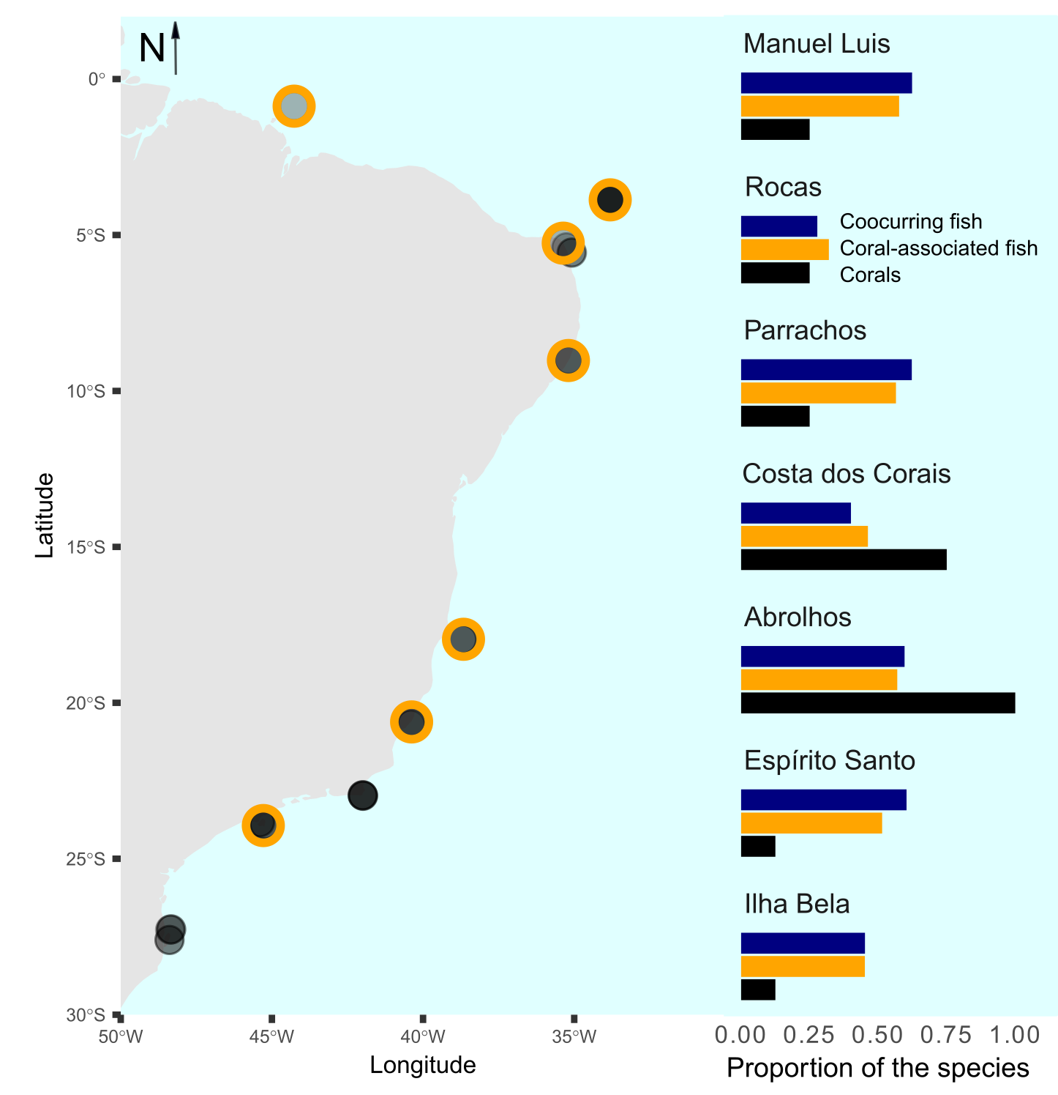

*Figure S1: Spatial distribution of the 36 studied sites (left) and the proportion of the total number of corals (n=8, black bars), coral-associated fish (n=42, orange bars), and co-occurring fish (n=21, blue bars) in seven selected sites (right). The selected sites are highlighted with orange strokes around points in the map. The represented localities within each site were (ordered from North to South): Manuel Luis: Ana Cristina; Rocas: Tartarugas; Parrachos: Rio do Fogo; Costa dos Corais: Gales; Abrolhos: Chapeirão; Espírito Santo: Três Ilhas; Ilhabela: Saco do Diogo.*

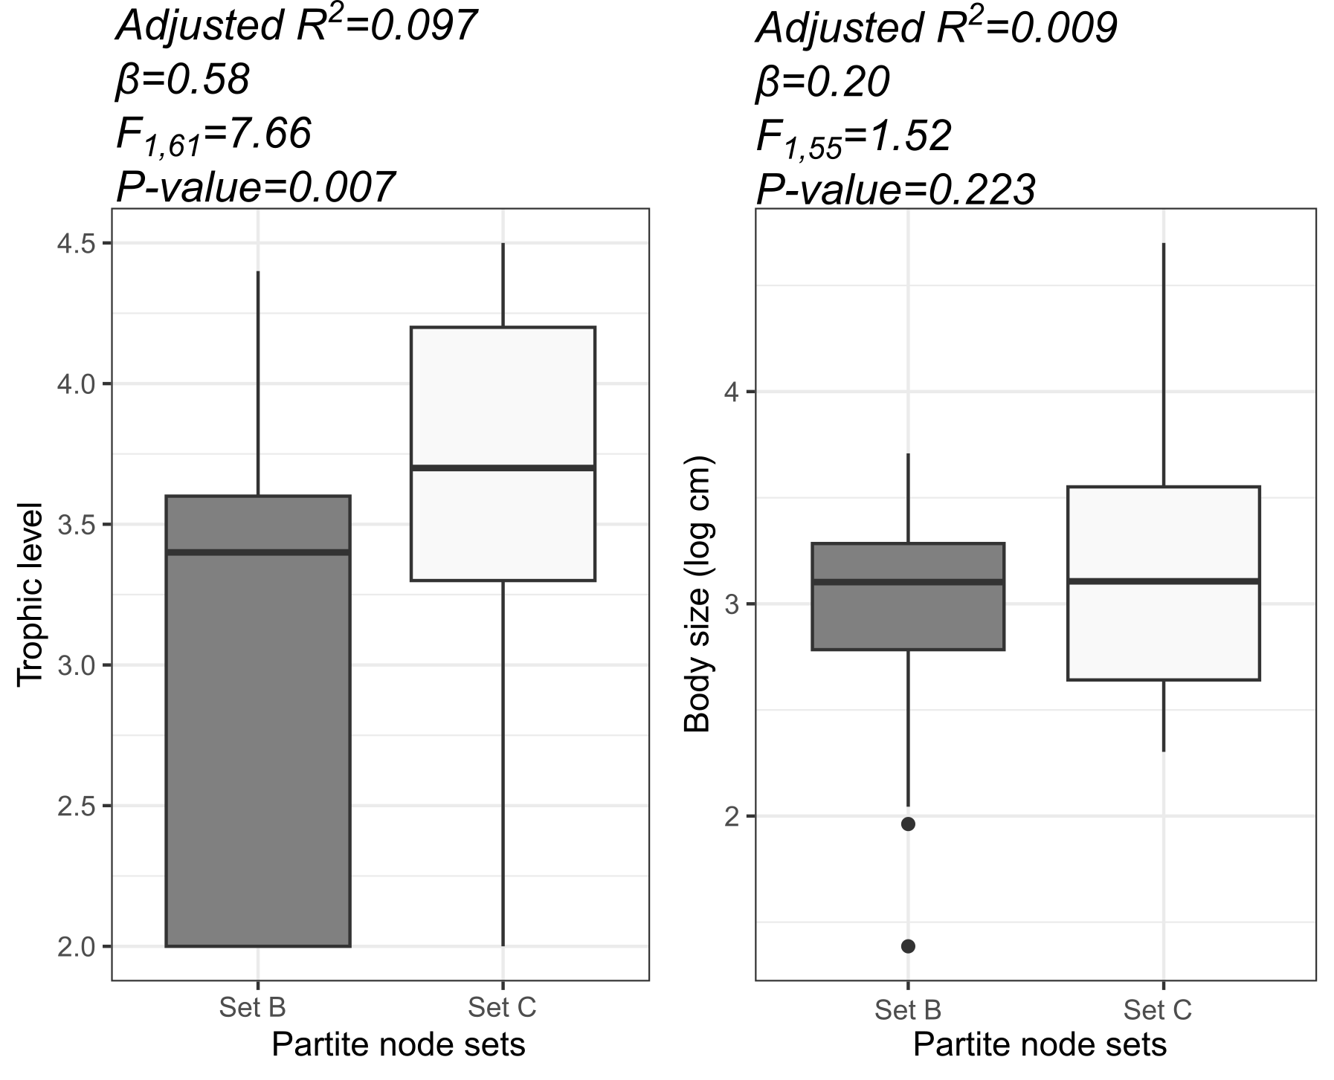

*Fig. S1.2: Variation of trophic level (A) and body size (B) between reef fish species in node sets B (coral-associated fish) and C (co-occurring fish).*