**Coping with Collapse: Functional Robustness of Coral-Reef Fish Network to** **Simulated Cascade Extinction**

André L Luza1,2, Mariana G Bender1, Carlos EL Ferreira3, Sergio R Floeter4, Ronaldo B Francini-Filho5, Guilherme O Longo6, Hudson T Pinheiro5, Juan P Quimbayo7, Vinicius A G Bastazini8,9

**Affiliation**

1 Department of Ecology and Evolution, Universidade Federal de Santa Maria, Santa Maria, Rio Grande do Sul, Brazil

2 UMR Biodiversité Gènes et Communautés INRAE. Université de Bordeaux, Bât. B2 - Allée Geoffroy St-Hilaire, 33615 Pessac, France

3 Department of Marine Biology, Universidade Federal Fluminense, Niterói, Rio de Janeiro, Brazil

4 Department of Ecology and Zoology, Universidade Federal de Santa Catarina, Florianópolis, Santa Catarina, Brazil

5 Centre for Marine Biology (CEBIMar), Universidade de São Paulo, São Sebastião, São Paulo, Brazil

6 Department of Oceanography and Limnology, Universidade Federal do Rio Grande do Norte, Natal, Rio Grande do Norte, Brazil

7 Department of Biology, University of Miami, Coral Gables, FL 33146, USA.

8 Mediterranean Institute for Agriculture, Environment and Development (MED), Global Change and Sustainability Institute (CHANGE), Institute for Advanced Studies and Research (IIFA), University of Evora, Evora, Portugal

9 Rui Nabeiro’ Biodiversity Chair, University of Evora, Evora, Portugal

**Corresponding author:** André Luza. [luza.andre@gmail.com](mailto:luza.andre@gmail.com)

**ORCID**

André Luís Luza: 0000-0003-0302-529X

Mariana Bender 0000-0001-5912-5471

Carlos Ferreira: 0000-0002-4311-0491

Sergio Floeter 0000-0002-3143-1474

Ronaldo Francini-Filho 0000-0002-7678-6797

Guilherme Longo 0000-0003-2033-7439

Hudson T. Pinheiro 0000-0002-3143-1474

Juan P. Quimbayo 0000-0001-5346-3488

Vinicius A. G. Bastazini: 0000-0001-5270-0621

**Funding**

ALL received post-doctoral fellowships from CNPq (#153024/2022-4, #164240/2021-7, #151228/2021-3, #152410/2020-1) and CAPES (PDPG-POSDOC, #88887.800011/2022-00). GOL, RBFFi and SRF are grateful to their research productivity scholarships provided by CNPq (#308072/2022-7; 309651/2021-2; 310906/2023-7, respectively). HTP thanks São Paulo Research Foundation (FAPESP) for funding and fellowship (grants #2019/24215-2 and 2021/07039-6). We acknowledge funding by the Brazilian Synthesis Institute (Sinbiose, CNPq; grant number #442417/2019-5; PI: MGB), PPBIO IntegraMar (CNPq #441226/2023-0, PI: MGB), and Portuguese National Funds through FCT – Foundation for Science and Technology under the Project UIDB/05183/2020 (to VAGB).

**Conflict of Interest Statement**

We have no conflict of interest to declare.

**Abstract**

Human activities and climate change have accelerated species losses and degradation of ecosystems to unprecedented levels. Both theoretical and empirical evidence suggest that extinction cascades contribute substantially to global species loss. The effects of extinction cascades can ripple across levels of ecological organization, causing not only the secondary loss of taxonomic diversity, but also functional diversity erosion. Here, we take a step forward in coextinction analysis by estimating the functional robustness of reef fish communities to species loss. We built a tripartite network with nodes and links based on a model output predicting reef fish occupancy (113 species) as a function of coral and turf algae cover in Southwestern Atlantic reefs. This network comprised coral species, coral-associated fish (site occupancy directly related to coral cover), and co-occurring fish (occupancy indirectly related to coral cover). We used Attack-Tolerance Curves and estimated network robustness () to quantify the cascading loss of reef fish taxonomic and functional trait diversity along three scenarios of coral species loss: degree centrality (removing first corals with more coral-associated fish), bleaching vulnerability and post-bleaching mortality (most vulnerable removed first), and random removal. Degree centrality produced the greatest losses (lowest ) in comparison with other scenarios. In this scenario, while functional diversity was robust to the direct loss of coral-associated fish (=0.85), the taxonomic diversity was not robust to coral loss (=0.54). Both taxonomic and functional diversity showed low robustness to indirect extinctions of fish (=0.31 and =0.57, respectively). Projections of 100% coral species loss reduced 69% of the regional trait space area. The effects of coral loss in the Southwestern Atlantic reefs went beyond the direct coral-fish relationships. Ever-growing human impacts on reef ecosystems can cause extinction cascades with detrimental consequences for fish assemblages that benefit from corals.

**Keywords:** cascading extinctions, coextinction, coral-fish association, ecological networks, species-habitat interactions

**Introduction**

We are facing an unprecedented biodiversity crisis, with species extinction occurring at a much faster rate than those inferred from fossil records (Ceballos et al., 2015; Pimm et al., 2014). Understanding the processes driving species extinction could help us anticipate and mitigate the anthropogenic impacts eroding ecosystems (Ceballos et al., 2015). For example, ecologists have long recognized that the primary loss of species might trigger cascading effects that ripple across ecological communities, through waves of secondary extinctions (e.g., Bastazini et al., 2022; Doherty et al., 2023; Estes et al., 1998; Strona and Bradshaw, 2022). This occurs because species in natural communities are linked to one another based on different kinds of ecological interactions (e.g., predator-prey, cleaner-clients, host-parasites, plant-pollinators) forming multi-dimensional networks (Estes et al., 2011). Thus, coextinctions will likely be common in future ecosystems if we keep the pace of ecosystem exploitation and the broad scale of impacts (Strona and Bradshaw, 2022). The extinction of large terrestrial mammals during the Pleistocene, for instance, resulted in the loss of fundamental ecological interactions, triggering a reorganization of ecological networks and the restructuring of terrestrial ecosystems (Pires, 2024). This process had far-reaching effects on ecosystem-scale processes such as energy flow and nutrient cycling (Pires, 2024). In marine ecosystems, there are notable examples of cascading extinctions following the loss of apex predators on trophic networks (Estes et al., 2011). Despite being under high human-induced threats (Blowes et al., 2019), knowledge on coextinctions in coral and rocky reef ecosystems is still incipient. Reefs hold intricate networks of interactions among species and between species and their habitat (Cantor et al., 2018; Capitani et al., 2022; Strona et al., 2021; Wilson et al., 2006), yielding one of the most diverse and productive ecosystems on the planet (Sheppard et al., 2018). Thus, determining how reef communities will respond to the current environmental crisis is crucial to accurately forecast reef functioning and resilience (Hughes et al., 2018).

Reef fish are connected to their habitat to different degrees, which can include the use of reef corals and macroalgae for sheltering, breeding, and foraging (Sheppard et al., 2018). Other fish can in turn associate or co-occur with coral-associated fish due to predator-prey relationships (Capitani et al., 2022), facilitation cascades, habitat engineering, and mutualistic interactions (Quimbayo et al., 2018). Reefs and the interactions they host are under threat due to global-scale climate change (Burke et al., 2023; Giglio et al., 2023), and numerous local impacts from unregulated exploitation to pollution (Bellwood et al., 2004; Giglio et al., 2023). Recent global estimates of the cumulative effect of these impacts show a striking 36% decline in global-scale coral cover from 1997 to 2018 (Tebbett et al., 2023). Complex reef architecture provides important habitat and refuge for many fish and invertebrates, and the erosion of reef complexity has important consequences for critical reef functions and processes (Alvarez-Filip et al., 2011). The degradation of reef habitats might impair the ecosystem's robustness to extinctions creating cascading effects that could lead the entire system to collapse (Strona and Bradshaw, 2022). Despite this scenario, the consequences of coextinction cascades caused by coral loss are virtually unknown.

A useful approach to determine how coral loss can lead to cascading extinctions in reef ecosystems are the widely used "knockout extinction models”, which are simulations of species or area removal aiming to estimate the robustness of ecological networks either formed by intraspecific interactions (Bane et al., 2018) or by species-habitat associations (Evans et al., 2013; Marini et al., 2019). Cascading extinctions were unveiled through multi-taxa species-habitat networks from tropical forests facing deforestation, whereby forest species declined to extinction when deprived from their preferred habitat (Palmeirim et al., 2022). Following the species-habitat approach (Marini et al., 2019), corals are distributed as habitat patches to which fish species are linked. While corals are not predominantly distributed in homogeneous patches — they rather coexist with a number of taxa such as algae, sponges, ascidians (Aued et al., 2018) — they do constitute critical habitat structures adding heterogeneity and resources to reef organisms, most notably to reef fish (Anderson et al., 2022; Coker et al., 2014; Luza et al., 2022; Wilson et al., 2006). The coral-fish association can be so specialized that coral mortality, cover loss and local species extinction causes direct population decline and even local extinction of coral-associated fish (Coker et al., 2014; Wilson et al., 2006). Yet, the strength of this relationship is still debated (recently reviewed by Muruga et al., 2024), and geographic variations underlying fish sensitivity to coral extinction were recently uncovered (Luza et al., 2022; Parravicini et al., 2014; Strona et al., 2021). In this context, the examination of potential cascading effects, i.e. the indirect fish extinctions that may happen as a consequence of direct fish extinctions caused by coral species loss, is a topic that remains virtually unexplored to date.

The effects of coextinction cascades can ripple across levels of ecological complexity, causing not only the loss of taxonomic diversity, but also the erosion of functional diversity (Bastazini et al., 2022; Srivastava et al., 2009; Valiente‐Banuet et al., 2015), affecting ecosystem functioning and the provision of services that we depend upon (Giglio et al., 2023). Simulations suggested global loss of 50% of fish species and 23% of functional entities with 100% coral species loss for tropical reefs, indicating significant changes to taxonomic and functional diversity, respectively (Strona et al., 2021). However, these analyses excluded Southwestern (SW) Atlantic reefs. For these reefs, the total loss of coral species caused the loss of 37% of fish species and 5% of its functional diversity (Luza et al., 2022). Both studies involved the removal of either single coral species or all coral species simultaneously, which limited their ability to assess the potential influence of cascading extinctions on the structure of reef fish communities. Climate change will likely affect corals differently and perhaps sequentially along a gradient of bleaching vulnerability and post bleaching mortality, with a more deleterious impact expected for branching corals (acroporids) and hydrocorals (milleporids) (Hughes et al., 2018; McWilliam et al., 2018). These coral groups confer exceptionally high habitat complexity and heterogeneity to reefs, and their decline could lead to the loss of several reef fish species (Coker et al., 2014; Wilson et al., 2006). Additionally, secondary extinctions can happen because other fish can interact indirectly with corals through predator-prey relationships (Capitani et al., 2022) and mutualistic interactions (Quimbayo et al., 2018) established with coral-associated fish.

Here, beyond using a tripartite network to estimate direct and indirect effects of habitat patch loss to taxonomic diversity, we take a step forward in coextinction analysis and design an algorithm that evaluates network functional robustness. We applied this approach for corals and fish of Southwestern Atlantic reefs, and considered three scenarios of coral (habitat) species loss: degree centrality, vulnerability to bleaching and post-bleaching mortality, and random removal. The degree centrality scenario reflects a deterministic mode of loss entirely based on the network structure, where the most connected species are considered more critical for the network's stability (Bastazini et al., 2019). The bleaching vulnerability scenario, where corals more susceptible to bleaching events are removed first, introduces a mechanistic influence on network robustness, considering real-world observations of coral vulnerability in Southwestern Atlantic reefs (Braz et al., 2022; Corazza et al., 2024; Pereira et al., 2022; Teixeira et al., 2019). Finally, corals were removed randomly, without imposing a specific order. Thus, the random scenario represents situations where corals might be lost due to unpredictable events or unknown factors, providing a baseline to compare against the other more realistic scenarios. We expected that the degree centrality scenario would result in the lowest network robustness to loss, since the corals with the highest degree centrality might provide the preferred habitat for reef fish. We expected to identify robustness of fish functional diversity after the removal of fish directly and indirectly related to corals, since the range of functions in the assemblage could be maintained through functional redundancy among species (Luza et al., 2022; Mouillot et al., 2013).

**Material and Methods**

We used the species-habitat network approach (Marini et al. 2019) coupled with Attack-Tolerance Curves (ATC; Albert and Barabási, 2002) and the Reduction in Functional Space approach (RFS, Luza et al., 2022) to quantify the cascading loss of reef fish species and functions as a response to the loss of corals. More specifically we tested the robustness, defined as the area under the ATC (Burgos et al., 2007), of the species-habitat network by building a tripartite network composed of two bipartite subnetworks. Then we simulated three scenarios of extinction of corals and used the ATCs to show how many species and functions (trait space area) would remain in the network after coral removals, and used a trait-based approach (Mammola and Cardoso, 2020) to explore the consequences of cascading extinctions on trait space area (or functional diversity (FD), Villéger et al., 2008) and occupancy (Carvalho and Cardoso, 2020; Mammola and Cardoso, 2020). The illustrated framework is shown in Fig. 1.

**Model predictions and the ecological network**

The tripartite network structure was constructed using data and estimates of a Bayesian community occupancy model produced by Luza et al. (2022). The community occupancy model was used to gauge the relative influence of coral and turf algae cover on 113 reef fish species detected in video plots deployed in 36 sites distributed throughout the Brazilian Province (Fig. S1.1) (data from Aued et al., 2018; Longo et al., 2019). In essence, these community models are a class of hierarchical models consisting of two interconnected Generalized Linear Mixed Models (GLMMs). These models simultaneously estimate site occupancy probability, denoted as (i.e., the probability that a species *k* will occupy site *i* based on its environmental conditions, specifically cover of corals and turf algae), and detection probability (i.e., the probability of detecting species *k*, on occasion *j* and site *i* where it truly exists) (Kéry and Royle, 2016). In this model, the 113 reef fish species were treated as random effects via random slopes and intercepts, ensuring that estimates for all species conform to a common statistical distribution. One relevant aspect not considered in this model is the spatial configuration of coral or turf patches and their effects on fish occupancy. Although spatial data on the exact size or isolation of sampled reefs were not estimated, all sampled reefs are considered large and well-connected reef environments. Accordingly, we assumed that each sample for each site had the same chance to capture the full spectrum of cooccurrence and network provided by the local species pool and the influence of benthic characteristics.

Using the estimates in the model output, we built the two bipartite subnetworks composing the tripartite network (Fig. 2). We classified species into two groups. The “coral-associated fish” group comprised fish positively influenced by coral cover on their site occupancy probability. The relationship between fish species occupancy and coral () and turf cover () was characterized using the regression coefficients. Fish species were categorized as 'coral-associated' if were positive and their 95% Credible Intervals of did not overlap zero, and if they exhibited either a neutral (= 0) or negative (< 0) association with turf algae cover. “Co-occurring fish” were those whose site occupancy probabilities were correlated (at Pearson's correlation coefficient *⍴* ≥ 0.8) with the site occupancy probabilities of coral-associated fish.

Based on this classification, the first subnetwork comprised corals and coral-associated fish, and the second one comprised coral-associated fish and co-occurring fish (Fig. 2). The thickness of the links connecting the nodes (species) in subnetwork 1 (partities A and B) was determined by predicting site occupancy probabilities based on coral cover variation while holding turf algae cover constant. To make these predictions, we used the model's intercept and regression coefficients to predict site occupancy probabilities at four standard deviations from the mean coral cover (which translates to approximately 10% cover for more abundant corals like *Siderastrea* spp. and *Millepora alcicornis*, and around 1% cover for less abundant species such as *Agaricia* spp., *Porites astreoides*, and *Favia gravida*) and zero standard deviations from the mean for turf algae cover (about 18% cover). In essence, this yielded one predicted site occupancy probability by fish species *k* in site *i.* This value represents the expected proportion of sites occupied by each fish species given the coral cover.

To establish the links between nodes in subnetwork 2 (partites B and C), we computed the Pearson’s correlation coefficient (*⍴*) between site occupancy probabilities for each coral-associated fish (42 species) and the remaining species (71 species) at the site level (n=36 sites). We then applied a correlation threshold of *⍴* ≥ 0.8 to define co-occurring species. In total, 21 species met this criterion. To understand the nature of the connections in subnetwork 2, we tested whether co-occurring fish belonged to higher trophic levels and had larger body sizes than coral-associated fish using ANOVA. Co-occurring fish belonged to higher trophic levels than coral-associated fish (*β*=0.58, F1,61= 7.66, P=0.007) (Fig. S1.2), indicating that nodes in subnetwork 2 are connected through trophic relationships. No differences in body size were found between partities (Fig. S1.2).

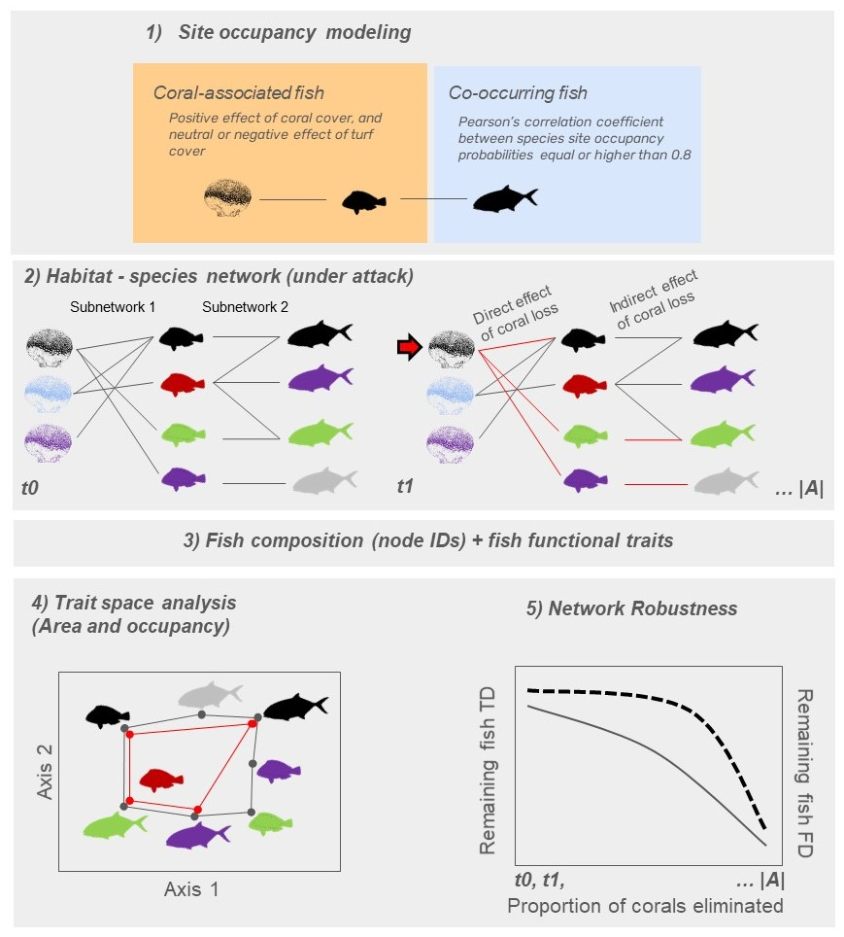

*Fig. 1: Framework used in the study. The first step (1) involved relating fish site occupancy probability with coral and turf algae cover using site occupancy modeling. Using the model output we classified species in coral-associated and co-occurring fish. The second step (2) comprised connecting corals and fish. The connection between corals and coral-associated fish in subnetwork 1 was established using the predicted site occupancy probability of each coral-associated fish (fish with different colors in the center of the network) relative to the cover of each coral species (corals with different colors in the left of the network). The connection between coral-associated and co-occurring fish in the subnetwork 2 was established based on the Pearson’s correlation between fish site occupancy probability. With the network already built, we ran the removal algorithm that eliminated corals, and subsequently computed the direct and indirect effects of coral species removal to the network robustness at each elimination step (t0, t1, to |A|). Lost links are shown in red. The third step (3) involved connecting fish species composition and species traits at each elimination step. The fourth step (4) consisted in computing the loss of trait space area along the elimination of corals and fish. The area delimited by the black polygon depicts the trait space area at t0, and the area delimited by the red polygon depicts the trait space area at t1. The fifth step (5) involved fitting a hyperbolic function (non-linear model) to robustness data regarding the remaining taxonomic (TD, first y-axis, solid curve) and functional diversity (FD, second y-axis, dashed curve) along the gradient of coral elimination (x-axis).*

**Attack-tolerance curves, removal algorithm, and robustness analyses**

We used the tripartite network to simulate and evaluate the direct and indirect effects of coral loss to reef fish communities. Robustness () was estimated based on the area below the attack-tolerance curves (; Albert and Barabási 2002, Burgos et al. 2007). This metric indicates how well the network maintains its structure under attack, with values ranging from 0 to 1. A value of 1 indicates the highest network robustness, meaning that fish taxonomic and functional diversity are tolerant to coral species removal. We simulated species extinctions in the network and evaluated direct and indirect effects using the following algorithm:

1. Let be a bipartite network (subnetwork) with two sets of nodes each:
   1. Subnetwork 1: corals () and coral-associated fish ()
   2. Subnetwork 2: Coral-associated fish and co-occurring fish ()

The links between and were defined by , and the Pearson's correlation coefficient *⍴* was used to connect and (Fig. 2).

1. Let be the function to estimate taxonomic and functional diversity for species in the set given losses . Let be the function to estimate taxonomic and functional diversity for species in given losses in the set .
2. Reduction in taxonomic diversity (TD) is the proportion of fish species being lost in and along eliminations of corals in .
3. The Reduction in Functional Space (RFS) of partites and is then calculated using traits and node identities (see below **Trait space area and occupancy**):

Time is defined in terms of coral removal order, where represents the baseline time step with no coral removal. depicts the number of corals in the partite .

From onwards, the algorithm will run while . In other words, the algorithm will run while there are nodes remaining in the subnetwork as follows:

1. Select a species in based on one specific criterion (see **Scenario analyses**), and remove it from the network at time ;
2. Update the network by removing the links associated with species :
3. Estimate the taxonomic and functional diversity for species in the partites and ( and , respectively);
4. Add the values of and to the cumulative sum of the area under the attack curve (ATC):

or

1. Increment the time step until . The algorithm then ends when all coral species from subnetwork 1 have been removed from the network.

To analyze the decay of taxonomic and functional robustness with coral loss, we fitted a hyperbolic function to data obtained across the time steps. This step involves attempting to fit a non-linear least squares’ model of the form to the data, represented as . The variable depicts the time (from to ), and the exponent is the decay function to be estimated by the model. If the fitting fails, we added a small amount of random noise () to to enable the fitting process to converge, and set as the starting value of the maximum likelihood algorithm.

Finally, robustness was quantified for taxonomic and functional diversity of node sets and separately by integrating (summing up) infinitesimally small values of the spline interpolation of the fitted hyperbolic function applied over the interval (, no coral removed) to (, all corals removed):

To simulate extinctions, we worked in parallel with the two subnetworks. Operationally, the subnetworks were represented as matrices, whose manipulation of rows and columns represented the consequences of losing nodes in each subnetwork. The first matrix had corals in the rows (partite A) and coral-associated fish in the columns (partite B). A coral-associated fish could be eliminated after the elimination of coral in time step if its column sum being zero (i.e., no positive site occupancy probability remains). In the second matrix, with coral-associated fish in the rows (partite B) and co-occurring fish in the columns (partite C), a co-occurring fish could be eliminated if the elimination of a coral-associated fish in time step results in its column sum being zero (i.e., no positive correlation between site occupancy probabilities of these fish remains).

Taxonomic diversity (TD) was measured as the ratio of the number of columns (fish species) in each matrix at each time step , relative to the total number of columns at . As with the taxonomic counterpart, our functional ATC is constrained within the unit square, starting at a value of 1 in the *y*-axis when there is no loss of area with coral loss, indicating that the entire fish functional space is intact. As coral removal proceeds, the hyperbolic curve decreases monotonically to 1 on the *x*-axis as the functional space shrinks with the removal of all corals.

**Scenario analyses**

We ran analyses using different criterion of coral removal in subnetwork 1 (step 1 of the algorithm). In the first scenario, coral species were removed according to their degree centrality, which was measured as the number of links between each coral and fish species. In this scenario, coral removal followed a decreasing order, from the highest to the lowest degree centrality. Therefore, coral with the largest number of associated fishes were the first to be eliminated.

The second scenario involved the random removal of coral species in step 1, where we shuffled the rows in partite one thousand times. Then, we ran the algorithm steps 2-7 as described above for each random data set. At the end of the randomization we obtained the average robustness and associated 95% Confidence Intervals.

The third scenario involved the removal of corals based on their vulnerability to bleaching and post-bleaching mortality. The key drivers of coral mortality and eventual loss are their vulnerability to bleaching and ability to recover from bleaching events (Bleuel et al., 2021; Freeman et al., 2013; Hoegh-Guldberg et al., 2007). Nonetheless, bleaching vulnerability and post-bleaching mortality vary with biological species traits such as occurrence depth, symbiotic association, growth rate and competitive ability (to endure against competition with algae and zoanthids). Using this background information, we went to the literature to gather data to build a vulnerability-based scenario, in which corals with higher bleaching probability and post-bleaching mortality and lower growth rates and competitive ability were removed first from the network. The vulnerability-based scenario respected the following order:

1- *Mussismilia harttii* - high bleaching levels, high post-bleaching mortality levels (see Corazza et al., 2024; Pereira et al., 2022; Teixeira et al., 2019), low recovery rates leading to colony erosion (Braz et al., 2022);

2- *Millepora alcicornis* - high bleaching levels, high post-bleaching mortality levels (see Corazza et al., 2024; Pereira et al., 2022; Teixeira et al., 2019). The species has high competitive ability and growth rates, often considered a weedy species in the Caribbean (Cramer et al., 2021), therefore with a higher recovery potential compared to *M. harttii*;

*3- Agaricia* spp. - high bleaching levels and post-bleaching mortality (Corazza et al., 2024; Pereira et al., 2022; Teixeira et al., 2019), and low recovery potential (Longo unpublished data; Cramer et al., 2021).

4 - *Mussismilia hispida* - high bleaching levels, low post bleaching mortality (Banha et al., 2020), slow growth and recovery rates (Corazza et al., 2024);

5 - *Montastraea cavernosa* - medium bleaching levels and low post bleaching mortality (Teixeira et al., 2019), considered a stress tolerant species (Cramer et al., 2021). This species is very important for the benthic community structure in turbid and deeper reefs in SW Atlantic (Santana et al., 2023).

6 - *Porites astreoides* - medium bleaching levels and low post bleaching mortality, considered a weedy coral in the Caribbean with a high reproductive output (Cramer et al., 2021).

7 - *Favia gravida* - high bleaching levels and post-bleaching mortality (Corazza et al., 2024; Pereira et al., 2022; Teixeira et al., 2019). The species is a monthly spawner with good recovery potential (Longo unpublished data; Pereira et al., 2020).

*8 - Siderastrea* sp., - high bleaching levels but extremely low post-bleaching mortality (Mello et al., 2023), considered a stress tolerant species (Cramer et al., 2021).

**Trait space area and occupancy**

We applied a trait-based approach to analyze the direct and indirect effects of coral species loss on the functional structure of reef fish assemblages for the scenario with lowest network robustness. The trait-based approach considers the relationship between fish species composition (node identities) and traits to produce a measurement of diversity (the trait space area) (Villéger et al., 2008) and frequency/density (trait space occupancy) of species across trait combinations (Mammola and Cardoso, 2020) (Fig. 1).

Functional robustness to cascading extinctions was measured through the Reduction in Functional Space approach (RFS, cf. Luza et al. 2022). The taxonomic and functional diversity at comprised the number of fish species and trait-space area occupied by coral-associated and co-occurring fish, respectively (*n*= 63 species). For trait space occupancy analysis, a Provincial trait space (*n*=113 species, all species in the fish data set) was built, as we were aiming to detect which portions of the Provincial trait space could be most affected by fish elimination with coral species loss. Based on this, subsequent spaces (polygons) were built for the following set of species:

1) coral-associated fish (*n*=42);

2) coral-associated + co-occurring fish (*n*=63 species);

3) all fish except coral-associated + co-occurring (*n*=50);

4) vulnerable species (*n*=5), based on IUCN status and price value (data from Quimbayo et al., 2021).

We used six fish ecological traits in trait space analysis: total length (cm), trophic level (the position in the food web, unitless), fin aspect ratio (unitless), group size (categories from solitary to large sized groups), maximum tolerated temperature (TºC), and depth (m). All traits, except for total body length which was obtained directly from the video estimates (Longo et al., 2019), were gathered from Quimbayo et al. (2021). These traits were chosen not only due to their availability and affordability (data set compiled by one of the authors (J.P. Quimbayo)) but also for their relevance for fish species and reef ecosystems (Hadj-Hammou et al., 2021).

Total length informs about the fitness variation across species, reflecting species metabolism, growth, reproduction, and mortality (Parravicini et al., 2021). Larger body sizes often correlate with higher metabolic demands and different ecological roles, impacting ecosystem-scale processes such as nutrient cycling and storage (Tavares et al., 2019). Trophic level represents the species' position in the food web and informs about species diet and ecosystem-level energy and nutrient transfer. Species at different trophic levels contribute differently to the flow of energy through the ecosystem, influencing the overall stability and functionality of the reef (Parravicini et al., 2021; Tavares et al., 2019). Group size represents gregariousness, which can influence predation rates on the benthos and other organisms. It also affects the distribution of energy within the reef through bioturbation and excretion, contributing to nutrient cycling and habitat structure (Tavares et al., 2019). Fin aspect ratio represents fish mobility and dispersion within and among reef areas. High aspect ratios typically indicate better swimming efficiency and greater mobility, which can affect the spatial distribution of species and their ability to exploit different habitats, thereby influencing gene flow and ecosystem resilience (Tavares et al., 2019). Maximum tolerated temperature and depth represent preferred habitats and position in the water column, respectively. These traits affect how energy cycles across water layers and can indicate a species' vulnerability to environmental changes such as temperature fluctuations and habitat degradation (Silva et al., 2023). They also provide insights into the vertical structure of the ecosystem and the distribution of species within the reef (Tavares et al., 2019). While these traits capture significant aspects of ecosystem function, it is acknowledged that other traits, such as metabolic rates, energy transfer, and nutrient excretion, might be needed to fully capture ecosystem functioning (Luza et al., 2023b; Tavares et al., 2019). However, as for other taxa (Luza et al., 2023b), these data are currently unavailable for most of the studied species.

Using these traits, we performed a Principal Coordinate Analysis (PCoA) to project, in a quasi-Euclidean multidimensional space, the matrix of trait dissimilarities (Gower distance applied to scaled trait values, using the daisy function of the ‘cluster’ R package, Maechler et al., 2023) between pairs of species, using the dudi.pco function (‘ade4’ R package, Dray and Dufour, 2007). Total body length, aspect ratio, trophic level, maximum preferred temperature and depth were treated as quantitative traits, whereas group size was treated as an ordered trait (schooling fishes had higher ranks than solitary fishes). Functional trait space area was calculated through the convex-hull approach of (Cornwell et al., 2006) and (Villéger et al., 2008), using the first two ordination axes. The correlation of each trait with each PCoA axis was calculated through the Pearson’s regression coefficient, and projected in the trait space to explore the relationship between traits and ordination axes.

Trait space occupancy (density) was estimated by applying a Kernel Density Estimation (KDE) (Duong, 2007) to the eigenvectors of the two first PCoA axes, which revealed areas of high and low species density in the trait space. We estimated the KDEs for each period using the ‘kde’ function (‘ks’ package), and produced plots using the ‘ggplot2’ R package, (Wickham, 2016). We used unconstrained bandwidth selectors for building the KDE, once the results depend on the choice of bandwidth used for smoothing kernels (Duong, 2007). The selected bandwidths were 0.5, 0.9, and 0.99 quantiles, representing 50%, 90%, and 99% probability of species occupancy in different portions/zones of the trait space. Finally, we used histograms (plotted along the PCoA axes) to depict the density of species in the PCoA area. All analyses were run in the R programming environment (R Core Team, 2023).

**Results**

Overall, 37% (*n*=42) out of 113 reef fish were coral-associated fish, and 19% (*n*=21) were co-occurring fish (Fig. 2). In total, the probability of site occupancy of 56% of the fish species (*n*=63) had both direct and indirect relationship with coral cover. Thus, the tripartite network comprised 71 species (eight corals, 63 reef fish species). The corals establishing more links with fish were *Millepora alcicornis* and *Mussismilia hispida* (13 and 12, respectively), and coral-associated fish establishing links with more coral species were *Acanthurus coeruleus*, *Sparisoma axillare*, and *Scarus zelindae* (6, 5 and 5, respectively) (Fig. 2). Co-occurring fish establishing more links with coral-associated fish were *Lutjanus analis*, *Amblycirrhitus pinos*, and *Sphyraena barracuda* (8, 7 and 5, respectively)(Fig. 2).

Coral removal based on degree centrality produced the lowest network robustness, considering the direct and indirect effects of coral species loss on fish taxonomic (TD) and functional diversity (FD) (Figs. 3 and 4). Despite the overlap with the confidence interval of random removals, robustness of TD considering direct and indirect effects was lower than 75% and 76% of the robustness produced by the random removals, and the robustness of FD was lower than 67% and 58% of the random removals considering the direct and indirect effects of coral species loss (Fig. 3). In contrast, the robustness of TD and FD produced by the vulnerability-based removal was generally higher than the robustness produced by random removals (Fig. 3). We hereby focus the forthcoming results on the degree centrality scenario that yielded the lower robustness to coral loss.

In the degree centrality scenario of coral removal, fish functional diversity showed greater robustness (*R*) to coral loss compared to taxonomic diversity. Despite the removal of corals and 42 fish species directly associated with them, the functional diversity of the fish assemblage remained robust in the face of the direct loss of corals (*R*=0.82), whereas the taxonomic diversity showed low robustness to coral loss (*R*=0.52). Additionally, the removal of corals and 63 fish species directly and indirectly related to corals resulted in both taxonomic and functional diversity showing limited robustness to coral loss (*R*=0.31 and *R*=0.57, respectively) (Fig. 4).

Along the gradient of coral species removal, we identified that the exclusion of 25% of the coral species reduced 50% of TD of coral-associated fish, but did not affect FD. The steepest decline of the FD of coral-associated fish happened after 40% of the coral species were removed (Fig. 4). The curves showed a reduction of 50% of the fish FD from 40% to 87% coral species loss (Fig. 4). Going forward in the secondary extinctions, the loss of corals caused a linear decrease in the TD and FD of co-occurring fish (Fig. 4), showing overall low network robustness to indirect effects of coral species removal.

Our trait-space analysis shows that 100% coral species loss has the potential to decrease the trait area of fish assemblages at the province scale by 69% (Fig. 5A). However, this estimation only considers total trait space area, and does not fully consider the trait redundancy observed between coral-associated and co-occurring fish species (n=63) and the remaining fish species (n=50). Specifically, coral-associated and co-occurring fish occupy 69% of the provincial trait space area, while the remaining fish occupy 87% of provincial trait space area, with a significant overlap (Fig. 5A). An area of 11% of the provincial trait space area is exclusively occupied by coral-associated and co-occurring fish. Furthermore, our analyses also show that 43% of the provincial trait space is occupied by species that are vulnerable to extinction, including *Epinephelus marginatus*, *Lutjanus cyanopterus*, *Mycteroperca interstitialis*, *Rhomboplites aurorubens*, and *Scarus trispinosus* (which is also a coral-associated fish). Notably, these species are situated in peripheral areas of the trait space occupied by few species (Fig. 5A).

In addition to the effects on trait space area (FD), cascading extinctions lead to less densely filled trait spaces (Fig. 5-B3). There is a high concentration of species in the core of the trait space (hot colors, Fig. 5-B3). The direct and indirect effects of coral loss affected species distributed within and along the edge of this core, resulting in lower functional variation among species (as shown by the marginal histograms). Regarding the traits per se, coral loss would directly affect species belonging to low trophic levels, with both small and large body sizes, occupying shallow and warm waters, and with small group sizes and aspect ratios (red areas in Fig. 5C, 1 vs 2). While also affecting species in similar trait space zones, the indirect effect additionally influenced species with large body sizes and aspect ratios (red areas in Fig. 5C, 2 vs 3).

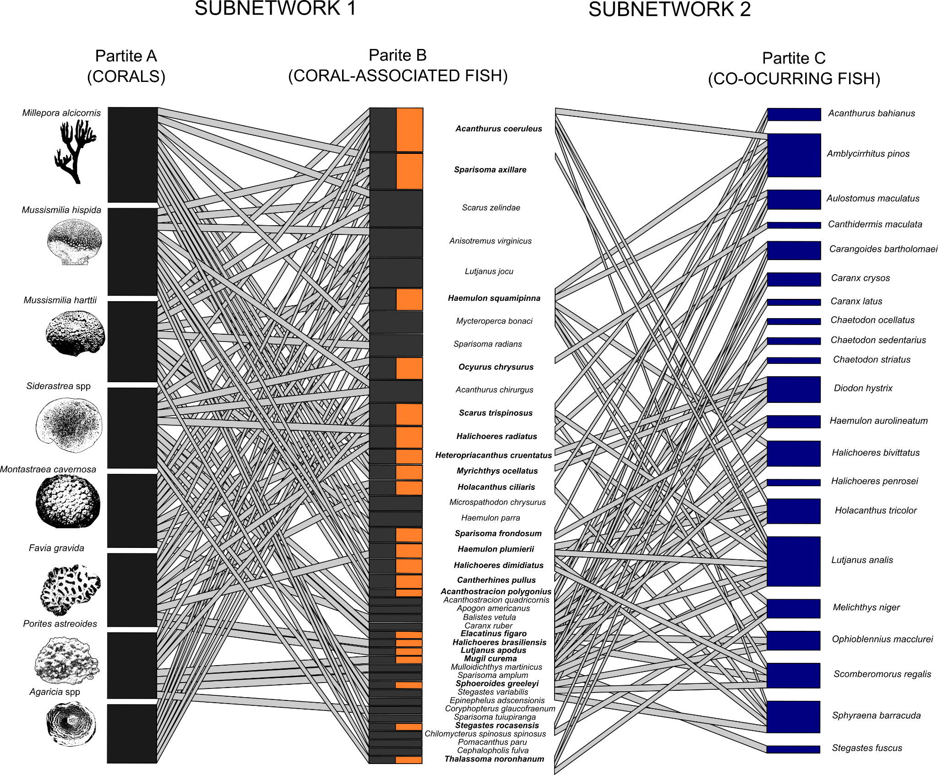

*Fig. 2 - Tripartite network showing the two subnetworks and their partites. In this network, the habitat is characterized by the cover of scleractinian corals and hydrocorals (left part). The network is organized according to the decreasing number of fish species associated with different corals. The width of the links in the left network depicts the predicted site occupancy probability by fish species (*) *as a function of coral cover (while maintaining turf algae cover constant), and in the right part the width of the links depicts the correlation between the site occupancy probability of coral associated fish and co-occurring fish. The height of black bars in Partite A depict the number of fishes associated with each coral species. The height of gray bars in Partite B depict the number of corals that each fish was associated with, and the height of bars in Partite C show the number of coral-associated fish that each co-occurring fish was connected (only pairwise correlations higher than ρ* ≥ *0.8 were projected in the figure and used in data analysis). The orange bars and bold scientific names in the partite B highlight coral-associated fish that establish relationships with co-occurring fish.*

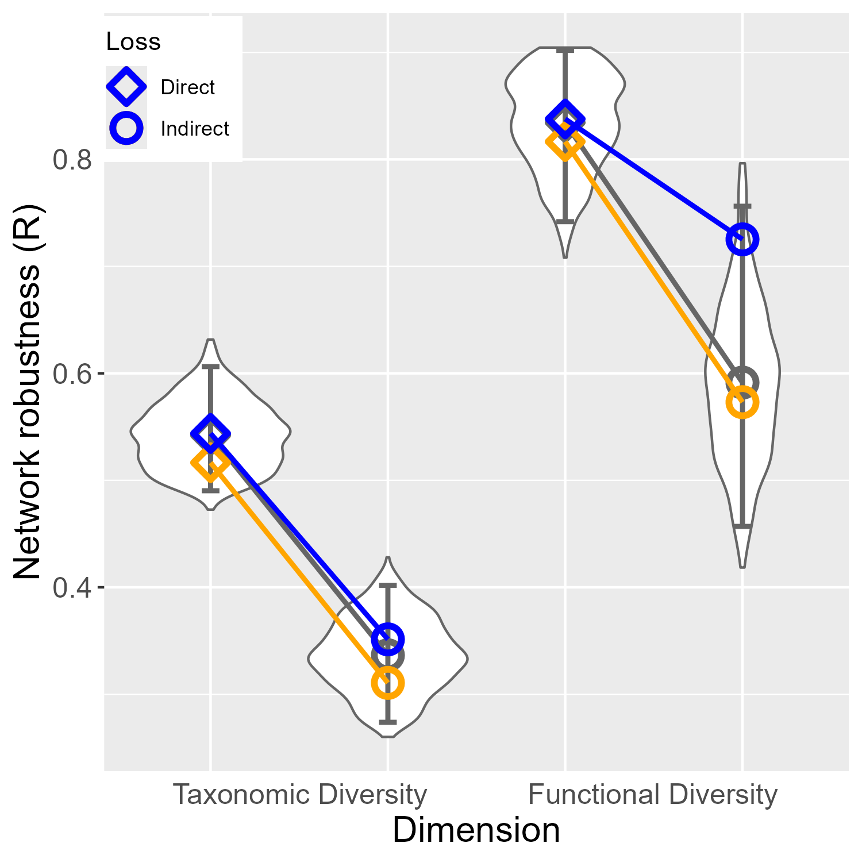

*Fig. 3 - Comparison of network robustness (y-axis) considering direct and indirect effects of coral loss (shapes) and diversity dimensions (x-axis), following the three scenarios of coral removal: degree centrality (orange), random (gray), and vulnerability (blue). and associated 95% Confidence Intervals are shown for the random removal scenario. Direct effects comprise the loss of fish taxonomic and functional diversity directly caused by coral specie removal. Indirect effects comprise the loss of fish whose number of occupied sites was correlated with the number of sites occupied by coral-associated fish.*

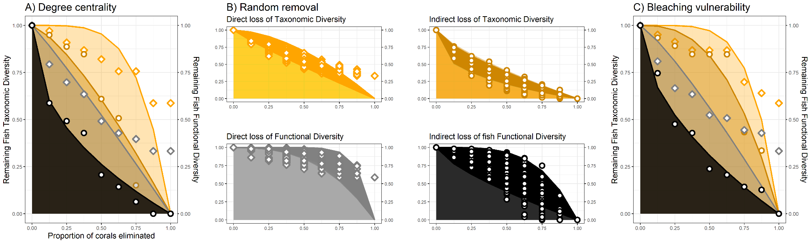

*Fig. 4 - Attack Tolerance Curves (ATC) depicting direct and indirect effects of coral loss on fish taxonomic and functional diversity along three scenarios of coral removal: A) degree centrality, B) random, C) bleaching vulnerability. The shaded area below each curve depicts the hyperbolic function curve fitted to the data shown in the two Y-axes. Direct effects comprise the loss of fish taxonomic and functional diversity caused by coral loss. Indirect effects comprise extinctions of fish whose number of occupied sites was correlated with the number of sites occupied by coral-associated fish. The colors and points shown in B (random scenario) aid to differentiate effects in scenarios based on degree centrality (A) and bleaching vulnerability (C).*

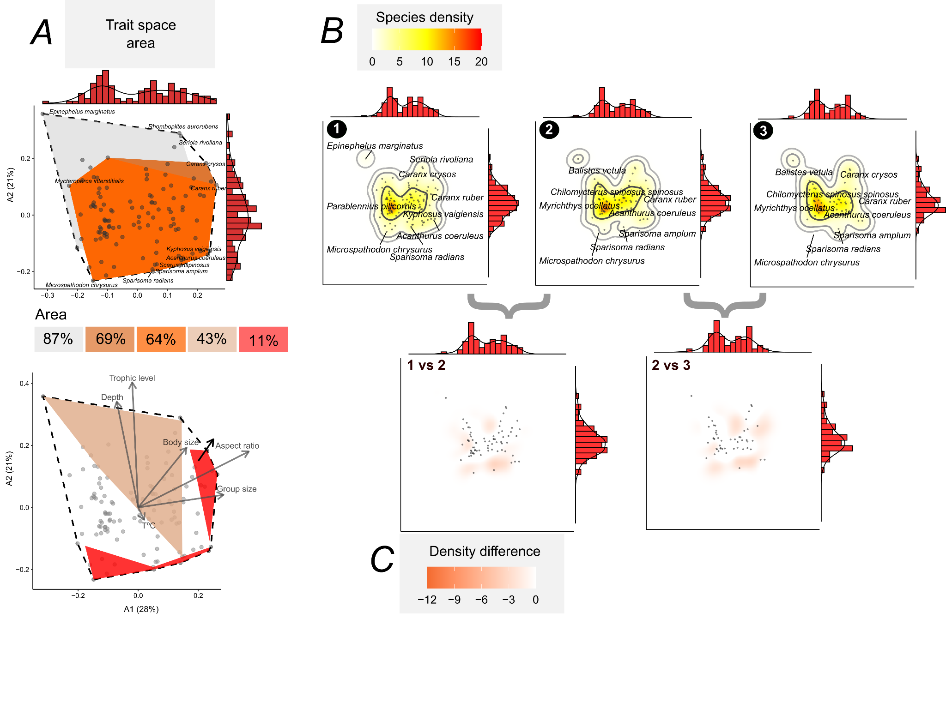

*Fig. 5 - Trait space occupancy by reef fish in the Brazilian Province, based on these results of the degree centrality scenario. At the top of* ***A,*** *we show the trait spaces of the Brazilian Province fish (n=113 species, white polygon with black dashed line), coral-associated fish (n=42, orange, trait space area: 64%), coral-associated + co-occurring fish (n=63 species, dark orange polygon, area: 69%), remaining species (n=50, inner light gray polygon, area: 87%). At the bottom of* ***A,*** *we show the correlation of each trait with the two first ordination axes, and the polygons of threatened species (brown polygon, area: 43%) and the area vulnerable to cascading extinctions (red, area: 11%). In* ***B,*** *we show trait space occupancy within the Provincial trait space (1), and the trait space occupancy after simulating the direct (2) and indirect effects of removing corals according to the degree centrality scenario (3). The density (trait space occupancy) was produced by a kernel density estimation algorithm, with contours depicting 50%, 95%, and 99% kernel density bands. In* ***C****, we show the difference in trait space occupancy after simulating the direct (1 vs 2) and indirect effects of losing coral species (2 vs 3). The marginal histograms (with density shown) of all plots depict the concentration of points (species) in the trait spaces. The trait space was produced by summarizing trait data with a Principal Coordinate Analysis (PCoA), and the variation explained by these axes are presented in the first plot (A).*

**Discussion**

Coextinctions are difficult to observe in nature as they are hard to detect or unfold over long time scales (Estes et al. 2011). Using simulated cascade extinctions in a tripartite species-habitat network, we showed that cascading loss of reef fish species and functions can occur as a response to coral species loss in Southwestern Atlantic reefs. There was a limited robustness of the network and ecological trait space to the direct and indirect influence of the removal of corals with high degree centrality. By evaluating network robustness across the gradient of coral species loss, our analyses of co-extinctions can represent a more realistic and applied scenario in terms of conservation than our previous results (Luza et al., 2022) based on a more conservative scenario of direct extinction of coral-associated fishes. Notably, fish TD and FD was more robust to the removal of the corals most vulnerable to bleaching, showing a weak relationship between coral bleaching vulnerability and fish assemblage vulnerability. The removal of corals with more associated fish (highest degree centrality, *Millepora alcicornis, Mussismilia hispida*) caused the largest direct and indirect impacts on the network's robustness. It was already shown for a seed dispersal network that species with a high degree centrality confer network robustness and stability (Bastazini et al., 2019). Such results are particularly useful for informing management and conservation actions, informing the key corals and fish to target conservation considering the major coral loss scenarios projected over the next 76 years (Bleuel et al., 2021; Freeman et al., 2013; Hoegh-Guldberg et al., 2007).

**Robustness of coral-fish species-habitat network**

Reefs comprise the most biodiverse and threatened marine ecosystem, and much of their biodiversity is due to the central role that corals play in building tridimensional reef habitats that support diverse communities of other organisms (Coker et al., 2014; McWilliam et al., 2018; Sheppard et al., 2018; Wilson et al., 2006; Woodhead et al., 2019). Coral survival and persistence in the Anthropocene are uncertain (Bleuel et al., 2021; Freeman et al., 2013), posing threats to the complex network of species relying on corals (Bellwood et al., 2004; Strona et al., 2021; Tebbett et al., 2023; Woodhead et al., 2019). Cascading loss of reef fish species and functions as a response to coral loss in Southwestern Atlantic reefs revealed by the Attack-Tolerance Curves (ATC) suggests a concerning scenario. Southwestern Atlantic reefs are overlooked marginal reefs, characterized by low coral cover (Aued et al., 2018; Kleypas et al., 1999; Schoepf et al., 2023), and are typically excluded from discussions and analyses addressing biodiversity loss resulting from coral decline (Giglio et al., 2023). This exclusion can have multiple causes, including the lower diversity of corals and fish when compared to coral reefs found in other biogeographic regions, and the generalist relationships between corals and fish in the region. Despite this, the loss of habitat patches with low overall coverage can have a disproportionate impact on ecological networks, as shown in other systems such as plant-insect networks in farmlands (Evans et al., 2013). The shape of the ATC curves, with steep declines in taxonomic diversity (for direct and indirect scenarios) and functional diversity (only the indirect scenario), depict two interesting aspects concerning the robustness of this network.

The analyzed fish assemblages demonstrated some ability to sustain functional diversity even in the face of direct losses of coral-associated fish. This might indicate functional resistance of coral-associated fish to direct coral losses. Coral-associated fish may exhibit a limited and generalized reliance on coral habitats (Muruga et al., 2024; Wismer et al., 2019), showcasing redundancy in their ecological traits (Luza et al., 2022) and functions (Brandl et al., 2019) when compared to other reef fish. Theoretically, such low specificity in the interactions between corals and fish might prevent co-extinctions (Brodie et al. 2014). However, while the loss of a single species does not necessarily exclude the presence of certain combinations of fish traits in reef sites, the delivery of a particular function could be affected (Bellwood et al., 2019). Additionally, fish may display extinction debt, with the potential for relationships to weaken and species, as well as their functions, to be lost over time (Anderson et al. 2022). Therefore, assumptions about the resilience or ability to maintain functions in disturbed communities that preserve similar ecological traits need caution.

Our comprehensive analysis of the tripartite network, including both direct and indirect links with corals, revealed a concerning low robustness of fish assemblages in the Brazilian Province. The loss of coral species had a profound impact on the network structure, with indirect losses proving to be even more detrimental to the fish assemblage than direct ones. Remarkably, the influence of coral loss extends beyond mere taxonomic diversity, affecting even those fish indirectly related to coral cover. We attribute this to two key factors: firstly, most fish with a higher likelihood of inhabiting areas with high coral cover often display a set of ecological traits (e.g., small body size, low trophic level, small group size) that are well distributed in the assemblage and not taxonomically constrained. These traits define a resilient core group of species within the trait space (i.e. functionally redundant) that remains relatively stable with the propagation of disturbances (here imposed by simulations). Secondly, this core group plays essential roles in forging vital links, connecting peripheral fish within the network, with species having a more restricted set of traits (few species sharing similar combinations) which then become susceptible to coral loss. As such, these core species that interact with vulnerable links are themselves theoretically susceptible to exhibit declines (Brodie et al., 2014). This dual function of coral-associated fish is crucial for maintaining ecosystem integrity, bridging benthic community-level processes (like carbon accretion and prey populations control) with broader nutrient cycling facilitated by mobile organisms (Brandl et al., 2019).

**Network structure and ecosystem functioning**

We observed that the low estimated robustness to coral loss signals a potential threat to ecosystem functioning. It is important to recognize that direct and indirect drivers of environmental change do not act in isolation; rather, they interact, creating synergies and antagonisms (Giglio et al., 2023; Hernández Ruiz et al., 2021; Soares et al., 2021). For example, ocean warming and acidification can lead to significant coral mortality (Sully et al., 2019; Tebbett et al., 2023). In conjunction with overfishing, they can adversely affect fish populations by altering habitat structures and the abiotic environment, as well as trait composition within an assemblage (Silva et al., 2023). These synergistic stressors can destabilize the trophic structure of ecological communities, exerting intense pressure on species that play a disproportionate role in maintaining network structure. This impact is observed in both land (Vidal et al., 2014) and marine networks (Bascompte et al., 2005; Márquez-Velásquez et al., 2021). A case in point comprises the Tropical Eastern Pacific food webs (coast of Colombia), where key species such as the hammerhead shark (*Sphyrna* spp.), which faces a high extinction risk and interacts with small-scale fisheries, have an expressive impact on the network structure (Márquez-Velásquez et al., 2021). Similarly, in the Caribbean, sharks and groupers, both threatened by fisheries, engage in the strongest interactions within food webs (Bascompte et al., 2005). While distinct from food webs, the species-habitat network approach is a valuable tool in identifying vulnerable links within the ecosystem, as it allows us to estimate the importance of habitat patches to the maintenance of local and regional biodiversity (Marini et al., 2019).

In the Southwestern Atlantic reefs, species like the endemic and endangered greenbeak parrotfish (*Scarus trispinosus*), the near-threatened yellowtail snapper (*Ocyurus chrysurus*) and the mutton snapper (*Lutjanus analis*),and the black grouper (*Mycteroperca bonaci*), fulfill crucial ecological roles and occupy regions of the trait space with low species density. Serving as major biomass consumers, they actively circulate nutrients and materials throughout the ecosystem. The former species, which feeds on turfs and endolithic algae on the reef matrix, and the three latter species, which primarily feed on vertebrates and invertebrates, show increased site occupancy (and likely greater abundance) with greater coral cover (Luza et al., 2022; Moura et al., 2013; Roos et al., 2019). Furthermore, these species are heavily targeted by fisheries in Brazil and present population declines across their geographical range (Eggertsen et al., 2024; Roos et al., 2019). Their extinction, severing links between corals and co-occurring fish, could affect coral health and reef structure (McCook et al., 2001), while potentially easing competition for smaller predators and removing a vital food source for larger ones. This suggests that the redundancy within the system, concentrated in the densely populated core of the trait space, may not suffice to sustain ecosystem functionality if these at-risk network nodes are lost. This is particularly concerning given the synergistic threats posed by coral loss, overfishing, and climate change, which exacerbate the situation.

**Assumptions, potential caveats, and perspectives**

In evaluating network robustness, we relied on broad generalizations. First, the primary dataset was designed to elucidate feeding interactions between reef fish and benthic organisms (Inagaki et al., 2020; Longo et al., 2019), which may not fully capture the nuances of fish-to-fish interactions (but see Fontoura et al., 2020). Similarly, pairwise correlations of site occupancy probability between species may not capture the full spectrum of fish-to-fish relationships. Relying on these correlations demand cautious interpretation (reviewed by Blanchet et al., 2020) even in species-habitat networks. For instance, two species may be linked because they prefer or avoid the same factor not included in the model (i.e., they like or dislike a factor beyond coral and turf cover, such as temperature, pollution), or because they are interacting with other species present in the system (Blanchet et al., 2020). However, we lack data to measure the relevance of these caveats.

We revealed processes at the regional scale, integrating data from various species and sites across the entire Brazilian marine biogeographical province. At this scale, extinctions are expected to be less frequent, as some populations of threatened species can persist locally. This means that a function might persist regionally, albeit in a significantly reduced capacity in small to large geographic scales (i.e. functional extinction, Brodie et al., 2014; Valiente‐Banuet et al., 2015). As the goal here was to evaluate robustness and present a new algorithm for functional robustness evaluation, the possibility of adaptive rewiring (i.e., interaction partner switch through time) was not accounted for. The redundancy between removed and remaining species may partially alleviate the loss of functional diversity caused by cascading extinctions from coral-associated to co-occurring fish, despite significant declines in taxonomic diversity (Mouillot et al., 2013). The ability of species to adapt to the absence of the interaction, or even interact with a different habitat or species, is an important component of the resistance to cascading extinctions (Brodie et al., 2014; Vizentin‐Bugoni et al., 2020). Indeed, the majority of fishes inhabiting the Brazilian Province tropical and subtropical reefs, besides being broadly distributed (Pinheiro et al., 2018), have a large level of trophic generalism (Cardozo-Ferreira et al., 2023; Liedke et al., 2016). Further examination of rewiring potential is warranted, as many fish species not associated with corals persisted in the system following simulated extinctions. Hence, we emphasize that the 11% reduction should not be disregarded, as it assumes that the remaining species will fulfill similar interactions and ecological functions as those directly and indirectly impacted by coral removal. This is not guaranteed, because even if they exhibit similar functional diversity, fish assemblages not associated with corals could not provide the same ecological functions (Bellwood et al., 2019). Furthermore, we still do not fully understand the mechanisms underlying ecological networks' reorganization in response to species loss (Bastazini et al., 2019). Thus, our approach provides a useful and conservative scenario, ignoring species rewiring. Future developments in our understanding of the nature of ecological interactions and the driving mechanisms of network reorganization in coral systems will certainly improve our ability to forecast the effects of species loss and provide more accurate scenarios of network robustness and resilience in a changing environment.

Despite such generalizations, our inference about species-habitat links derives from fine-scale resolution and the close matching of fish and coral sampling (Aued et al., 2018; Longo et al., 2019), a positive point emphasized by Blanchet et al. (2020). These insights underscore the necessity for future research with sampling designs tailored to detect multi-level interactions (Bascompte et al., 2005; Márquez-Velásquez et al., 2021), and emphasize the importance of local-scale assessments of species-habitat networks.

**Concluding Remarks**

Tropical and subtropical reefs of the Brazilian Province are nominally marginal compared to the nearby Caribbean, with different evolutionary histories (Pinheiro et al. 2018), and with environmental conditions considered suboptimal for most tropical coral species (Schoepf et al., 2023), including high turbidity and nutrient-rich waters (Mies et al., 2020; Santana et al., 2023). These reefs hold a relatively species-poor coral fauna with low redundancy, which makes coral-fish associations less obvious when compared to the Great Caribbean and for the Indo-Pacific realm, but still existent (Coni et al., 2013; Luza et al., 2023a). Despite offering numerous functions and ecosystem services, Brazilian reef environments are increasingly under the strain of escalating anthropogenic pressures at various scales (Soares et al., 2021). Here we detected a limited ability of reef fish assemblages to endure one of the main changes of the Anthropocene: the possible loss of corals. We observed higher levels of robustness of functional diversity to direct species loss, yet the indirect effects of coral loss on the species-habitat network structure were expressive when considering indirect effects of coral species loss. Such coral loss stems from both global factors, like warming, and local impacts, including pollution and overfishing of herbivores (Tebbett et al., 2023). Coral-associated fishes exhibit a resilient functional structure in healthy reefs, potentially due to adaptation to marginal conditions (Wismer et al., 2019). However, it remains an open question whether this resilience holds in scenarios where coral loss is driven by anthropogenic impacts. Human influence in the Brazilian province has been long-standing (Eggertsen et al., 2024; Fogliarini et al., 2022), and there is scant historical data on what may have already been lost (Fogliarini et al., 2022). Furthermore, many coral-associated and co-occurring fishes are also directly affected by overfishing or aquarium trade (Carvalho et al., 2022; Gasparini et al., 2005). This combination of factors can lead to additive effects, potentially setting off a cycle of extinction capable of eroding critical ecological processes mediated by unique species and function entities. Our study represents a significant conceptual advancement in coextinction analysis for two reasons: it evaluates network robustness within a biodiverse, complex, and threatened ecosystem, and it delves deeper than just the taxonomic facet of biodiversity to include a functional perspective. Overall, ecological networks offer a rich theoretical and empirical basis for grappling with the complex implications of the Anthropocene crisis.

**Data availability statement**

This project is on GitHub: <https://github.com/andreluza/species_habitat_interactions.git>. Basic data supporting analyses will be made public after the acceptance of the manuscript.

**References**

Albert, R. and Barabási, A.-L.: Statistical mechanics of complex networks, Rev. Mod. Phys., 74, 47–97, https://doi.org/10.1103/RevModPhys.74.47, 2002.

Alvarez-Filip, L., Gill, J. A., and Dulvy, N. K.: Complex reef architecture supports more small-bodied fishes and longer food chains on Caribbean reefs, Ecosphere, 2, art118, https://doi.org/10.1890/ES11-00185.1, 2011.

Anderson, L., McLean, M., Houk, P., Graham, C., Kanemoto, K., Terk, E., McLeod, E., and Beger, M.: Decoupling linked coral and fish trait structure, Mar. Ecol. Prog. Ser., 689, 19–32, https://doi.org/10.3354/meps14023, 2022.

Aued, A. W., Smith, F., Quimbayo, J. P., Cândido, D. V., Longo, G. O., Ferreira, C. E. L., Witman, J. D., Floeter, S. R., and Segal, B.: Large-scale patterns of benthic marine communities in the Brazilian Province, PLoS ONE, 13, e0198452, https://doi.org/10.1371/journal.pone.0198452, 2018.

Bane, M. S., Pocock, M. J. O., and James, R.: Effects of model choice, network structure, and interaction strengths on knockout extinction models of ecological robustness, Ecology and Evolution, 8, 10794–10804, https://doi.org/10.1002/ece3.4529, 2018.

Banha, T. N. S., Capel, K. C. C., Kitahara, M. V., Francini-Filho, R. B., Francini, C. L. B., Sumida, P. Y. G., and Mies, M.: Low coral mortality during the most intense bleaching event ever recorded in subtropical Southwestern Atlantic reefs, Coral Reefs, 39, 515–521, https://doi.org/10.1007/s00338-019-01856-y, 2020.

Bascompte, J., Melián, C. J., and Sala, E.: Interaction strength combinations and the overfishing of a marine food web, Proc. Natl. Acad. Sci. U.S.A., 102, 5443–5447, https://doi.org/10.1073/pnas.0501562102, 2005.

Bastazini, V. A., Debastiani, V. J., Azambuja, B. O., Guimarães, P. R., and Pillar, V. D.: Loss of Generalist Plant Species and Functional Diversity Decreases the Robustness of a Seed Dispersal Network, Envir. Conserv., 46, 52–58, https://doi.org/10.1017/S0376892918000334, 2019.

Bastazini, V. A. G., Debastiani, V., Cappelatti, L., Guimarães, P., and Pillar, V. D.: The role of evolutionary modes for trait-based cascades in mutualistic networks, Ecological Modelling, 470, 109983, https://doi.org/10.1016/j.ecolmodel.2022.109983, 2022.

Bellwood, D. R., Hughes, T. P., Folke, C., and Nyström, M.: Confronting the coral reef crisis, Nature, 429, 827–833, https://doi.org/10.1038/nature02691, 2004.

Bellwood, D. R., Streit, R. P., Brandl, S. J., and Tebbett, S. B.: The meaning of the term ‘function’ in ecology: A coral reef perspective, Functional Ecology, 33, 948–961, https://doi.org/10.1111/1365-2435.13265, 2019.

Blanchet, F. G., Cazelles, K., and Gravel, D.: Co‐occurrence is not evidence of ecological interactions, Ecology Letters, 23, 1050–1063, https://doi.org/10.1111/ele.13525, 2020.

Bleuel, J., Pennino, M. G., and Longo, G. O.: Coral distribution and bleaching vulnerability areas in Southwestern Atlantic under ocean warming, Sci Rep, 11, 12833, https://doi.org/10.1038/s41598-021-92202-2, 2021.

Blowes, S. A., Supp, S. R., Antão, L. H., Bates, A., Bruelheide, H., Chase, J. M., Moyes, F., Magurran, A., McGill, B., Myers-Smith, I. H., Winter, M., Bjorkman, A. D., Bowler, D. E., Byrnes, J. E. K., Gonzalez, A., Hines, J., Isbell, F., Jones, H. P., Navarro, L. M., Thompson, P. L., Vellend, M., Waldock, C., and Dornelas, M.: The geography of biodiversity change in marine and terrestrial assemblages, Science, 366, 339–345, https://doi.org/10.1126/science.aaw1620, 2019.

Brandl, S. J., Rasher, D. B., Côté, I. M., Casey, J. M., Darling, E. S., Lefcheck, J. S., and Duffy, J. E.: Coral reef ecosystem functioning: eight core processes and the role of biodiversity, Frontiers in Ecol & Environ, 17, 445–454, https://doi.org/10.1002/fee.2088, 2019.

Braz, G. B., Lacerda, C. H. F., Evangelista, H., Güth, A. Z., Rumbelsperger, A. M. B., Capel, K. C. C., Dall’Occo, P. L., and Mies, M.: Unprecedented erosion of Mussismilia harttii, a major reef-building species in the Southwestern Atlantic, after the 2019 bleaching event, Coral Reefs, 41, 1537–1548, https://doi.org/10.1007/s00338-022-02303-1, 2022.

Brodie, J. F., Aslan, C. E., Rogers, H. S., Redford, K. H., Maron, J. L., Bronstein, J. L., and Groves, C. R.: Secondary extinctions of biodiversity, Trends in Ecology & Evolution, 29, 664–672, https://doi.org/10.1016/j.tree.2014.09.012, 2014.

Burgos, E., Ceva, H., Perazzo, R. P. J., Devoto, M., Medan, D., Zimmermann, M., and María Delbue, A.: Why nestedness in mutualistic networks?, Journal of Theoretical Biology, 249, 307–313, https://doi.org/10.1016/j.jtbi.2007.07.030, 2007.

Burke, S., Pottier, P., Macartney, E. L., Drobniak, S. M., Lagisz, M., Ainsworth, T., and Nakagawa, S.: Mapping literature reviews on coral health: A review map, critical appraisal and bibliometric analysis, Ecol Sol and Evidence, 4, e12287, https://doi.org/10.1002/2688-8319.12287, 2023.

Cantor, M., Longo, G. O., Fontoura, L., Quimbayo, J. P., Floeter, S. R., and Bender, M. G.: Interaction Networks in Tropical Reefs, in: Ecological Networks in the Tropics, edited by: Dáttilo, W. and Rico-Gray, V., Springer International Publishing, Cham, 141–154, https://doi.org/10.1007/978-3-319-68228-0_10, 2018.

Capitani, L., De Araujo, J. N., Vieira, E. A., Angelini, R., and Longo, G. O.: Ocean Warming Will Reduce Standing Biomass in a Tropical Western Atlantic Reef Ecosystem, Ecosystems, 25, 843–857, https://doi.org/10.1007/s10021-021-00691-z, 2022.

Cardozo-Ferreira, G., Ferreira, C., Choat, J., Mendes, T., Macieira, R., Rezende, C., Joyeux, J., and Clements, K.: Seasonal variation in diet and isotopic niche of nominally herbivorous fishes in subtropical rocky reefs, Mar. Ecol. Prog. Ser., 722, 125–143, https://doi.org/10.3354/meps14442, 2023.

Carvalho, J. C. and Cardoso, P.: Decomposing the Causes for Niche Differentiation Between Species Using Hypervolumes, Front. Ecol. Evol., 8, 243, https://doi.org/10.3389/fevo.2020.00243, 2020.

Carvalho, L. M., Mies, M., Inagaki, K. Y., Sanches, E. G., Souza, M. R., Longo, G. O., and Tomás, A. R. G.: The marine ornamental market in Brazil (Southwestern Atlantic) frequently trades prohibited and endangered species, and threatens the ecosystem role of cleaning mutualism, Marine Policy, 146, 105305, https://doi.org/10.1016/j.marpol.2022.105305, 2022.

Ceballos, G., Ehrlich, P. R., Barnosky, A. D., García, A., Pringle, R. M., and Palmer, T. M.: Accelerated modern human–induced species losses: Entering the sixth mass extinction, Sci. Adv., 1, e1400253, https://doi.org/10.1126/sciadv.1400253, 2015.

Coker, D. J., Wilson, S. K., and Pratchett, M. S.: Importance of live coral habitat for reef fishes, Rev Fish Biol Fisheries, 24, 89–126, https://doi.org/10.1007/s11160-013-9319-5, 2014.

Coni, E. O. C., Ferreira, C. M., De Moura, R. L., Meirelles, P. M., Kaufman, L., and Francini-Filho, R. B.: An evaluation of the use of branching fire-corals (Millepora spp.) as refuge by reef fish in the Abrolhos Bank, eastern Brazil, Environ Biol Fish, 96, 45–55, https://doi.org/10.1007/s10641-012-0021-6, 2013.

Corazza, B. M., Lacerda, C. H. F., Güth, A. Z., Marcançoli, R. K. M., Bianchini, A., Calderon, E. N., Capel, K. C. C., Conceição, E., Faria, S. C., Francini-Filho, R. B., Garrido, A. G., Guebert, F. M., Kitahara, M. V., Longo, G. O., Lotufo, T. M. C., Salvi, K. P., Segal, B., Sumida, P. Y. G., Zilberberg, C., and Mies, M.: No coral recovery three years after a major bleaching event in reefs in the Southwestern Atlantic refugium, Mar Biol, 171, 114, https://doi.org/10.1007/s00227-024-04432-3, 2024.

Cornwell, W. K., Schwilk, D. W., and Ackerly, D. D.: a trait-based test for habitat filtering: convex hull volume, Ecology, 87, 1465–1471, https://doi.org/10.1890/0012-9658(2006)87[1465:ATTFHF]2.0.CO;2, 2006.

Cramer, K. L., Donovan, M. K., Jackson, J. B. C., Greenstein, B. J., Korpanty, C. A., Cook, G. M., and Pandolfi, J. M.: The transformation of Caribbean coral communities since humans, Ecology and Evolution, 11, 10098–10118, https://doi.org/10.1002/ece3.7808, 2021.

Doherty, S., Saltré, F., Llewelyn, J., Strona, G., Williams, S. E., and Bradshaw, C. J. A.: Estimating co‐extinction threats in terrestrial ecosystems, Global Change Biology, 29, 5122–5138, https://doi.org/10.1111/gcb.16836, 2023.

Dray, S. and Dufour, A.-B.: The **ade4** Package: Implementing the Duality Diagram for Ecologists, J. Stat. Soft., 22, https://doi.org/10.18637/jss.v022.i04, 2007.

Duong, T.: **ks** : Kernel Density Estimation and Kernel Discriminant Analysis for Multivariate Data in *R*, J. Stat. Soft., 21, https://doi.org/10.18637/jss.v021.i07, 2007.

Eggertsen, L., Luza, A. L., Cordeiro, C. A. M. M., Dambros, C., Ferreira, C. E. L., Floeter, S. R., B. Francini-Filho, R., Freire, K. M. F., Gasalla, M. A., Giarrizzo, T., Giglio, V. J., Hanazaki, N., Lopes, P. F. M., Longo, G. O., Luiz, O. J., Magris, R. A., Mendes, T. C., Pinheiro, H. T., Quimbayo, J. P., Reis-Filho, J. A., Vila-Nova, D. A., and Bender, M. G.: Complexities of reef fisheries in Brazil: a retrospective and functional approach, Rev Fish Biol Fisheries, 34, 511–538, https://doi.org/10.1007/s11160-023-09826-y, 2024.

Estes, J. A., Tinker, M. T., Williams, T. M., and Doak, D. F.: Killer Whale Predation on Sea Otters Linking Oceanic and Nearshore Ecosystems, Science, 282, 473–476, https://doi.org/10.1126/science.282.5388.473, 1998.

Estes, J. A., Terborgh, J., Brashares, J. S., Power, M. E., Berger, J., Bond, W. J., Carpenter, S. R., Essington, T. E., Holt, R. D., Jackson, J. B. C., Marquis, R. J., Oksanen, L., Oksanen, T., Paine, R. T., Pikitch, E. K., Ripple, W. J., Sandin, S. A., Scheffer, M., Schoener, T. W., Shurin, J. B., Sinclair, A. R. E., Soulé, M. E., Virtanen, R., and Wardle, D. A.: Trophic Downgrading of Planet Earth, Science, 333, 301–306, https://doi.org/10.1126/science.1205106, 2011.

Evans, D. M., Pocock, M. J. O., and Memmott, J.: The robustness of a network of ecological networks to habitat loss, Ecology Letters, 16, 844–852, https://doi.org/10.1111/ele.12117, 2013.

Fogliarini, C. O., Longo, G. O., Francini-Filho, R. B., McClenachan, L., and Bender, M. G.: Sailing into the past: Nautical charts reveal changes over 160 years in the largest reef complex in the South Atlantic Ocean, Perspectives in Ecology and Conservation, 20, 231–239, https://doi.org/10.1016/j.pecon.2022.05.003, 2022.

Fontoura, L., Cantor, M., Longo, G. O., Bender, M. G., Bonaldo, R. M., and Floeter, S. R.: The macroecology of reef fish agonistic behaviour, Ecography, 43, 1278–1290, https://doi.org/10.1111/ecog.05079, 2020.

Freeman, L. A., Kleypas, J. A., and Miller, A. J.: Coral Reef Habitat Response to Climate Change Scenarios, PLoS ONE, 8, e82404, https://doi.org/10.1371/journal.pone.0082404, 2013.

Gasparini, J. L., Floeter, S. R., Ferreira, C. E. L., and Sazima, I.: Marine Ornamental Trade in Brazil, Biodivers Conserv, 14, 2883–2899, https://doi.org/10.1007/s10531-004-0222-1, 2005.

Giglio, V. J., Aued, A. W., Cordeiro, C. A. M. M., Eggertsen, L., S. Ferrari, D., Gonçalves, L. R., Hanazaki, N., Luiz, O. J., Luza, A. L., Mendes, T. C., Pinheiro, H. T., Segal, B., Waechter, L. S., and Bender, M. G.: A Global Systematic Literature Review of Ecosystem Services in Reef Environments, Environmental Management, https://doi.org/10.1007/s00267-023-01912-y, 2023.

Hadj-Hammou, J., Mouillot, D., and Graham, N. A. J.: Response and Effect Traits of Coral Reef Fish, Front. Mar. Sci., 8, 640619, https://doi.org/10.3389/fmars.2021.640619, 2021.

Hernández Ruiz, L., Ekumah, B., Asiedu, D. A., Albani, G., Acheampong, E., Jónasdóttir, S. H., Koski, M., and Nielsen, T. G.: Climate change and oil pollution: A dangerous cocktail for tropical zooplankton, Aquatic Toxicology, 231, 105718, https://doi.org/10.1016/j.aquatox.2020.105718, 2021.

Hoegh-Guldberg, O., Mumby, P. J., Hooten, A. J., Steneck, R. S., Greenfield, P., Gomez, E., Harvell, C. D., Sale, P. F., Edwards, A. J., Caldeira, K., Knowlton, N., Eakin, C. M., Iglesias-Prieto, R., Muthiga, N., Bradbury, R. H., Dubi, A., and Hatziolos, M. E.: Coral Reefs Under Rapid Climate Change and Ocean Acidification, Science, 318, 1737–1742, https://doi.org/10.1126/science.1152509, 2007.

Hughes, T. P., Kerry, J. T., Baird, A. H., Connolly, S. R., Dietzel, A., Eakin, C. M., Heron, S. F., Hoey, A. S., Hoogenboom, M. O., Liu, G., McWilliam, M. J., Pears, R. J., Pratchett, M. S., Skirving, W. J., Stella, J. S., and Torda, G.: Global warming transforms coral reef assemblages, Nature, 556, 492–496, https://doi.org/10.1038/s41586-018-0041-2, 2018.

Inagaki, K. Y., Pennino, M. G., Floeter, S. R., Hay, M. E., and Longo, G. O.: Trophic interactions will expand geographically but be less intense as oceans warm, Global Change Biology, 26, 6805–6812, https://doi.org/10.1111/gcb.15346, 2020.

Kéry, M. and Royle, J. A.: Applied hierarchical modeling in ecology: analysis of distribution, abundance and species richness in R and BUGS, Elsevier/AP, Academic Press is an imprint of Elsevier, Amsterdam ; Boston, 2016.

Kleypas, J. A., Mcmanus, J. W., and Meñez, L. A. B.: Environmental Limits to Coral Reef Development: Where Do We Draw the Line?, Am Zool, 39, 146–159, https://doi.org/10.1093/icb/39.1.146, 1999.

Liedke, A. M. R., Barneche, D. R., Ferreira, C. E. L., Segal, B., Nunes, L. T., Burigo, A. P., Carvalho, J. A., Buck, S., Bonaldo, R. M., and Floeter, S. R.: Abundance, diet, foraging and nutritional condition of the banded butterflyfish (Chaetodon striatus) along the western Atlantic, Mar Biol, 163, 6, https://doi.org/10.1007/s00227-015-2788-4, 2016.

Longo, G. O., Hay, M. E., Ferreira, C. E. L., and Floeter, S. R.: Trophic interactions across 61 degrees of latitude in the Western Atlantic, Global Ecol Biogeogr, 28, 107–117, https://doi.org/10.1111/geb.12806, 2019.

Luza, A. L., Quimbayo, J. P., Ferreira, C. E. L., Floeter, S. R., Francini-Filho, R. B., Bender, M. G., and Longo, G. O.: Low functional vulnerability of fish assemblages to coral loss in Southwestern Atlantic marginal reefs, Sci Rep, 12, 17164, https://doi.org/10.1038/s41598-022-20919-9, 2022.

Luza, A. L., Aued, A. W., Barneche, D. R., Dias, M. S., Ferreira, C. E. L., Floeter, S. R., Francini‐Filho, R. B., Longo, G. O., Quimbayo, J. P., and Bender, M. G.: Functional diversity patterns of reef fish, corals and algae in the Brazilian biogeographical province, Journal of Biogeography, 50, 1163–1176, https://doi.org/10.1111/jbi.14599, 2023a.

Luza, A. L., Barneche, D. R., Cordeiro, C. A. M. M., Dambros, C. S., Ferreira, C. E. L., Floeter, S. R., Giglio, V. J., Luiz, O. J., Mendes, T. C., Picolotto, V. A. P., Quimbayo, J. P., Silva, F. C., Waechter, L., Longo, G. O., and Bender, M. G.: Going across taxa in functional ecology: Review and perspectives of an emerging field, Functional Ecology, 37, 3091–3110, https://doi.org/10.1111/1365-2435.14442, 2023b.

Maechler, M., Rousseeuw, P., Struyf, A., Hubert, M., Hornik, K.: cluster: Cluster Analysis Basics and Extensions. R package version 2.1.6 — For new features, see the 'NEWS' and the 'Changelog' file in the package source), https://CRAN.R-project.org/package=cluster. 2023

Mammola, S. and Cardoso, P.: Functional diversity metrics using kernel density *n* ‐dimensional hypervolumes, Methods Ecol Evol, 11, 986–995, https://doi.org/10.1111/2041-210X.13424, 2020.

Marini, L., Bartomeus, I., Rader, R., and Lami, F.: Species–habitat networks: A tool to improve landscape management for conservation, Journal of Applied Ecology, 56, 923–928, https://doi.org/10.1111/1365-2664.13337, 2019.

Márquez-Velásquez, V., Navia, A. F., Rosa, R. S., Guimarães, P. R., and Raimundo, R. L. G.: Resource partitioning between fisheries and endangered sharks in a tropical marine food web, ICES Journal of Marine Science, 78, 2518–2527, https://doi.org/10.1093/icesjms/fsab129, 2021.

McCook, L., Jompa, J., and Diaz-Pulido, G.: Competition between corals and algae on coral reefs: a review of evidence and mechanisms, Coral Reefs, 19, 400–417, https://doi.org/10.1007/s003380000129, 2001.

McWilliam, M., Hoogenboom, M. O., Baird, A. H., Kuo, C.-Y., Madin, J. S., and Hughes, T. P.: Biogeographical disparity in the functional diversity and redundancy of corals, Proc. Natl. Acad. Sci. U.S.A., 115, 3084–3089, https://doi.org/10.1073/pnas.1716643115, 2018.

Mello, T. J., Vieira, E. A., Garrido, A. G., Zilberberg, C., De Lima, J. L., Santos, L. P. S., and Longo, G. O.: Drivers of temporal variation in benthic cover and coral health of an oceanic intertidal reef in Southwestern Atlantic, Regional Studies in Marine Science, 60, 102874, https://doi.org/10.1016/j.rsma.2023.102874, 2023.

Mies, M., Francini-Filho, R. B., Zilberberg, C., Garrido, A. G., Longo, G. O., Laurentino, E., Güth, A. Z., Sumida, P. Y. G., and Banha, T. N. S.: South Atlantic Coral Reefs Are Major Global Warming Refugia and Less Susceptible to Bleaching, Front. Mar. Sci., 7, 514, https://doi.org/10.3389/fmars.2020.00514, 2020.

Mouillot, D., Graham, N. A. J., Villéger, S., Mason, N. W. H., and Bellwood, D. R.: A functional approach reveals community responses to disturbances, Trends in Ecology & Evolution, 28, 167–177, https://doi.org/10.1016/j.tree.2012.10.004, 2013.

Moura, R. L., Secchin, N. A., Amado-Filho, G. M., Francini-Filho, R. B., Freitas, M. O., Minte-Vera, C. V., Teixeira, J. B., Thompson, F. L., Dutra, G. F., Sumida, P. Y. G., Guth, A. Z., Lopes, R. M., and Bastos, A. C.: Spatial patterns of benthic megahabitats and conservation planning in the Abrolhos Bank, Continental Shelf Research, 70, 109–117, https://doi.org/10.1016/j.csr.2013.04.036, 2013.

Muruga, P., Siqueira, A. C., and Bellwood, D. R.: Meta-analysis reveals weak associations between reef fishes and corals, Nat Ecol Evol, 8, 676–685, https://doi.org/10.1038/s41559-024-02334-7, 2024.

Palmeirim, A. F., Emer, C., Benchimol, M., Storck-Tonon, D., Bueno, A. S., and Peres, C. A.: Emergent properties of species-habitat networks in an insular forest landscape, Sci. Adv., 8, eabm0397, https://doi.org/10.1126/sciadv.abm0397, 2022.

Parravicini, V., Villéger, S., McClanahan, T. R., Arias‐González, J. E., Bellwood, D. R., Belmaker, J., Chabanet, P., Floeter, S. R., Friedlander, A. M., Guilhaumon, F., Vigliola, L., Kulbicki, M., and Mouillot, D.: Global mismatch between species richness and vulnerability of reef fish assemblages, Ecology Letters, 17, 1101–1110, https://doi.org/10.1111/ele.12316, 2014.

Parravicini, V., Bender, M. G., Villéger, S., Leprieur, F., Pellissier, L., Donati, F. G. A., Floeter, S. R., Rezende, E. L., Mouillot, D., and Kulbicki, M.: Coral reef fishes reveal strong divergence in the prevalence of traits along the global diversity gradient, Proc. R. Soc. B., 288, 20211712, https://doi.org/10.1098/rspb.2021.1712, 2021.

Pereira, C. M., Fonseca, J. S., Paiva, E. S., Costa, P. G., Mies, M., Silva, A. G., Calderon, E. N., Bianchini, A., and Castro, C. B.: Larvae of the South Atlantic coral Favia gravida are tolerant to salinity and nutrient concentrations associated with river discharges, Marine Environmental Research, 161, 105118, https://doi.org/10.1016/j.marenvres.2020.105118, 2020.

Pereira, P. H. C., Lima, G. V., Pontes, A. V. F., Côrtes, L. G. F., Gomes, E., Sampaio, C. L. S., Pinto, T. K., Miranda, R. J., Cardoso, A. T. C., Araujo, J. C., and Seoane, J. C. S.: Unprecedented Coral Mortality on Southwestern Atlantic Coral Reefs Following Major Thermal Stress, Front. Mar. Sci., 9, 725778, https://doi.org/10.3389/fmars.2022.725778, 2022.

Pimm, S. L., Jenkins, C. N., Abell, R., Brooks, T. M., Gittleman, J. L., Joppa, L. N., Raven, P. H., Roberts, C. M., and Sexton, J. O.: The biodiversity of species and their rates of extinction, distribution, and protection, Science, 344, 1246752, https://doi.org/10.1126/science.1246752, 2014.

Pinheiro, H. T., Rocha, L. A., Macieira, R. M., Carvalho‐Filho, A., Anderson, A. B., Bender, M. G., Di Dario, F., Ferreira, C. E. L., Figueiredo‐Filho, J., Francini‐Filho, R., Gasparini, J. L., Joyeux, J., Luiz, O. J., Mincarone, M. M., Moura, R. L., Nunes, J. D. A. C. C., Quimbayo, J. P., Rosa, R. S., Sampaio, C. L. S., Sazima, I., Simon, T., Vila‐Nova, D. A., and Floeter, S. R.: South‐western Atlantic reef fishes: Zoogeographical patterns and ecological drivers reveal a secondary biodiversity centre in the Atlantic Ocean, Diversity and Distributions, 24, 951–965, https://doi.org/10.1111/ddi.12729, 2018.

Pires, M. M.: The Restructuring of Ecological Networks by the Pleistocene Extinction, Annual Review of Earth and Planetary Sciences, 52, 133–158, https://doi.org/10.1146/annurev-earth-040722-104845, 2024.

Quimbayo, J. P., Cantor, M., Dias, M. S., Grutter, A. S., Gingins, S., Becker, J. H. A., and Floeter, S. R.: The global structure of marine cleaning mutualistic networks, Global Ecol Biogeogr, 27, 1238–1250, https://doi.org/10.1111/geb.12780, 2018.

Quimbayo, J. P., Silva, F. C., Mendes, T. C., Ferrari, D. S., Danielski, S. L., Bender, M. G., Parravicini, V., Kulbicki, M., and Floeter, S. R.: Life‐history traits, geographical range, and conservation aspects of reef fishes from the Atlantic and Eastern Pacific, Ecology, 102, e03298, https://doi.org/10.1002/ecy.3298, 2021.

R Core Team: R Programming Environment v.4.3.1, 2023.

Roos, N., Pennino, M., Carvalho, A., and Longo, G.: Drivers of abundance and biomass of Brazilian parrotfishes, Mar. Ecol. Prog. Ser., 623, 117–130, https://doi.org/10.3354/meps13005, 2019.

Santana, E. F. C., Mies, M., Longo, G. O., Menezes, R., Aued, A. W., Luza, A. L., Bender, M. G., Segal, B., Floeter, S. R., and Francini-Filho, R. B.: Turbidity shapes shallow Southwestern Atlantic benthic reef communities, Marine Environmental Research, 183, 105807, https://doi.org/10.1016/j.marenvres.2022.105807, 2023.

Schoepf, V., Baumann, J. H., Barshis, D. J., Browne, N. K., Camp, E. F., Comeau, S., Cornwall, C. E., Guzmán, H. M., Riegl, B., Rodolfo-Metalpa, R., and Sommer, B.: Corals at the edge of environmental limits: A new conceptual framework to re-define marginal and extreme coral communities, Science of The Total Environment, 884, 163688, https://doi.org/10.1016/j.scitotenv.2023.163688, 2023.

Sheppard, C. R. C., Davy, S. K., Pilling, G. M., and Graham, N.: The biology of coral reefs, 2nd ed., Oxford university press, Oxford, 2018.

Silva, F., Floeter, S., Lindegren, M., and Quimbayo, J.: Warming-induced changes in reef fish community traits in the Southwestern Atlantic transition zone, Mar. Ecol. Prog. Ser., 710, 107–123, https://doi.org/10.3354/meps14288, 2023.

Soares, M. O., Rossi, S., Gurgel, A. R., Lucas, C. C., Tavares, T. C. L., Diniz, B., Feitosa, C. V., Rabelo, E. F., Pereira, P. H. C., Kikuchi, R. K. P. D., Leão, Z. M. A. N., Cruz, I. C. S., Carneiro, P. B. D. M., and Alvarez-Filip, L.: Impacts of a changing environment on marginal coral reefs in the Tropical Southwestern Atlantic, Ocean & Coastal Management, 210, 105692, https://doi.org/10.1016/j.ocecoaman.2021.105692, 2021.

Srivastava, D. S., Cardinale, B. J., Downing, A. L., Duffy, J. E., Jouseau, C., Sankaran, M., and Wright, J. P.: Diversity has stronger top‐down than bottom‐up effects on decomposition, Ecology, 90, 1073–1083, https://doi.org/10.1890/08-0439.1, 2009.

Strona, G. and Bradshaw, C. J. A.: Coextinctions dominate future vertebrate losses from climate and land use change, Sci. Adv., 8, eabn4345, https://doi.org/10.1126/sciadv.abn4345, 2022.

Strona, G., Lafferty, K. D., Fattorini, S., Beck, P. S. A., Guilhaumon, F., Arrigoni, R., Montano, S., Seveso, D., Galli, P., Planes, S., and Parravicini, V.: Global tropical reef fish richness could decline by around half if corals are lost, Proc. R. Soc. B., 288, 20210274, https://doi.org/10.1098/rspb.2021.0274, 2021.

Sully, S., Burkepile, D. E., Donovan, M. K., Hodgson, G., and Van Woesik, R.: A global analysis of coral bleaching over the past two decades, Nat Commun, 10, 1264, https://doi.org/10.1038/s41467-019-09238-2, 2019.

Tavares, D. C., Moura, J. F., Acevedo-Trejos, E., and Merico, A.: Traits Shared by Marine Megafauna and Their Relationships With Ecosystem Functions and Services, Front. Mar. Sci., 6, 262, https://doi.org/10.3389/fmars.2019.00262, 2019.

Tebbett, S. B., Connolly, S. R., and Bellwood, D. R.: Benthic composition changes on coral reefs at global scales, Nat Ecol Evol, 7, 71–81, https://doi.org/10.1038/s41559-022-01937-2, 2023.

Teixeira, C. D., Leitão, R. L. L., Ribeiro, F. V., Moraes, F. C., Neves, L. M., Bastos, A. C., Pereira-Filho, G. H., Kampel, M., Salomon, P. S., Sá, J. A., Falsarella, L. N., Amario, M., Abieri, M. L., Pereira, R. C., Amado-Filho, G. M., and Moura, R. L.: Sustained mass coral bleaching (2016–2017) in Brazilian turbid-zone reefs: taxonomic, cross-shelf and habitat-related trends, Coral Reefs, 38, 801–813, https://doi.org/10.1007/s00338-019-01789-6, 2019.

Valiente‐Banuet, A., Aizen, M. A., Alcántara, J. M., Arroyo, J., Cocucci, A., Galetti, M., García, M. B., García, D., Gómez, J. M., Jordano, P., Medel, R., Navarro, L., Obeso, J. R., Oviedo, R., Ramírez, N., Rey, P. J., Traveset, A., Verdú, M., and Zamora, R.: Beyond species loss: the extinction of ecological interactions in a changing world, Functional Ecology, 29, 299–307, https://doi.org/10.1111/1365-2435.12356, 2015.

Vidal, M. M., Hasui, E., Pizo, M. A., Tamashiro, J. Y., Silva, W. R., and Guimarães, P. R.: Frugivores at higher risk of extinction are the key elements of a mutualistic network, Ecology, 95, 3440–3447, https://doi.org/10.1890/13-1584.1, 2014.

Villéger, S., Mason, N. W. H., and Mouillot, D.: new multidimensional functional diversity indices for a multifaceted framework in functional ecology, Ecology, 89, 2290–2301, https://doi.org/10.1890/07-1206.1, 2008.

Vizentin‐Bugoni, J., Debastiani, V. J., Bastazini, V. A. G., Maruyama, P. K., and Sperry, J. H.: Including rewiring in the estimation of the robustness of mutualistic networks, Methods Ecol Evol, 11, 106–116, https://doi.org/10.1111/2041-210X.13306, 2020.

Wickham, H.: ggplot2: Elegant Graphics for Data Analysis., Springer-Verlag New York, 2016.

Wilson, S. K., Graham, N. A. J., Pratchett, M. S., Jones, G. P., and Polunin, N. V. C.: Multiple disturbances and the global degradation of coral reefs: are reef fishes at risk or resilient?, Global Change Biology, 12, 2220–2234, https://doi.org/10.1111/j.1365-2486.2006.01252.x, 2006.

Wismer, S., Tebbett, S. B., Streit, R. P., and Bellwood, D. R.: Young fishes persist despite coral loss on the Great Barrier Reef, Commun Biol, 2, 456, https://doi.org/10.1038/s42003-019-0703-0, 2019.

Woodhead, A. J., Hicks, C. C., Norström, A. V., Williams, G. J., and Graham, N. A. J.: Coral reef ecosystem services in the Anthropocene, Functional Ecology, 33, 1023–1034, https://doi.org/10.1111/1365-2435.13331, 2019.