Online Supporting Information

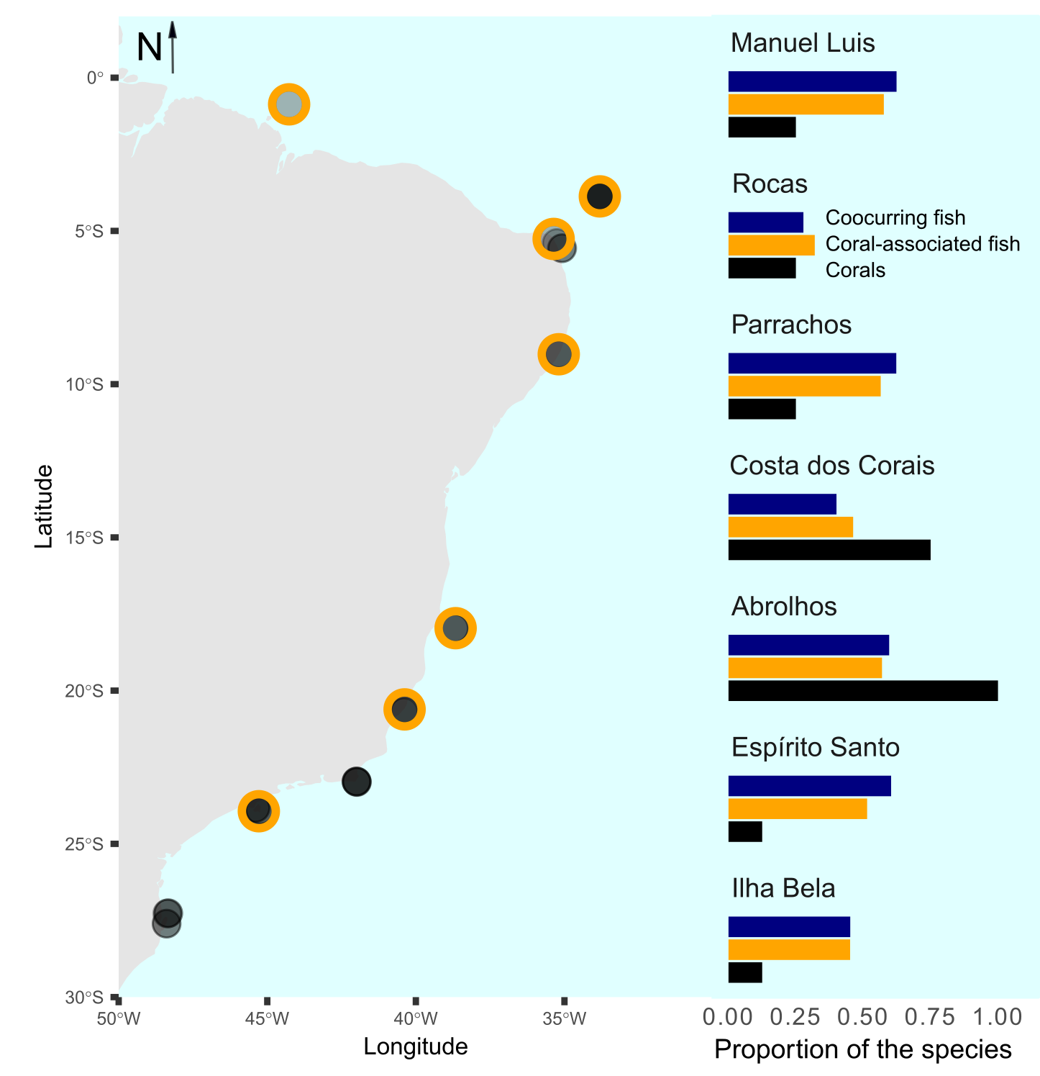

*Figure S1.1: Spatial distribution of the 36 studied sites (left) and the proportion of the total number of corals (n=8, black bars), coral-associated fish (n=42, orange bars), and co-occurring fish (n=21, blue bars) in seven selected sites (right). The selected sites are highlighted with orange strokes around points in the map. The represented localities within each site were (ordered from North to South): Manuel Luis: Ana Cristina; Rocas: Tartarugas; Parrachos: Rio do Fogo; Costa dos Corais: Gales; Abrolhos: Chapeirão; Espírito Santo: Três Ilhas; Ilhabela: Saco do Diogo.*

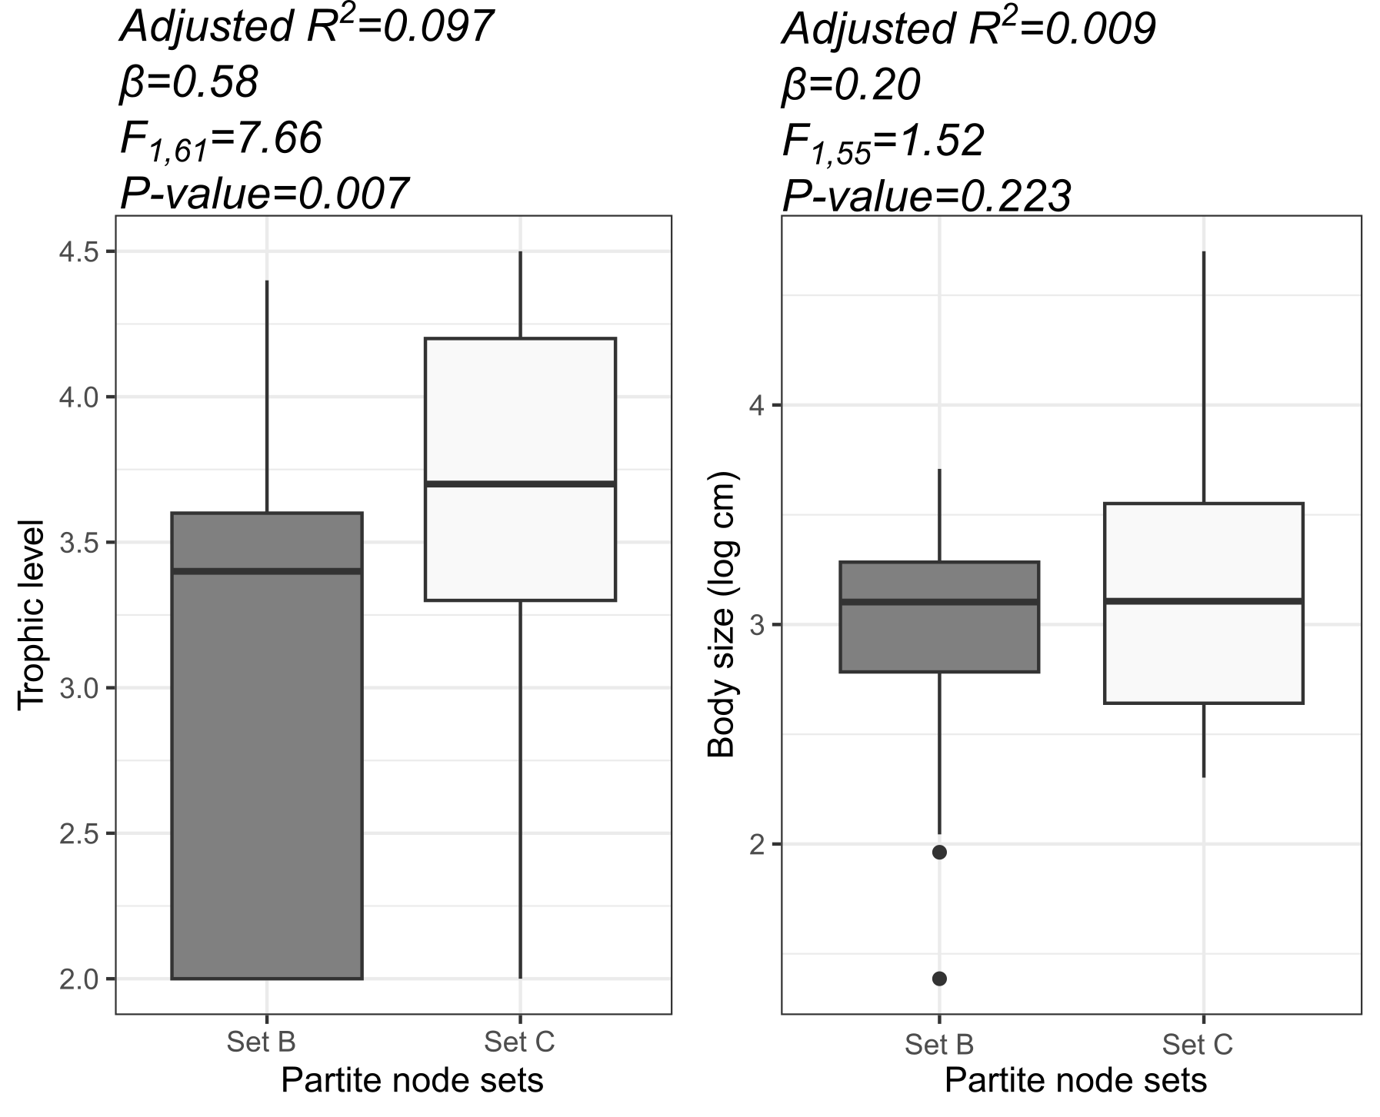

*Fig. S1.2: Variation of trophic level (A) and body size (B) between reef fish species in node sets B (coral-associated fish) and C (co-occurring fish).*