Universidade do Minho

Sistemas Digitais - Laboratórios

Circuitos Combinacionais

André Machado 66693

Luís Pedro Araújo 73232

1.

Not:

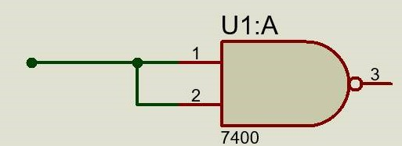

OR:

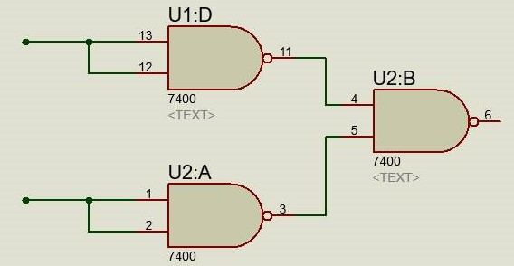

AND:

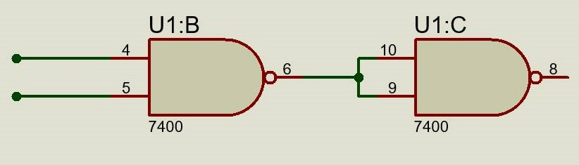

2.

a)

|  |  |  |  |  |
| --- | --- | --- | --- | --- |
| A | B | C | D | Culpado |
| 0 | 0 | 0 | 0 | 0 |
| 0 | 0 | 0 | 1 | 0 |
| 0 | 0 | 1 | 0 | 0 |
| 0 | 0 | 1 | 1 | 0 |
| 0 | 1 | 0 | 0 | 0 |
| 0 | 1 | 0 | 1 | 0 |
| 0 | 1 | 1 | 0 | 0 |
| 0 | 1 | 1 | 1 | 1 |
| 1 | 0 | 0 | 0 | 0 |
| 1 | 0 | 0 | 1 | 0 |
| 1 | 0 | 1 | 0 | 0 |
| 1 | 0 | 1 | 1 | 1 |
| 1 | 1 | 0 | 0 | 1 |
| 1 | 1 | 0 | 1 | 1 |
| 1 | 1 | 1 | 0 | 1 |
| 1 | 1 | 1 | 1 | 1 |

b)

|  |  |  |  |  |
| --- | --- | --- | --- | --- |
| AB  CD | 00 | 01 | 11 | 10 |
| 00 | 0 | 0 | 1 | 0 |
| 01 | 0 | 0 | 1 | 0 |
| 11 | 0 | 1 | 1 | 1 |
| 10 | 0 | 0 | 1 | 0 |

F= AB+BCD+ ACD

c)

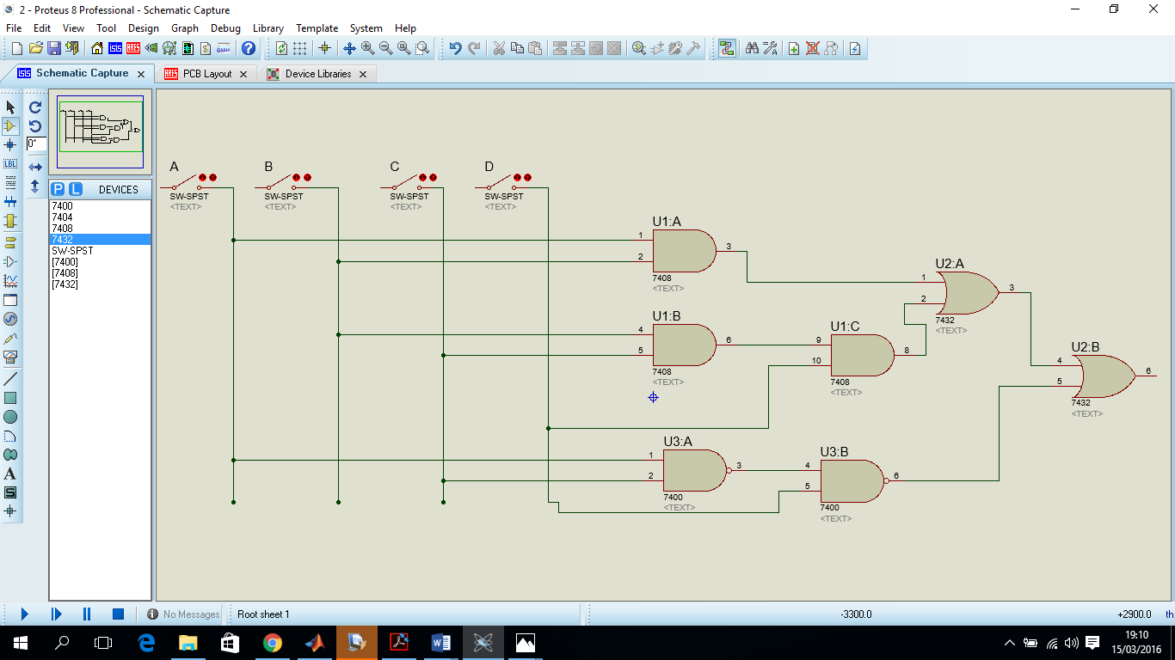

e)

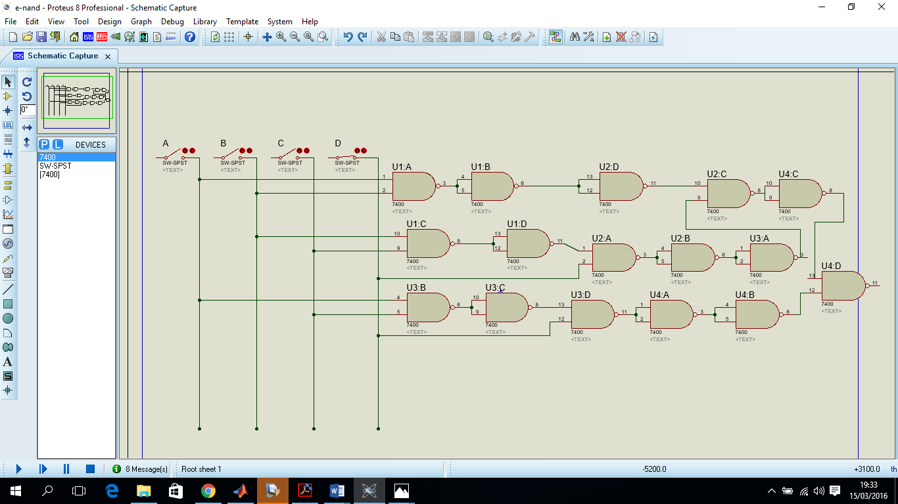

3.

|  |  |  |  |  |  |  |  |  |
| --- | --- | --- | --- | --- | --- | --- | --- | --- |
| E1 | E2 | E3 | E4 |  | S1 | S2 | S3 | S4 |
| 0 | 0 | 0 | 0 | x | X | x | x | x |
| 0 | 0 | 0 | 1 | 7 | 0 | 1 | 1 | 1 |
| 0 | 0 | 1 | 0 | 3 | 0 | 0 | 1 | 1 |
| 0 | 0 | 1 | 1 | 2 | 0 | 0 | 1 | 0 |
| 0 | 1 | 0 | 0 | 3 | 0 | 0 | 1 | 1 |
| 0 | 1 | 0 | 1 | 2 | 0 | 0 | 1 | 0 |
| 0 | 1 | 1 | 0 | 6 | 0 | 1 | 1 | 0 |
| 0 | 1 | 1 | 1 | 6 | 0 | 1 | 1 | 0 |
| 1 | 0 | 0 | 0 | 6 | 0 | 1 | 1 | 0 |
| 1 | 0 | 0 | 1 | 9 | 1 | 0 | 0 | 1 |
| 1 | 0 | 1 | 0 | 3 | 0 | 0 | 1 | 1 |
| 1 | 0 | 1 | 1 | X | X | X | X | X |
| 1 | 1 | 0 | 0 | X | X | X | X | X |
| 1 | 1 | 0 | 1 | X | X | X | X | X |
| 1 | 1 | 1 | 0 | X | X | X | X | X |
| 1 | 1 | 1 | 1 | 9 | 1 | 0 | 0 | 1 |

S1

|  |  |  |  |  |
| --- | --- | --- | --- | --- |
| E1 E2  E3 E4 | 00 | 01 | 11 | 10 |
| 00 | x | 0 | x | 0 |
| 01 | 0 | 0 | X | 1 |
| 11 | 0 | 0 | 1 | X |
| 10 | 0 | 0 | X | 0 |

S1*= E1E4*

S2

|  |  |  |  |  |
| --- | --- | --- | --- | --- |
| E1 E2  E3 E4 | 00 | 01 | 11 | 10 |
| 00 | x | 0 | X | 1 |
| 01 | 1 | 0 | X | 0 |
| 11 | 0 | 1 | 0 | X |
| 10 | 0 | 1 | x | 0 |

S2= $\overline{E2}\overline{E3E4}+\overline{E1E2E3}+\overline{E1}E2E3$

S3

|  |  |  |  |  |
| --- | --- | --- | --- | --- |
| E1 E2  E3 E4 | 00 | 01 | 11 | 10 |
| 00 | x | 1 | x | 1 |
| 01 | 1 | 1 | X | 0 |
| 11 | 1 | 1 | 0 | X |
| 10 | 1 | 1 | x | 1 |

S3= $\overline{E4}+\overline{E1}$

S4

|  |  |  |  |  |
| --- | --- | --- | --- | --- |
| E1 E2  E3 E4 | 00 | 01 | 11 | 10 |
| 00 | x | 1 | X | 0 |
| 01 | 1 | 0 | X | 1 |
| 11 | 0 | 0 | 1 | X |
| 10 | 1 | 0 | X | 1 |

S4= $E1E4+\overline{E1E3E4}+\overline{E1E2E3}+\overline{E2}E3\overline{E4}$

