Universidade do Minho

Sistemas Digitais - Laboratórios

Multiplexadores, Descodificadores e Buffers 3-State

André Machado 66693

   Luís Pedro Araújo 73232

1**.**

|  |  |  |  |  |  |  |  |  |  |
| --- | --- | --- | --- | --- | --- | --- | --- | --- | --- |
| 1 | 2 | 3 | 4 | 5 | 6 | 7 | 8 | 9 | 10 |
| B1 | B2 | B3 | B4 | B5 | A1 | A2 | A3 | A4 | A5 |
| 7 | 3 | 2 | 3 | 2 | 6 | 6 | 6 | 9 | 3 |

|  |  |  |  |  |  |  |  |  |  |
| --- | --- | --- | --- | --- | --- | --- | --- | --- | --- |
|  | A | B | C | D | Nº | Q4 | Q3 | Q2 | Q1 |
| 0 | 0 | 0 | 0 | 0 | X | X | X | X | X |
| 1 | 0 | 0 | 0 | 1 | 7 | 0 | 1 | 1 | 1 |
| 2 | 0 | 0 | 1 | 0 | 3 | 1 | 0 | 1 | 1 |
| 3 | 0 | 0 | 1 | 1 | 2 | 0 | 0 | 1 | 0 |
| 4 | 0 | 1 | 0 | 0 | 3 | 0 | 0 | 1 | 1 |
| 5 | 0 | 1 | 0 | 1 | 2 | 0 | 0 | 1 | 0 |
| 6 | 0 | 1 | 1 | 0 | 6 | 0 | 1 | 1 | 0 |
| 7 | 0 | 1 | 1 | 1 | 6 | 0 | 1 | 1 | 0 |
| 8 | 1 | 0 | 0 | 0 | 6 | 0 | 1 | 1 | 0 |
| 9 | 1 | 0 | 0 | 1 | 9 | 1 | 0 | 0 | 1 |
| 10 | 1 | 0 | 1 | 0 | 3 | 0 | 0 | 1 | 1 |
| 11 | 1 | 0 | 1 | 1 | X | X | X | X | X |
| 12 | 1 | 1 | 0 | 0 | 9 | X | X | X | X |
| 13 | 1 | 1 | 0 | 1 | x | 1 | 1 | 1 | 1 |
| 14 | 1 | 1 | 1 | 0 | X | X | X | X | X |
| 15 | 1 | 1 | 1 | 1 | x | X | X | X | X |

|  |  |  |  |  |
| --- | --- | --- | --- | --- |
| **AB** | **S0** | **S1** | **S2** | **S3** |
| **00** | **0** | $$\overline{CD}$$ | **1** | $$\overline{C}+D$$ |
| **01** | **0** | **BC** | **1** | $$\overline{CD}$$ |
| **11** | **1** | **0** | **0** | **1** |
| **10** | $$\overline{CD}$$ | $$\overline{CD}$$ | $$A\overline{D}$$ | $$C\overline{D}$$ |

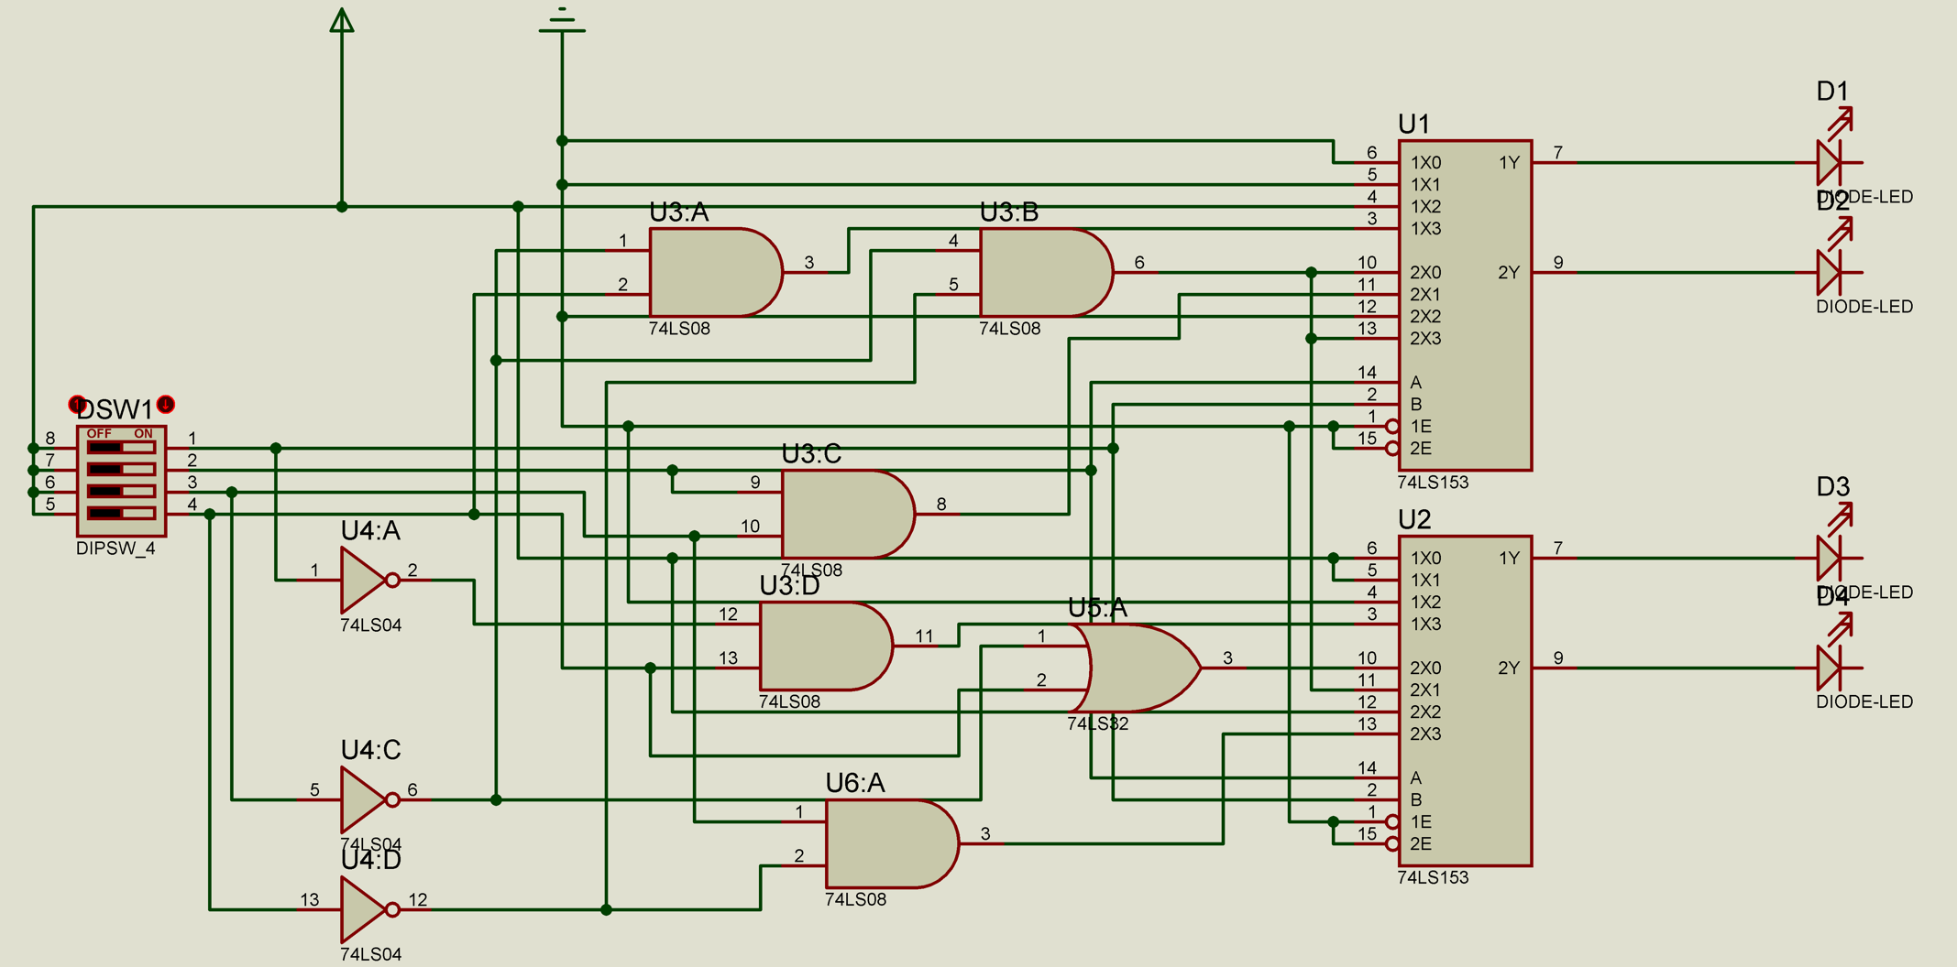

2.

|  |  |  |  |
| --- | --- | --- | --- |
| A | B | C | OUTPUT |
| 0 | 0 | 0 | D(7) D(6) |
| 0 | 0 | 1 | D(2) |
| 0 | 1 | 0 | D(6) D(3) |
| 0 | 1 | 1 | D(3) D(7) D(2) |
| 1 | 0 | 0 | D(2) |
| 1 | 0 | 1 | D(9) D(2) |
| 1 | 1 | 0 | D(6) |
| 1 | 1 | 1 | D(3) |

|  |  |  |  |  |  |  |  |  |  |  |  |  |
| --- | --- | --- | --- | --- | --- | --- | --- | --- | --- | --- | --- | --- |
| A | B | C | D9 | D8 | D7 | D6 | D5 | D4 | D3 | D2 | D1 | D0 |
| 0 | 0 | 0 |  |  | 1 | 1 |  |  |  |  |  |  |
| 0 | 0 | 1 |  |  |  |  |  |  |  | 1 |  |  |
| 0 | 1 | 0 |  |  |  | 1 |  |  | 1 |  |  |  |
| 0 | 1 | 1 |  |  | 1 |  |  |  | 1 | 1 |  |  |
| 1 | 0 | 0 |  |  |  |  |  |  |  | 1 |  |  |
| 1 | 0 | 1 | 1 |  |  |  |  |  |  | 1 |  |  |
| 1 | 1 | 0 |  |  |  | 1 |  |  |  |  |  |  |
| 1 | 1 | 1 |  |  |  |  |  |  | 1 |  |  |  |

D9=Z5

D7=~(Z0 + Z3)

D6=~(Z0 + Z2 + Z6)

D3=~(Z2 + Z2 + Z7)

D2=~(Z1 + Z3 + Z4 + Z6)

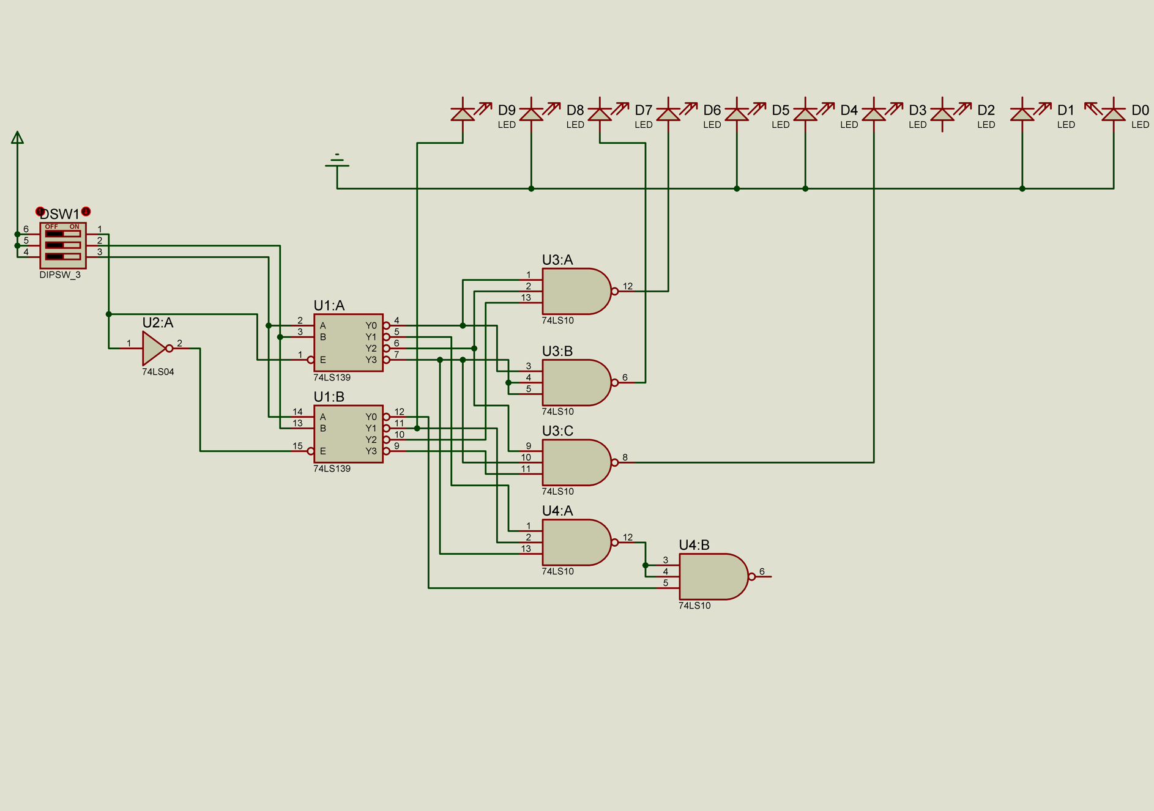

3.

a)

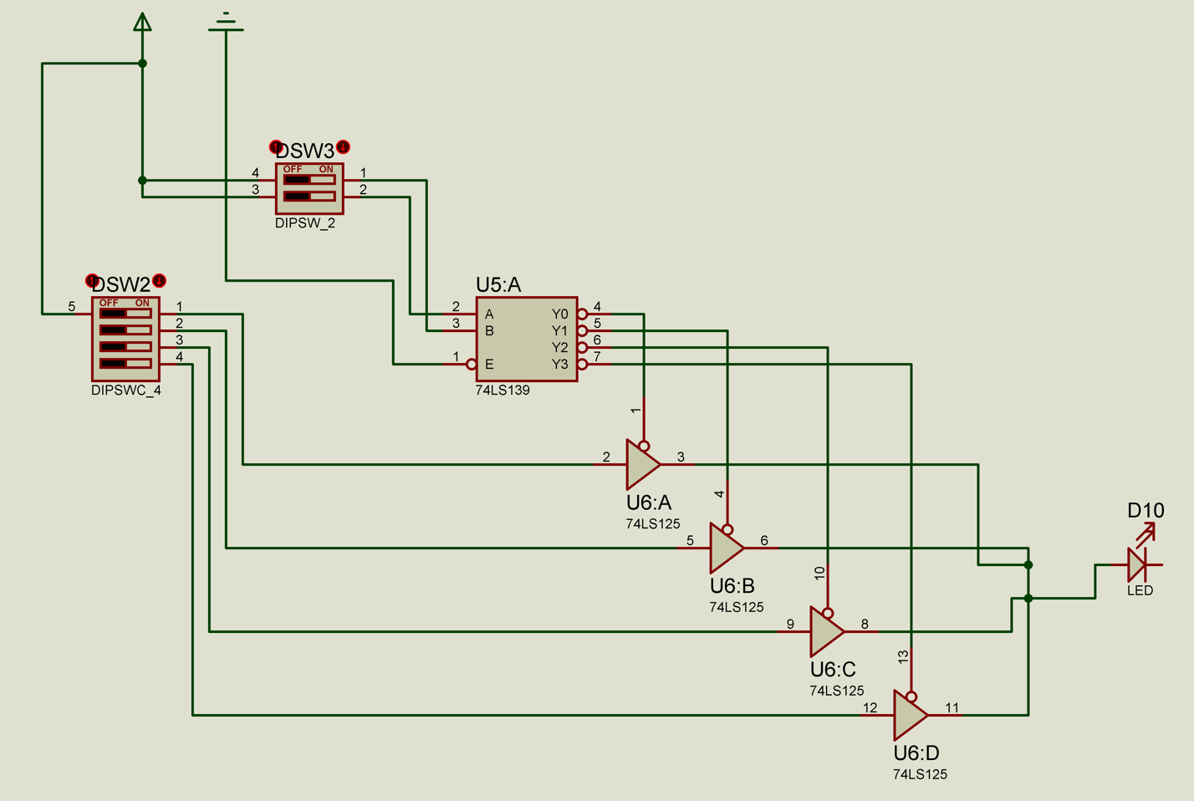

b)

|  |  |  |  |  |  |  |  |  |  |
| --- | --- | --- | --- | --- | --- | --- | --- | --- | --- |
| SelA | SelB | D0 | D1 | D2 | D3 | D3 | S2 | S1 | S0 |
| 0 | 0 | 0 | 0 | 1 | 0 | 0 | Hi-z | Hi-z | Hi-z |
| 0 | 1 | 0 | 0 | 1 | 0 | Hi-z | 0 | Hi-z | Hi-z |
| 1 | 0 | 0 | 0 | 1 | 0 | Hi-z | Hi-z | 1 | Hi-z |
| 1 | 1 | 0 | 0 | 1 | 0 | Hi-z | Hi-z | Hi-z | 0 |

|  |  |  |  |
| --- | --- | --- | --- |
| D0 | D1 | D2 | D3 |
| 0 | 0 | 1 | 0 |