**Projeto PE**

**Exercicio 9**

**Alunos: 99052, 102666, 103590**

**Codigo em R:**

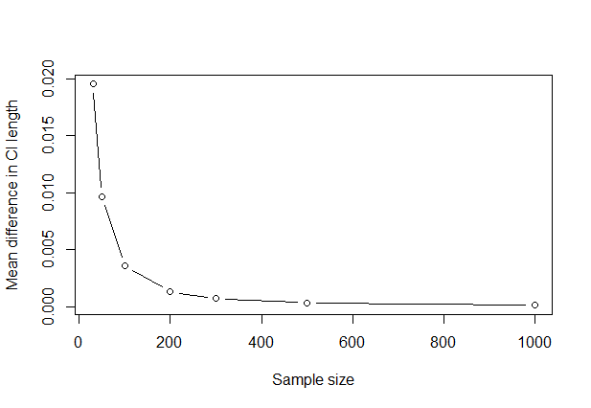

nValues <- c(30, 50, 100, 200, 300, 500, 1000)

k <- 3000

p <- 0.3

gamma <- 0.97

z <- qnorm((1 + gamma) / 2)

meanDiffs <- numeric(length(nValues))

for (i in seq_along(nValues)) {

n <- nValues[i]

diffs <- numeric(k)

for (j in 1:k) {

sampleX <- rbinom(n, size = 1, prob = p)

sampleMean <- mean(sampleX)

# Method 1

a <- 1 + (z^2)/n

b <- -2 * sampleMean - (z^2)/n

meanSquared <- sampleMean^2

roots <- (-b + c(-1, 1) * sqrt(b^2 - 4 * a * meanSquared)) / (2 * a)

ci_1_length <- diff(roots)

# Method 2

ci_2_length <- diff(sampleMean + c(-1, 1) * z * sqrt(sampleMean * (1 - sampleMean) / n))

diffs[j] <- ci_2_length - ci_1_length

}

meanDiffs[i] <- mean(diffs)

}

plot(nValues, meanDiffs, type = "b", xlab = "Sample size", ylab = "Mean difference in CI length")