Johnathon Hein

CM301

CSSE375

Milestone 2 refactoring

# Changing the Piece color to be an Enum rather than Boolean.

*Trello:* [*https://trello.com/c/BtPrg9wm/18-refactor-remove-unused-method-in-piece-class-and-associated-classes*](https://trello.com/c/BtPrg9wm/18-refactor-remove-unused-method-in-piece-class-and-associated-classes)

*Merge request:* [*https://ada.csse.rose-hulman.edu/zhangq2/Chess/merge_requests/9*](https://ada.csse.rose-hulman.edu/zhangq2/Chess/merge_requests/9)

## Bad code smells And Changes:

The bad smell in the Piece class was the fact that the color the piece was determined by a Boolean rather than a type code. This was mucking up code everywhere else, making it inexplicit what piece color the code is actually talking about.

I replaced this Boolean with a type code. This type code can be easily replaced by a class in the future if needed. This type code makes logic statements more expressive in around 50 places. The hard part of this change was fixing the 50 errors that the change caused. There is a lot of logic dependent on the Piece color. I think this revealed another bad code smell that we may want to pursue in the future.

Code Changes:

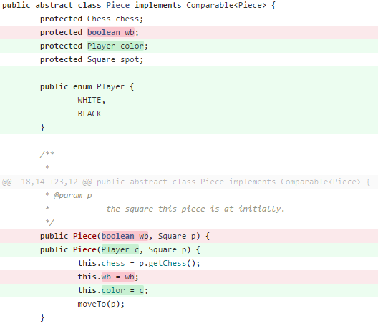

# Chess.getReachableSquares() refactoring:

*Trello:* [*https://trello.com/c/BtPrg9wm/18-refactor-remove-unused-method-in-piece-class-and-associated-classes*](https://trello.com/c/BtPrg9wm/18-refactor-remove-unused-method-in-piece-class-and-associated-classes)

*Merge request:* [*https://ada.csse.rose-hulman.edu/zhangq2/Chess/merge_requests/14/*](https://ada.csse.rose-hulman.edu/zhangq2/Chess/merge_requests/14/)

## Bad code smells And Changes:

The original Chess object has many functions that make it seem like a horrible God class. In the process of refactoring the Piece class, I noticed one of these functions that can easily moved into the Piece class. This was chess.getReachableSquares().

This function clearly is using the Piece’s data more than the Chess objects data. It simply works off its parameter, a Piece object. This functionality could just as easily be in the Piece class.

In the end I made two primary changes for this refactor. The first was to move the function into the Piece class and update references to it. Then I moved on to testing the function to verify its functionality. This was definitely the hardest part of the change. The function relies on many different dependencies (Chess, Square, Board, etc.). I used the mocking framework a ton to test the function for its desired behavior. Luckily, the code had fully used dependency injection, so the tests were not impossible.

Code Changes:

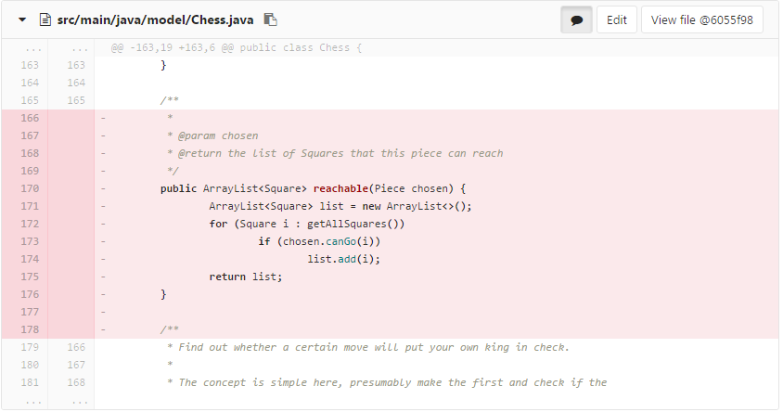

Piece Class:

