Learning in Ubiquitous Computing Environments
J. L.V. Barbosaª, D. N. F. Barbosa^{b}, R. M. Hahnª, A. Wagnerª
ªPIPCA/Unisinos, São Leopoldo, RS, Brasil
^{b}Learningware, São Leopoldo, RS, Brasil

Abstract
Ubiquitous learning refers to learning supported by the use of mobile and wireless communication technologies, sensors and location/tracking mechanisms, that work together to integrate learners with their environment. GlobalEdu is a model created to support ubiquitous learning. The model has the necessary support to implement learning-related functionalities in ubiquitous environments. However, the basic ubiquitous computing support must be supplied by a middleware where GlobalEdu lays atop. This article proposes the GlobalEdu model and its integration with two ubiquitous middlewares: ISAM and LOCAL. ISAM supports the creation of large-scale ubiquitous systems. As such, its integration with GlobalEdu results in large-scale ubiquitous learning environments. On the other hand, LOCAL is dedicated to create small-scale, location and context-aware ubiquitous learning environments. The integration GlobalEdu/LOCAL results in a local ubiquitous learning environment. Based on this small-scale environment, we created a system and applied it in a practical scenario involving the community of a Computer Engineering undergraduate course. The initial results attest the system’s usefulness. Two functionalities tests proved that the system can be used to stimulate the learner interaction and to distribute contextualized Learning Objects. In a third test, the system usefulness was positively evaluated by 20 individuals of the course.

Introduction
In last years, studies about mobility in distributed systems have been stimulated by the proliferation of portable electronic devices (for example, cell phones, handheld computers, tablet PCs and notebooks) and the use of interconnection technologies based on wireless communication (such as WiMAX, WiFi and bluetooth). This mobile and distributed paradigm is called Mobile Computing (Diaz, et al., 2009; Satyanarayanan, et al., 2009). Moreover, the improvement and proliferation of Location Systems (Hightower & Borriello, 2001; Hightower & Smith, 2006) have motivated the adoption of solutions that consider the user’s precise location for the provision of services (Location-Based Services (Dey, et al., 2010; Vaughan-Nichols, 2009)).
The adoption of these technologies combined with the diffusion of sensors enabled the availability of computational services in specific contexts – Context-aware Computing (Baldauf, et al., 2007; Dey A. K., 2001; Hoareau & Satoh, 2009). The idea consists in the perception of characteristics related to the users and their surroundings. These characteristics are normally referred to as context, i.e. any information that can be used to describe the circumstances concerning an entity. Based on perceived context, the application can modify its behavior. This process, in which software modifies itself according to sensed data, is named Adaptation (Satyanarayanan, 1996). In this scenario, the Ubiquitous Computing initially introduced by (Abowd & Mynatt, 2000), (Satyanarayanan, 2001) and (Weiser, 1991) is becoming reality.
The application of mobile and ubiquitous computing in the improvement of education strategies has created two research fronts called Mobile Learning and Ubiquitous Learning. Mobile learning (m-learning) (Tatar, 2003) is fundamentally about increasing learners' capability to carry their own learning environment along with them. M-learning is the natural evolution of e-learning, and has the potential to make learning even more widely accessible. However, considering the ubiquitous view, mobile computers are still not embedded in the learners' surrounding environment, and as such they cannot seamlessly obtain contextual information.
On the other hand, Ubiquitous Learning (Barbosa, et al., 2008; Lewis, 2010; Ogata & Yano, 2009; Ogata, et al., 2010; Rogers, et al., 2005; Yin, et al., 2004; Yin, et al., 2010) refers to learning supported by the use of mobile and wireless communication technologies, sensors and location/tracking mechanisms, that work together to integrate learners with their environment. Ubiquitous learning environments connect virtual and real objects, people and events, in order to support a continuous, contextual and meaningful learning. A ubiquitous learning system can use embedded devices that communicate mutually to explore the context, and dynamically build models of their environments. It is considered that while the learner is moving with his/her mobile device, the system dynamically supports his/her learning by communicating with embedded computers in the environment. The opportunities made available by the context can be used to improve the learning experience.
This learning scenario is attractive, but is not easily implemented. We are investigating how to better match people's expectations for such a system. In our point of view, ubiquitous learning environments should support the execution of context-aware, distributed, mobile, pervasive and adaptive learning applications.
GlobalEdu is a model created to support ubiquitous learning. The model is structured into layers (detailed in section 3) and can also be coupled with a ubiquitous computing middleware (considered the third layer). This article proposes the GlobalEdu Model and its integration with two ubiquitous middleware projects: ISAM (Augustin, et al., 2004) and LOCAL (Barbosa, et al., 2008).
The ISAM project focuses on the building and management of large-scale ubiquitous computing environments (Augustin, et al., 2005), and is being developed at UFRGS (Federal University of Rio Grande do Sul, Brazil). The integration GlobalEdu/ISAM results in a large-scale ubiquitous learning environment.
On the other hand, LOCAL aims to support small-scale, location-and-context-aware computing environments. It is being developed at Unisinos (University of Vale do Rio dos Sinos, Brazil). Integrating GlobalEdu and LOCAL we have got a small-scale ubiquitous learning environment. This integration was fully implemented and it was applied in three practical experiments to evaluate the system´s functionality and usability. In this evaluation we involved the community of a specific Computer Engineering undergraduate course at Unisinos.
This article is organized in six sections. Section two presents previous work in the area of ubiquitous technology used to create pedagogical applications, and how it relates to our work. Section three details the model GlobalEdu. Section four proposes the integration between GlobalEdu and the middlewares. Section five approaches a full implementation of the GlobalEdu/LOCAL integration and describes three experiments used to evaluate it. Finally, Section six presents some conclusions and plans for future work.

Related work
In the field of mobile applications and infrastructure, user profiles are employed to customize the interaction between the applications and the users. The Selene (Rigaux & Spyratos, 2010) and the Elena (Simon, et al., 2002) projects consider user profiles in distributed environments, but they do not take into account location data. Others works approach the subject of location technology (like SmartClassroom (Yau, et al., 2003) and AmbientWood (Rogers, et al., 2005)), incorporating it into an architecture, but don't implement user profiles.
The integration between contextualized user profiles, and location technologies is key to ubiquitous learning environments. For instance, this type of integration allows features like the distribution of contextualized Learning Objects (Lewis, 2010) in a specific location, and the match of students with common interests within a learning context. Therefore, we introduced into GlobalEdu the match between location technology and user profiles. This match is a central feature of the model.
The technologies used to create ubiquitous learning environments can be used to support specific applications. For instance, JAPELAS (Yin, et al., 2004) is a system created with the goal of supporting learning of polite expressions in Japanese. The students, using handheld PCs, are assisted in the identification of the correct polite expressions to be used in a particular context. JAPELAS only allows the contact between two users.
A new version called JAPELAS2 (Yin, et al., 2010) is oriented towards supporting the interaction between many people, with a collaborative/social approach. Both systems use location technology and user profiles, but they represent a specific application, namely, the correct use of Japanese polite expressions. In order to support several pedagogical applications, a generic infrastructure should be available. This infrastructure should provide applications that use location technology, aiming at supporting particular tasks. GlobalEdu uses location information and learner profiles in a generic approach, in order to explore pedagogical opportunities in a context-aware environment.
The Ambient Wood Project (Rogers, et al., 2005) is dedicated to the design and building of pervasive environments. WiFi and sensor-based technologies are connected with a variety of mobile and standalone computational devices. The proposal is that digital augmentation offers a promising way for enhancing both indoors and outdoors learning processes. The GlobalEdu uses the context management to improve the learning process. The integration GlobalEdu/LOCAL explores indoors learning applications through WiFi technology, and with ISAM integration, GlobalEdu intends to explore both indoors and outdoors applications.
Other approaches explore RFID (Radio Frequency Technology) technology to integrate the real world in the pedagogical experience. TANGO (Ogata, et al., 2010) allows placement of RFID tags on real objects. The tags can be detected when a learner visits an environment. A mobile device can be used to interact with objects, in order to improve the learner’s vocabulary through the questions and answers previously registered in each object.
Mobio Threat (Segatto, et al., 2008) is a pervasive game that represents another pedagogical approach based on RFID technology. Pervasive gaming is an emerging type of gaming, in which players must physically move to specific places in order to perform tasks within the game. Users must interact with each other and with the environment around them. In Mobio Threat, RFID tags are implanted in game objects, such as trees and rooms, to allow learners to interact with these real objects using their mobile devices. The game is meant to be a fun learning experience. Its main goal is to support learning about epidemics and disease control. During the game, the players have to work with pathological agents and chemical reactions. The pedagogical contributions are centered in the areas of Chemistry and Biology.
TANGO and Mobio Threat use the same strategy to improve the pedagogical experience, i.e., they integrated the real world in the educational process using RFID technology. Differently from GlobalEdu, both proposals focus on specific pedagogical areas. GlobalEdu is a generic ubiquitous learning model. Moreover, it does not support the interaction with real objects using RFIDs or any other kind of technology.
Few projects in the area of ubiquitous learning use Learning Objects (Lewis, 2010) to represent pedagogical content. JAPELAS (Yin, et al., 2004; Yin, et al., 2010) was designed for a specific purpose, and does not use Learning Objects. The Ambient Wood Project (Rogers, et al., 2005) does not support Learning Objects. Its focus is specifically on pervasive environments based on digital augmentation. Yang (2006) proposes a peer-to-peer access to content in a ubiquitous learning environment. The proposal also does not specify how the content is going to be represented. Unlike these works, GlobalEdu employs the notion of Learning Objects in order to enable a generic content management approach.
Schmidt (2005) summarizes the characteristics of context-aware learning systems and presents a case study that uses Learning Objects based on the SCORM standard (SCORM, 2010). GlobalEdu, however, uses the LOM standard (LOM, 2010). SeLeNe (Rigaux & Spyratos, 2010) and Elena (Simon, et al., 2002) also use the LOM standard, however, they do not consider the adaptation of content according to the learners’ current context, as GlobalEdu does.

The GlobalEdu model
GlobalEdu aims to support ubiquitous educational applications. Its architecture is based on a layered organization, as shown in Figure 1. The Application Layer is represented by a Pedagogical Agent (PA), which follows the learner throughout the environment and helps in her/his interactions with the system.
Figure 1: GlobalEdu architecture
The System Layer is a set of Educational Modules (EM) and Support Modules (SM). The Educational Modules are responsible for performing content management tasks as well as manipulation of the learner model. The system has three Educational Modules: Profile, Content and Context Management. The first module is responsible for managing learner profiles. The second one deals with the learning objects which are manipulated by the learner. The third one controls information in the context of interest of the learner and is in charge of adapting the resources that he/she is manipulating. The Support Modules are intended to help in the execution of the Educational Modules and the Pedagogical Agent, by managing the aspects of communication, adaptation of interfaces to devices, user's access and persistence.
The Runtime Layer is a middleware which supports the execution of educational applications, providing the system with necessary features, such as perception of contextual elements, code migration and communication mechanisms.
For us, one of the characteristics of ubiquitous learning is that the user's context can be connected with the learner's local context, joining this information with educational objectives. The Context Management module manages learner context in each location the learner interacts. This module detects changes of contextual elements in the different locations where the learner is. The Social Context and Physical Context compose the learner context.
The Social Context has contextualized information about Location Context and the presence of other PAs in the current context. Location Context contains information about People (name, e-mail, commitments and roles), Events (type, description and location) and Resources (name, type, description and commitments) related to a specific location. The presence of other PAs presupposes the existence of other learners with the same goals, competencies and preferences, whose information the learner may access for contact or not. This information can also be used for the creation of learner groups within the same context.
The Physical Context represents the resources accessed by the learner, such as network, locations and devices. We consider that the ubiquitous computing environment monitors Physical Context elements. Besides, any element state changes are informed to the Context Management.
The Context Management module has the capability to know how to locate the learner in his/her current environment, to identify a learner in the corresponding context and to provide information adapted to the device the learner is using. In the same way, each location is modeled as a Geographic Region and has information about Location Context. So, for GlobalEdu, the ubiquitous environment is composed by cells and these have different contexts (Figure 2). For example, a University can be considered a cell and its buildings, different contexts.
Figure 2: The GlobalEdu environment
Learners need to authenticate themselves in order to interact with the environment. This event is handled by the Context Management module. When a new learner enters into the environment, the Social Context changes. In this case, the service takes two actions: (1) notifies other learners in the corresponding context (Location Context), and (2) sends to the new learner adapted information about the current context he/she is in. User profiles are compared in order to define learners with the same goals, competencies and preferences, whose information the learner may access for contact or not.
For the adaptation process, there is a relationship between the Context Management module and the other elements of the architecture (Figure 3). With this, learners can ask explicit information about the Social Context they are part of. They can also extend the search for information to other contexts. This can be useful in the case of finding learning objects related to the learner's goals, for instance.

Figure 3: Context management

GlobalEdu, ISAM and LOCAL
GlobalEdu supports the basic features needed to implement learning-related functionalities in ubiquitous environments. The basic ubiquitous computing support must be supplied by a middleware (see Figure 1). GlobalEdu has been integrated with two ubiquitous environments: ISAM (Augustin, et al., 2004) and LOCAL (Barbosa, et al., 2008). ISAM supports the creation of large-scale ubiquitous systems. As such, its integration with GlobalEdu results in a large-scale ubiquitous learning system. On other hand, LOCAL is dedicated to create small-scale location and context-aware ubiquitous systems. GlobalEdu integrated with LOCAL results in a local ubiquitous learning system.

Large-scale: GlobalEdu and ISAM
The ISAM Project (Augustin, et al., 2004) provides a common system platform, allowing the execution of applications across a wide range of equipment as well as automatic distribution and installation. ISAM is based on the vision that ubiquitous applications are distributed, mobile and context-aware by nature, and assumes that "the computer" is the whole network (large-scale pervasiveness (Augustin, et al., 2005)). The ISAM Pervasive Environment (ISAMpe) is composed of elements that correspond to the physical infrastructure of the mobile network. The physical organization adopted in ISAM is the cellular hierarchy (see Figure 4). Each cell has a base and the cells are connected to support the ubiquitous environment. A cell manages nodes such as desktops and mobile devices which can be connected either by wired or wireless networks.
Figure 4: GlobalEdu and ISAM
As can be seen in the Figure 2, GlobalEdu also uses a cellular hierarchy. It is possible to map the GlobalEdu architecture to ISAM (as shown in Figure 4). The Pedagogical Agent (PA) is mapped to mobile nodes and the Educational and Support Modules are mapped to the bases (servers in a cell). The Modules are heavyweight execution units, and are executed in network servers. On the other hand, PA is a lightweight execution unit, so it can be executed in mobile devices.
Each ISAM cell has one instance of GlobalEdu. Users can change their context (cell), carrying their PA. ISAM supports the basic ubiquitous computing-related aspects and GlobalEdu supports the specific learning aspects.

Small-scale: GlobalEdu and LOCAL
The LOCAL project (Barbosa, et al., 2008) aims to provide a location-and-context-aware ubiquitous architecture geared to create small-scale learning environments. LOCAL is composed by seven subsystems (see Figure 5): (1) User Profiles, which store information related to the users using the PAPI standard (IEEE, 2008); (2) Personal Assistant, which acts as the system's interface, residing in the user's mobile device; (3) Location System, used to determine the physical position of the mobile devices; (4) Learning Objects Repository, which stores and indexes content related to the teaching process; (5) Tutor, an analysis engine capable of making inferences by using the data supplied by the profiles and the location system; (6) Communication System, used to establish communication between the different parts of LOCAL, and between the system and its users; (7) Event System, used to schedule tasks.
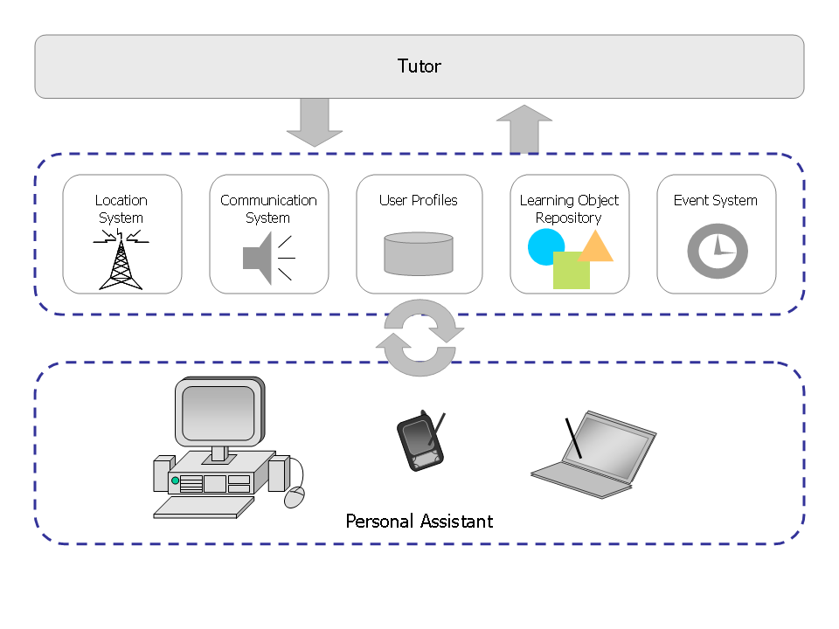
Figure 5: The LOCAL architecture
The personal assistant (PA) is the module which accompanies the learner in its mobile device. It allows users to stay connected to the system, while providing a certain degree of independence. The location system ties users' physical location data to symbolic names (contexts). This allows real time mapping of mobile device positions. As the learner authorizes the location system in its PA, it begins to determine the device's position and physical context changes, along with the time and date of such changes. With this data, it is possible to completely track the learner's movements. User profile data, alongside context information, is used in the learning process.
GlobalEdu uses the services offered by LOCAL to monitor and control the environment (see Figure 6). GlobalEdu's PAs are executed in the learner's devices, mapped to the LOCAL’s Personal Assistant.
The Location System and the Event System are used to treat the location and event information used by the Context Management Module. Moreover, the central role of pedagogical inferences to explore the Social Context (see Figure 3) is mapped to the tutor subsystem.
Content Management Module is supported by the Learning Object Repository and the Profile Management by the User Profiles System. Communication Support Module is mapped to the LOCAL Communication System. Other Support Modules are not used.
LOCAL is oriented to small-scale ubiquitous environments and its architecture was projected to a centralized execution (only one server). As such, there is only one GlobalEdu instance (see Figure 1). Modules are executed in the network server and the PA executes in the users' mobile devices.
Figure 6: LOCAL adapted for GlobalEdu

Practical scenario: GlobalEdu and LOCAL
Since 2005, the Mobile Computing lab (MobiLab) at Unisinos has been working on research topics related to the area of ubiquitous computing. One of the main goals is to investigate how ubiquitous technologies could be used to improve learning in the undergraduate courses (Barbosa, et al., 2007). Moreover, in 2002 the University has created a specific undergraduate course focuses in the integration of knowledge areas related to Engineering and Computer Science. The course is called Computer Engineering course (nicknamed ComEng). The ComEng forms a strongly-tied, interdisciplinary community where both teachers and learners are encouraged to use the mobile computing infrastructure in their daily activities. There is a permanent search for new ways to better explore this technological infrastructure in pedagogical activities in this course.
ComEng and MobiLab share the same physical space in a building at the Unisinos. The first choice in order to evaluate our proposal was the creation of a ubiquitous learning scenario in this space. We used the integration GlobalEdu/LOCAL described in the section 4.2 to implement a small-scale ubiquitous learning system, called LocalEdu system. The LocalEdu was implanted in the ComEng/MobiLab shared physical space and it was used to conduct functionality and usability tests.
The scenario encloses nine rooms covered by four wireless access points (see Figure 7). This coverage is needed for our location technology, where we use the access points for WiFi signal triangulation. MobiLab is located specifically in the room 212. The other eight rooms support most of educational activities of ComEng. Currently, MobiLab has 45 HP iPAQ hx4700 pocket PCs, 20 HP tc1100 tablet PCs, 14 docking stations for the tablets and several wireless antennas. These equipments were used in the experiments described in this article.
The location system has two parts: (1) a webservice created in C# and (2) a database which stores context information. The Personal Assistant was developed in C#, using the .NET Compact Framework. The assistant runs in iPAQs hx4700 and tablet PCs tc1100. It reads potency information from the four wireless access points and forwards it to the location system. The system uses this information to determine the position of users' mobile devices.
The profile system was implemented using MySQL. Users fill in their personal and contact information using an online tool made in PHP and AJAX technology. This tool can be accessed via desktops and via mobile devices. The Tutor and Communication System were conceived as modules that perform their tasks without user intervention. They were both implemented in C# as Windows Services.
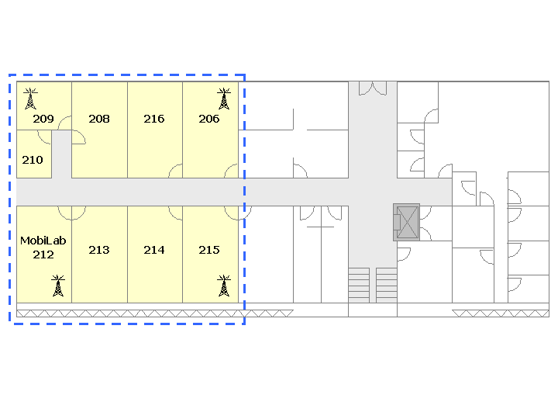
Figure 7: Prototype test scenario

Functionality Test 1: Following a Lesson
The learner profiles data can be used to create bonds between learners (see Figure 8). There are two interaction forms: 1) Similar interests: the LocalEdu finds learners with similar interests in the same context, and stimulates interaction. This approach can be used in the creation of workgroups in a classroom, for example; 2) Complementary interests: the system finds learners with complementary interests. For example, a learner who wishes to learn more about a particular subject is paired along a user who wishes to teach or knows more about it. This way, LocalEdu can be used, for example, to create pairs of students who complement each other.
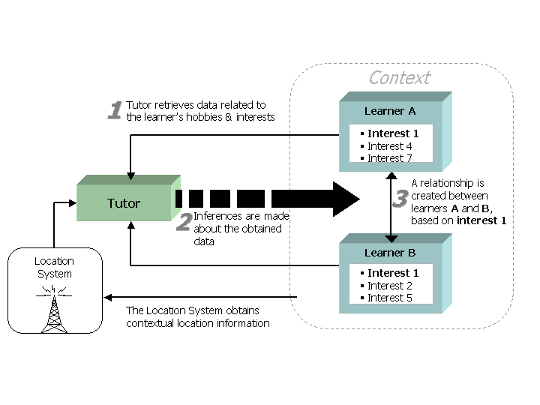
Figure 8: Stimulating Interaction between learners

Our first experiment was a lesson involving 10 learners, using mobile devices (HP iPAQ hx4700). The experiment focus in the system’s potential to stimulate the interaction among learners, more specifically the creation of workgroups. The lesson lasted two and a half hour (between 7:30pm and 10:00pm) and involved a debate around the subject “Programming Language Paradigms”. All the profiles were previously registered by the students (from the Computer Engineering course). Test results are organized into five steps (Table 1).
The first step occurred before the lesson. The professor set an appointment in a message with the subject of the upcoming debate, as well as a list of online resources. This message was tied to room 216, where the debate was going to occur. The appointment spanned the whole duration of the lesson.
The second step was the start of the lesson. Seven students entered the classroom, and they were detected by the Location System. They receive the appointed message.
In the third step, the professor requested the formation of groups for debating. The groups were formed according to the similarity between user interests in “Programming Languages”. In this particular case, three groups were formed: one (A) with four students interested in Java; the second (B) with two students interested in C# and another one (C) with just one student, interested in C++.
The debate started, and each group presented the pros and cons of each language. At this time, two students came late. Both received the appointed message, and were also informed about what group they should participate in. One of them entered group A, and the other entered group C.
In the fourth moment, another late student arrived, and received the appointed messages. However, the debate had already ended, and this student was not directed to any group.
The fifth moment occurred after the end of the lesson. The system registered student attendance via sampled location data. A student was considered present if he/she was in the classroom for at least 60% of the meeting's duration. The last student was considered absent.
The initial results proved that it was possible: (1) to create groups of students via profile and physical location data; (2) to offer a predetermined list of research materials, which can be related to the topic at hand; (3) to automatically handle student attendances in the classroom, based on location data.
Table 1: Following a Lesson
# | Initial Time | Final Time | Actor | Action
1 | - | 07:00 | Professor | Inserts an appointment to be sent between 7:30 and 10:00, to all users in room 216. This appointment accompanies a list of online resources related to the subject to be debated.
2 | 07:30 | 07:30 | Learners | Seven users enter the room (authentication using the Personal Assistant).
 | 07:30 | 07:30 | LocalEdu | Location System begins tracking user location.
 | 07:30 | 07:30 | LocalEdu | Communication System sends the previously appointed message to all users in room 216.
3 | 08:00 | 08:10 | Professor | Professor asks for the creation of groups for the debate.
 | 08:10 | 08:10 | LocalEdu | Communication System sends messages, creates groups: A (4 users, Java), B (2 users, C#) and C (1 user, C++).
 | 08:10 | 08:30 | Learners | The debate starts.
 | 08:30 | 08:30 | Learners | Two users enter the room (authentication using the Personal Assistant).
 | 08:30 | 08:30 | LocalEdu | Location System begins tracking location for the last 2 users. Communication System sends appointed message to these users informing where they should participate.
 | 08:30 | 09:00 | Learners | The debate comes to a conclusion.
4 | 09:00 | 09:00 | Learner | The last user arrives (authentication).
 | 09:00 | 09:00 | LocalEdu | Location System begins tracking location for the last user. Communication System sends previously appointed message to this user.
 | 09:00 | 10:00 | Professor, Learners | The participants keep exchanging ideas about the debate that was just held.
5 | 10:00 | - | LocalEdu | Tutor uses the tracking of each participant (Location System) to register the attendances.

Functionality Test 2: Distributing Learning Objects
Through the LocalEdu system, Learning Objects can be made available to learners in accordance with whatever pedagogical opportunities may appear during their interaction with the different contexts (Figure 9). The location system keeps the tutor aware of which context the learner is in (step 1). The tutor uses this information, as well as the learner's profile data, to select the objects meeting the learner's goals and the context (steps 2 and 3). The objects meeting these criteria are then forwarded to the learner (step 4). This adaptive process can be started by two events: (1) when the learner enters a new context or (2) insertion of new objects in the repository.
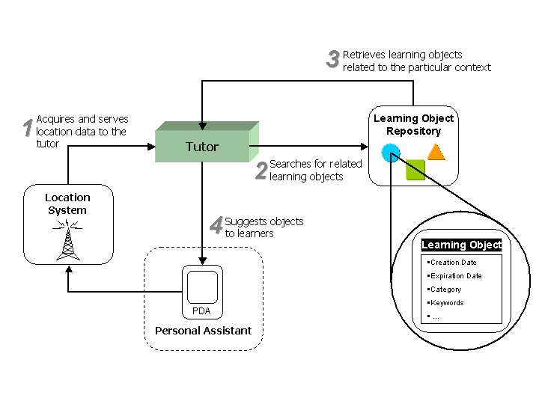
Figure 9: Learning Objects management
The scientific community has been using scenarios to validate context-aware environments (according to approach of (Dey A. K., 2001)) and ubiquitous environments (according to Satyanarayanan (2001)). Following this strategy, our second experiment was a scenario involving the content distribution in a daily routine of a Computer Engineering student. This scenario focuses on the distribution of Learning Objects (LOs) in different contexts based on the learner's profile, according to the described below:
"Jorge is professor of the Programming Techniques discipline of the Computer Engineering course at Unisinos. At the beginning of the week scheduled to the basic teaching of programming using the Java language, he registered in the LocalEdu repository a group of learning objects (LOs) that support different preferences of media (for example, text, video, and audio). The register involved the indication of the contexts in which the objects would be available.
In the classroom, Jorge registered some curricular objects concerning the basic concepts. In the laboratory, he registered optional objects that will be available for improvement, involving different themes (such as "Interfaces" and "Parallel Programming").
João is a Computer Engineering student. At the day of the Programming Techniques class, João entered the classroom and logged in the LocalEdu using the Personal Assistant (see Figure 10(a)), subsequently he received a notification of the availability of a curricular LO. João accessed the object and received a PDF file (preference text). LocalEdu used the Learner Profiles subsystem to determine this preference.
After the class, João entered the laboratory and received a notification regarding the availability of a LO related to the subject of his interest in Java (in this case, "Interfaces").
In the laboratory, João preferred audio objects, because he could listen to them while he was using the computer (determined using the Learner Profiles). João accessed the object and, after its use, received another notification of available object (see Figure 10b)) concerning the subject of his interest (this time, the object was about "Parallel Programming").
Always that the students receive a notification of LOs, they can delay the access. This action indicates that the students are interested in the object, but they do not want to access it at the moment, i.e., they want to access the object at the first opportunity of available time. João postponed the access to the optional object (see Figure 10(c)).
At the end of the day, João moved to the train station. When he entered the train, LocalEdu notified him that a postponed LO was identified (Figure 10(d)). Getting home, João still received another notification saying that the professor had provided an additional object to a subject of his interest ("Polymorphism" in Java). In the register, the professor informed that the interested students should be notified independently of their locations."

Figure 10: LOCAL snapshots in the scenario of Learning Objects distribution
João (a real student) carrying an iPAQ 4700 simulated the scenario, moving around the environment rooms. The train and the learner’s house were simulated through the rooms 206 and 215. Table 2 summaries the scenario.
The results of this test proved that it was possible: (1) to distribute the learning objects using the contexts visited by the learners; (2) to use the learner's profiles to choose the learning objects to be distributed; (3) to manage the access to the learning objects using the concept of postponed objects.
Table 2: Distributing Learning Objects
# | Actor | Action
1 | Professor | Registers the learning objects in LocalEdu, relating them to contexts.
2 | Learner | Enters the classroom and logs in LocalEdu using an iPAQ 4700; see Figure 10(a)
3 | LocalEdu | LocalEdu detects the entry of the learner into the classroom. Tutor uses the Learner Profiles to determine the learner’s preference of media in the context. Subsequently, it requests the sending of a message about the LO available in the preferred media.
4 | Learner | Accesses the curricular object.
5 | Learner | Moves to the laboratory.
6 | LocalEdu | Tutor detects the entry of the learner into the laboratory (Location System) and uses the Learning Objects Repository to verify the available LOs, related to the student’s interest. Tutor still uses the Learner Profiles subsystem to define the learner’s preferred media in the context. Finally, Tutor requests to the Communication subsystem the sending of messages about the available LOs; see Figure 10(b).
7 | Learner | Uses the Personal Assistant to access one of the two identified objects and postpones the access to the other to the first moment of available time (see Figure 10(c)).
8 | Learner | Moves to the train.
9 | LocalEdu | LocalEdu detects the entry of the student into the train and calls the Learning Objects Repository subsystem to verify the LOs that can be accessed during the trip. LocalEdu identifies the postponed object and notifies the learner, see Figure 10(d).
10 | Learner | Accesses the object that has been postponed.
11 | Professor | Registers a new optional LO concerning “Polymorphism” in Java that can be accessed in any context.
12 | Learner | Enters his home.
13 | LocalEdu | Tutor informs the learner (Communication subsystem) of the new optional LO available that corresponds to his areas of interest.
14 | LocalEdu | Accesses the new object.

Usability test
In order to further validate our proposal to ubiquitous learning, a third experiment was conducted. This new experiment involved a sample consisting of 20 individuals, teachers and students of the Computer Engineering course. The test was conducted in five steps; in each one of the steps, a set of 4 individuals interacted with the system. The following steps were considered:
1. Each participant received an HP iPAQ hx4700 mobile device, which they used to access the system;
2. The participants received suggestions to participate in one out of two workshops (based on each learner's profile);
3. The participants were notified whenever a professor they wanted to chat with was available;
4. In the fourth step, the system searched for matches between the subjects' profiles, suggesting learning resources related to their interests;
5. The users were instructed to go to the workshop rooms. The system then made available on the iPAQs the program of the chosen event.
After following these steps, the users were asked to answer a survey that presented statements related to their experience using LocalEdu. The statements were based on the concepts proposed by the Technology Acceptance Model (created by Davis (1989) and expanded by Yoon and Kim (2007) in a study focused on the acceptance of wireless networks).
The TAM considers both perceived usefulness and perceived ease of use as the main influences for the acceptance of a new technology. Ease of use is defined by Davis (1989) as “the degree of which a person believes that using a particular system would be free of effort”. Perceived usefulness is defined as the degree of which a person believes that using a particular system would enhance his or her performance (Davis, 1989). These two constructs of the TAM model were considered to create a set of evaluation statements about the system and the contextual information generated by it.
Subjects were asked to rate how strongly they agreed or disagreed with a series of statements (shown in Table 3). This evaluation was based on a five points Likert (1932) scale with values between 1 (strongly disagree) and 5 (strongly agree). An answer with the value 3 (indifferent) meant that the user had no particular opinion about that feature. It is important to explain that the TAM model was not applied to test hypothesis or to predict an acceptance level, only its main constructs (ease of use and perceived usefulness) were applied to evaluate the system as a whole.
Table 3: Statements to evaluate the system
No. | Statement
1 | The notifications you received about the availability of professors helped you to get answers to your questions quicker.
2 | The notifications about events, based on location and your profile data, helped you to get relevant information according to your interests.
3 | The notification about the availability of related physical resources in your context made the task of finding those resources easier.
4 | The information you received about users like you, at your location, helped to establish contact with them.
5 | The presentation of content related to events at your location usually brought out relevant items according to your interests, improving the learning experience.
6 | The context aware features in this system make it useful as a learning tool.
7 | The system was capable of determining your position with precision.
8 | The system improved your interaction with other users in the same location by helping you to identify other people like you.
9 | This system could be easily used to improve your daily academic activities.
10 | This system would be useful in a standard classroom setting.

Figure 11 presents the combined scores obtained in statements 1 to 7, as answered by the 20 test subjects. The results indicate that most of the users (80%) agree or strongly agree that the contextual information provided by LocalEdu was useful for them, helping them in the educational activities as well as during the interaction between users and contextual elements. The presence of a location system used to track user location allowed the creation of contextualized services, which were evaluated as positive by most of the subjects.
The aspects related to the idea of a daily use of the system as a learning tool in the classroom, were analyzed in the statements 8 to 10. The results in Figure 12 indicate that 95% of the subjects agreed or strongly agree that this system fits well for daily usage, being also easy to use.
Most of the results indicating “Indifferent”, “Disagree” or “Strongly Disagree” in both groups of statements occurred because the location system showed limitations of accuracy during the experiment. This limitation caused the sending of useless information to some users. The improvement of the location system is an important work to be approached in our future research.
It should be noted that, in this survey, adaptability aspects were not given a proper analysis. These aspects could be better analyzed if the test involved a heterogeneous sample of mobile devices (desktop PCs, tablet PCs and iPAQs).

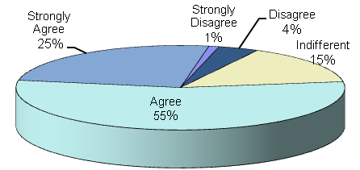
Figure 11: Contextual information (statements 1 to 7)

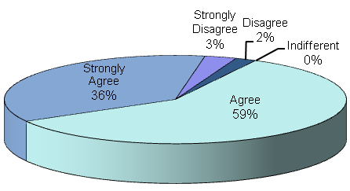
Figure 12: Daily usage (statements 8 to 10)

Conclusion
In this article we proposed GlobalEdu, a model to support ubiquitous learning. The model was integrated with two middlewares to create small-scale and large-scale ubiquitous learning environments. A prototype of a small-scale system was implemented and used in the three experiments involving the community of an undergraduate Computer Engineering course.
The results of the experiments show that GlobalEdu can be used to stimulate the interaction among students in a classroom and to distribute contextualized learning objects. Moreover, the system usefulness was positively evaluated by a group of individuals of the course. Currently, we are improving the prototype. After that, another round of tests shall be conducted.
So far, the following general conclusions can be underlined:
1. location technologies stimulate the use of mobile devices as learning tools;
2. user profiles allow to address personalized pedagogical resources according to different contexts.
Specific conclusions about the proposal can be highlighted:
1. GlobalEdu contains the basic modules to support ubiquitous learning and its integration with LOCAL creates a practical and viable system that can be applied in real learning situations;
2. the location system, by providing precise location data, is a key component of the contextualization process. Therefore, improvements to the location system will benefit the proposal as a whole (and the learner experience as well);
3. the prototype and initial results attest the usefulness of the model.
GlobalEdu and its integration with the middlewares constitute an initial proposal. The following activities will allow the future of the study:
1. the current pedagogical inferences made by the GlobalEdu, and more specifically, by the LocalEdu system can be improved;
2. a future expansion of the learner profiles would support a more extensive handling of learner information, enabling a better match between the system features and each learners’ personality and learning style (considering, for instance, the issue of competences development or cognitive styles);
3. currently, GlobalEdu stimulates the initial contact among students using their profiles and locations. A future model expansion will contemplate more sophisticated aspects of collaborative learning, for example, specific tools to support and to articulate collaborative activities such as projects development;
4. new tests should be performed in order to evaluate GlobalEdu as a learning tool in long-term courses. We intend to use an improved version of LocalEdu system to support this future work;
5. we intend to create and evaluate a large-scale ubiquitous learning system based on the integration GlogalEdu/ISAM described in the section 4.1.
We need to highlight that this work did not analyze the ethical issues of constantly knowing the user's location. We believe this does not constitute a point of special concern in a small-scale ubiquitous learning environment. However, this subject (privacy) should be considered when specifying a larger area for activities supported by large-scale ubiquitous learning environments (Augustin, et al., 2005).

Bibliography
Abowd, G. D., & Mynatt, E. D. (2000). Charting Past, Present, and Future Research in Ubiquitous Computing. ACM Transactions on Computer-Human Interaction , 7 (1), 29-58.
Augustin, I., Yamin, A., & Geyer, C. F. (2005). Managing the Follow-me Semantics to Build Large-Scale Pervasive Applications. Workshop on Pervasive and Ad-Hoc Computing. New York: ACM Press.
Augustin, I., Yamin, A., Barbosa, J. L., Silva, L. C., Real, R. A., Frainer, G., et al. (2004). ISAM, Join Context-awareness and Mobility to Building Pervasive Applications. In C. Press (Ed.), Mobile Computing Handbook, (pp. 73-94). New York.
Baldauf, M., Dustdar, S., & Rosenberg, F. (2007). A survey on context-aware systems. International Journal of Ad Hoc and Ubiquitous Computing , 2 (4), 263-277.
Barbosa, J. L., Hahn, R., Rabello, S. A., & Barbosa, D. N. (2007). Mobile and Ubiquitous Computing in a Innovative Undergraduate Course. Technical Symposium on Computer Science Education (pp. 379-383). New York: ACM Press.
Barbosa, J. L., Rabello, S. A., Hahn, R., & Barbosa, D. N. (2008). LOCAL: a Model Geared Towards Ubiquitous Learning. 39th ACM Technical Symposium on Computer Science Education (SIGCSE) (pp. 432-436). Portland: Proceedings of the ACM SIGCSE 2008.
Davis, F. D. (1989). Perceived Usefulness, Perceived Ease of Use, and User Acceptance of Information Technology. MIS Quarterly , 13 (3), 319-340.
Dey, A. K. (2001). Understanding and Using Context. Personal and Ubiquitous Computing , 6 (1), 4-7.
Dey, A., Hightower, J., Lara, E., & Davies, N. (2010). Location-Based Services. IEEE Pervasive Computing , 9 (1), 11-12.
Diaz, A., Merino, P., & Rivas, F. J. (2009). Mobile Application Profiling for Connected Mobile Devices. IEEE Pervasive Computing , 9 (1), 54-61.
Hightower, J. L., & Smith, I. E. (2006). Practical Lessons from Place Lab. IEEE Pervasive Computing , 5 (3), 32-39.
Hightower, J., & Borriello, G. (2001). Location Systems for Ubiquitous Computing. Computer , 34 (8), 57-66.
Hoareau, C., & Satoh, I. (2009). Modeling and Processing Information for Context-Aware Computing: A Survey. New Generation Computing , 27 (3), 177-196.
IEEE. (2008). Draft standard for learning technology - Public and Private information to learners (PAPI). Retrieved May 2008, from http://jtc1sc36.org/doc/36N0179.pdf
Lewis, M. N. (2010). A Management Model of Learning Objects in a Ubiquitous Learning Environment. IEEE International Workshop on Pervasive Learning (PerEL 2010), (pp. 256-261). Mannheim, Germany.
Likert, R. (1932). A technique for the measurement of attitudes. Archives of Psychology , 22 (140), 1-55.
LOM. (2010). IEEE/LTSC/LOM. Draft Standard for Learning Object Metadata. Retrieved Aug 20, 2010, from http://ltsc.ieee.org/wg12/files/LOM\_1484\_12\_1\_v1\_Final\_Draft.pdf
Ogata, H., & Yano, Y. (2009). Supporting Awareness in Ubiquitous Learning. International Journal of Mobile and Blended Learning , 1 (4), 1-11.
Ogata, H., Yin, C., El-Bishouty, M., & Yano, Y. (2010). Computer Supported Ubiquitous Learning Environment for Vocabulary Learning using RFID Tags. International Journal of Learning Technology , 5 (1), 5-24.
Rigaux, P., & Spyratos, N. (2010). SeLeNe Report: Metadata Management and Learning Object Composition in a Self eLearning Network. Retrieved from http://www.dcs.bbk.ac.uk/selene/reports/seleneLRI3.pdf
Rogers, Y., Price, S., Randell, C., Fraser, D. S., Weal, M., & Fitzpatrick, G. (2005). Ubi-learning Integrates Indoor and Outdoor Experiences. Communications of the ACM , 48 (1), 55-59.
Satyanarayanan, M. (1996). Fundamental challenges in mobile computing. ACM Symposium on Principles of Distributed Computing, (pp. 1-7).
Satyanarayanan, M. (2001). Pervasive Computing: Vision and Challenges. Personal Communications, IEEE , 8, 10-17.
Satyanarayanan, M., Bahl, P., Cáceres, R., & Davies, N. (2009). The Case for VM-Based Cloudlets in Mobile Computing. IEEE Pervasive Computing , 8 (4), 14-23.
Schmidt, A. (2005). Potentials and challenges of context-awareness for learning solutions. 13th Annual Workshop of the SIG Adaptivity and User Modeling in Interactive Systems, (pp. 63-68). Saarbrücken, Austria.
SCORM. (2010). Advanced Distributed Learning (ADL) - The Sharable Content Object Reference Model (SCORM). Retrieved Aug 20, 2010, from http://www.adlnet.org
Segatto, W., Herzer, E., Mazzotti, C. L., Bittencourt, J. R., & Barbosa, J. L. (2008). moBIO Threat: a Mobile Game based on the Integration of Wireless Technologies. ACM Computers in Entertainment , 6 (3), 1-14.
Simon, B., Miklós, Z., Nejdl, W., & Sintek, M. (2002). Elena: A Mediation Infrastructure for Educational. WWW Conference. Budapest, Hungary.
Tatar, D. e. (2003). Handhelds go to school: Lessons Learned. SRI International Journal Computer , 36 (9), 30-37.
Vaughan-Nichols, S. J. (2009). Will Mobile Computing’s Future Be Location, Location, Location? Computer, IEEE Press , 42 (2), 14-17.
Weiser, M. (1991). The computer for the 21st century: vision and challenges. Scientific America , 94-104.
Yang, S. (2006). Context aware ubiquitous learning environments for peer-to-peer collaborative learning. Educational Technology & Society , 9 (1), 188-201.
Yau, S. S., Gupta, S. K., Gupta, E. K., Karim, F., Ahamed, S. I., Wang, Y., et al. (2003). Smart Classroom: Enhancing Collaborative Learning Using Pervasive Computing Technology. II Annual Conference and Exposition - American Society for Engineering Education (ASEE ‘03). Nashville, Tennessee.
Yin, C., Ogata, H., & Yano, Y. (2004). JAPELAS: Supporting Japanese Polite Expressions Learning Using PDA towards Ubiquitous Learning. The Journal of Information and Systems in Education , 3 (1), 33-39.
Yin, C., Ogata, H., Tabata, Y., & Yano, Y. (2010). Supporting the Acquisition of Japanese Polite Expressions in Context-Aware Ubiquitous Learning. International Journal of Mobile Learning and Organisation , 4 (2), 214-234.
Yoon, C., & Kim, S. (2007). Convenience and TAM in a ubiquitous computing environment: The case of wireless LAN. Electronic Commerce Research and Applications , 6 (1), 102-112.

http://www.inf.unisinos.br/~mobilab/index_eng.html

