Learning in Small and Large Ubiquitous Computing Environment
J. Barbosaª, R. Hahnª, D. N. F. Barbosa^{b}, A. Wagnerª
ªPIPCA/Unisinos, São Leopoldo, RS, Brasil
^{b}UniLasalle, Canoas, RS, Brasil

Abstract
GlobalEdu is a generic model created to support learning in ubiquitous computing environments. This model has the necessary support to implement learning-related functionalities in ubiquitous environments. The basic ubiquitous computing support must be supplied by a middleware where GlobalEdu lays atop. This paper proposes the integration of GlobalEdu with two middlewares: ISAM and LOCAL. ISAM supports the creation of large-scale ubiquitous systems. As such, its integration with GlobalEdu results in large-scale ubiquitous learning environments. On the other hand, LOCAL is dedicated to create small-scale, location and context-aware ubiquitous learning environments. The integration between GlobalEdu and LOCAL results in a local ubiquitous learning system. We created a practical scenario, where our proposal was evaluated.

Introduction
Mobile computing is a computational paradigm emerging from wireless networks and distributed systems technologies. Mobility allows the existence of various scenarios, from nomadic computing to ubiquitous computing (Weiser, 1991; Satyanarayanan, 2001). In the last scenario, the users, carrying portable devices (such as handhelds and notebooks) have access to a shared infrastructure, independently from their physical location or displacement form. In the viewpoint of ubiquitous computing, the computational power will be available anytime and everywhere.
In this scenario, new learning perspectives are essential, due to the relationship between teaching and learning changes (Rogers, 2005). In our point of view, a great amount of educational resources will soon be distributed in a global network, and learning processes will need to explore this diversity everywhere, anytime and in any device the learners may be employing in their activities. Educational applications will explore all the learning opportunities, joining contextual information (for example, a work of art in a museum that is being visited) with educational objectives (the learner can be studying history of art).
GlobalEdu is a model oriented to ubiquitous learning. It supplies the necessary support to explore the new learning opportunities available in ubiquitous environments. GlobalEdu is structured into layers (detailed in section 3) and can also be coupled with an ubiquitous computing middleware (considered the third layer). This paper proposes the integration of GlobalEdu with two middleware projects: ISAM (Yamin, 2002; Augustin, 2004) and LOCAL (Barbosa et al., 2008; Barbosa et al., 2007). The ISAM project focuses on the building and management of large-scale ubiquitous computing environments (Augustin, 2005), and is being developed at UFRGS (Federal University of Rio Grande do Sul, Brazil). On the other hand, LOCAL aims to support small-scale, location-and-context-aware computing environments. It is being developed at UNISINOS (University of Vale do Rio dos Sinos, Brazil).
This paper is organized as follows. Section 2 presents the definitions and standards associated with ubiquitous learning. Section 3 details GlobalEdu. Section 4 proposes the integration between GlobalEdu and the middleware projects ISAM and LOCAL. Section 5 describes a practical approach where a small-scale scenario is being evaluated. Section 6 compares our proposal with others in the same area. Finally, Section 7 presents some conclusions and plans for future work.

Towards ubiquitous learning support
Mobile learning (m-learning) (Tatar, 2003) is fundamentally about increasing learners' capability to carry their own learning environment along with them. M-learning is the natural evolution of e-learning, and has the potential to make learning even more widely accessible. However, considering the ubiquitous view, mobile computers are still not embedded in the learners' surrounding environment, and as such they cannot seamlessly obtain contextual information.
An ubiquitous learning system (Ogata & Yano, 2003) can use embedded devices that communicate mutually to explore the context, and dynamically build models of their environments. It is considered that while the learner is moving with his/her mobile device, the system dynamically supports his/her learning by communicating with embedded computers in the environment. The opportunities made available by the context can be used to improve the learning experience.
This learning scenario is attractive, but is not easily implemented. We are investigating how to better match people's expectations for such a system. In our point of view, ubiquitous learning environments should support the execution of context-aware, distributed, mobile, pervasive and adaptative learning applications. Differently from other research projects (Ogata & Yano, 2003; Simon, 2003; SELENE, 2008), the GlobalEdu proposal readily supports these characteristics.

GlobalEdu
GlobalEdu (Barbosa et al., 2005) aims to support ubiquitous educational applications. Its architecture is based on a layered organization, as shown in Figure 1. The Application Layer is represented by a Pedagogic Agent (PA), which follows the learner throughout the environment and helps in her/his interactions with the system.
Figure 1: GlobalEdu architecture
The System Layer is a set of Educational Modules (EM) and Support Modules (SM). The Educational Modules are responsible for performing content management tasks as well as manipulation of the learner model. The system has three Educational Modules: Profile, Content and Context Management. The first module is responsible for managing learner profiles. The second one deals with the learning objects which are manipulated by the learner. The third one controls information in the context of interest of the learner and is in charge of adapting the resources that he/she is manipulating. The Support Modules are intended to help in the execution of the Educational Modules and the Pedagogical Agent, by managing the aspects of communication, adaptation of interfaces to devices, user's access and persistence.
The Runtime Layer is a middleware which supports the execution of educational applications, providing the system with necessary features, such as perception of contextual elements, code migration and communication mechanisms.
For us, one of the characteristics of ubiquitous learning is that the user's context can be connected with the learner's local context, joining this information with educational objectives. The Context Management module manages learner context in each location the learner interacts. This module detects changes of contextual elements in the different locations where the learner is. The Social Context and Physical Context compose the learner context.
The Social Context has contextualized information about Location Context and the presence of other PAs in the current context. Location Context contains information about People (name, e-mail, commitments and roles), Events (type, description and location) and Resources (name, type, description and commitments) related to a specific location. The presence of other PAs presupposes the existence of other learners with the same goals, competencies and preferences, whose information the learner may access for contact or not. This information can also be used for the creation of learner groups within the same context.
The Physical Context represents the resources accessed by the learner, such as network, locations and devices. We consider that the ubiquitous computing environment monitors Physical Context elements. Besides, any element state changes are informed to the Context Management.
The Context Management module has the capability to know how to locate the learner in his/her current environment, to identify a learner in the corresponding context and to provide information adapted to the device the learner is using. In the same way, each location is modeled as a Geographic Region and has information about Location Context. So, for GlobalEdu, the ubiquitous environment is composed by cells and these have different contexts (Figure 2). For example, a University can be considered a cell and its buildings, different contexts.
Figure 2: The GlobalEdu environment
Learners need to authenticate themselves in order to interact with the environment. This event is handled by the Context Management module. When a new learner enters into the environment, the Social Context changes. In this case, the service takes two actions: (1) notifies other learners in the corresponding context (Location Context), and (2) sends to the new learner adapted information about the current context he/she is in. User profiles are compared in order to define learners with the same goals, competencies and preferences, whose information the learner may access for contact or not.
For the adaptation process, there is a relationship between the Context Management module and the other elements of the architecture (Figure 3).
Figure 3: Context management
With this, learners can ask explicit information about the Social Context they are part of. He can also extend the search for information to other contexts. This can be useful in the case of finding learning objects related to the learner's goals, for instance.

GlobalEdu, ISAM and LOCAL
GlobalEdu is a generic model created in order to support ubiquitous learning. This model supports the basic features needed to implement learning-related functionalities in ubiquitous environments. The basic ubiquitous computing support must be supplied by a middleware (see Figure 1). GlobalEdu has been integrated with two ubiquitous environments: ISAM (Yamin, 2002; Augustin, 2004) and LOCAL (Barbosa et al., 2007; Barbosa et al., 2008). ISAM supports the creation of large-scale ubiquitous systems. As such, its integration with GlobalEdu results in a large-scale ubiquitous learning system. On other hand, LOCAL is dedicated to create small-scale location and context-aware ubiquitous systems. GlobalEdu integrated with LOCAL results in a local ubiquitous learning system.

Large-scale: GlobalEdu and ISAM
The ISAM Project (Yamin, 2002; Augustin, 2004) provides a common system platform, allowing the execution of applications across a wide range of equipment as well as automatic distribution and installation. ISAM is based on the vision that ubiquitous applications are distributed, mobile and context-aware by nature, and assumes that "the computer" is the whole network (large-scale pervasiveness). The ISAM Pervasive Environment (ISAMpe) is composed of elements that correspond to the physical infrastructure of the mobile network. The physical organization adopted in ISAM is the cellular hierarchy (see Figure 4). Each cell has a base and the cells are connected to support the ubiquitous environment. A cell manages nodes such as desktops and mobile devices which can be connected either by wired or wireless networks.
Figure 4: GlobalEdu and ISAM
As can be seen in the Figure 2, GlobalEdu also uses a cellular hierarchy. It is possible to map the GlobalEdu architecture to ISAM (as shown in Figure 4). The Pedagogical Agent (PA) is mapped to mobile nodes and the Educational and Support Modules are mapped to the bases (servers in a cell). The Modules are heavyweight execution units, and are executed in network servers. On the other hand, PA is a lightweight execution unit, so it can be executed in mobile devices.
Each ISAM cell has one instance of GlobalEdu. Users can change their context (cell), carrying their PA. ISAM supports the basic ubiquitous computing-related aspects and GlobalEdu supports the specific learning aspects.

Small-scale: GlobalEdu and LOCAL
The LOCAL project (Barbosa et al., 2007; Barbosa et al., 2008) aims to provide a location-and-context-aware ubiquitous architecture geared to create small-scale learning environments. LOCAL is composed by seven subsystems (see Figure 5): (1) User Profiles, which store information related to the users using the PAPI standard (IEEE, 2008a); (2) Personal Assistant, which acts as the system's interface, residing in the user's mobile device; (3) Location System, used to determine the physical position of the mobile devices; (4) Learning Objects Repository, which stores and indexes content related to the teaching process; (5) Tutor, an analysis engine capable of making inferences by using the data supplied by the profiles and the location system; (6) Communication System, used to establish communication between the different parts of LOCAL, and between the system and its users; (7) Event System, used to schedule tasks.
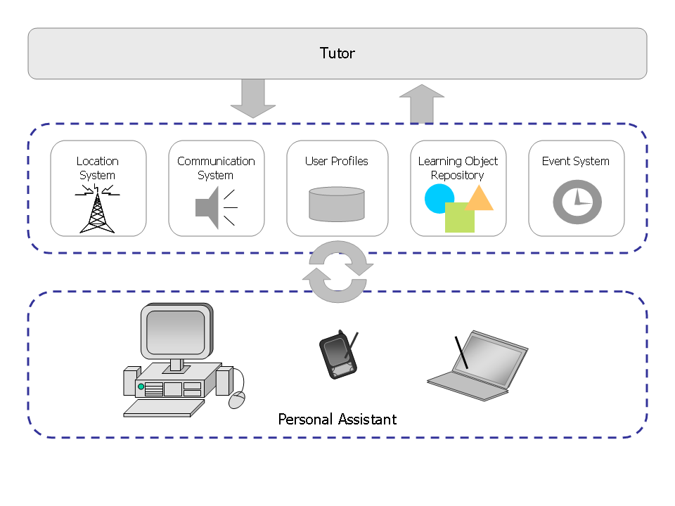
Figure 5: The LOCAL architecture
The personal assistant (PA) is the module which accompanies the learner in its mobile device. It allows users to stay connected to the system, while providing a certain degree of independence. The location system ties users' physical location data to symbolic names (contexts). This allows real time mapping of mobile device positions. As the learner authorizes the location system in its PA, it begins to determine the device's position and physical context changes, along with the time and date of such changes. With this data, it is possible to completely track the learner's movements. User profile data, alongside context information, is used in the learning process.
Learning objects in LOCAL are made available to learners in accordance with whatever pedagogical opportunities may appear during their interaction with the different contexts. The location system keeps the tutor aware of which context the learner is in. The tutor uses this information, as well as the learner's profile data, to select the objects meeting the learner's goals and the context. The objects meeting these criteria are then forwarded to the learner. The metadata specification for Learning Objects in LOCAL was made in accordance with the IEEE LTSC (IEEE, 2008b). The tutor uses profile and location data to find learning opportunities. It can act in two ways: (1) providing relevant, contextualized learning objects and (2) stimulating interaction between learners, by using learner profile data to create bonds between learners.
GlobalEdu uses the services offered by LOCAL to monitor and control the environment (see Figure 6). GlobalEdu's PAs are executed in the learner's devices, mapped to the LOCAL Personal Assistant. The Location System and the Event System are used to support the Context Management Module. Context Management Module is supported by the Learning Object Repository and the Profile Management by the User Profiles System. Communication Support Module is mapped to the LOCAL Communication System. Other Support Modules are not used.
Figure 6: LOCAL adapted for GlobalEdu
LOCAL is oriented to small-scale ubiquitous environments and its architecture was projected to a centralized execution (only one server). As such, there is only one GlobalEdu instance (see Figure 1). Modules are executed in the network server and the PA executes in the users' mobile devices.

Learner Profiles
In the last few years, the search for standardization of user profiles has led to several research efforts like PAPI (IEEE, 2008a) and LIP (IMS, 2009). In the scope of ubiquitous learning, profiles allow the exploration of resources based on characteristics of both the learner and the contexts in which he/she interacts. This is underlined in (Barbosa et al., 2006; Ogata & Yano, 2003; Nivo et al., 2007; SELENE, 2008).
The user profiles in LOCAL are based on the PAPI standard. Reasons behind this decision include: 1) flexibility -- PAPI can be freely extended, and all of its components are optional; 2) modularity -- profile fields and/or sections can be handled separately, allowing part of the profile to reside in the personal assistant, while another part is tied to the visited contexts. User profile data can be either persistent or contextual (see Figure 7).
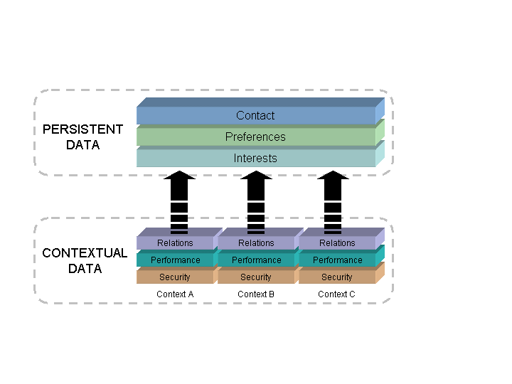
Figure 7: Organization of learner profiles in LOCAL
The persistent data (Contact, Preferences, Interests) is stored in the personal assistant, and it always accompanies the learner, no matter which context he/she is in. The contextual data (Relations, Performance, Security) is associated with the many contexts in which the learner interacts. LOCAL manages both kinds of data, seeking for pedagogical opportunities.
Contact stores basic user data, such as name, address, e-mail and phone number. The Preferences section helps the system customize the user experience, storing configuration data related to the preferred media type (audio, video and/or text), and others not directly related to pedagogical activities. Also, the learner might suffer from some kind of physical disability. In this case, according to specific disability scenarios, the system can provide the same content in different formats. For example, if the learners of a particular group are following a video tutorial, a transcript would be of particular use to people who are hard of hearing.
The Interests section follows the knowledge areas defined in the ACM Computing Classification System (ACM, 2009), having a general knowledge area (for example, "Math") and a specific interest topic, in the scope of said knowledge area (for example, "Group Theory"). The specific areas are then classified according to the apprentice's own goals (for example, "to learn" or "to teach"). Relations stores data which specifies relations between other users in the same context (for example, "student", "teacher" or "researcher"). Performance refers to proposed goals and evaluations conducted in a context. Security stores credentials (names and passwords) to allow for different access levels in specific contexts.

Personal Assistant and Location System
The personal assistant (PA) is the module which accompanies the learner in its mobile device. It allows users to stay connected to the system, while providing a certain degree of independence. The PA presents the following functionalities:
- Authentication, keeping track of the learner's connection status.
- Access to the location system, allowing for turning it off at will.
- Receiving and storing notifications proceeding from the communication system.
The location system used by the LOCAL is based on a generic architecture, supporting different methods of determining user's physical locations. The system ties physical location data to symbolic names (contexts). This allows real time mapping of mobile device positions. As the learner authorizes the location system in its PA, it begins to determine the device's position and physical context changes, along with the time and date of such changes. With this data, it is possible to completely track the learner's movements. User profile data, alongside context information, is used in the learning process.

Learning Objects
Learning objects in LOCAL are made available to learners in accordance with whatever pedagogical opportunities may appear during their interaction with the different contexts (see Figure 8). The location system keeps the tutor aware of which context the learner is in (step 1). The tutor uses this information, as well as the learner's profile data, to select the objects meeting the learner's goals and the context (steps 2 and 3). The objects meeting these criteria are then forwarded to the learner (step 4). This adaptive process can be started by two events: 1) when the learner enters a new context or 2) insertion of new material at the object repository. The metadata specification for Learning Objects in LOCAL was made in accordance with the IEEE LTSC (IEEE, 2008a). The ample acceptance of this standard is underlined in (Rigaux & Spyratos, 2009).
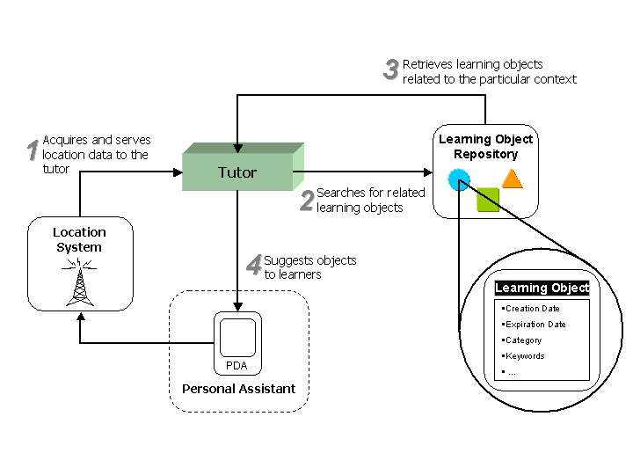
Figure 8: Learning Objects Management

Tutor
The tutor uses profile and location data to find learning opportunities. It can act in two ways: 1) sending learning objects (described in the last section) and 2) stimulating interaction between learners. It uses learner profile data to create bonds between learners (see Figure 9). There are two interaction forms: 1) Similar interests: the tutor finds learners with similar interests in the same context, and stimulates interaction. This approach can be used in the creation of workgroups in a classroom, for example; 2) Complementary interests: the tutor finds learners with complementary interests. For example, a learner who wishes to learn more about a particular subject is paired along a user who wishes to teach or knows more about it. This way, the tutor can be used, for example, to create pairs of students who complement each other.
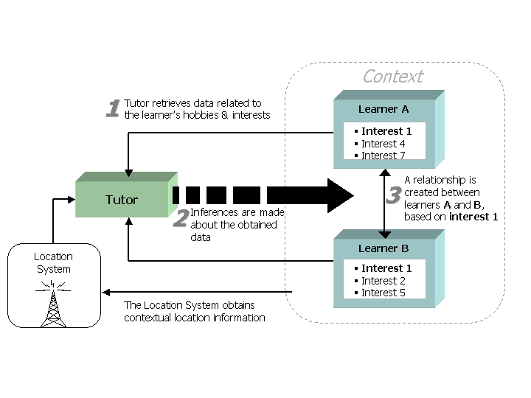
Figure 9: Stimulating Interaction between learners

Communication System & Events
The communication system present in LOCAL is used to establish contact with learners, notifying them of new pedagogical opportunities. This system can be controlled automatically, or by an operator using the administrative interface. Users are contacted by textual notifications. The notifications are sent according to profiles, objects, location and event data. The following services are supported:
- Sending messages to a specific user in the system, wherever it is.
- Sending messages to a specific context (everyone in the context receives the notification).
- Sending messages to a user, but only if he/she is inside a particular context.
- Sending messages to all users, regardless of context.
The messages also have an associated date of expiration, delimiting a time interval after which the message loses its validity. Figure 10 shows an example of use for the communication system where, based on the location data (1) and user profiles (2A), the tutor contacts the learner (3). This can be used to presenting new pedagogical opportunities, for instance. The communication system also supports the creation of events. An event is characterized by a series of properties, including keywords, starting date and location. Events can be defined to a future date, in usual date format (yyyy-mm-dd hh:mm:ss) and have an arbitrary duration. When a message is associated to an event, it is up to the tutor to find correspondences, and forward the messages at the appropriate time.
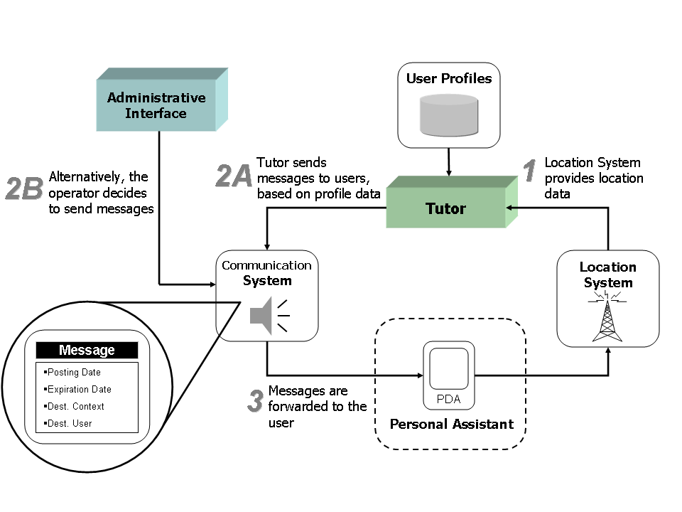
Figure 10: Communication System

Practical scenario: GlobalEdu and LOCAL
Our first choice in order to evaluate our proposal was the creation of a small-scale ubiquitous learning scenario. We used the integration GlobalEdu/LOCAL described in the section 4.2. The prototype scenario encloses nine rooms, covered by four wireless access points (see Figure 11). The location system has two parts: (1) a webservice created in C# and (2) a database which stores context information. The Personal Assistant was developed in C#, using the .NET Compact Framework. The assistant runs in iPAQs hx4700 and tablet PCs tc1100. It reads potency information from the four wireless access points and forwards it to the location system. The system uses this information to determine the position of users' mobile devices. The profile system was implemented using MySQL. The tutor and message system were also implemented as web services in C#.
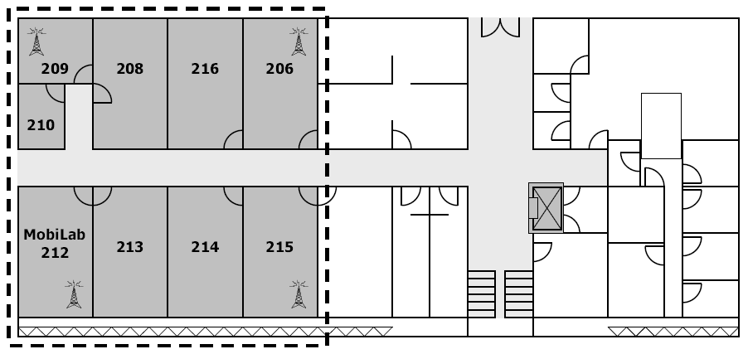
Figure 11: Prototype Scenario

Functionality Test 1: Following a Lession
The first moment occurs before the lesson. The professor sets an appointment consisting of a message with the subject of the upcoming debate, as well as a list of online resources. This appointment spans the whole duration of the lesson. This message is tied to room 216, where the debate will occur. The second moment corresponds to the start of the lesson. Seven students enter the classroom, and are promptly detected by the location system. They receive the appointed message. In the third moment, the professor requests the formation of groups for debating. The groups are formed according with similarity between user interests for "Programming Languages". In this particular case, three groups were formed: one (A) with four students interested in Java; the second (B) with two students interested in C# and another one (C) with just one student, interested in C++. The debate starts, where each group presents the pros and cons of each language. At this time, two students come late. Both receive the appointed message, and are also informed about what group they should participate in. One enters group A, and the other one enters group C. In the fourth moment, another late student arrives, and receives the appointed messages. However, the debate had already ended, and he is not directed to any group. The fifth moment occurs after the ending of the lesson. The system registers student attendance via sampled location data. A student is considered present if he was in the classroom for at least 60% of the meeting's duration. The last student was considered absent.

# | Initial Time | Final Time | Actor | Action
1 | - | 07:00 | Professor | Inserts an appointment to be sent between 7:30 and 10:00, to all users in room 216. This appointment accompanies a list of online resources related to the subject to be debated.
2 | 07:30 | 07:30 | Learners | Seven users enter the room (authentication using the Personal Assistant).
 | 07:30 | 07:30 | LOCAL | Location System begins tracking user location.
 | 07:30 | 07:30 | LOCAL | Communication System sends the previously appointed message to all users in room 216.
3 | 08:00 | 08:10 | Professor | Professor asks for the creation of groups for the debate.
 | 08:10 | 08:10 | LOCAL | Communication System sends messages, creates groups: A (4 users, Java), B (2 users, C#) and C (1 user, C++).
 | 08:10 | 08:30 | Learners | The debate starts.
 | 08:30 | 08:30 | Learners | Two users enter the room (authentication using the Personal Assistant).
 | 08:30 | 08:30 | LOCAL | Location System begins tracking location for the last 2 users. Communication System sends appointed message to these users informing where they should participate.
 | 08:30 | 09:00 | Learners | The debate comes to a conclusion.
4 | 09:00 | 09:00 | Learner | The last user arrives (authentication).
 | 09:00 | 09:00 | LOCAL | Location System begins tracking location for the last user. Communication System sends previously appointed message to this user.
 | 09:00 | 10:00 | Professor,  Learners | The participants keep exchanging ideas about the debate that was just held.
5 | 10:00 | - | LOCAL | Tutor uses the tracking of each participant (Location System) to register the attendances.
Table 1: Following a Lesson
The initial technological results proved that it was possible to: (1) create groups of students via profile and physical location data; (2) distribute material based on their profiles and in the debate theme; (3) automatically handle student attendances in the classroom, based on location data.
The previous simulated test couldn't present evidence of usability in a real environment. In order to validate ubiquitous learning using GlobalEdu/LOCAL, another experiment was conducted. This new experiment involved a sample consisting of 20 individuals, between learners and professors of a Computer Engineering undergraduate course at University of Vale do Rio dos Sinos (Unisinos, Brazil).
This test was realized into five moments: each moment, a set of four individuals interacted with the system. The following steps were considered: 1) each participant was given an HP iPAQ hx4700 mobile device, which they used to authenticate into the system; 2) the participants then received suggestions to participate in one of two workshops (based into user profile data); 3) the participants were notified whenever a professor they wanted to chat with was available; 4) in the fourth step, the system searched for matches between participants' profiles, suggesting learning resources related to their interests; 5) the users were instructed to go to the workshop rooms. The ubiquitous system then made available on the iPAQs the program of the chosen event (per user).

Functionality Test 2: Distributing Learning Objects
The scientific community has been using scenarios to validate context-aware environments (according to approach of (Dey, 2001)) and ubiquitous environments (according to (Satyanarayanan, 2001)). Following this strategy, our second experiment was a scenario involving the content distribution in a daily routine of a Computer Engineering student.
This scenario focuses on the distribution of Learning Objects (LOs) in different contexts based on the learner's profile, according to the described below:
"Jorge is professor of the Programming Techniques discipline of the Computer Engineering course at Unisinos. At the beginning of the week scheduled to the basic teaching of programming using the Java language, he registered in the LOCAL repository a group of learning objects (LOs) that support different preferences of media (for example, text, video, and audio). The register involved the indication of the contexts in which the objects would be available.
In the classroom, Jorge registered some curricular objects concerning the basic concepts. In the laboratory, he registered optional objects that will be available for improvement, involving different themes (such as "Interfaces" and "Parallel Programming").
João is a Computer Engineering student. At the day of the Programming Techniques class, João entered the classroom and logged in the LOCAL using the Personal Assistant (see Figure 12(a)), subsequently he received a notification of the availability of a curricular LO. João accessed the object and received a PDF file (preference text). LOCAL used theLearner Profiles subsystem to determine this preference.
After the class, João entered the laboratory and received a notification regarding the availability of a LO related to the subject of his interest in Java (in this case, "Interfaces").
In the laboratory, João preferred audio objects, because he could listen to them while he was using the computer (determined using the \emph{Learner Profiles}). João accessed the object and, after its use, received another notification of available object (see Figure 12b)) concerning the subject of his interest (this time, the object was about "Parallel Programming").
Always that the students receive a notification of LOs, they can delay the access. This action indicates that the students are interested in the object, but they do not want to access it at the moment, i.e., they want to access the object at the first opportunity of available time. João postponed the access to the optional object (see Figure 12(c)).
At the end of the day, João moved to the train station. When he entered the train, LOCAL notified him that a postponed LO was identified (Figure 12(d)). Getting home, João still received another notification saying that the professor had provided an additional object to a subject of his interest ("Polymorphism" in Java). In the register, the professor informed that the interested students should be notified independently of their locations."

# | Actor | Action
1 | Professor | Registers the learning objects in LOCAL, relating them to contexts.
2 | Learner | Enters the classroom and logs in LOCAL using an iPAQ 4700; see Figure 7(a)
3 | LOCAL | LOCAL detects the entry of the learner into the classroom. Tutor uses the Learner Profiles to determine the learner’s preference of media in the context. Subsequently, it requests the sending of a message about the LO available in the preferred media.
4 | Learner | Accesses the curricular object.
5 | Learner | Moves to the laboratory.
6 | LOCAL | Tutor detects the entry of the learner into the laboratory (Location System) and uses the Learning Objects Repository to verify the available LOs, related to the student’s interest. Tutor still uses the Learner Profiles subsystem to define the learner’s preferred media in the context. Finally, Tutor requests to the Communication subsystem the sending of messages about the available LOs; see Figure 7(b).
7 | Learner | Uses the Personal Assistant to access one of the two identified objects and postpones the access to the other to the first moment of available time (see Figure 7(c)).
8 | Learner | Moves to the train.
9 | LOCAL | LOCAL detects the entry of the student into the train and calls the Learning Objects Repository subsystem to verify the LOs that can be accessed during the trip. LOCAL identifies the postponed object and notifies the learner, see Figure 7(d).
10 | Learner | Accesses the object that has been postponed.
11 | Professor | Registers a new optional LO concerning “Polymorphism” in Java that can be accessed in any context.
12 | Learner | Enters his home.
13 | LOCAL | Tutor informs the learner (Communication subsystem) of the new optional LO available that corresponds to his areas of interest.
14 | LOCAL | Accesses the new object.
Table 2: Distributing Learning Objects
The scenario was tested in the validation environment described in Section 5.1. The João student carrying an iPAQ 4700 simulated the scenario, moving around the environment rooms. The train and the learner's house were simulated through the rooms 206 and 215. Table 2 summarizes the actions, emphasizing the character involved in each one.
Figure 12: LOCAL snapshots in the scenario of Learning Objects distribution
The results of this test proved that it was possible:
- To distribute the learning objects using the contexts visited by the learners;
- To use the learner's profiles to choose the learning objects to be distributed;
- To manage the access to the learning objects using the concept of postponed objects.

Survey
After following these steps, the users were asked to answer a survey, with questions relating to their experience. The questions had answers in a scale going from 1 (very weak) to 5 (excellent). An answer with the value 0 (zero) meant the user had no particular opinion about that feature. The relation of questions in the survey presented to participants is seen in Table 2. Several considerations can be made from the analysis of each question. In order to demonstrate this, we have chosen charts representative of the most important questions.

N. | Q: “What was your evaluation of…”
1 | …notifications about the availability of professors?
2 | …notifications about events, based on location and your profile data?
3 | …notification about the availability of physical resources?
4 | …information about users related to your interests, at your location?
5 | …the presentation of content related to events at your location?
6 | …the usefulness of this system for teaching?
7 | …the use of this system to determine your physical location?
8 | …the stimulus to interaction between users in the same location?
9 | …the possibility of using this system in daily activities?
10 | …the possibility of using this system in the classroom?
Table 3: Relation of Questions
The aspects of context-awareness were analyzed through questions 1 to 7. There was special interest into the adequate presentation of content related to pedagogical events, and the use of the system to track user location. Figure 13 presents the results of these questions, as answered by 20 test subjects. As can be seen, results indicate good acceptance in relation to contextual information.
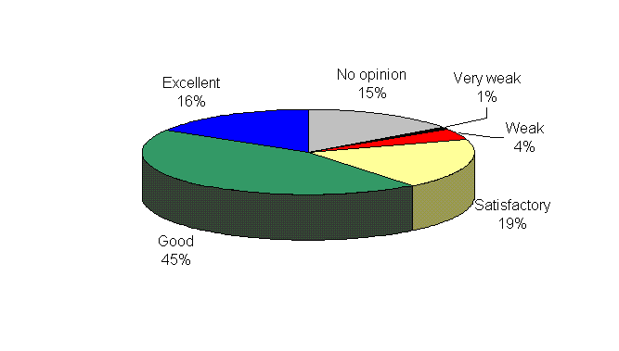
Figure 13: Context Data (questions 1 to 7)
The proposed daily use of the system as learning tool in the classroom, as well as interaction between users and contextual elements were analyzed through questions 8 to 10. These relate mostly to the usability of the system. The results in Figure 14 indicate a good acceptance by the test subjects. Over 60% of those subjects considered the system good orexcellent. If we take into consideration the test was performed in a limited and controlled scenario, the 32% of people that considered the system satisfactory are also a good indication that this system is well fit for daily usage.
It should be noted that, in this survey, adaptability aspects were not given a proper analysis. These aspects could be better analyzed if the test involved an heterogeneous sample of mobile devices (desktop PCs, tablet PCs and iPAQs).
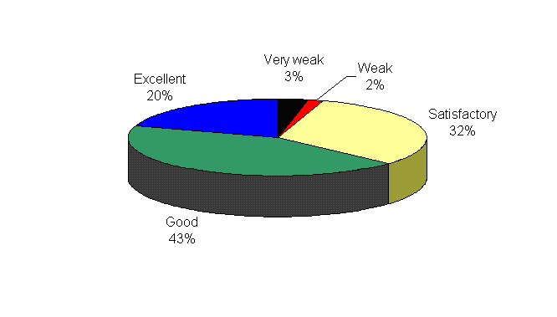
Figure 14: Daily usage (questions 8 to 10)

Related work
Some projects are investigating the use of ubiquitous computing to provide new learning perspectives. (Ogata & Yano, 2003) present JAPELAS, a context-aware system to support learning of Japanese language expressions. Learners carrying PDAs are assisted by the system to help identify the adequate polite expressions, considering the context where they are. JAPELAS is directed for a specific content. With GlobalEdu's Content Management it's possible to learn about any kind of content.
The Ambient Wood Project (Rogers, 2005) is dedicated to the design and building of pervasive environments. WiFi and sensor-based technologies are connected with a variety of mobile and standalone computational devices. The proposal is that digital augmentation offers a promising way for enhancing both indoors and outdoors learning processes. The GlobalEdu Context Managment module uses the Social and Physical information to improve the learning process. LOCAL explores indoors learning applications through WiFi technology, and with ISAM, we intend to explore both indoors and outdoors applications.
A ubiquitous computing scenario needs to support general purpose educational processes, where mobility, context and learner information will be considered. None of the current projects (Rogers, 2005; Ogata & Yano, 2003) addressing this particular problem use location data to both: (a) accurately track users' movements; (b) present contextual information to the learner. As such, GlobalEdu (alongside LOCAL) presents an innovation in this aspect, since location data can be used in many new pedagogical opportunities.

Conclusion
GlobalEdu is an innovative proposal that allows the exploration of the benefits of ubiquitous learning environments. Different from other approaches, GlobalEdu does not depend on a specific ubiquitous environment. Also, it can be coupled with mostly any learner model or learning objects model.
The results of the experiments show that GlobalEdu can be used in a specific classroom learning situation and in generic learning situations. Currently, we are improving the GlobalEdu prototype and its integration with LOCAL. After that, another round of tests shall be conducted.

Bibliography
ACM , 2009. The 1998 ACM Computing Classification System. [Online] Available at: http://www.acm.org/about/class/1998.
Augustin I. et al, 2004. ISAM, Joing Context-awareness and Mobility to Building Pervasive Applications. In Press, C., ed. Mobile Computing Handbook. New York, 2004.
Augustin I. et al, 2005. Managing the Follow-me Semantics to Build Large-Scale Pervasive Applications. In Workshop on Pervasive and Ad-Hoc Computing. New York, 2005. ACM Press.
Barbosa D. N. F. et al., 2006. Learning in a Large-Scale Pervasive Environment. In 2nd IEEE International Workshop on Pervasive Environment. New York, 2006. IEEE Press.
Barbosa D. N. F., Geyer C. F. R. & Barbosa J. L. V., 2005. GlobalEdu - an Architecture to Support Learning in a Pervasive Computing Environment. International Federation for Information Processing - Publications IFIP. Springer, 192, p.1.
Barbosa J. L. V., Hahn R.M. , Rabello S. A. & Barbosa D. N. F., 2007. Mobile and Ubiquitous Computing in a Innovative Undergraduate Course. In Technical Symposium on Computer Science Education. New York, 2007. ACM Press.
Barbosa J. L. V., Rabello S. A., Hahn R.M. & Barbosa Débora N. F., 2008. LOCAL: a Model Geared Towards Ubiquitous Learning. In 39th ACM Technical Symposium on Computer Science Education (SIGCSE). Portland, 2008. Proceedings of the ACM SIGCSE 2008.
Dey A. K., 2001. Understanding and Using Context. Personal and Ubiquitous Computing, 6(1), pp.4-7.
IEEE, 2008a. Draft standard for learning technology - Public and Private information to learners (PAPI). [Online] Available at: http://jtc1sc36.org/doc/36N0179.pdf [Accessed May 2008].
IEEE, 2008b. Draft Standard for Learning Object Metadata. [Online] Available at: http://ltsc.ieee.org/wg12/files/LOM\_1484\_12\_1\_v1\_Final\_Draft.pdf [Accessed May 2008].
IMS, 2009. Learner Information Package Specification (LIP). [Online] Available at: http://www.imsglobal.org/profiles.
Nivo C. P. et al., 2007. Context-Aware Model in an Ubiquitous Learning Environment. In Proc. 3rd International Workshop on Pervasive Learning (PerEL '07)., 2007.
Ogata H. & Yano Y. , 2003. How Ubiquitous Computing can support language learning. Proc. of KEST, pp.1-6.
Rigaux P. & Spyratos N. , 2009. SeLeNe Report: Metadata Management and Learning Object Composition in a Self eLearning Network. [Online] Available at: http://www.dcs.bbk.ac.uk/selene/reports/seleneLRI3.pdf.
Rogers Y. et al, 2005. Ubi-learning Integrates Indoor and Outdoor Experiences. Communications of the ACM, 48(1), pp.55-59.
Satyanarayanan M. , 2001. Pervasive Computing: Vision and Challenges. Personal Communications, IEEE, pp.10-17.
SELENE, 2008. Self e-Learning Networks. [Online] Available at: http://www.dcs.bbk.ac.uk/selene [Accessed May 2008].
Simon B. et al, 2003. Elena: A Mediation Infrastructure for Educational Services. In WWW Conference. Budapest, Hungary, 2003.
Tatar D. et al, 2003. Handhelds go to school: Lessons Learned. SRI International Journal Computer, 36(9), pp.30-37.
Weiser M. , 1991. The computer for the 21st century: vision and challenges. Scientific America, pp.94-104.
Yamin A.C. et al, 2002. ISAM: a Pervasive View in Distributed Mobile Computing. In IFIP/IEEE Network Control and Engineering (NET-CON). New York, 2002. IEEE Press.

