ANTLR
ANTLR, Another Tool for Language Recognition, is a parser generator under a three clause BSD-license [NRNRNRN]. It is a successor of PCCTS, sometimes called ANTLR v1, and the latest version is ANTLR v3. PCCTS was developed by Professor Terrence Parr of the University of San Francisco, now the primus motor behind ANTLR.
ANTLR generates recursive-decent recognizers that utilizes predicated LL(*) – an extension to LL(k) that uses arbitrary lookahead to make decisions. LL parsers are often said to be more intuitive and easier for humans to read than e.g. LALR parsers. This is supported by the fact that most hand written parsers are LL parsers. ANTLR supports multiple target languages, including Java. There are generally three types of recognizers ANTLR can generate: lexers, parsers and tree parsers/walkers.

LL(*)
The LL(*) parsing strategy is a strategy unique to ANTLR, invented by Terrence Parr for ANTLR v3. It is much more powerful than traditional LL(k) parsing [FLASS], because it is not limited to a finite amount of lookahead. It enhances the LL decision’s predictive capabilities, but does not by means alter the recursive decent parsing strategy. By automatically doing left-factoring LL(*) allows developers to write more natural and human readable grammar. If a grammar is specified as LL(k), LL(*) will degenerate into LL(k) for this grammar. A decision is LL(*) if a DFA exist that recognizes the decision’s exact lookahead language and has the following [FLASS]:
- No unreachable states
- No dangling states, i.e. states that cannot reach an accept state
- At least one accept state for each alternative.
All alternatives have a lookahead language, and if the lookahead languages of the alternatives are disjoint, the decision is LL(*). Except for not having a finite lookahead, LL(*) differs from LL(k) with backtracking in that it is looking ahead with the DFA, and not the whole parser. A thorough description of LL(*) can be found in [LOOKAHEAD].

Grammar Specification
The grammar is specified in a type of extended Backus- Naur form (EBNF), where the extension from BNF consists of the Kleene operators “?”,” +” and “*”, and the not-operator “~”. In addition, ANTLR introduces some types of predicates, namely validating, hoisting and gated semantic predicates and syntactic predicates. Validating and disambiguating semantic predicates is on the form “{sem. predicate}?”, gated semantic predicates is on the form “{sem. predicate}?=>” and syntactic predicates is on the form “(syn. pred.)=>”.
Actions specified in the target language can be inserted at appropriate places in the production rules wrapped by “{“ and “}”. Lexer productions and token names start with a capital letter, and parser productions do not. It is possible, and even common, to specify both the lexer and parser grammar in one file, thus ANTLR will determine which productions that belong to the lexer and the parser respectively by looking at the case of the first letter in the name of the production rules. An example of ANTLR grammar can be seen in [dsda].
NAME: ( ‘a’..’z’ | ‘A’..’Z’)+; AGE: (‘1’..’9’)? (‘1’..’9’|’0’);
sentence: NAME ‘ is ’ AGE ‘ years old’;

Lexer
//TODO: innhold: hvordan I grove trekk ser en lexer antlr generer ut. Sekvensdiagram/pseudokode

Parser
//TODO: innhold: hvordan I grove trekk ser en parser antlr generer ut. Evt. Sekvensdiagram(veldig likt lexer)/pseudokode

Generating an Abstract Syntax Tree
//TODO: innhold: Hvordan generer antlr AST, hvordan spesifisere annet en default (rotnode ^, imaginary tokens, unnlate tokens !, rewrite rules ->)

Semantic Predicates
Even though LL(*) allows the parser to scan arbitrarily far forward for any symbol or sequence of symbols to distinguish alternatives, it still has some weaknesses - particularly so when it comes to recursive rules. Semantic predicates are boolean expressions evaluated during runtime used to specify the semantic validity of an alternative. Predicate in this case simply means conditional, and the term semantic implies you are talking about arbitrary boolean expressions rather than a syntactic condition. As previously mentioned, ANTLR provides three types of semantic predicates:
- Disambiguating semantic predicates; which disambiguate syntactically identical alternatives.
- Gated semantic predicates; which can dynamically turn on and off parts of the grammar.
- Validating semantic predicates; which throw a recognition exception if the predicate fails.

Validating Semantic Predicates
If the expression being evaluated in a validating semantic predicate yields “false”, an exception is thrown, expressing that a semantic predicate has failed. These predicates are never included in the decision-making process. Validating semantic predicates can be very handy in cases where e.g. identifiers cannot contain a specific sequence of letters like “xml”, or to check if a variable is being references before its declaration. An example of a validating semantic predicate can be seen in [BAJZ].
expr: ID {$ID.getText().equalsIgnoreCase(“xml”);}?
| …..
;

Disambiguating Semantic Predicates
Disambiguating semantic predicates are hoisted into the prediction decisions of the LL(*) recognizer, but only if no decision can be made by syntax alone. There are generally two cases where these types of predicates are really useful: when a property of a token must dictate how the parser interprets it, and when a surrounding construct or some runtime information should alter how the parser matches the current construct. In most cases when a validating semantic predicate is applied, it can be transformed into a disambiguating semantic predicate. This will result in a syntax error instead of an exception if the predicate evaluates to false.
To fully resolve a non-determinism with disambiguating semantic predicates, all alternatives that contribute to the non-determinism will have to be covered, as seen in [fdfdf]. The DFA generated in [fdfdf] is illustrated in [1eksempeldisambig1].
expr : {pred1}? A | {pred2}? A; [fdfdf].
1 eksempeldisambig1
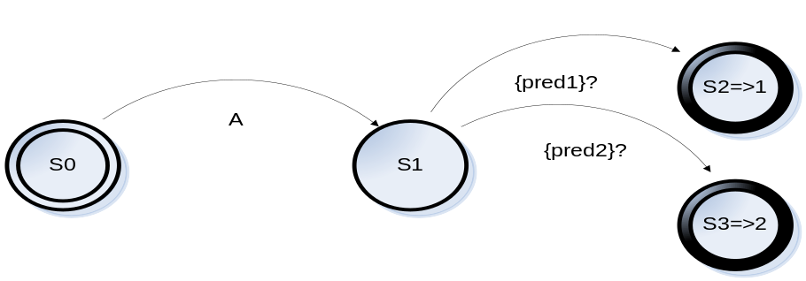
As mentioned earlier, ANTLR hoists disambiguating semantic predicates into the state where the alternative prediction is made, which can be illustrated by the fact that the grammar inn [glgs] also yields the DFA shown in [1eksempeldisambig1]. This includes only the predicates visible at the left edge of the production rule.
expr: a | b; [glgs]
a: {pred1}? A ;
b: {pred2}? A;
Predicates implicitly specify precedence among the alternatives, where an earlier specified alternative has precedence over a later one. If both pred1 and pred2 would evaluate to true in [fdfdf]., the first A would be matched. In the case of only the first n-1 non-deterministic alternatives among n are covered by a semantic predicate, the nth alternative would be covered with a {true}? Predicate. However, if this uncovered alternative was places first, it would be covered by a predicate that is the complement of the union of the following n-1 predicates.

Gated Semantic Predicates
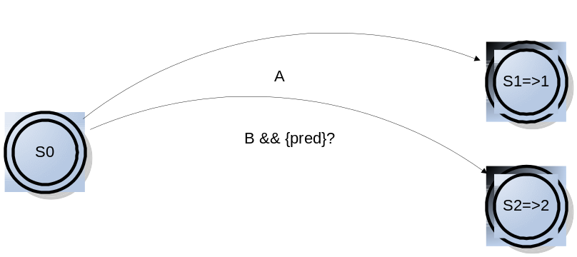Gated semantic predicates are used when it is desirable to turn parts of a grammar on or off based on runtime information. The predicate will be hoisted into the decision even if the decision is deterministic by considering syntax alone. The difference between gated and disambiguating semantic predicates is that decisions use disambiguating semantic predicates only when syntax alone is insufficient to distinguish between alternatives. [yrtyrt] shows an example of a gated semantic predicate, the resulting DFA is illustrated in [2exgated1], showing how the predicate is hoisted even with no syntactic ambiguity.
expr: a | b; [yrtyrt]
a: A;
b:{pred}?=>B
2 exgated1

Syntactic Predicates
Syntactic predicates are similar to semantic predicates except that they specify the syntactic validity of applying an alternative rather than the semantic validity. As with the semantic predicates their syntactic counterparts alter the parse based upon information available at runtime, but the only information the syntactic predicates use are future input symbols. Both syntactic predicates and LL(*) support arbitrary lookahead, but whereas LL(*) uses a DFA to examine the future input symbols, the predicates use a pushdown machine, making them capable of recognizing more complicated structures in the lookahead than DFAs. Syntactic predicates are especially useful to specify the precedence between to ambiguous alternatives, or when LL(*) cannot handle the grammar the way you would like to write it.
When used to disambiguate between alternatives, ANTLR will try the alternatives in order. The alternative whose predicate is the first to return true, is the one chosen (“if it looks like A, it is A”). In its simplest form, syntactic predicates can be used to look ahead an arbitrarily number of symbols, to check if they match the symbols specified in the predicate. In a case like this ANTLR rewrites the predicate to a gated semantic predicate, an example of this is [123] being translated to the equivalent grammar of [666].
expr: (A)=> A | B; [123]
expr: {input.LA(1)==A}?=>A | B; [666]
In more complex cases, syntactic predicates are implemented as disambiguating semantic predicates that invoke parser backtracking methods. These methods compare the input stream with the symbols specified in the predicate. If the stream and the symbols match, the method returns true, and the input stream is rolled back to the place where the comparing started. Such a case is exemplified by [lolol].
expr: (simple)=> simple ‘;’ [lolol].
| (recur)=> recur ‘;’ | simple ‘!’;
simple: ‘(‘ ID ‘)’;
recur: ‘(‘ recur ’)’
| ID;

[NRNRNRNRNRN] www.antlr.org
[FLASS] Antlrboka
[LOOKAHEAD] http://www.antlr.org/blog/antlr3/lookahead.tml

