Table of Contents
XQuery / XPath with full text extensions 2
General 2
Xpath / path expressions 2
FLWOR 2
Full text extensions 3
Current state of XQuery 4
Implementations with full-text extensions 4
Quark / TexQuery 4
GalaTex 5
Implementations sans full-text extensions 6
Pathfinder 6
Ongoing research 6
Relational Algebra 7
Primary Operators 7
Selection 7
Projection 8
Union And Difference 8
Cross product 9
Rename 9
Derived Operators 9
Intersection 10
Joins 10
Natural Join 10
Equi-join and theta-join 10
Division 10
Semi-join 11
Anti-join 11
Outer joins 11

XQuery / XPath with full text extensions

General
XML is a markup language and a form of data representation capable of storing data from a vast number of diverse data sources. These data sources include relational databases and in particular data structures bearing a resemblance to trees. XQuery is primarily an XML document query language, developed as an recommendation by the World Wide Web Consortium (abbrev. W3C) [W3C00] . This implies that XQuery is capable of querying any data structure which may be represented as an XML document.
The full text extensions to Xquery 1.0 and Xpath 2.0 employs tokenisation and phrase search to provide more accurate search results, and generally giving the benefits known from modern search engines. This is also believed to provide better support for diverse languages, and more accurate search queries (see [W3C02], “Introduction”).

Xpath / path expressions
XPath is, as well as a recommendation by the W3C [W3C01], a subset of Xquery. However XPath predates XQuery and is also limited only to path expressions, which includes axis specifiers for addressing nodes in a document as well as node tests, predicates, and arithmetic operators.
Consider this trivial example, from [W3S00]:
/bookstore/book[price>35]/title
This strongly resembles a reference to a file or folder on a standard Unix file system, with the exception of the conditional expression enclosed within angular brackets. In terms of Xpath, this particular example would translate into “fetch all title nodes where the price attribute is higher than 35”.

FLWOR
FLWOR is an integral part of XQuery, and can be compared to the select-from-where in SQL by a loose analogy. The abbreviation FLWOR means:
- For – imperative for-loop for iterating over tuples
- Let – assignment of tuples to variables
- Where – conditional filtering of tuples
- Order by – ordering of the resulting tuples
- Return – not to be mistaken with return statements from imperative languages. Returning in this context is more similar to yielding known from functional programming. The return statement is executed once for every iteration
This example from [STYL00] illustrates the usage of FLWOR, and compares it to its SQL counterpart:
/* FLWOR example */
for $v in $doc//video
where $v/year = 1999
return $v/title

/* Corresponding SQL example */
SELECT v.title FROM video v WHERE v.year = 1999

Full text extensions
The Xquery 1.0 and Xpath 2.0 specifications have been extended with full text capabilities (see [W3C02]), which enables the use of stemming, thesaurus, and similar tools for full-text queries. Specifically, the full-text extensions extend Xquery 1.0 and Xpath 2.0 in the following ways:
- A new and essential expression, FTContainsExpr, as well as new operators such as FTOr and FTAnd
- The addition of score variables to FLWOR expressions, for keeping track of search result scores, also known as rank, as seen in most modern search engines
- Static context declarations for full-text match options to the query prologue

Current state of XQuery

Implementations with full-text extensions

Quark / TexQuery
Quark is an experimental full-text search engine It is capable of indexing and querying XML documents, and it uses the TexQuery query language (see below). Quark was developed as a research project at Cornell University by Jayavel Shanmugasundaram and his associates.
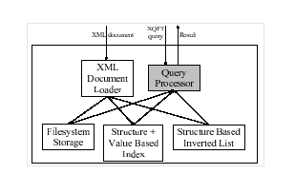Illustration 1: Quark architecture
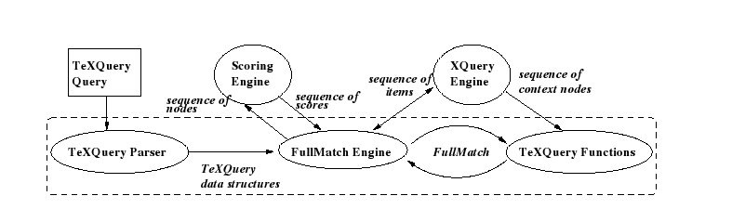Illustration 2: TexQuery architecture
TexQuery is a query language extending upon Xquery with added full-text search capabilities. These extensions do not necessarily conform to the W3C recommendation, however TexQuery is an early precursor to the current W3C recommendation (see [TEXQ00]), in whose development Shanmugasundaram actively participates.

GalaTex
GalaTex is a complete implementation of the Xquery 1.0 and Xpath 2.0 specifications with full-text extensions. GalaTex is an extension of Galax, which is a generic Xquery engine. The XQFT query is parsed and converted to an equivalent Xquery query which is passed to the Galax query engine. The GalaTex source code is not immediately availble, but can be obtained by contacting Emiran Curtmola at the University of California, San Diego, or Sihem Amer-Yahia, AT&T Research Labs.
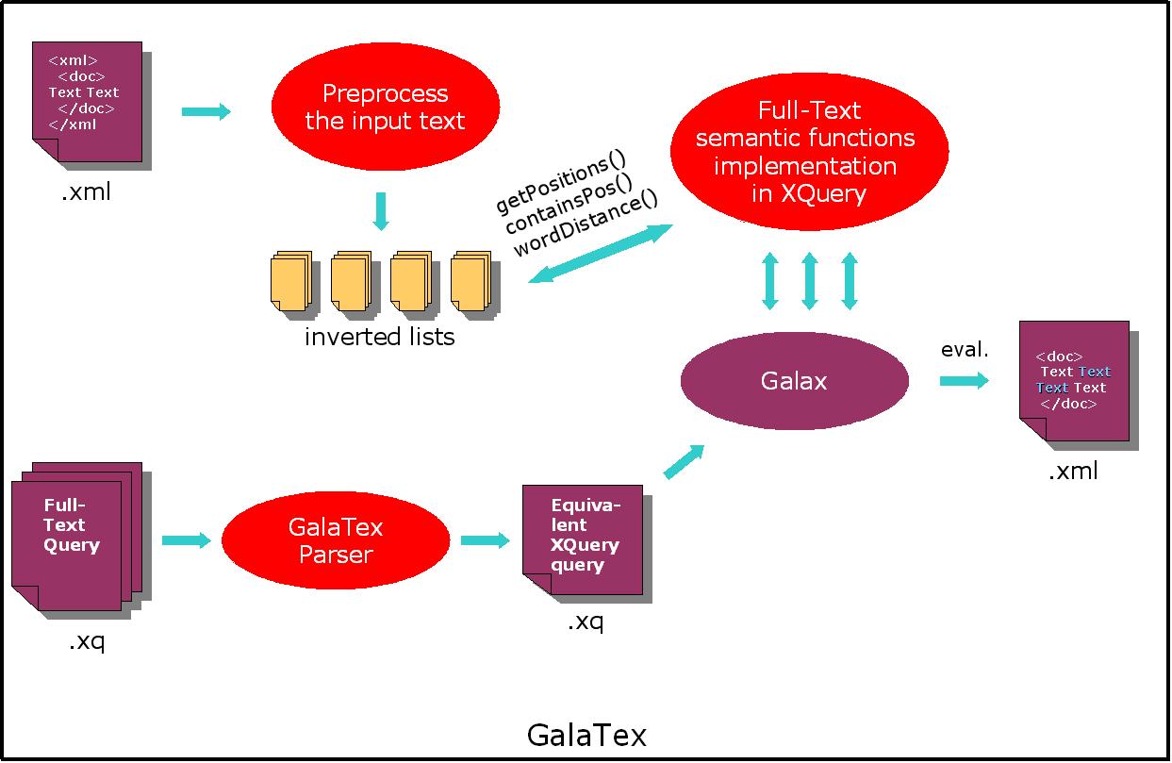Illustration 3: GalaTex architecture
TODO: wait for email about src

Implementations sans full-text extensions

Pathfinder
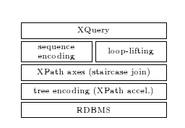Illustration 4: Pathfinder architecture / development stack
The Pathfinder project is an XQuery parser running on top of relational database systems, namely MonetDB. The goal of the Pathfinder project is to investigate how relational database technology can be utilized to create a scalable and efficient XQuery implementation. However, the Pathfinder project has, at the current time of writing, no support for full text extensions.
A future version of Pathfinder is planned to be capable of emitting SQL code generated from the XQuery parse tree. This illustrates Pathfinders capabilities of inter operating with relational database systems.

Ongoing research

Relational Algebra
The relational model for database management was introduced for the first time by Edgar Frank Coddin 1974 [BABA]. It was based on relational algebra which is an offshoot of first-order logic. Several terms are used when talking about relational algebra [COOL, NYRA,BIRA]:
- Set: A mathematical definition for a collection of objects which contains no duplicates
- Domain: A set of atomic values
- Attribute: A real world role played by a named domain
- Tuple: A collection of attributes which describe some real world entity
- Relation; A set of tuples
- Degree; The number of attributes a relation contains. Sometimes called arity
- Cardinality; The number of tuples in a relation
- Union compatible; Two relations R and S are union compatible iff they have the same degree and the domains of the corresponding attributes are the same

Primary Operators
The primary operators is a set of operators which constitutes the base of an algebra. Other operators can be defined in terms of the primary ones. If one of the primary operators is excluded, the algebra will loose some of it's expressiveness. The primitive operators of Codd's algebra are: selection, projection, union, difference, cross product and rename (later added for the sake of the named relational algebra).

Selection
Selection is a unary operator, and is used to obtain a subset of the tuples of a relation that satisfy a select condition. The resulting relation may have fewer tuples but it will have the same degree as the original relation. It is sometimes called restriction to avoid confusion with SELECT in SQL. The operator is often symbolized by sigma:
σ_{C}(R)
Where R is a relation and C is the select condition: a truth value or an expression yielding a truth value. The expression can be made up of any combination of logical operators, {∧,∨,¬}, and part expressions in the form aθb, where a is an attribute name, b is an attribute name or a value constant and θ is a binary operator in the set {<, ≤, =, ≥, >}. Illustration 1 shows an example of a select operation.

Projection
Illustration 5: Selection example:σ_{Letter='A' ∧ Number > 2}(R) yields (b)
(a)
(b)
Projection is also a unary operator, and is used to obtain a subset of the attributes of a relation. The resulting relation will have an equal or lower degree than the original relation. In the case of duplicates being produced as a result of omitting some attributes, the resulting relation will have fewer tuples than the original. Pi is often used to symbolize the operation:
π_{attr}(R)
Where R is a relation and attr is the set of attributes to be returned from R. Illustration 2 shows an example of a projection.

Union And Difference

Illustration 6: Projection example: π_{Number,Symbol}(R) yields (b)
(b)
(a)
Union and difference are two binary operators analogous with union and difference operators in set theory. The relational algebra version of the operators requires that the relations involved are union compatible.
The union of two relations returns a relation which includes all the tuples that are in either or both of the original relations. As the result is also a relation, any potential duplicates will be removed. The operation is commutative, and the returned relation will have the same degree as the two relations involved. A union between two relations are often symbolized thus:
R∪S
Where R and S are relations.
The difference of two relations R and S is a relation that contains all the tuples that are in R but not in S. The returned relation will, as was the case with union, have the same degree as the two relations involved. A difference between relations R and S may be written like this:
R−S

Cross product
The cross product operator is sometimes referred to as the cartesian product operator. As with union and difference, it also stems from set theory. The operator is used to combine all tuples in one relation with all the tuples from another. The returned relation will have a degree equal the sum of the degrees of each of the original relations, and a cardinality equal the product of the cardinalities. The operator is written as a cross:
R×S = S×R
Where R and S are relations. Illustration 3 shows an example of a cross product.

Illustration 7: Cross product example: R×S yields (c)
(a)
(b)
(c)

Rename
Rename is a unary operator used to rename a relation and/or a subset of its attributes. The resulting relation will be equal to the original one in all aspects except maybe some of its name properties. The Greek letter rho is often used to mark the presence of the rename operator:
ρ_{S}(R)
Where R is the relation being renamed, and S is a relational scheme. S is on the form T(a₁,...a_{n}) for a n-degree relation, where T is the new relation name and a_{1,}...a_{n} is the new names for relation R's attributes from 1 to n. The degree of the scheme must be the same as the degree of the relation being operated on.

Derived Operators
None of the six primary operators can be expressed as a combination of any of the others. In contrast, some useful operators can be derived using one or more of the primary ones. Most notably among these are intersection and join.

Intersection
Intersection is the fourth mentioned operator that stems from set theory. It is a binary operator, and the resulting relation will contain the set of tuples that are in both of the relations operated on. It can be expressed with the help of the difference operator, and hence require that the input relations are union compatible:
R∪S = R−(R−S) = S−(S−R)

Joins
Joins are a group of operators that all are derived from the primary operators with the cross product as a base. Among the operators in this group is natural join, theta-join, equi-join, anti-join, semi-join, outer joins and division. Some of these will be presented in this section.

Natural Join
Natural join is a binary operator that returns a relation consisting of all combinations of tuples in input relations that are equal on their common attribute names. The result relation will have a degree equal to the sum of the degrees of the two original relations subtracted the number of common attributes. It is possible to express natural join as a combination of cross product, projection and selection:
R⋈S = π_{a1,..am,R.b1,..R.bn,c1,..,ck}(σ_{R.b1=S.b1∧...∧R.bn=S.bn}(R×S))
Where R and S are relations, b1,..,bn are the common attributes, a1,..,am are the attributes unique to R and c1,...,ck are the attributes unique to S. A rename operator can lastly be used to remove the prefix of the common attributes.

Equi-join and theta-join
Theta-join returns a relation which is a combination of all the tuples in the two input relations that satisfy a condition C. C is in the form aθb, where a is a attribute name from one relation, b is an attribute from the other and θ is a binary operator in the set {<, ≤, =, ≥, >}. An equi-join is a theta-join where the binary operator in the condition is the equality operator. Theta-join can be expressed as a combination of select and cross product:
R⋈_{aθb}S = σ_{aθb}(R×S)

Division
Division in relational algebra can be described as the inverse operator of cross product, in the same way division and multiplication are inverse in natural numbers calculus – i.e. they are not inverse if the division gives a residue:
(R×S) ÷ R = S and (R×S) ÷ S = R
The resulting relation after a division contains the attribute values of the divisor relation that are associated with every member of the dividend relation [RDLM]. The operation may be better explained as a combination of cross product, projection and difference:
R÷S = π_{a1,...,an}(R)−π_{a1,...an}((π_{a1,...,an}(R)×S)−R)
Where R and S are relations and a1,...,an are the attributes unique to R.

Semi-join
Semi-join is a binary operation which returns a relation with the attributes of the first relation, and all the tuples in this same relation for which there is a tuple in the second relation that is equal on their common attributes. Semi-join can be described with the projection and natural-join operators:
R⋉S = π_{a1,...,an}(R⋈S)

Anti-join
The anti-join operator is very similar to the anti-join operator (and is also sometimes referred to as the anti-semi-join), except that it returns all the tuples in the first relation for which there is not a tuple in the other relation on their common attributes. It can be described with help of semi-join and difference:
R⊳S = R−R⋉S

Outer joins
The outer joins works in many ways as the natural join, except the resulting relation will include some extra tuples based on one or both of the input relations. The right outer join (⟖) will return a relation with all the tuples from a natural join between the first (left) and the second (right) relation, but also the tuples from the right relation that did not match any tuples from the left one on their common attributes. These extra tuples will have the value NULL in the result relation for all attributes that were unique to the left one. The left outer join (⟕) is analogous with the right version, the only difference is that the extra tuples will be based on the left input relation. The result relation of a full outer join (⟗) will have extra tuples based the ones that did not find a match in both input relations.

[BABA] TDT4225 Lagring og behandling av store datamengder, Kjell Bratbergsengen
[COOL] Dr Gordon Russel, Database eLearning, http://db.grussell.org/
[NYRA] City University of New York, Database Management Systems – Relational Algebra, http://cisnet.baruch.cuny.edu/holowczak/classes/3400/relationalalgebra/
[BIRA] A Quick Introduction to Relational Algebra, Sudarshan S. Chawathe http://www.umcs.maine.edu/~chaw/200609/mat500db/relnalg.pdf
[RDLM] On Making Relational Division comprehensible, Lester I. McCann, http://fie.engrng.pitt.edu/fie2003/papers/1057.pdf

Illustration Index
Illustration 1: Quark architecture 4
Illustration 2: TexQuery architecture 4
Illustration 3: GalaTex architecture 5
Illustration 4: Pathfinder architecture / development stack 6
Illustration 5: Selection example:σLetter='A' ∧ Number > 2(R) yields (b) 8
Illustration 6: Projection example: πNumber,Symbol(R) yields (b) 8
Illustration 7: Cross product example: R×S yields (c) 9

Bibliography
W3C00: W3C, XQuery 1.0 Specification, 2007, http://www.w3.org/TR/xquery/
W3C02: W3C, XQuery 1.0 and XPath 2.0 Full-Text 1.0, 2007, http://www.w3.org/TR/xquery-full-text/
W3C01: W3C, XML Path Language (XPath) 2.0 Specification, 2007, http://www.w3.org/TR/xpath20/
W3S00: Refsnes Data, W3 Schools XPath Tutorial, 2007, http://www.w3schools.com/xpath/
STYL00: Stylus Studio, Stylus Studio XQuery Tutorials, 2007, http://www.stylusstudio.com/tutorials/xquery_tutorials.html
TEXQ00: Chavdar Botev, Sihem Amer-Yahia, Jayavel Shanmugasundaram, A TeXQuery-Based XML Full-Text Search Engine, 2004

