Table of Contents
XQuery / XPath with full text extensions 2
General 2
Xpath / path expressions 2
FLWOR 2
Full text extensions 3
Current state of XQuery 4
Implementations with full-text extensions 4
Quark 4
TexQuery 4
GalaTex 4
Implementations sans full-text extensions 4
Pathfinder 4
Ongoing research 4

XQuery / XPath with full text extensions

General
XML is a markup language and a form of data representation capable of storing data from a vast number of diverse data sources. These data sources include relational databases and in particular data structures bearing a resemblance to trees. XQuery is primarily an XML document query language, developed as an recommendation by the World Wide Web Consortium (abbrev. W3C) [W3C00] . This implies that XQuery is capable of querying any data structure which may be represented as an XML document.
The full text extensions to Xquery 1.0 and Xpath 2.0 employs tokenisation and phrase search to provide more accurate search results, and generally giving the benefits known from modern search engines. This is also believed to provide better support for diverse languages, and more accurate search queries (see [W3C02], “Introduction”).

Xpath / path expressions
XPath is, as well as a recommendation by the W3C [W3C01], a subset of Xquery. However XPath predates XQuery and is also limited only to path expressions, which includes axis specifiers for addressing nodes in a document as well as node tests, predicates, and arithmetic operators.
Consider this trivial example, from [W3S00]:
/bookstore/book[price>35]/title
This strongly resembles a reference to a file or folder on a standard Unix file system, with the exception of the conditional expression enclosed within angular brackets. In terms of Xpath, this particular example would translate into “fetch all title nodes where the price attribute is higher than 35”.

FLWOR
FLWOR is an integral part of XQuery, and can be compared to the select-from-where in SQL by a loose analogy. The abbreviation FLWOR means:
- For – imperative for-loop for iterating over tuples
- Let – assignment of tuples to variables
- Where – conditional filtering of tuples
- Order by – ordering of the resulting tuples
- Return – not to be mistaken with return statements from imperative languages. Returning in this context is more similar to yielding known from functional programming. The return statement is executed once for every iteration
This example from [STYL00] illustrates the usage of FLWOR, and compares it to its SQL counterpart:
/* FLWOR example */
for $v in $doc//video
where $v/year = 1999
return $v/title

/* Corresponding SQL example */
SELECT v.title FROM video v WHERE v.year = 1999

Full text extensions
The Xquery 1.0 and Xpath 2.0 specifications have been extended with full text capabilities (see [W3C02]), which enables the use of stemming, thesaurus, and similar tools for full-text queries. Specifically, the full-text extensions extend Xquery 1.0 and Xpath 2.0 in the following ways:
- A new and essential expression, FTContainsExpr, as well as new operators such as FTOr and FTAnd
- The addition of score variables to FLWOR expressions, for keeping track of search result scores, also known as rank, as seen in most modern search engines
- Static context declarations for full-text match options to the query prologue

Current state of XQuery

Implementations with full-text extensions

Quark
Quark is an experimental implementation of Xquery with full-text extensions. It is capable of indexing and querying XML documents, and . Quark was developed as a research project at Cornell University by Jayavel Shanmugasundaram and his associates. Quark is now discontinued, however research efforts are now concentrated around the TexQuery project at the same university, for which Quark may be considered a precursor.
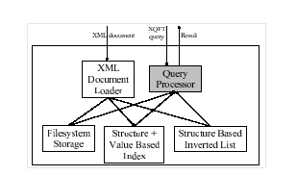Illustration 1: Quark architecture sketch,

TexQuery
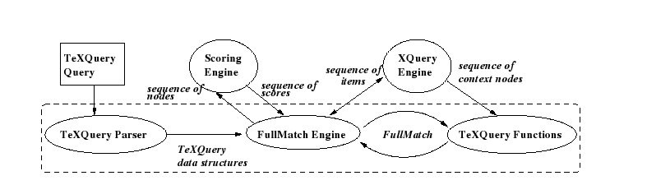Illustration 2: TexQuery architecture

GalaTex

Implementations sans full-text extensions

Pathfinder

Ongoing research

Illustration Index
Illustration 1: Quark architecture sketch, 4

Bibliography
W3C00: W3C, XQuery 1.0 Specification, 2007, http://www.w3.org/TR/xquery/
W3C02: W3C, XQuery 1.0 and XPath 2.0 Full-Text 1.0, 2007, http://www.w3.org/TR/xquery-full-text/
W3C01: W3C, XML Path Language (XPath) 2.0 Specification, 2007, http://www.w3.org/TR/xpath20/
W3S00: Refsnes Data, W3 Schools XPath Tutorial, 2007, http://www.w3schools.com/xpath/
STYL00: Stylus Studio, Stylus Studio XQuery Tutorials, 2007, http://www.stylusstudio.com/tutorials/xquery_tutorials.html

